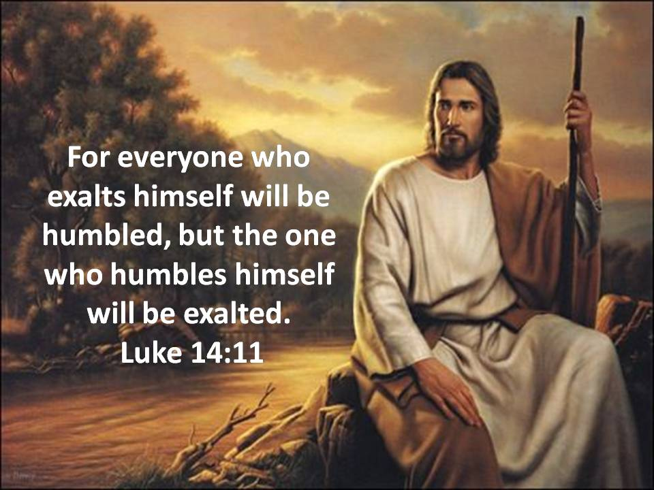

August 28, 2022

Twelfth Sunday after Pentecost

Carson City United Methodist Church

10:30 am
Greeting/Announcements

Call to Worship

L: Amid all the storms in our lives, God is with us!
P: Come, Lord, and pour your words into our hearts.
L: In the anguish and grief of everyday living, God is with us!
P: Hear our cries O Lord, and quiet our troubled spirits!
L: Come; let us open our hearts and minds to the Lord.
P: Let us come with hope and confidence before God.
L: For as high as the heavens are above the earth.
P: So great is his love for those who seek him.
L: As far as the east is from the west.
P: So far has he removed our transgressions from us.

*Hymn: Joyful, Joyful We Adore Thee UMH 89

Opening Prayer:
Heavenly Father make us instruments of your peace. Where there is doubt help us to sow faith in you. Where there is despair help us to sow the hope found only in you. Where there is pain and hurt help us to bring healing and comfort in your name. Where there is hate, let us sow your love. In Jesus name we ask this AMEN.

Contemporary Song: Who am I (Casting Crowns)

Offering

Doxology UMH 95

Offertory Prayer

Sharing of our Joys and Concerns

Call to Prayer: Turn Yor Eyes Upon Jesus UMH 349

Pastoral Prayer

Gospel Reading: LUKE 14:7-14

Old Testament: PSALM 18:27
Epistle Lesson: JAMES 4:6
Contemporary Song: The God Who Stays
(Matthew West)

MESSAGE

*Hymn: How Great Though Art UMH 77

Benediction

CCUMC – Announcements & Upcoming Events:

As a courtesy to others please silence or shut off cellphones

==================================================
UWF Kitchen clean: Aug 29th @ 10:00 am.
==================================================
Ad Board/Finance mtg: Rescheduled for Sep 7th @ 6:30 pm. Everyone is welcome.
==================================================
UWF Thank Offering: Join other United Women in Faith (UMW) in the Fellowship Hall on Monday, Sep 12th at 11:00 am for the World Thank Offering program. Bring a sack lunch to enjoy as we fellowship together. Drinks will be provided. If you wish to pick up a donation box, please pick one up from the table as you enter the
Sanctuary.
==================================================
UWF Soup Luncheon: 9/16, 11:00 am to 1:00 pm.
==================================================Michigan Conference Mission U: Is held at Gaylord UMC October 17-18. Walthagaye is attending both so if you need a ride, please get in touch with her. The flyer is on the What’s Happening bulletin board with registrations on the shelf under it.
==================================================
Craft & Vendor Show: CCUMC will be hosting a Craft Show on Sat, Nov 5th, 9:00 am thru 2:00 pm. If you are a Vendor interested in reserving a spot, please contact Dawn Wager @ 989-285-2518.
==================================================
SPRC/Single Board Governance Meetings & Charge Conference Information

SPRC
Saturday, September 10th 3:00 pm, to be held at the Alma UMC.

CHURCH CONFERENCE 2022
Sunday, October 30th 2:00 pm, to be held at the Alma UMC.
Everyone is welcome to attend.

Look what’s returning

Come join the fun on Sun, Sep 11th
@ 9:15 am for lots of activities to welcome back our Sunday “Cool” Hour. Kids, teens, and/or Adults are invited.

Resumes on Sun, Sep. 11th
from 6:30-8:00 pm

Resumes on Sun, Sep. 14th
from 6:30-8:00 pm

Classes resume on
Sun, Sep. 18th at 9:15 am

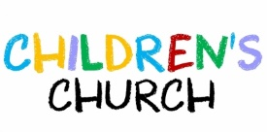
Resumes on Sun, Sep. 18th during
Worship Services @ 10:30 am

Serving & Supporting Sunday Worship
Audio/Video: Pat Monroe

Joys, Concerns & Prayer Request
For those battling cancers:
Jim Dunlap, Carolyn Nykerk, Dillan Abell,
Amorena Newman-Wojciakowski

For those who need support, guidance or have health concerns: Mindy Dennis, Jim Dunlap, Heather Kile

Weekly Giving
8/7/22 $2452.45 8/14/22 $2406.92 $4322.99

Nursery Schedule
Resumes Sep 18th, Volunteers needed, contact Roberta

Lighting of Candles

Passing of Collections Plate

Our Church in Ministry This Week
Mon: PT Class 6:30-8 pm
Tue & Thu: COA Meal 10 am – 2 pm

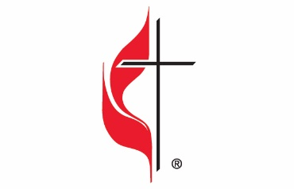

Carson City United Methodist Church
Location: 119 East Elm St., Carson City, MI
Mail: PO Box 298, Carson City, MI 48811
Phone: 989-584-3797 Email: carsoncityumc@gmail.com
Website: carsoncityumc.com
Sunday Worship Service: 10:30 am
Office Hours: Monday-Thursday, 9:00 am-12:00 pm
After hours by appointment
Pastor: Ian McDonald 906-322-5318
Secretary: Bonnie Seaman 989-763-1674

Weekly Sunday Bulletin now available on our website
@ www.carsoncityumc.com

“Father, what a friend I have in Jesus!
May I be that kind of friend others”

