2023
Ladies Singles Open

Disappointing only six people entered the competition this year, but we did have the 2022 winner defending her title, Joy Hart.

Round one saw Joy off to a good start with a 13 – 8 win over Margaret, Mo Gruchy had a great win 13 – 4 over Delphine from Guernsey and 2020 winner Jean won 13 – 2.

Round two Delphine recovered 13 – 1 win over Janet and Jean took an epic win over Joy 13 – 12. This was the same score as Mo made it two wins beating Margaret.

Round three saw Jean and Mo continue their winning streaks with Jean beating Margaret and Mo beating Janet.

Delphine won 13 – 11 over Joy as the title holder suffered back to back defeats.

In Round four the top two played each other with Jean taking a 13 – 6 win over Mo, this result ended Joy’s chance to retain her title despite her win over Janet.

Delphine beating Margaret 13 – 7 for three straight wins.

In the final Round Mo beat Joy who finished forth as a result, the first time she hadn’t finished in the top two.

Delphine handed Jean her fist defeat but it wasn’t enough on points difference as Jean took her second Ladies Singles title with Delphine third place.

Margaret took the spoils over Janet to finish fifth.

Final Tables

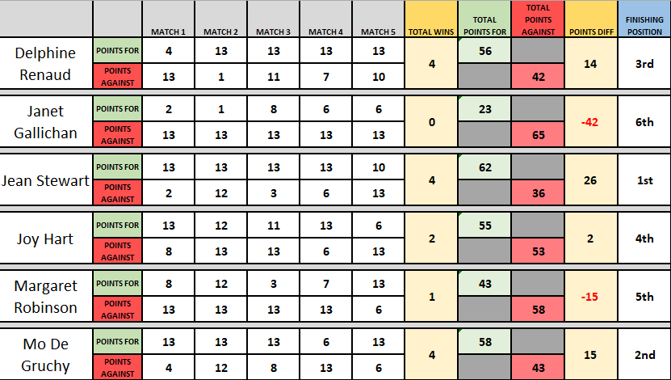

2023 Winner Jean Stewart

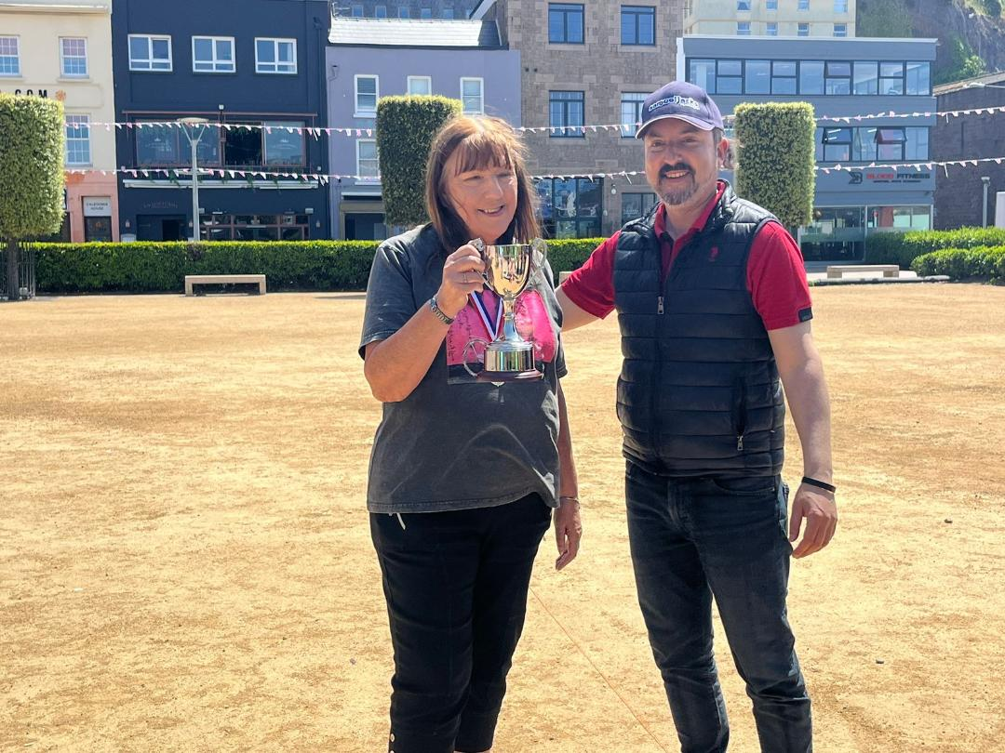

Thank you to those players who took part, your support for our competitions is appreciated.

Thank you also to Geoffroy Buffetrille for running the competition on the day.

Sponsored by

CoinShares | Digital Asset Investment Strategies for Professionals 🚀

Club email address - liberationpc@gmail.com

Club Website - www.liberationpetanque.co.uk

Kind Regards

Toby Northern

Chairman

Liberation Petanque Club

