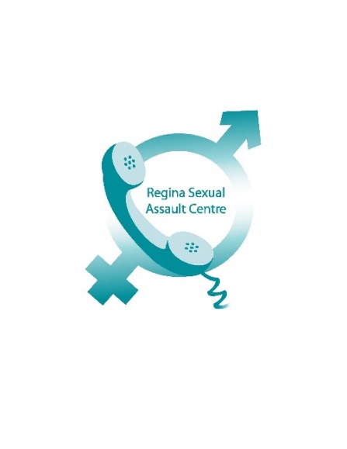
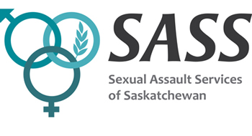

First Responder to Sexual Assault and Abuse Training™
Registration Form

Requested Date:
Time: 9:00 a.m. – 4:30 p.m. daily, with scheduled breaks
________________________________________________________________________
Name:

Email Address:

Occupation/Partner Agency/Faculty/Reason for Taking this Course:

Please note:
The First Responder to Sexual Assault and Abuse Training™ is a comprehensive workshop that covers all forms of sexual violence and contains content that could be difficult for some individuals. Please read the agenda included on the last page. We encourage everyone to practice self-awareness and participate in a way that is comfortable for them; however, we also strive to provide a quality education for all participants through a detailed curriculum and cannot be responsible for physical, emotional/mental impacts that may be experienced due to content. Participants must attend both days to receive a certificate. **Registration is not complete until full payment has been received.

Please complete the following questions:
I have received disclosures from children who were sexually abused | in my work  in my personal life  other (please explain)  I have not received disclosures
I have received disclosures from adults who were sexually abused as children | in my work  in my personal life  other (please explain)  I have not received disclosures
I have received disclosures from adults who were recently sexually assaulted | in my work  in my personal life  other (please explain)  I have not received disclosures
In responding to disclosures of sexual violence, what are the important things to communicate to the person you are supporting?
I have made reports to Child and Family services | in my work  in my personal life  I have not made a report
I am aware of resources in my community to support children, families and adults | for children  for families  for adults  please explain:
I can say words like penis, vagina, penetration and oral sex in front of a group of people | I could never  I never have, but probably could  it has taken practice  Easily and often

Module 1 – Critical Communication Skills for First Response
- What is Sexual Violence?
- Continuum of sexual violence
- Importance of effective feedback and support
- Intersectionality: experiences and responding
- Adult process of disclosure
Module 2 – Child Sexual Abuse
- Definitions and application of the Criminal Code of Canada
- Dynamics of victims and abusers
- Age of consent
- Child process of disclosure
- Behavioural, physical, mental and social indicators and impacts
- Reporting (Saskatchewan Child Abuse Protocol)
- Demonstration of responding skills using scenarios
Module 3 – Adults Who Were Abused as Children
- Behavioural, physical, mental and social impacts of abuse in adults
- Complex post-traumatic stress response
- Reporting options
- Grounding techniques
- Demonstration of responding skills using scenarios
Module 4 – Sexual Harassment
- Defining sexual harassment (Sask. Human Rights), harassment versus flirting
- Sexual harassment on the continuum of violence
- Impacts of sexual harassment
- Reporting options
Module 5 – Sexual Assault
- Definitions and application of the Criminal Code of Canada
- Examination of myths and biases
- Prevalence rates
- Immediate and long-term impacts
- Sexual assault trauma: stages and responses
- Reporting options
- Demonstration of responding skills using scenarios
Module 6 – Rethinking Prevention
- Define and discuss the anti-violence continuum
- Discuss negative impacts of prevention tips aimed at people who may be assaulted
- Myths and the “Just World” hypothesis
- Personal challenges: boundaries, being media savvy, involvement, speaking out

