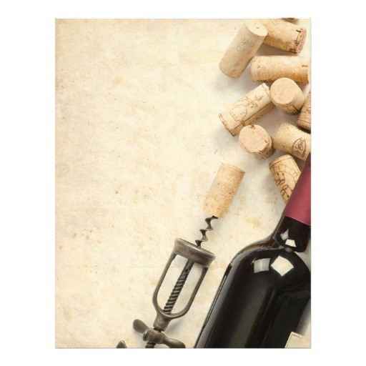

Il Grande Friselle Miste

Frito misto with squid, shrimp, cod, zucchini, eggplant, polenta.

Pairing Wine:

Prosecco, Fantinel. Friuli, Italy

----------

Panzanella

Classic Tuscan Summer Salad.

Pairing Wine:

Verdicchio, Gia. Marche, Italy

----------

Farfalle con Prosciutto e Melone

Cold Bowtie Pasta, Parma Prosciutto, Cantaloupe, EVOO, White Balsamic.

Pairing Wine:

Primitivo, Soleto. Puglia, Italy

----------

Branzino al Cartoccio con Vino Bianco

Sea Bass baked in Foil with Thyme, Sage, Rosemary and Cherry Tomatoes, wine.

Pairing Wine:

Teodosia, Basilisco. Basilicata, Italy

----------

Finish the Evening

**Watermelon Granitta**

**RSVP Speranza   
614.459.7000**

**NicolaColumbus@gmail.com**

Nicola Wine Dinner

Festa di Ferragosto

Wednesday, August 26th, 2015

7:00 ~ 9:00 | $49 per person