******The International Association of Lions** **Clubs**

**(Lions Clubs International)**

**New Jersey Lions Eye Glass Recycling Center**

**Operating Center at Katzenbach School for the Deaf**

**320 Sullivan Way, West Trenton, NJ  08628**

**Mail To: P.O. Box 7263; West, Trenton, NJ 08628**

**Tel: 908-788-LION (5466); Fax: 908-788-5467**

**NJCURE / VISION USA**

**Eye Care Provider**

**Instruction Sheet**

On behalf of NJ Lions Eyeglass Recycling Center and Vision USA we want to thank you for participating in the NJCURE “Pilot Program.”

The NJCURE Program is a pilot Lions Club Vision Program designed to allow local Lions Clubs access to Lions Lenses at a reduced cost. The program is designed as a low cost alternative to providing both an eye examination and a pair of custom eyewear to financially needy people.

The goal is to assist as many financially challenged people as possible to receive a free eye exam and to reduce the costs associated with providing eyeglasses to those less fortunate.

As a participating Eye Care Provider (ECP) your responsibilities will be:

1. To schedule client for an appointment, perform an eye examination and write a prescription
2. To have the patient pick a frame from those provided upon assignment of your first referral
3. To contact the NJCURE Coordinator at [NJLERC@aol.com](mailto:NJLERC@aol.com) (if you do not receive a frame kit)
4. To download a prescription blank by visiting [www.NJLERC.org](http://www.NJLERC.org) (Click NJ CURE on homepage)
5. To forward a frame and prescription to our designated finishing/edging Lab (See below) or to complete the Vision USA PATIENT Information Form noting the frame selection and fax it to (908)788-5467. In either case, both the PIF and RX must be faxed to the Program Coordinator.
6. To schedule patient to fit and dispense finished eyeglasses

Note: All Vision USA Optometrist’s should follow the normal procedure as outlines by the AOA. You **must** fax the PIF Form To (908)788-5467 so that the NJCURE Coordinator knows the exam is complete. The form will be faxed to the lab for processing.

Finishing Lab Address:

Essilor of NJ, 5 Powderhorn Drive, Warren, NJ 07059

Phone 1-877-265-9884 Fax: 1-877-263-9884

Deb Case (Manager)

If you are an Optometrist working with a local Lions Club and once your first referral is scheduled for an appointment, NJLERC will send you a frame kit containing 12 Men, 12 Women and 12 Children’s frames for patients to select from after your examination. At this point, you will need to send the prescription (Download from website) and selected frame to Essilor of New Jersey. Copy of signed application and rx must be faxed to NJCURE Coordinator the same as participating Vision USA Optometrists.

Page Two

NJLERC will pay the cost of shipping the finished eyeglasses back to the original ECP using a Pitney Bowles Prepaid Postage Meter via US Regular Mail. As a participating ECP doing an exam, you **will not** be charged for edging, lab fees or return shipping costs. You will only be asked to get the original prescription and frame to the above lab for processing. Lions Lenses are S.V. (-8.00 to +4.00 measured in .25 steps w/cylinders up to 2.00), any prescription which falls outside this ‘In-Range” category will require special handling and time to process. Please expect an additional 7 day delay for processing these out-of-range jobs. Shipping glasses from the lab to you by USPS (Regular Mail) will take approximately 2 days depending on your zip code.

You will find enclosed in this welcome package and available on-line at [www.njlerc.org](http://www.njlerc.org) a prescription blank which was specially designed for the NJCURE Program. Please use this form and **do not** substitute it for another blank. You can see that a designated billing account has been established (NJCURE #579). This account will be invoiced directly for all preapproved applications or referrals sent to you.*

Each patient shall be responsible to bring you a copy or upon request your request, get you a copy of their approved application prior to scheduling an examination. Please write the NJCURE /Vision USA Application # assigned in the lower right hand box of the Essilor Prescription Form. This will be used for billing and payment purposes.

Special Comment(s)*

Access to the Lion Lense is limited and can only be used in Lions Refractive Error Programs for indigent patients that provide comprehensive exams, and appropriate prescription and matched frames.

Each referral **must** have a Patient #579 followed by the Patient Last Name noted on every application along with a signature from a certifying Lions Club President / Secretary. The NJCURE Coordinator is also authorized to certify and preapprove an application.

If an incomplete application is presented with no signature or without a patient number please do not schedule an examination or forward a job for processing as it will not be authorized for payment.

In the event you need immediate assistance, please contact the NJCURE Coordinator:

Alan P. Brewer

(908)244-9996 Cell (Call will be answered with 24 hours)

(908)788-5466 Phone (Call will be returned within 24-48 hours)

(908)788-5467 Fax

[NJLERC@aol.com](mailto:NJLERC@aol.com)

[WWW.NJLERC.ORG](http://WWW.NJLERC.ORG)

The NJCURE Vision Program is designed to assist those less fortunate in receiving eye care, and to potentially reduce the costs of providing that assistance for the Lions Clubs and possibly the generous Eye Care Provider. Lions Clubs are known for their service mission of eradicating preventable blindness and assisting those less fortunate who are visually impaired ---“*We Serve.”*

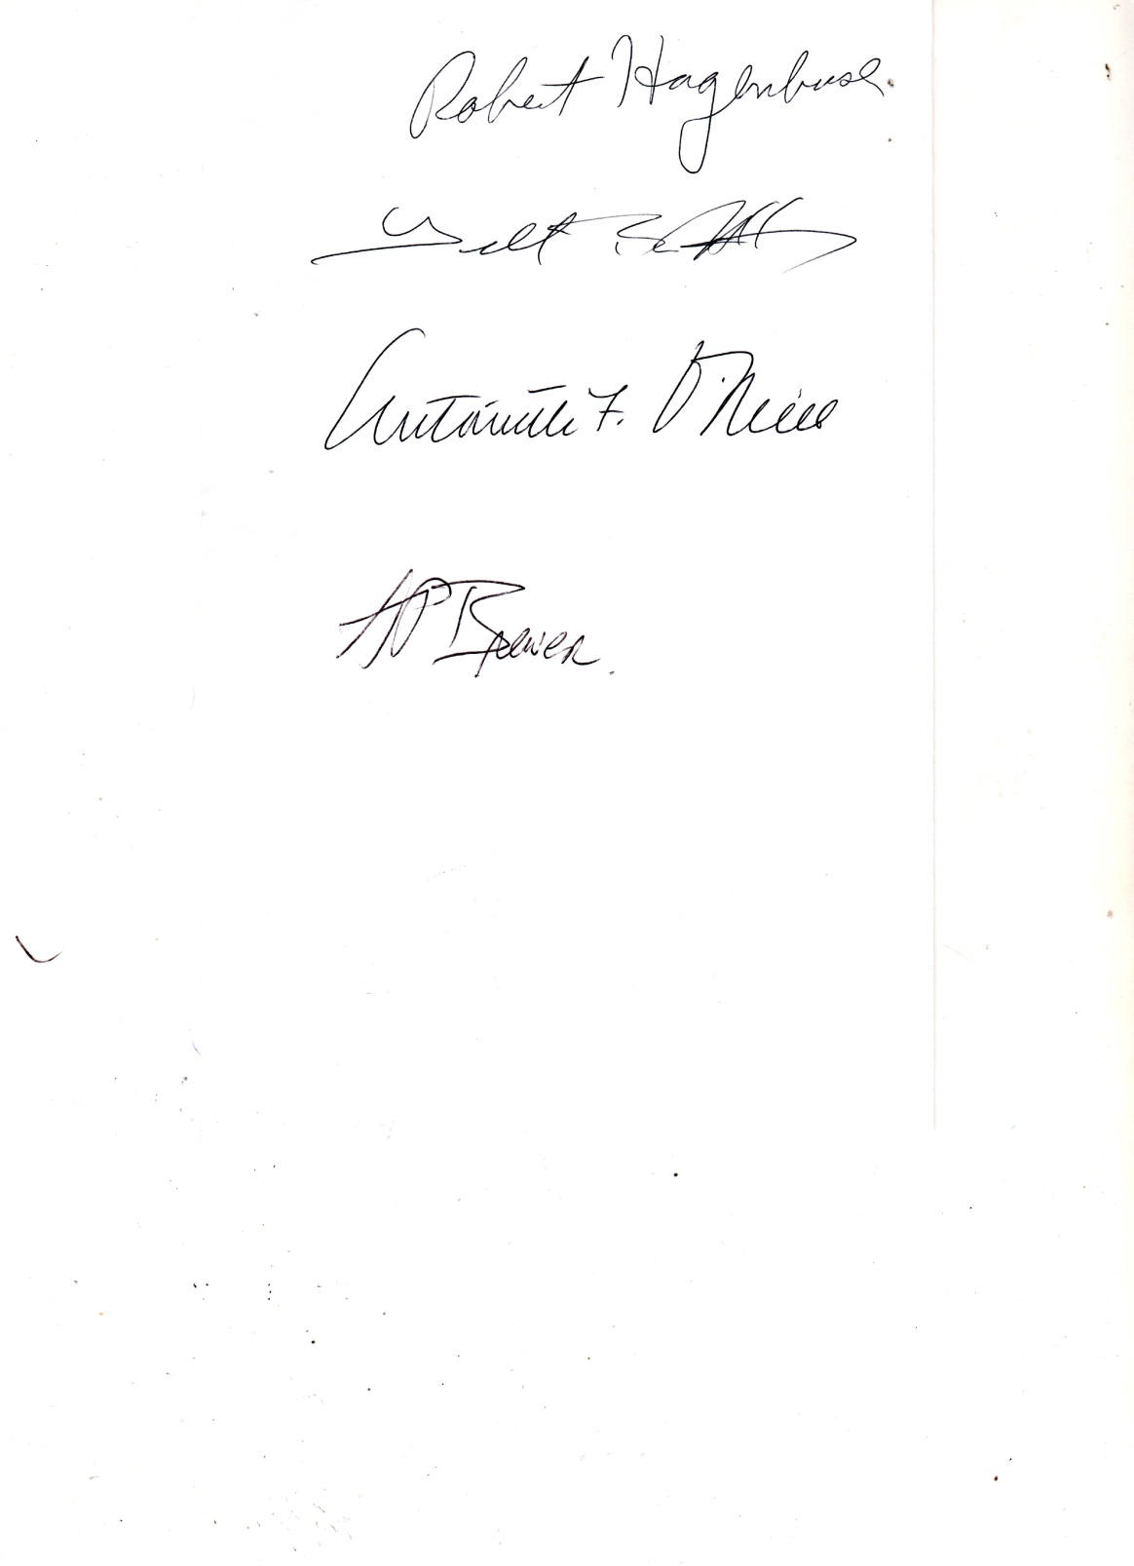Yours in Service,

PCC Alan P. Brewer

Page Three

**Special Note:** The above Instructions are designed for NJ Lions Club Eye Care Provider’s (Optometrist’s) to use who have an existing relationship or agreement with a local club and have “Opt-In” to the NJCURE Vision Program. All Vision USA ECP’s have their own existing procedure to follow as outlined by AOA Optometry Cares (AOA).Vision.The only exception is that a fax copy of the PIF and prescription form must be faxed to (908)788-5467 upon completion of an examination.