Broomball Rules for Cozzie’s Tavern

Game Basics:
This is a 7-week season, Tuesday nights with games at 6:30, 7:30pm. and 8:30pm (if we have 8 teams total.)

Game consists of two, 20-minute halves with a five-minute halftime. The basic strategy is to get the ball in the net. Pretty simple.

Play-off games will be Tuesday February 12, weather permitting.

Teams:
Each team has a goalie and three forwards (Cozzie’s rink is smaller than standard size so only allows for four players per team on the ice at a time.) 6-8 players per team is recommended.

All players must be 18 years or older.

Wins + Losses:
Game scores will be recorded by the ref each week and the top two teams at the end of the season wins prize $.

Forfeits:
If a team fails to present enough players for a game night, it will result in a forfeit and a loss for that team. Cozzie’s must be notified by 4pm on game day if they will not be able to play.

Weather:
We’ll play in anything unless roads aren’t drivable. Cancellations due to weather will be posted on Cozzie’s website by 5pm on game day.
For subzero temps, obviously dress in extra layers and use hand/feet warmers in your gloves and boots if need be. You will be contacted via email by 4pm game day if a game will be cancelled.

Rules
General penalty rules will be enforced. i.e. Tripping, slashing, elbowing, high-sticking, butt-ending, body checking, cross-checking etc.

*You CAN stop a ball with your hand if it’s above or below shoulder level but only to stop it in the air. Then it must be dropped to your stick to pass or shoot.

*You CAN kick the ball from an opponent or to get it out of a tight spot, but if it is kicked into the goal it doesn’t count as a point. Goals must be hit off the stick in order to count for points.

*Substitutions will happen on the fly, when a player wishes to come out. Game play continues so you switch quickly.

Required Equipment

Shoes
Official Broomball shoes are REQUIRED for this league. They give a player more traction than standard shoes or boots. They can be the most expensive piece of equipment but having them can help to keep you upright longer and allow you to run on the ice with more ease and confidence. WINTER/HIKING BOOTS WITH CHAINS ARE PROHIBITED. YOU WILL NOT BE ALLOWED ON THE ICE WITH THIS FORM OF FOOTWEAR. (If you don’t want to purchase new broomball shoes, you can find them used on Ebay and Craigslist.)
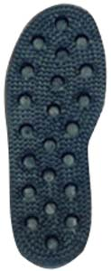 | 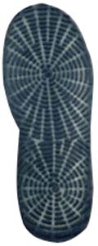

Sticks
Commercially produced broomball sticks are required for play. Sticks (a.k.a. brooms) have either wood or aluminum shafts.
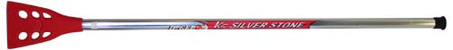
Broomball Stick

Helmet
Hockey helmets with chin straps are REQUIRED for all games at Cozzie’s. A face shield or cage is also recommended, but not required. Some prefer to remove those so they can see better during play. But be prepared for potential sticks or ball shots to the face. It CAN occur.
Balls
The outdoor ball looks very similar to a small soccer ball. These are provided by Cozzie’s.
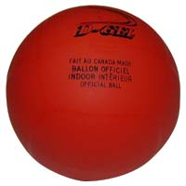 | 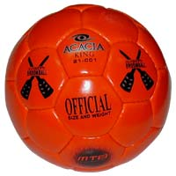
Indoor Ball | Outdoor Ball

Pads
Shin, knee and elbow pads are not required but recommended. Falling and sliding on the ice is a part of the game and better to keep those joints protected. A full knee + shin guard is ideal, that you can wear over a base layer and under snow or wind pants so they can be firmly held in place. Same with elbow pads.
Jerseys
Matching Jerseys are optional. Some teams have them, some just play in their winter coats or hoodies. Heritage Embroidery sells big hockey jerseys you can wear over your coats/sweatshirts, but that’s up to you and whether you want to spend $ on that.

