Copyright © All rights reserved worldwide.

YOUR RIGHTS: This book is restricted to your personal use only. It does not come with any other rights.

LEGAL DISCLAIMER: This book is protected by international copyright law and may not be copied, reproduced, given away, or used to create derivative works without the publisher’s expressed permission. The publisher retains full copyrights to this book.

The author has made every reasonable effort to be as accurate and complete as possible in the creation of this book and to ensure that the information provided is free from errors; however, the author/publisher/ reseller assumes no responsibility for errors, omissions, or contrary interpretation of the subject matter herein and does not warrant or represent at any time that the contents within are accurate due to the rapidly changing nature of the Internet.

Any perceived slights of specific persons, peoples, or organizations are unintentional.

The purpose of this book is to educate and there are no guarantees of income, sales or results implied. The publisher/author/reseller can therefore not be held accountable for any poor results you may attain when implementing the techniques or when following any guidelines set out for you in this book.

Any product, website, and company names mentioned in this report are the trademarks or copyright properties of their respective owners. The author/publisher/reseller are not associated or affiliated with them in any way. Nor does the referred product, website, and company names sponsor, endorse, or approve this product.

COMPENSATION DISCLOSURE: Unless otherwise expressly stated, you should assume that the links contained in this book may be affiliate links and either the author/publisher/reseller will earn commission if you click on them and buy the product/service mentioned in this book. However, the author/publisher/reseller disclaim any liability that may result from your involvement with any such websites/products. You should perform due diligence before buying mentioned products or services.

This constitutes the entire license agreement. Any disputes or terms not discussed in this agreement are at the sole discretion of the publisher.

Introduction

There is one extremely important thing that can really make or break the success of any website, but a lot of webmasters are underutilizing it – or worse, aren’t using it at all. That is analytics. Specifically, Google Analytics.

What makes Google Analytics so great?

Well, not only is it a great way to monitor how much traffic your site is getting and where it’s coming from, but if you use it properly you can glean a wealth of other information including your bounce rate, most popular pages or articles, and even your conversion rates!

The trouble is, it can be confusing. There are tons of features that seem hopelessly hidden amongst a wide variety of options, and the majority of people don’t even know they’re there, much less how to use them.

In this guide, you’re going to learn about some of the most important features of Google Analytics, and how you can use those features to improve your traffic, conversions and more!

So let’s get started, shall we?

Installing Analytics

The first thing you need to do is get a Google Analytics account, if you don’t already have one:

http://analytics.google.com

You can use an existing Google account. Just sign in and press “Sign up” you’re ready to start using Google Analytics.



Next, you’ll need to add a site to Analytics. To do this, you can take a look at this great guide Google has already made for you:

https://support.google.com/analytics/answer/1008080?hl=en

Analytics with WordPress

If you’re using WordPress, and a great number of sites are these days, you can use a nifty little plugin to make it easier to install Analytics on your pages. This is especially helpful if your theme doesn’t already have a specific place to add your Analytics code. (Some do.)

If your theme doesn’t, you might want to check out the Analytics by Yoast plugin. This plugin will connect to your Analytics account and let you choose which site you want to track and will then automatically add your Analytics code to all of your posts and pages.

Take a look at the plugin here:

https://yoast.com/wordpress/plugins/google-analytics/

The Five Report Suites

There are five report suites inside Google Analytics that will each offer you different types of information.

These five different report times include:

- Real Time
- Audience
- Acquisition
- Behavior
- Conversions

Some sites may not use all of these reports. For example, if you’re not selling anything, you may not need to use the conversions suite. (However, it’s still useful for tracking conversions to your email list and such.)

Real-Time

Real-time reports let you know what is happening with your site right now. You can find out what is happening on your website at the moment you’re viewing the report. This will give you live information about how much traffic you’re getting and what pages people are currently viewing.

Audience

The audience reports give you information about the people visiting your site. They let you know their demographics such as age and gender, their interests, where they are located, what type of devices and browser they use, etc.

Acquisition

Acquisition reports tell you where your traffic is coming from. It gives you information such as keywords used to find you and links they came from. This will help you determine which are your most effective keywords and marketing channels.

Behavior

The behavior reports let you know information such as which pages people are viewing, where they go, how fast your pages load, etc. This will tell you which articles are most popular, and what you could do to make people enjoy your content more.

Conversions

The conversion reports will let you know how effective your site is at making sales or getting email signups or getting users to take whatever other action you’d like them to take.

Those are the five different types of reports and what type of information you can get from each one.

Ideally, you’ll be using each of these different types of reports in order to take full advantage of the power offered by Google Analytics.

You can learn a lot about how to increase your traffic and conversions by using these reports.

Basic Date Range Reports

Using date ranges can help you in many ways. It will allow you not only to see your traffic over a time period, but also compare it to other time periods in the past to see if your traffic is growing or shrinking, and how certain events affected your traffic.

If you look at the top of your screen while logged into Analytics, you’ll notice a date range. You can set this to pretty much any date range you want in order to see historical data and compare your information to times in the past.

This is useful for figuring out if your traffic is growing or shrinking, when you might have had spikes in traffic to figure out what may have contributed to the spikes, etc.

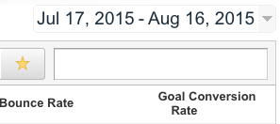

You can also compare data easily by selecting “Compare to” in order to select two different time periods in order to get a comparison that will show you different lines to let you compare historical data.

Here’s how to do it:

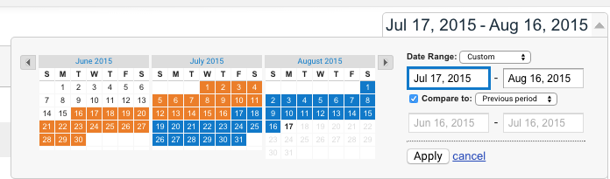

Just tick the “Compare to” box after you click your date range, and then select the time period you want to compare it to.

Note: You can do this while viewing a single site, OR while viewing an overview of your entire account at once to give you a snapshot of how all your sites are doing.

Here’s what it looks like to view your main page with this:

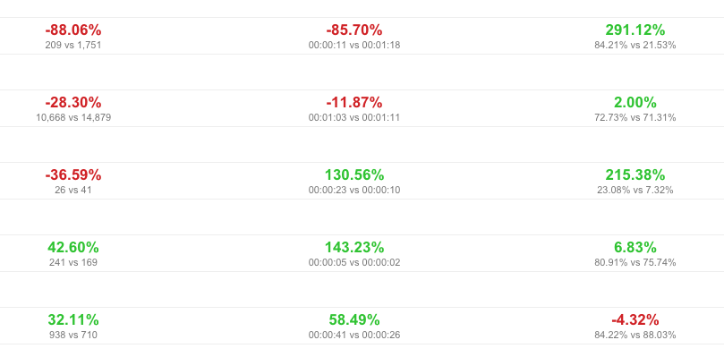

And here is what it looks like to view a single site:

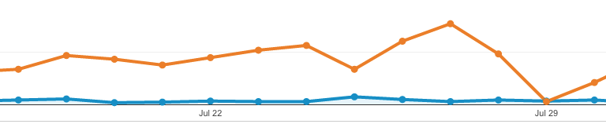

If you look at the bottom of your chart, you can add an annotation. This will help you add notes to remind you in the future what happened on certain dates.

For example, you might add notes such as:

- Ran Facebook ad, traffic up 28%
- Launched new website
- Added article on Pinterest, traffic doubled overnight
- Site hacked, traffic dropped by 75% for several days

Not only will this help you figure out what kind of marketing and such is working, but if you sell your site later, you’ll be able to remember what happened at various times in order to explain traffic discrepancies to potential buyers.

Date ranges make it easy to get an idea of how your traffic is growing or shrinking. Be sure to remember to add those annotations to major traffic events so you remember what caused them.

Goals

Goals are a function of Analytics that is dramatically underused. Many people don’t even know goals exist in Analytics, and others know little about them or don’t know how to use them.

Goals can be very helpful. Goals will let you track the effectiveness of your sales funnel, your squeeze page, your ads, etc.

Here’s how goals work:

- Traffic comes in from a specific traffic source
- You have a specific action you want people to take
- Users take that action
- You now know where the traffic comes from, how many people saw the offer, and how many people took the desired action

To set up a goal, open Analytics and go to Admin at the top of the page. Then click Goals on the left hand menu. Select New Goal, then select Custom. Click Next Step.

Choose a name for your goal. It can be whatever you want, but be sure it will be easy for you to remember what you’re tracking with it.

You might name it something like “Squeeze Page For Weight Loss Report”, for example.

There are several types of events you can track:

- Destination – User ends up at a specific page
- Duration – User is on page for a specific length of time
- Page/Screens per session - User views at least X number of pages
- Event – User views a video, for example

Let’s say your ultimate goal is to get users to make it to the download page for your lead magnet, which happens after they opt in to your list. You’d choose a Destination goal, then set your value to the URL of your thank you page.

If you’d like more detailed information about setting up all the different types of goals, here is an in-depth tutorial from Analytics:

https://support.google.com/analytics/answer/1032415?hl=en

Practical Uses for Analytics

There are so many uses for Analytics it would be impossible to name all of them in a short guide, but we’re going to take a look at some of the best ways you can use Analytics to increase your traffic and income.

Identifying Successful Content

Analytics is great for figuring out which pages your visitors are landing on most. Not only that, it will also tell you where they go NEXT. This is useful for finding out which content is most effective at pulling in traffic so you can write more content along the same lines.

Let’s say you see a large portion of your traffic visiting an article on Pinterest marketing. You could write more articles on Pinterest marketing, going more in-depth or covering different angles. Or you could write articles about different types of social media like Facebook or Twitter.

Identifying your key content is important, because you will be able to decide:

- What type of content you should write more of
- What kind of content isn’t working, so you don’t waste time on it
- Which topics your visitors are most interested in
- Which articles to focus links on to boost their search rankings

Getting More Search Engine Traffic

Everyone wants more traffic from search engines, but without Analytics is can be hard to figure out where to concentrate your efforts. You can use Analytics to figure out a plan to help boost your search engine positions and attract more traffic.

Most of your information for this will come from the acquisition reports. If you go to Acquisition > Search Engine Optimization > Queries, you’ll discover the keywords people are using to find your site. It will also tell you the position you were in at the time, and how many people clicked when they saw your page on Google.

(Note: This will be more accurate if your site is added to Google Webmaster Tools and linked to your Analytics account.)

Here are some ways you can use Analytics to get more traffic from search engines:

- Identify successful and unsuccessful content
- Figure out which keywords users are using to find your site
- Find out which keywords you’re ranking near page one for so you can get a few more links to boost them to the first page
- Find out which pages are most popular so you can send more people to them
- Find out which keywords are getting the highest CTR in search results to know which articles might need to be changed (such as title or description changes) to get more clicks

Which Traffic Sources Are Working Best

If you visit your dashboard and go to Acquisition > All Traffic > Source/Medium, you will find out which sites are sending you the most traffic. This can be helpful in figuring out where to focus your marketing efforts, as well as what you could improve to get more traffic from other sites.

It can also let you know if too much of your traffic is coming from a single source, which is dangerous. For example, if most of your traffic is coming from Google and there’s a huge update that drops your rankings, your whole site would be in serious trouble.

Conclusion

Analytics is a complex tool, but that makes it incredibly useful. Yes, it takes a bit of getting used to. It’s not one of those intuitive, at-a-glance tools that put everything right at the fingertips of the average user.

But if you really take the time to delve deep into it, Analytics can really help you boost your traffic, conversions, and income.

Analytics can be used to:

- Track traffic sources
- See which keywords people are using to find your site
- Track conversion results
- Learn what content people want more of
- And much more!

Don’t be like the average Analytics user who installs it on their site and then forgets it other than maybe checking overall traffic numbers now and then. Take the time to learn the different features and how you can use them effectively.

Trust me, you’ll really be glad you did!

Resources

Here are quick links to the resources mentioned in the guide:

Google Analytics:
http://analytics.google.com

Analytics Setup Help:
https://support.google.com/analytics/answer/1008080?hl=en

Analytics Goals Help:
https://support.google.com/analytics/answer/1032415?hl=en

Here are some tools that will help you make the most of the traffic that you have been tracking:

Landing Page Monkey: http://landingpagemonkey.com/

Catcha Monkey: http://catchamonkey.com/

Social Share Monkey: http://socialsharemonkey.com/

Pop Up Monkey: http://popupmonkey.com/

Countdown Monkey: http://countdownmonkey.com/

Attention Monkey: http://attentionmonkey.com/

