CTSI
CLINICAL THERMOGRAPHIC
SOCIETY INTERNATIONAL

(formerly known as CTS-
California Thermographic Society)

BASIC
THERMOGRAPHIC MANUAL

Edited By:
George E. Chapman, DC, DABCT, FIACA, FCTS
Claire H. O’Neill, DC, FICPA, FICCT, BCTSI
Barbara A. Britt, BA, CTT, RTT
Victoria Lea, BA, MLS, CTT
Copyright by CTA Publishers
First Edition 1981, Second Edition 1984
Third Edition 1987
Fourth Edition Published 2013
All right reserved
No part of this publication may be reproduced, stored in a retrieval system, or transmitted in any form or by any means, electronic, mechanical, photocopying, recording, or otherwise, without the prior written permission of the CTA Publishing Company.
CTA Publishing Company 2802 Juan St. #24 A San Diego, California 92110
Previous Copyright, 1987
Printed in the United States of America
Library of Congress Copyright
TX – 1 – 630 – 680

BASIC
THERMOGRAPHIC MANUAL
Fourth Edition

Editor
George E. Chapman, DC, DABCT, FCTS

Co-Editors
Barbara A. Britt, BA, RTT
Victoria Lea, BA, CTT
Claire O’Neill, DC, FICCT, BCTSI

EXECUTIVE BOARD

PRESIDENT
Claire O’Neill, DC, FICPA, FICCT, BCTSI
Board Certified Clinical Thermologist
Fellow of International College of Clinical Thermology
Fellow of International Pediatric Chiropractic Association

VICE-PRESIDENT 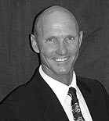
John Tomlsoff, DC, BCCT, FICCT
Board Certified Clinical Thermologist
Fellow of International College of Clinical Thermology

SECRETARY 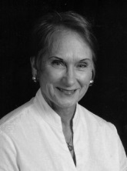
Victoria Lea, BA, MLS, CTT
Certified Thermographic Technician
Masters Library Science

TREASURER
Hal Jay Close, BA
CFO GFCA & TWC
Bachelor Arts, Psychology

TRAINING DIRECTOR
Debra Wyghel, CA, MT, CTT
Chiropractic Assistant
Massage Therapist
Certified Thermographic Technician

PAST PRESIDENT and THERMOGRAPHIC ADVISOR
George E. Chapman, DC, DABCT, FCTS, FIACA
Board Certified Clinical Thermologist
Diplomate American Board of Clinical Thermologist
Fellow of Clinical Thermographic Society International

MEDICAL ADVISOR
William Hobbins, MD, FICS, FCTS
Fellow of Clinical Thermographic Society International
Past President of the Wisconsin Breast Cancer Detection Foundation, Inc.
Director of the Madison Pain Diagnostic Clinic

Contributors
Barbara A. Britt, BA, CTT, RTT
Registered Thermographic Technologist
Certified Thermographic Technician Educational Director for CTA Research Center Member of the Post Graduate Teaching Faculty of: Cleveland Chiropractic College, Life-West Chiropractic College Pasadena College of Chiropractic, Palmer-West College of Chiropractic
George E. Chapman, DC, FIACA, FACTP, FCTS
Board Certified Clinical Thermographer Diplomate American Board of Clinical Thermography Chief of Diagnostic Thermology for CTA Research Center Member of the Post Graduate Teaching Faculty of: Cleveland Chriopractic College, Life-West Chiropractic College Pasadena College of Chiropractic, Palmer-West College of Chiropractic
Harold Farris, DC, FCTS
Board Certified Clinical Thermographer Director of Thermal Diagnostic Laboratories Member of the Post Graduate Teaching Faculty of: Life-West Chiropractic College, Cleveland Chiropractic College
William Guenther, DC, FCTS
Fellow of Californial Thermographic Society Diplomate American Board of Clinical Thermology Director of Sacramento Thermographic Associates
William Hobbins, MD, FICS, FCTS
Fellow of California Thermographic Society President of the Wisconsin Breast Cancer Detection Foundation, Inc. Director of the Madison Pain Diagnostic Clinic

Contributors (FIX FONTS etc)
Claire H. O’Neill, DC, CCT, FICCT
Certified Clinical Thermologist
Fellow of International College Clinical Thermology

John Tomlsoff, DC, BCCT, FICCT
Board Certified Clinical Thermologist
Fellow of International College Clinical Thermology
Gail Mosely
Certified Thermographic Technician Senior Thermographic Technician for Thermographic Diagnostic Imaging Center
Victoria Lea, BA, MLS, CTT
Masters Library Science
Certified Thermographic Technician

Debra Wyghel, CA, MT, CTT
Certified Thermograhic Technician
Toby Watkins, DC, ABCT Diplomate in therm thru ACA Find info to fill in

Pete Wahl
President of Wahl and Associates
Bruce G. Kramer
Director: Industry Products and Technology – CTB/McGraw Hill

Clinical Thermographic Society International is the continuation of high standards for Clinical Thermographers presented by its former society, California Thermographic Society. This manual has been voted on and approved by CTSI’s current members.

Acknowledgment
In writing a manuscript of this nature, many debts are incurred. Our thanks go to:
The many pioneers in thermography, whose research and clinical experience assisted in developing our concepts.
Wahl and Associates, for the many hours of help they provided.
The Clinical Thermographic Society International general membership for demanding quality standards in thermography.
Daniel Quincy, PhD, for his input concerning the necessity of a manual of this nature.
The many committees and members who contributed their time and effort in establishing high quality standards for the betterment of thermography.

Contents
Preface
Chapter I Introduction to Thermography History of Thermography : An Overview
Infrared Spectrum
Chapter II
Introduction to Modern Thermography Purpose for Thermographic Assessment Evaluation Normal Thermographic Findings
Chapter III Thermographic Equipment Electronic Equipment Liquid Crystal Equipment Equipment Manufacturers
Chapter IV Thermographic Examination Room
Chapter V Overview of Thermographic Technique Technique Thermographic Technician Technique Concepts
Chapter VI
Patient Preparation Procedures and Guidelines
Chapter VII
Rx Thermography Requests
Chapter VIII Liquid Crystal Technique and Protocol Room Temperature Patient Preparation (Serial Thermography) Patient Preparation (Isolated Clinical Views) Serial Thermography Baseline Thermograms Stress Thermograms Topographical Studies External Medical Photography Physical Examination Recommended Routine: An Oveview Concept Notes

Contents
Chapter VIIII Telethermography Room Temperature Patient Preparation (Serial Thermography) Patient Preparation (Isolated Clinical Views) Serial Thermography Baseline Thermograms Stress Thermograms Topographical Studies External Medical Photography Physical Examination Recommended Routine: An Oveview Concept Notes
Glossary
Appendix I Clinical Thermographic Society International Testing Criteria
Appendix II
Clinical Thermographic Society International Certification Requirements
Appendix III
Clinical Thermographic Society International Opinion Letter
Appendix IV
Thermographic Societies
Appendix V
Clinical Thermographic Society International Executive Board
Appendix VI
Clinical Thermographic Society International Membership Board Certified Clinical Thermographers Fellows of the Clinical Thermographic Society International Certified Thermographic Technicians Provisional Thermographic Technicians General Society Membership
Preface
During the formation of the Clinical Thermographic Society International, it was deemed necessary to establish appropriate guidelines for certification and quality thermal imaging. It is not the purpose of this society to regulate thermography, but to promote scientific validity and quality imaging potential. In order to be worthy of state and national recognition and the trust of the general public, the Clinical Thermographic Society International has proposed several guidelines for the establishment of proper and accepted Thermographic criteria and protocol.
This manual has been prepared on behalf of CTSI as a general review of acceptable scientific guidelines for appropriate Thermographic imaging. It is our purpose and resolve to promote valid Thermographic data within the scope of acceptable standards and to establish validity of findings based on the current state of the art.
It is recognized that Thermography is a rapidly expanding field, and may change with the advent of new equipment and technology. However, several basic criteria should remain the same and standard requirements will continue to be needed for adequate imaging potential. Based on a review of European and American literature, the CTSI Protocol and Criteria Committee has determined several areas which were established many decades ago through Dr. George E. Chapman in 1965, in addition Dr. Gauthrie 1972 and Dr. Hobbins1978 for breast thermograms. These areas are considered necessary for distinction of physiological heat emission signatures versus anatomical diagnostic testing.

Chapter 1

Historical Overview Of

Clinical Thermography

“…a walk through history”

Historical Overview of Clinical Thermology
“…a walk through history”

Historical Overview of Clinical Thermology

Use of Thermography or heat differentiation, to detect human ailments, has been documented throughout medical literature over the centuries.

The first recorded utilization of temperature associated with disease, appeared in the Edwin Smith Papyrus. Considered the oldest medical text, this text concentrated on 47 individual case studies, six of which included temperature variations. Date of the Papyrus was 1700 B.C. This then, places the origin of Thermology during the age of the pyramids, with Imhotep, the first known physician in recorded history.

Edwin Smith Papyrus currently in the Rare Book Room at the New York Academy of Medicine.

Use of Thermography, or heat differentiation, to detect human ailments has been documented throughout medical literature over the centuries. The first recorded

medical application was as early as 400 B.C., when physicians would place wet mud or a slurry of wet clay over the abdomen and where the clay dried first, was considered the site of disease. Hippocrates is quoted as saying “…should one part of the body be colder or hotter than the other, disease is present in that part.” The early Greek physicians regarded changes in temperature, as a reflection of change in the four basic elements (fire, water, earth and air). They also considered fever to be a specific disease entity, as opposed to being only a symptom of disease. .

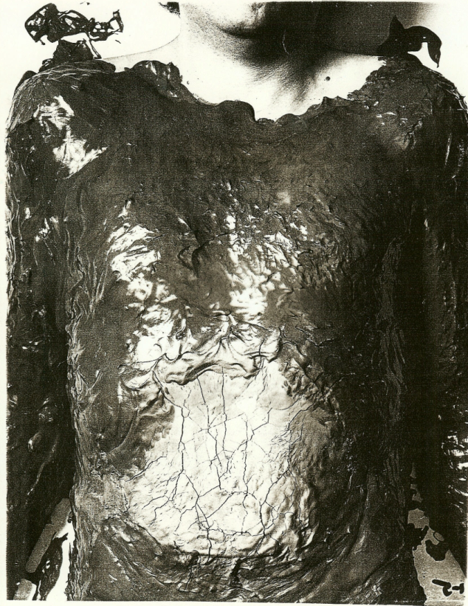

Photo of mud on abdomen, taken from a Bales thermographic handout

During the second century A.D., Heron of Alexandria, developed a special bulb called a thermoscope. Although, this was the first step in an attempt to quantify heat, additional advances in thermal measurement ceased until re-introduced by Galileo in 1592.

Heron of Alexandria, 2nd Century AD

Galileo

The concept of the thermoscope was renewed by Galileo and temperature quantification regarding health issues was established by Galileo and his friend Sanctorio Sanctorius, who converted the thermoscope into a crude thermometer. In order to correlate the relationship between body temperature and a patient’s state of health, the thermoscope was gradiated into 110 arbitrary divisions.

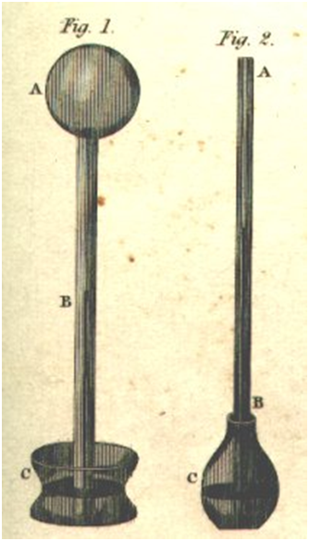

On the Left, A Galileo Thermoscope (thermometer)
On the Right, A Florentine Thermometer. Photo taken from “The Engines of Our Ingenuity”, Copyright © 1988-1998 by John H. Lienhard.

In the early 1700’s, Herman Boerhaave established important clinical information at the University of Leyden, with a special thermometer made by Fahrenheit. Additionally, specific determination of temperature reference points, including
32 °f as the melting point of ice and 96 °f as the standard human temperature, were set by Fahrenheit. Several years later, in 1742, the freezing point of water was set by Celsius (an astronomy professor) at 0 °C and the boiling point of water at 100°C.

Conversion formula for Fahrenheit to Celsius: F= (9/5 C) + 32

Anders Celsius, 1742

Dr. Boerhaave’s students, Dr. DeHaen and Dr. Van Swieten in Vienna, prepared several volumes of data correlating temperature and disease. Many years after Dr. DeHaen’s death, thermometry continued to be evaluated by numerous scientists and physicians, but failed to receive general medical recognition.

Sir William Herschel, King George III’s Royal Astronomer, in early 1800’s developed the first thermograph using colored filters in a large refracting telescope. The invisible rays of the sun were termed at that time infrared (beneath red).

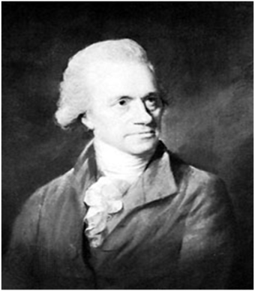
William Herschel

The actual beginning of modern thermometry was in 1835, when Becquerel and Breschet evaluated temperature variances in different body areas. Their instrument was a thermo-electrical device, which they utilized to establish that temperature in inflamed regions was higher than in normal ones. It was also established, at this time, that 98.6°f or 37 °C was the mean healthy human temperature.

In 1844, Henri Roger recorded temperatures for several types of febrile diseases. His major contribution in thermology was that he recorded temperature variables in the diagnosis, prognosis and treatment course. In 1870, Dr Thomas Allbutt introduced the self-registering mercury thermometer, which is the prototype of those used in clinics today (called the “pocket thermometer”)

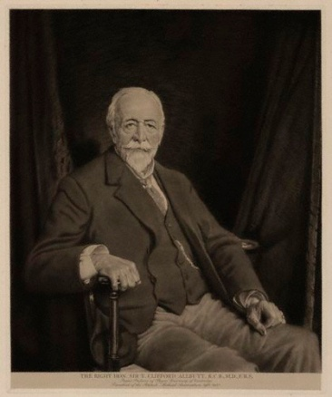

Dr Thomas Clifford Allbutt, 1879

Between 1851- 1877, Dr. C. A. Wunderlich studied over 25,000 cases correlating temperature variances and the patient’s state of disease. To do this, he relied on Allbutt’s mercury thermometer and based on his work, wide scale use of thermometry soon followed.

In the early 1920’s, research turned to the recording of the infrared spectrum in photography, based on refraction and reflection of infrared (IR) waves from outside sources. At the 1924 Palmer Lyceum, a new approach to spinal heat evaluation was introduced to the chiropractic profession. The instrument was called an NCM (neurocalometer) and was invented by Dossa Evans, with clinical development by Dr. B.J. Palmer, DC.

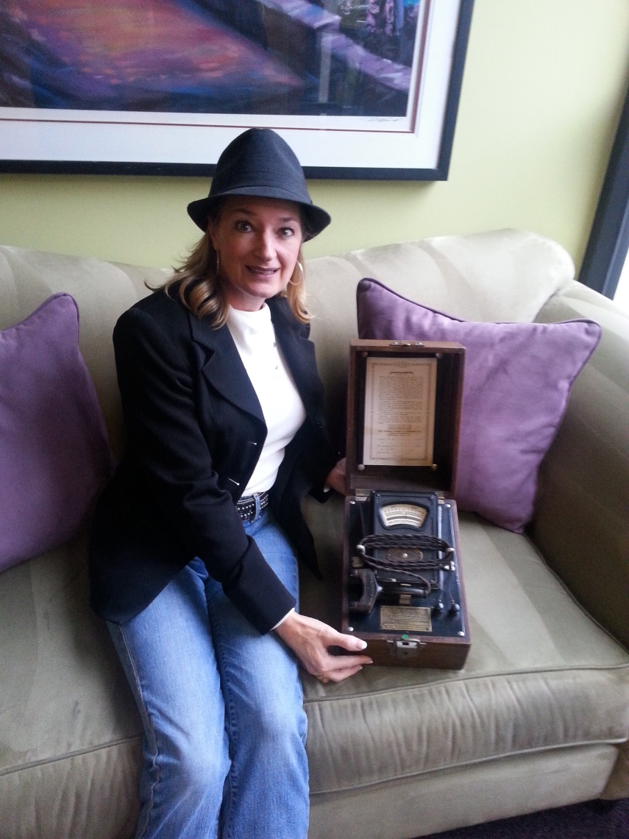

Dr. Claire O’Neill DC, BCTSI with a Neurocalometer

This picture of one of Dossa Evans’ original neurocalometers is thanks to Dr. Olman Mata DC.

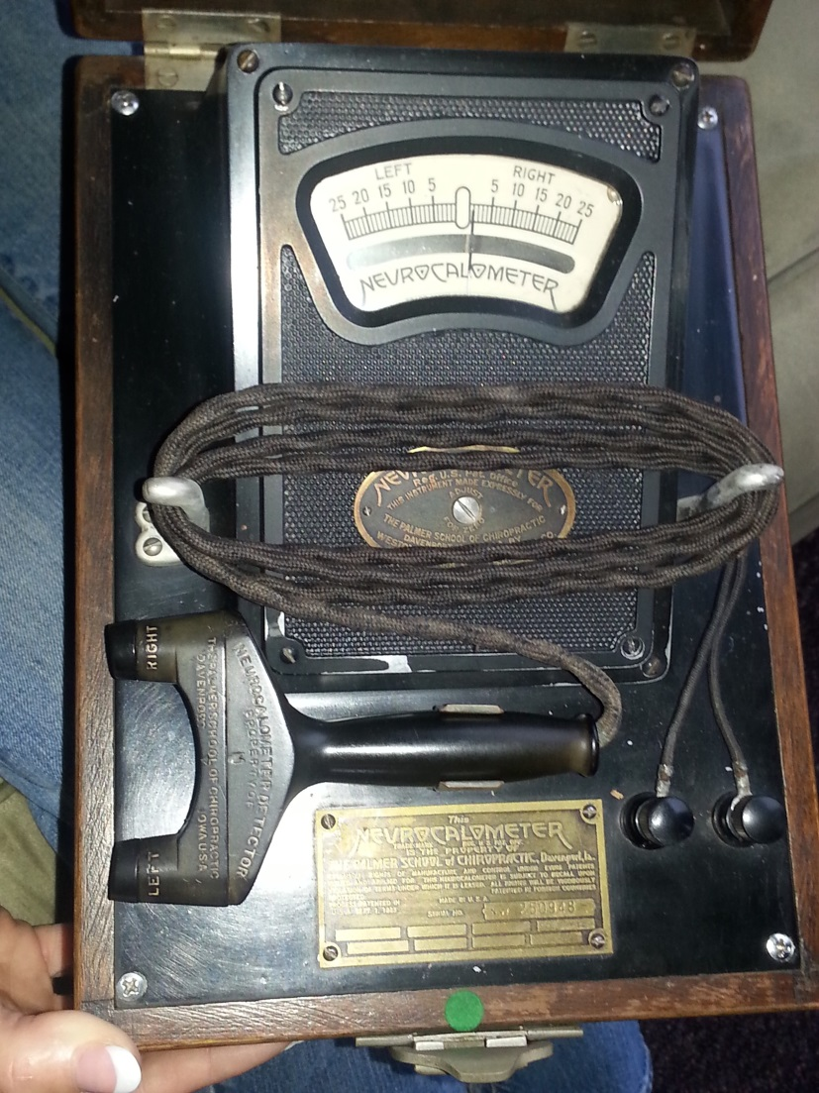

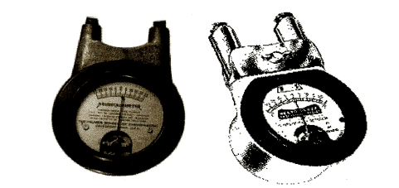

Neurocalometers (neurocollometers) measursed heat along the spine via thermocouples.

Research in infrared photography and the development of special infrared sensors continued to be refined throughout World War II and the Korean conflict. During this period, much of the data and equipment developed, was classified “Top Secret”. Military use of infrared included such applications as troop movement, monitoring and the development of heat seeking missiles.

In 1939, the first published use of Thermology using infrared photography was by Gorman, who evaluated changes in vascular structure in breasts. In 1948, the first known clinical thermograms were taken by Dr. Leo Massopust. His primary images were of vascular patterns in the extremities and breasts, but he did evaluate other skin surfaces as well.

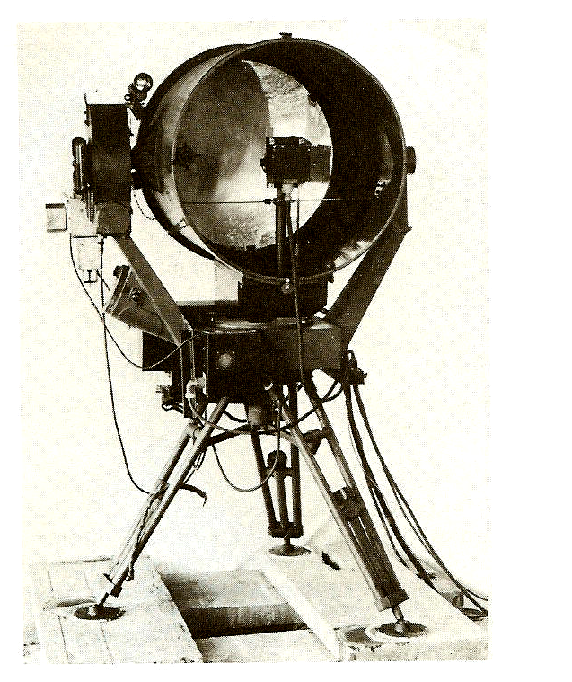

Baird Evaporograph Sysem used by Leo Massapust in 1948

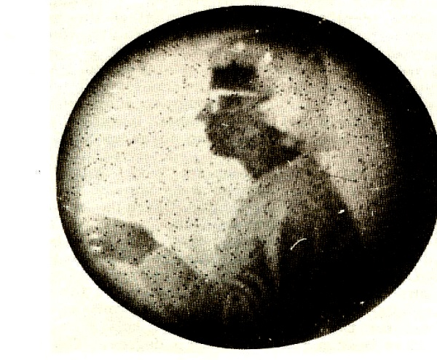

Photo from Baird Evaporograph

1954, The United States declassified much of its thermographic work. Also in 1954, a standard photo and Thermographic image taken by the U.S. Army Corps of Engineers, using the Salford Infrared Scanner.

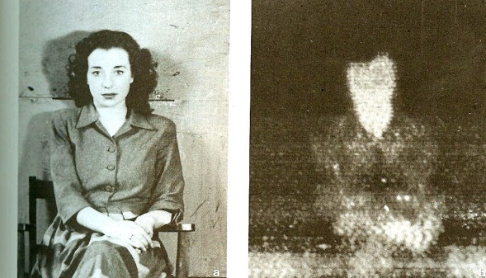
A Canadian physician, Dr. Ray Lawson, established the first known medical application for modern thermography, with extensive research regarding breast patterns. He published his first paper in 1956, entitled “Implications of surface temperature in the diagnosis of breast cancer.” Shortly after Dr. Lawson’s work, a good amount of thermographic information was declassified at the end of 1958 and research on industrial and medical applications slowly began again.

1959- 1960 Hotel del Coronado
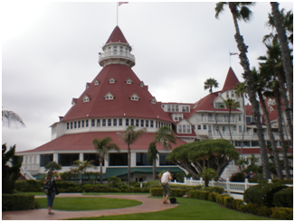
Shortly after thermography was declassified by the military, George Chapman, Sr., Chief Engineer at the Hotel Del Coronado, was able to get technicians from the San Diego submarine base to image the hotels boilers and electrical panels.

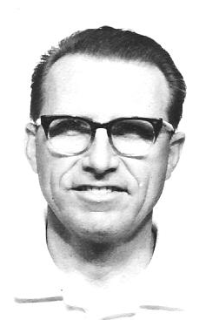

George Chapman, Sr.

In 1963, a composite of 28 papers regarding medical and veterinary applications of thermology were submitted for publication with the New York Academy of Sciences.

In 1965, George E. Chapman published the first work on Dental Thermography and cephalic imaging with his paper on ‘Temporomandibular joint imaging and Thermography”.

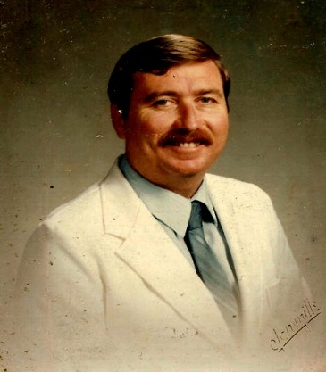

George E. Chapman

In 1968, the American Academy of Thermology was formed, noting this was the first American organization of physicians utilizing thermography.

In 1972, the Department of Health, Education and Welfare declared that thermography was beyond experimental in the following areas:

- Evaluation of the female breast
2. Vascular analysis
- Extracranial evaluations
- Neuromusculoskeletal evaluations.

(HEW opinion has not been changed or altered since it wa prepared by HEW Director Thomas Tierney , it was written in 1972.)

In 1974, a large national study of thermography was undertaken regarding Breast Cancer. The study was seriously flawed, equipment was not standardized, technique was not controlled, data analysis was not consistent and very few individuals involved in the study were trained in the use of thermography. This study is frequently the one referenced by other physicians, often with competitive interests, in order to advance the value of mammography and MRI.

Development of a specific analytical system for breast thermal imaging was established in France at the Marseille Cancer Center and at the Louis Pasteur University School of Medicine. The “TH” system was developed and refined at the Marseille Cancer Center and further refined by M. Gautherie and associates and remains the basis of breast thermography diagnosis used today.

In 1976, Sumio Uematrsu (Johns Hopkins neurosurgeon) published a book on “Medical Thermography, Theory and Clinical Applications”. Text was limited to neurological applications for thermography.

In 1977, Clinical Thermography Associates Research Clinic was established under the direction of George E. Chapman (Cleveland University Chiropractic Sports Physician) and Barbara A. Britt, with hundreds of published research projects, articles and textbooks produced by them over the years. Several seminars in the field of Thermology have been provided by Dr. Chapman, every year training physicians of all types and technicians. Additionally over 550 physicians and technicians have been trained and certified in thermography with the California Thermographic Society (CTS) since 1977.

In 1978, the first text was published introducing specific scientific techniques and protocols regarding medical thermography by Barbara A Britt and Dr. Chapman. This provided specific standards for reproducibility and controlled thermography.

Barbara A Britt, BA, CTT. RTT

Cholesteric Thermography was introduced in Europe around 1972 with the Vectra system and in the United States with the Flexi-Therm Mark II, around 1978. Pictured below is Flexi-Therm Mark II and a copy of a posterior neck/shoulders thermogram taken with the unit.

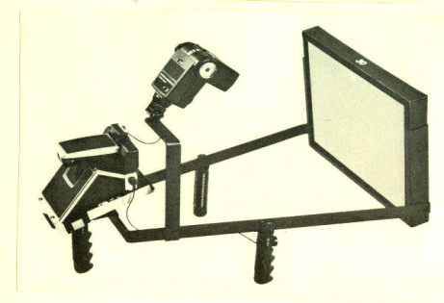
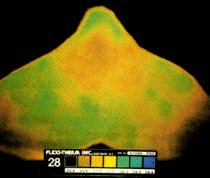
Flexi-Therm Mark II LCT thermogram of the posterior neck/upper back

LCT Breast Series: Taken by Barbara A. Britt, BA, RTT
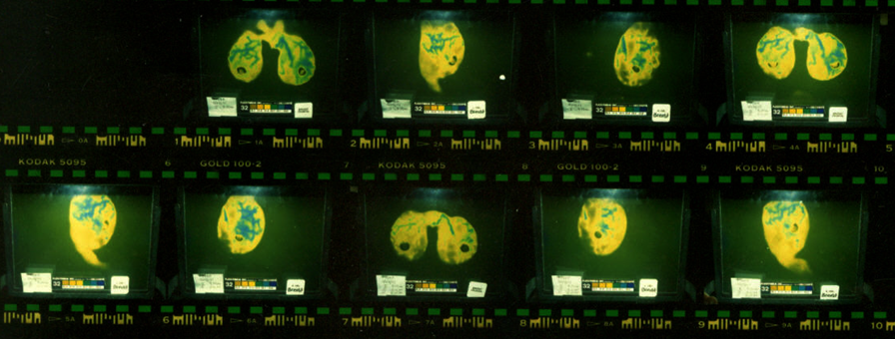

Around 1978, William Hobbins and Phil Meyers associated with Flexi-Therm and developed a training program for physicians and technicians. They also developed a Newsletter called “TIA” (center part of the word Initial), producing several articles from around the world regarding Thermographic research.

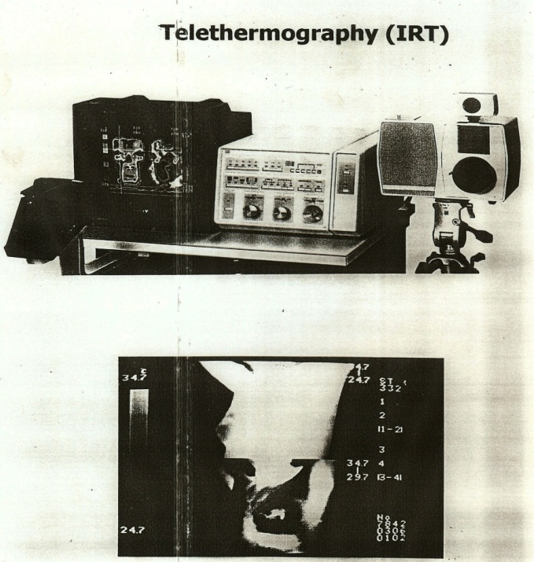

Flexi-Therm Mark V Telethermography and split screen film

Around 1978-1979, Charles Wexler began presenting thermographic programs at his clinic in Tarzana, California. He concentrated on neuromusculoskeletal thermography and later established the neuromusculoskeletal thermographic society for medical and osteopathic physicians only. Dr Wexler and Dr Chapman contributed to getting thermography approved by Workers Compensation, in California.

In 1980, the ITS (International Thermographic Society) was formed as a chiropractic organization. It later developed the American Board of Thermography, which was adopted by the ACA (American Chiropractic Association) as a specialty certification and recognition for Chiropractors.

In 1981, the California Thermographic Society (CTS) was formed in San Francisco, California. First president was George E. Chapman, DC with medical advisor William Hobbins, MD. Group was the first and only multi-disciplinary professional group established in the United States. The CTS changed their name to the IACT (International Academy of Clinical Thermology) in 1988, as membership exceeded 500 and was now worldwide. Group published quarterly newsletters (Second Opinion), a bi-annual magazine, provided certification programs for physicians and technicians, and was a co-sponser with Cleveland University for the first Diplomate program. Organizion published a text on what thermography is, how to get certified as a recognized Clinical Thermographer or Technician and provided recognized testing that was CCE and re-licensure approved.

In 1981 to November 1984, the first College Approved formal thermographic programs, receiving both re-licensure status and CCE approval, where presented by George E. Chapman, D.C. and Barbara A. Britt at Pasadena Chiropractic College in California.

In 1982, the Bureau of Medical Devices, Federal Drug Administration (FDA) classified medical telethermography as a category II device. This allowed for medical applications, but limited thermography to conditions where variation of skin temperatures may occur. The FDA suggests the following applications for thermography: (only minor changes from the HEW opinion 10 years earlier)

- Abnormalities of the female breast.
- Peripheral vascular disease.
- Musculoskeletal disorders
- Extracranial cerebral vascular disease
- Abnormalities of the thyroid gland
- Various neoplastic and inflammatory conditions.

In 1984, following testimony from Dr. George Chapman, Clinical Thermography was approved by the California Chiropractic Board of Examiners as being within a chiropractor’s scope of practice (rule 302). Also in 1984, Thermography was included in the California Workers’ Compensation system, under the code 76000.

In 1985, Thermography was included into Medicare and specific codes were established for payment of thermal imaging. Clinical Thermography was also provided at Palmar-West College of Chiropractic post graduate programs from 1985-1986, Program was re-licensure and CCE approved and taught by Dr. George E Chapman and Barbara A. Britt.

In 1985, Clinical Thermography was presented at New York Chiropractic College. Program was under the direction of Dr. Parino with both under graduate and post graduate programs. In 1985 Palmar-West College of Chiropractic sponsored a week long symposium in Hawaii (Pacific Basin Conference) with program directed by George E. Chapman, D.C., Barbara A. Britt, R.T.T. and Harry Rein, M.D. In 1985-1986, several programs were sponsored by Palmer-West College of Chiropractic under the direction of George E. Chapman, D.C. and Barbara Britt in concert with the California Thermographic Society. Programs were CCE and re-licensure approved for several states.

1986-1991, Clinical Thermography was presented with Life-West College of Chiropractic. Programs were CCE and re-licensure approved and presented in concert with the CTS (later the IACT). Conducted under the direction of Dr George E. Chapman and Barbara A. Britt. In 1986, National College of Chiropractic presented under graduate and post graduate programs under the direction of James Christiansen, PhD

1987-1991, Cleveland University provided post graduate thermographic programs,, including a CCE approved Diplomate program at the University. Programs were conducted by George E. Chapman, DC and Barbara A. Britt, R.T.T. with Dr. Chapman also directing the Diplomate program (multiple specialties were included as instructors). Appearance at AAMI (Association for Advancement of Medical Instruments) May 1987 Presenting the Visi-Therm by Glen Stillwagon with his son Kevin Stillwagon Co-Inventor of the Visi-Therm, a type of Telethermometry.

In 1988, Kansas City College of Chiropractic presented a post graduate program on thermography under the direction of George E. Chapman, DC. In 1988, the U.S. Department of Labor authorized the use of thermographic imaging for Federal Workers Compensation claims.

In 1988, the American Chiropractic Association established the first recognized college of thermal imaging and continues to be one of the recognized chiropractic specialties. In 1989, the first recognized Diplomate Program in Clinical Thermology was presented at Cleveland University under the direction of George Chapman D.C. Program was in concert with the IACT (recently changed name from the CTS to IACT).

1990 Texas College of Chiropractic presented Thermology in concert with the American College of Chiropractic Thermology. Program was CCE and re-licensure approved and was presented under the direction of Stewart Dorrow, DC

In 1991, thermography was listed in the ICD9 cm Coding manual (International Classification of Diseases). In 1992, thermography was listed in the CPT Coding Book Current Procedural Terminology), which is a publication of the American Medical Association.

In 1992, the International Chiropractic Association established the ICA College of Thermography. Again, thermographic sciences were considered a chiropractic specialty. The IACT surrendered their charter as an organization in 1992, giving it all to the newly established International Chiropractic Association’s new College of Thermography.

In 1992, Palmer-East College of Chiropractic and was co-sponsored by the ACA College of Thermology.

In 1992, HCFA did a limited review of Thermography and indicated it did not meet the criteria necessary for re-imbursement with Medicare. Breast thermography was then dropped from Medicare coverage and Breast mammography was introduced. This appeared to be a political maneuver, more than a scientific one, considering there were well over 40,000 published articles and texts indicating the value of Infrared Imaging in a clinical setting. It was surprising to review the HICFA opinion, noting that only 77 references where listed and no textbooks were reviewed and no experts were allowed to present opinions demonstrating a significantly flawed review. All had been provided to HCFA by George E. Chapman, DC, prior to their resolution not to continue authorization with Medicare.

In 1995, Life – East College of Chiropractic sponsored and presented multiple post graduate programs on Thermography in conjunction with the ICA College of Thermography. Life-East has also included Thermography as an elective in there under graduate programs

In 1995, the British Medical Journal “Lancet” reported on problems with mammograms and research that had been doctored or misrepresented. Papers indicating the dangers of mammography were now published and major concerns began to develop that mammography was not as accurate or as safe as previously thought. Evaluation of mammography continued for the remainder of the 1990’s and renewed interest was established regarding thermography and breast evaluations.

1996, Cleveland Chiropractic University, included thermography as an under graduate program and it was presented by William Cockburn, DC and Robert Fleishner, DC.

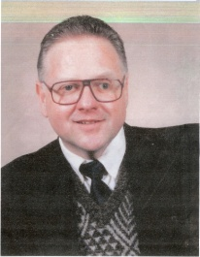

William Cockburn, DC

Thermography is again gaining the interest of patients and physicians. With new computer programs, digital infrared imaging and a better understanding of what is being imaged, Clinical Thermography is being re-introduced to the medical/chiropractic professions.

2006

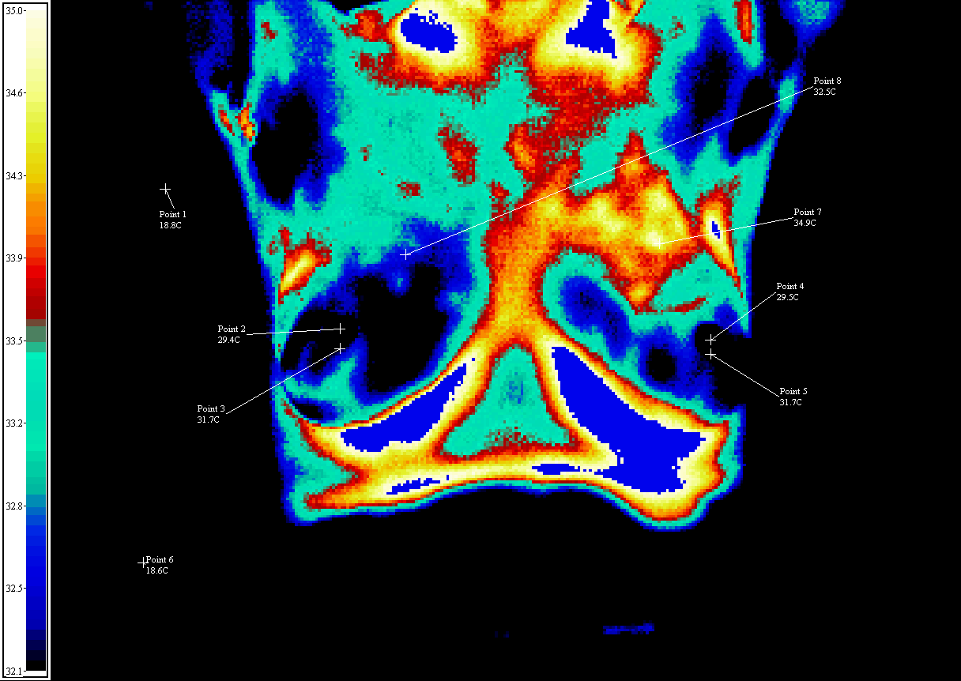

2006 Modern Digital Thermography with the FLIR infrared system
(image taken with the FLIR scanner by Barbara A Britt, RTT)

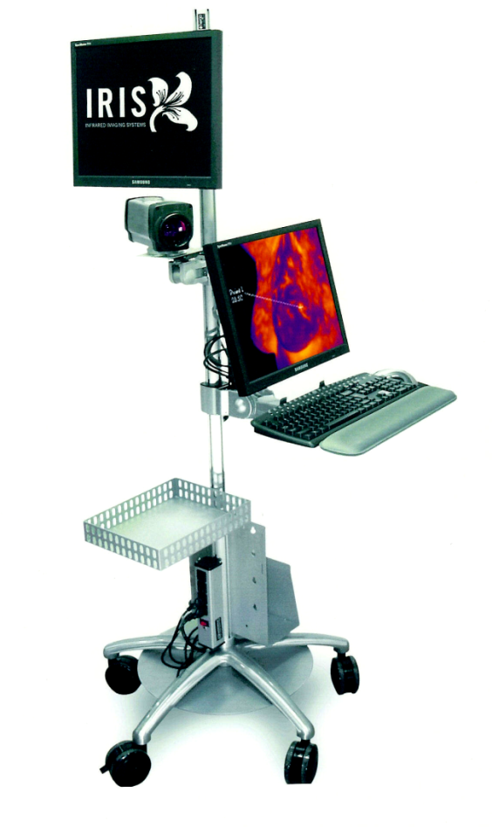

In 2007, the International College of Clinical Thermology, ICCT, was formed with John Tolmosoff, DC, BCCT as president.

In 2013 The California Thermographic Society, CTS, has officially changed its name to Clinical Thermographic Society- International, CTSI. The organization is a multi- Disciplinary group and has taken over the CTS foundation regarding thermographic education, certification, testing, research, and college sponsorship. CTSI is allowing membership to those who have already received certification with CTS and ICCT.
Current president for the CTS-International, is Claire O’Neill, DC, FICPA, FICCT,BCTSI.

CHAPTER 2

INTRODUCTION TO MODERN THERMOGRAPHY

Thermographic Equipment

Types of Equipment Currently Employed:
A. Telethermography (also known as DITI: Digital Infrared Thermagraphic Imaging, ET: Electronic Thermography, CTT: Computerized Thermographic Telethermography)
1. Electronic Thermography is a process that does not have direct contact with the patient.
2. Normally the patient is between 3-6 feet away from scanning device that picks up the individuals infrared heat emission.
3. The infrared heat emission is picked up on the scanner and the information is transferred to a visual monitor for display. This may then be recorded on Electronic Health Record Digital Format.
4. Earlier Electronic Thermographic units require the use of liquid nitrogen gas or argon gas for operational purposes.
5. Most current Electronic Thermographic units are electronically cooled and have multiple palates to determine qualitative and quantitative features.
6. Most of the more sophisticated units have thermal focusing capability and isotherm functions.
7. Units cost between $10,000 to an excess of $200,000 depending on variable computer capabilities.

B. Liquid Crystal Thermography (also known as LCT, Cholestric, and Contact Thermography):
1. Liquid Crystal Thermography is a process that does have direct contact with the patient.
2. Instrument measures only radiant heat via conduction.
3. Heat emission is picked up on the detector, which is an elastomeric sheet embedded with optically active organic crystals.
4. Various colors appear on the front plexiglass side of the detector and are photographed for permanent record with standard 35mm or polaroid film.
5. Liquid crystals are optically active organic materials that are extremely sensitive to temperature changes. The color is specific for each compound and the wavelength of the reflection band is determined by the liquid crystals molecular structure. If the temperature is above or below the usable temperature range, the compound is colorless.
6. Most Liquid Crystal Thermographic equipment is self-contained and does not require the use of Liquid Nitrogen or Argon Gas.
7. LCT units currently provide both quantitative and qualitative imaging potential in the same picture and do not require special studies.
8. Thermal focusing for LCT units is accomplished by merely raising or lowering detector plates. When done properly, the results are equally effective to electronic studies.
9. Isotherm function is established by cooling down the area examined with a fine mist of water. Results currently are similar to the electronic isotherm function.
10. Units currently cost between $5,600 and $10,000.
11. Majority of all Thermographic users are currently employing Liquid Crystal Thermography. This appears to be due to an economical consideration and does not suggest more value of either medium.

State of the Art Thermographic Equipment Manufacturers:
Dorex Inc. 1019 North Main Street Orange, CA 92667
Hughes Industrial Products Division Probeye Marketing 6155 El Camino Real Carlsbad, CA 92008
Inframetrics, Inc. 225 Crescent Street Waltham, MA 02154
Q-Scan- LCT

Qmax Medical, Inc. 125 Bacon Street PO Box 1181 Dayton, OH 45401
FLIR

BIOTHERM-LCT

NOVATHERM
England

CHAPTER III

THERMOGRAPHIC EXAMINATION ROOM

Examination Room

Examination Room Requirements:
It is always important to make patients feel as relaxed as possible, but in Thermographic examinations this is particularly important because a patient’s psychoneuropathophysiological reaction can affect the thermal emissions. Anxiety or embarrassment, often cause sweating and blushing (cutaneous vasodilation), both of which can disturb the thermogram. A well thought out and properly organized examination room and/or patient equilibrating area can facilitate the exam.
The following information will discuss the minimally accepted standards for room protocol as established by the California Thermographic Society (CTS).
The Thermographic equipment utilized within a facility will directly reflect what the minimum size room can be. Telethermography equipment will require a room at least 8`x 8` for 2 persons in the room, 8’X12’ for 3 people in room . This is due to the different patient positioning and the specificity of the ambient room temperature. In a room smaller than this will be difficult to maintain a homogeneous temperature due to the small volume of air. In either case you must have enough room to move around freely.
Quality thermometers (ºC) are recommended on all four walls approximately 6` above the floor. This is an objective means of monitoring the homogeneous temperature within the exam room. The ambient temperature is specified according to the nature of the Thermographic examination. Generally, this will be 20º C + or – 1º C. Until recently, the effects of humidity has been ignored, but many authorities now suggest that relative humidity should not be a problem provided that it is kept within reasonable bounds (25%-50%).
Heaters and air conditioners play an important role in quality Thermographic exam. Asymmetrical drafts blowing onto the patient must be avoided because they cause part of the body to be abnormally cool. To check for a draft, tape 3` strips of thread, string or audio tape to the ceiling of the room at various locations. Any type of air turbulence will cause the strips to move. Infra-red radiation sources such as, central heating radiators, sunny windows, or tungsten lighting can also cause a great deal of trouble during Thermographic examinations by heating the patients skin and being detected as an area of hyperthermia. They can also cause convection currents in the room, which might lead to asymmetrical cooling.
To avoid draft artifacts during an exam, either turn the air conditioner/heater off or use a baffle to redirect the air flow away from the patient. Preferably, the Thermography room should be windowless. If this is not possible they should be covered as follows: Place foamcore against the window and drapes to insulate. Because tungsten lamps emit more energy in the infrared region of the spectrum than they do in the visible region and are a heat source, only florescent tube lighting should be used. It is also possible that hot water pipes might run through the room, if this is the case they will need to be lagged.
Environmentally controlled cooling chambers adjacent to the examination room are optimal for busy clinics. Patients can be equilibrating while another exam is taking place. Be sure to maintain a homogeneous temperature between the cooling chamber and the exam room. For liquid crystal exams, the patient may use a light weight paper gown or cotton gown while equilibrating. For Telethermography the patient should be disrobed in area to be imaged and gowned while equilibrating to avoid patient from getting chilled. A good way to ensure that each patient is equilibrated for the correct time is to attach some sort of timer to each cubicle or in the exam room itself. Also, a staff member should constantly check that the patient is following the correct equilibrating procedures.
All floors within the examination room and/or cooling area must be carpeted to prevent vaso-construction of the lower extremities. Parallel lines (tape) on the floor can help to ensure proper patient positioning for accurate bilateral comparisons and will help to prevent rotation of the feet.
The examination room should also be equipped with a stool and swivel chair for the patient, together with a chair for the Thermographer. Three to five pound weights are advisable for stress testing. With Telethermography, Foamcore should be used instead of cardboard to isolate body parts, because cardboard has a tendency to retain heat. A desk and filing cabinet are also useful, but patient records are better kept in the reception office. For patient privacy a privacy screen is advisable between the patient and the technician or thermographer.
The examination room should also have a blood pressure cuff, stethoscope, thermometer, and watch with second hand so pulse and respiration can be taken. Gamardynometer is also useful for RSD patients etc. To keep hair off imaging areas a hair net, pins or clips would be recommended.
These are considered to be the minimal guidelines and basic necessities needed within an examination room in order to perform quality Thermographic studies. However, depending upon the type of Thermographic equipment being used in each office may vary, and its final floor plan and supplies will be left to the individual doctor’s discretion.

