**USAOTP**TM

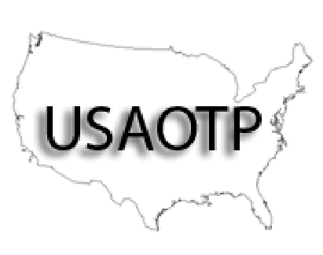

The UNITED STATES ASSOCIATION of OPIOID TREATMENT PROVIDERSTM

USAOTP MEMBER SERVICES \*\***DUE NOW**

2021-2022

# NEW MEMBERSHIP & **RENEWAL** APPLICATION

PLEASE CHECK: ____RENEWAL ___NEW

**PLEASE PRINT CLEARLY**

## NAME OF PROGRAM or INDIVIDUAL: ___________________________________________________

## NUMBER OF LOCATIONS IN TEXAS: ______

## NUMBER OF LOCATIONS OUTSIDE OF TEXAS: ______

## NAME OF PROGRAM REPRESENTATIVE: _________________________________

## CONTACT ADDRESS: ___________________________________________________

## CONTACT PHONE: ____________________CONTACT FAX:___________________

E-MAIL: ____________________________________________

USAOTP WILL NOT GIVE YOUR E-MAIL ADDRESS TO ANY ENTITY.

# DUES TABLES

TEXAS PROGRAMS (Please include any programs in your total that you are affiliated with that are outside Texas. Your programs outside Texas automatically become members also.

|  |  |
| --- | --- |
| **TOTAL # OF CLIENTS FOR**  **ALL LOCATIONS (Incl. Outside Texas)** | **MEMBERSHIP FEE** |
| 700 OR MORE | $720 |
| 451-700 | $620 |
| 201-450 | $515 |
| 151-200 | $410 |
| 101-150 | $310 |
| 1-100 | $205 |
| Individual Membership | $75 |

If ALL your PROGRAMS are located OUTSIDE TEXAS (NO affiliated PROGRAMS IN TEXAS):

|  |  |
| --- | --- |
| **TOTAL # OF CLIENTS FOR ALL LOCATIONS (Outside Texas)** | **MEMBERSHIP FEE** |
| 500 OR LESS | $155 |
| 501-1000 | $205 |
| EA. ADDITIONAL 500 | $50 |

**YOUR COMMENTS & SUGGESTIONS? _________________________________________________**

## **________________________________________________________________________**

**PLEASE REMIT WITH THIS FORM TO**

**USAOTP**

**c/o Kirk McLaughlin 806-790-0006**

**2701 19th Street, Lubbock Texas 79410**

**Email: usaotp@yahoo.com**

AMOUNT ENCLOSED (SEE TABLE ABOVE FOR AMOUNT): $ __________.00

CHECK #: ________ CHECK DATE: ___________

**PLEASE KEEP A COPY OF THIS FORM FOR YOUR RECORDS.**

USAOTP was created by TMTA to better serve our neighboring states.

**Visit us at USAOTP.org**

**USAOTP**TM



The UNITED STATES ASSOCIATION of OPIOID TREATMENT PROVIDERSTM

*Due to COVID-19 the Board Members voted to not collect association fees for existing members for the year 2020. We expected to be back in full operation as of January 1, 2021 and will be collecting dues for the year 2021. We also will resume regional and annual conferences.*

*We are looking forward to reconnecting with our members in 2021.*

Sincerely,

USAOTP Board Members