+ FIRST CONGREGATIONAL CHURCH
An Open and affirming congregation of the
United Church of Christ, Saugus, Massachusetts
Service of Worship & Baptism 10 a.m.
23rd Sunday after Pentecost, November 12, 2017
*Indicates for those who are able to, please stand.
Bold print indicates congregational response.
NCH = New Century Hymnal (black cover)
HOP = Spiral bound cover

Reader is David McCarthy.
Greeters & Ushers are Linda Anderson & Jessie Allison.
Coffee Hour Host is Barbara Davis.
Deacons are Rick Florentino & Barbara Davis.

PRELUDE Mae Stroshane
WELCOME & ANNOUNCEMENTS Rev. Martha Leahy
STEWARDSHIP PLEDGE DRIVE KICKOFF Paul Lima
LIGHTING THE CANDLE OF PEACE HOP 119
“Make Me a Channel of Your Peace”

Make me a channel of your peace/Where there is hatred

Let me bring your love/Where there is injury, your pardon, Lord/And where there’s doubt, true faith in you.

CALL TO WORSHIP (“God, we’re here!”):
L: Gather round, everyone, for I have a story to tell.
P: It is a story from long ago, all the way up to right now.
L: Listen up, children, for this is your story too.
P: Listen up, everyone, hear of the glorious deeds of God
and the wonders God has done for us.
L: Parents, grandparents, tell your children about our God;
All: So that this new generation will put their hope in God and follow God’s ways.

*OPENING HYMN: “All Things Bright and Beautiful” HOP23

CHILDREN’S MESSAGE

*PRAYER OF CONFESSION (“God, we’re sorry), in unison: Loving God, we confess that we sometimes get impatient with you. We criticize you for not showing up when we need you most. We criticize you for having unrealistic expectations of us. Forgive us. Help us look up, out of the fog of our own worries, and look beyond to see how you are working in the wider world. Show us the part we can play in making the world a safer, more just, and more holy place. Amen.
CHORAL RESPONSE: Glory to God, Glory to God/In excelsis deo/Gloria, Gloria/Alleluia, Alleluia.

*ASSURANCE OF PARDON (“God forgives us”), in unison:
Forgiving God, thank you for your understanding of our flaws and your willingness to love us despite them. Amen.

*GLORY TO GOD “Holy, Holy, Holy” NCH 277
Holy, holy, holy, God the Almighty! Early in the morning we praise your majesty./ Holy, holy, holy! Merciful and mighty/ God in three persons/ blessed Trinity!

SACRAMENT OF BAPTISM (see insert)

BAPTISM SONG: “Child of Blessing” Liz Manalo

SCRIPTURE READING: Psalm 78:1-7 (SP417; LP914)
(SP=Small Print Bible; LP=Large Print)

MESSAGE: “Tell Your Children” Rev. Martha Leahy

PRAYER INTRO: “Sanctuary” HOP 135

Lord, prepare me to be a sanctuary/pure and holy,

tried and true./With thanksgiving, I’ll be a living

sanctuary for you.

PASTORAL PRAYER & LORD’S PRAYER
Our Father, who art in heaven, hallowed be thy name.
Thy kingdom come, thy will be done, on earth as it is in heaven. Give us this day our daily bread; and forgive us our trespasses, as we forgive those who trespass against us; and lead us not into temptation, but deliver us from evil. For thine is the kingdom, the power and the glory forever. Amen.

PRAYER RESPONSE: “Take My Life & Let it Be” HOP 129 Take my life and let it be/Consecrated Lord, to thee./ Take my hands and let them move at the impulse of thy love/ At the impulse of thy love.

OFFERTORY INVITATION (“God, we give back”), in unison: Generous God, is there any way we can show our gratitude to you for all you have done for us? All we can do is show, by giving our gifts this morning and by living lives of faith, how much your love and compassion mean to us. Amen.

OFFERTORY: “Water of the Trinity” Mae Stroshane

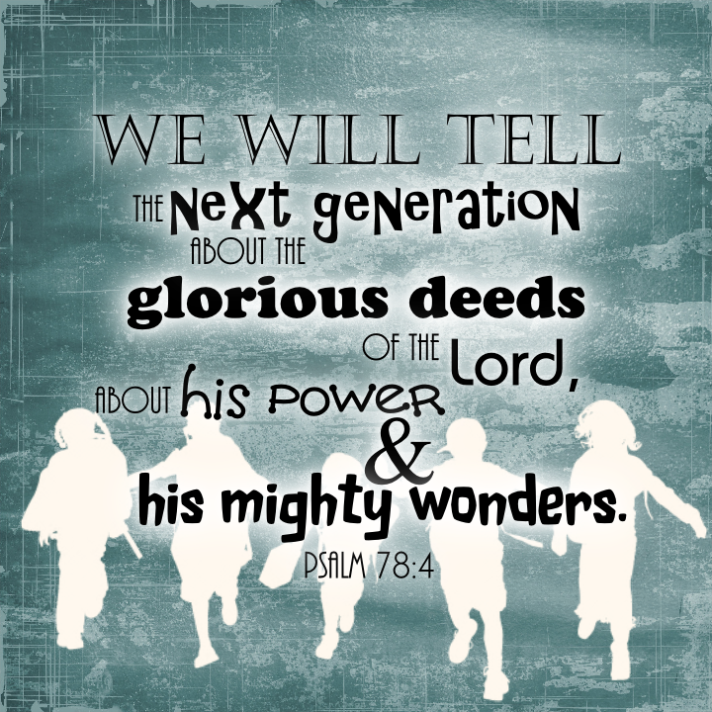
*DOXOLOGY: NCH #778
Praise God from whom all blessings flow;
Praise God all creatures here below;
Praise God for all that love has done.
Creator, Christ and Spirit, One. Amen.

*PRAYER OF DEDICATION FOR OUR GIFTS & PLEDGES (“God bless our gifts”), in unison: God of All Gifts, we ask your blessing upon the offerings we place upon your altar. We pray your blessing will inspire us to use them to reach out to children and adults who are seeking a deeper meaning to their lives. For us, that deeper meaning is you. Amen.
*CLOSING HYMN: “Shine, Jesus, Shine” HOP 63
*COMMISSION AND BLESSING (“God, we will try”), in unison:
Holy God, we will try to teach our children – and anyone else who will listen – about the wonderful, healing work you have done, are doing, and will do in our lives. Bless us in our trying. Amen.

BENEDICTION (“God, please bless us”):
L: We have told the story of God’s great love for us here today.
P: It is a story from long ago, all the way up to right now.
L: It’s a story for children, for teaching about God’s ways.
P: We heard about the glorious deeds of God
and the wonders God has done for us.
L: Parents, grandparents, tell your children about our God;
All: So that this new generation will put their hope in God and follow God’s ways.

*CHORAL BENEDICTION: “This Little Light of Mine”
This little light of mine, I’m gonna let it shine (3x)
Let it shine, let it shine, let it shine.
Everywhere I go, I’m gonna let it shine (3x)
Let it shine, let it shine, let it shine.

POSTLUDE Mae Stroshane

www.leylandmethodist.org.uk

“Tell Your Children”
Service of Worship and Baptism
November 12, 2017

First Congregational Church, United Church of Christ
300 Central Street, Saugus, MA 01906
Rev. Martha Leahy, Pastor
Office 781-233-3028 Cell phone 617-763-7354
Mae Siu-Wai Stroshane, Music Minister
Carolyn Davis, Secretary
E-mail address: uccsaugus@verizon.net
Website: http://1stchurchsaugus.org
Facebook: https:www.facebook.com/uccsaugus
Healing Circle: https://facebook.com/healingcirclesaugus
Twitter: http:www.twitter.com/1stchurchsaugus

Water of the Trinity
By Mae Stroshane

Water of the Trinity, water of life
Rushing through eternity, soothing us in strife
God’s love endures, in water clear and pure
Praise God’s holy name.

Water of the Trinity springing from God’s earth
Shaping human history, bringing us to birth
By water we are claimed in God’s holy Name
Most precious gift of God.

Water of the Trinity, rushing through the years
Nourishing us, sustaining us through our hopes and fears
From our youngest days, You guide us in Your ways
We raise our praise to You.

Child of Blessing, Child of Promise
Ronald S. Cole by -Turner, 1980
1. Child of blessing, child of promise,
Baptized with the Spirit's sign,
With this water God has sealed you
Unto love and grace divine.

2. Child of love, our love's expression,
Love's creation, loved indeed!
Fresh from God, refresh our spirits,
Into joy and laughter lead.

3. Child of joy, our dearest treasure,
God's you are, from God you came.
Back to God we humbly give you:
Live as one who bears Christ's name.

4. Child of God, your loving Parent,
Learn to listen for God's call.
Grow to laugh and sing and worship,
Trust and love God more than all.

THE SACRAMENT OF HOLY BAPTISM
For Julian Dominic McCarthy
Child of Kristina and Michael McCarthy
Brother of Nathanael McCarthy
Godchild of Janine Bourque and Andrew McCarthy

OPENING WORDS
L: Baptism is a moment in the Christian community when we recognize the grace of God living in each newborn creation. God offers us the possibility of transformation, a continuing process of renewal of body, mind and spirit, which takes place within faith communities. So it is that parents and guardians bring their children into this community to be baptized.

INVITATION & READINGS
L: They were bringing children to Jesus that Jesus might touch them; and the disciples rebuked them. But when Jesus saw it, Jesus was indignant, and said to them,
P: “Let the children come to me, do not hinder them; for to such belongs the realm of God. Truly, I say to you, whoever does not receive the realm of God like a child shall not enter it.”
L: And Jesus took them in his arms and blessed them, laying his hands upon them.

L: Jesus came to John to be baptized by him. But John tried to make him change his mind. “I ought to be baptized by you,” John said. “Yet you have come to me.”
P: Jesus said, “Let it be so for now. For in this way, we shall do all that God requires.” So John agreed.
L: As soon as Jesus was baptized, he came up out of the water. Then heaven was opened to him and he saw the Spirit of God coming down like a dove and lighting on him. Then a voice said from heaven, “This is my beloved Son with whom I am well pleased.”

P: At another time Jesus said: “Go and make disciples of all nations, baptizing them in the name of the Father and of the Son and of the Holy Spirit.”
L: The Sacrament of Baptism is an outward and visible sign of the grace of God. Inasmuch as the promise of the gospel is not only to us, but also to our children, baptism with water and the Holy Spirit is the mark of their acceptance into the care of Christ’s Church, the sign and seal of their participation in God’s forgiveness, and the beginning of their growth into full Christian faith and discipleship.

BLESSING OF THE WATER OF BAPTISM

L: Bless by your Holy Spirit, gracious God, this water. Bless by your Holy Spirit this child, baptized this day. Glory to you, eternal God, the one who was, and is, and shall always be, world without end. Amen.

COVENANT WITH GOD AND ONE ANOTHER
L: A covenant is integral to a relationship with God and one another, so today we state the responsibilities of parents, godparents, and community to God and this child. As parents, do you promise to bring your child into the life of the Christian community to worship, to hear the stories of the roots of our faith, and to be in relationship with other believers as he grows into a faith of his own?
Parents: We will, with the help of God.
L (to Godparents): I ask you now to affirm your covenant with God, this child and his parents. Do you promise to give your time and yourselves to this child, providing him with opportunities to explore his experience of God and self?
Godparents: We will, with the help of God.
L: Now I ask this congregation, what will be your part in helping this child discover the grace of God?
P: We promise our love, support and care to this child and his family as he lives and grows in Christ’s Church.

ACT OF BAPTISM
L: By what name have you called this child?
Parents: Julian Dominic McCarthy.
L: Julian Dominic McCarthy, I baptize you in the name of the Father, and of the Son, and of the Holy Spirit.

WALKING IN FAITH WITH THE NEWLY BAPTIZED
(The Pastor walks with the child through the sanctuary, introducing him to his church family.)

PRAYER FOR THE BAPTIZED
L: Let us pray. Gracious God, giver of life, you have called us by name, and pledged to each of us your faithful love. We pray today for your blessing upon this child, that you will watch over him and guide him as he grows in faith. Remind us of the promises of our own baptism, and renew our trust in you. Make us strong to obey your will and to serve you with joy, through the power of the Holy Spirit. Amen.

THE GIVING OF GIFTS

Psalm 78:1-7

¹ My people, hear my teaching;
listen to the words of my mouth.
² I will open my mouth with a parable;
I will utter hidden things, things from of old—
³ things we have heard and known,
things our ancestors have told us.
⁴ We will not hide them from their descendants;
we will tell the next generation
the praiseworthy deeds of the Lord,
his power, and the wonders he has done.
⁵ He decreed statutes for Jacob
and established the law in Israel,
which he commanded our ancestors
to teach their children,
⁶ so the next generation would know them,
even the children yet to be born,
and they in turn would tell their children.
⁷ Then they would put their trust in God
and would not forget his deeds
but would keep his commands.

