Current Clients:

Big R Stores Inc., CO, NM, TX
City of Pueblo, CO
County of Pueblo, CO
Chemical Depot of Pueblo, CO
Denver Public Schools, CO
Peterson AFB, CO
Pueblo West Metro, CO
Waste Connections, CO

We actively seek teaming arrangements with other small businesses and prime contractors in the janitorial, railroad, mechanic, plumbing, construction, auto body shops, heavy industrial and government fields.

NAICS Codes:

313210 – Broadwoven Fabric Mills
314999 – All other Miscellaneous Textile Products Mills
423450 – Medical, Dental, and Hospital Equipment and Supplies Merchant Wholesalers
423930 – Recyclable Material Merchant Wholesalers
812331 – Linen Supply

DUNS: 196901511

CAGE Code: 39QA5

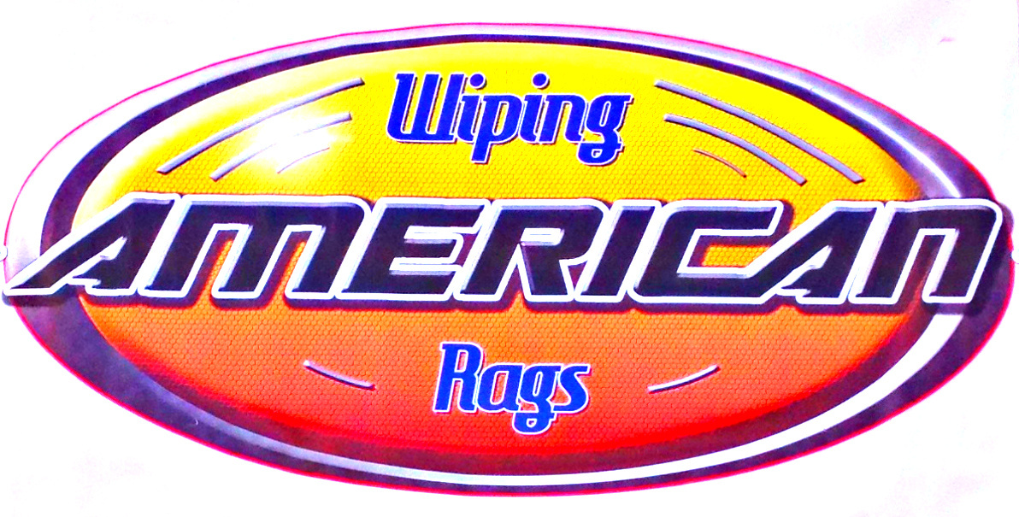

Company Overview:

Established in 2003, we wanted to make a difference in our state. So we decided to start our own recycling business in Colorado and recently expanded into Wyoming. We buy materials before they end up in the landfill. This material is then remanufactured into rags.

Two years into the business we added a microfiber line.
Five years in we started recycling clothing, i.e. T-shirts.

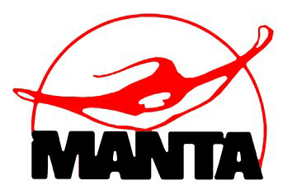
Services:

- No service contract involved.

- All orders are appreciated and filled in a timely manner, whether big or small.

- We sell to both residential and commercial clients.

- Our products are guaranteed to be clean, lint free.

- We are happy to send out samples of our products so you can judge the quality.

- We also custom cut disposable rags for your needs.

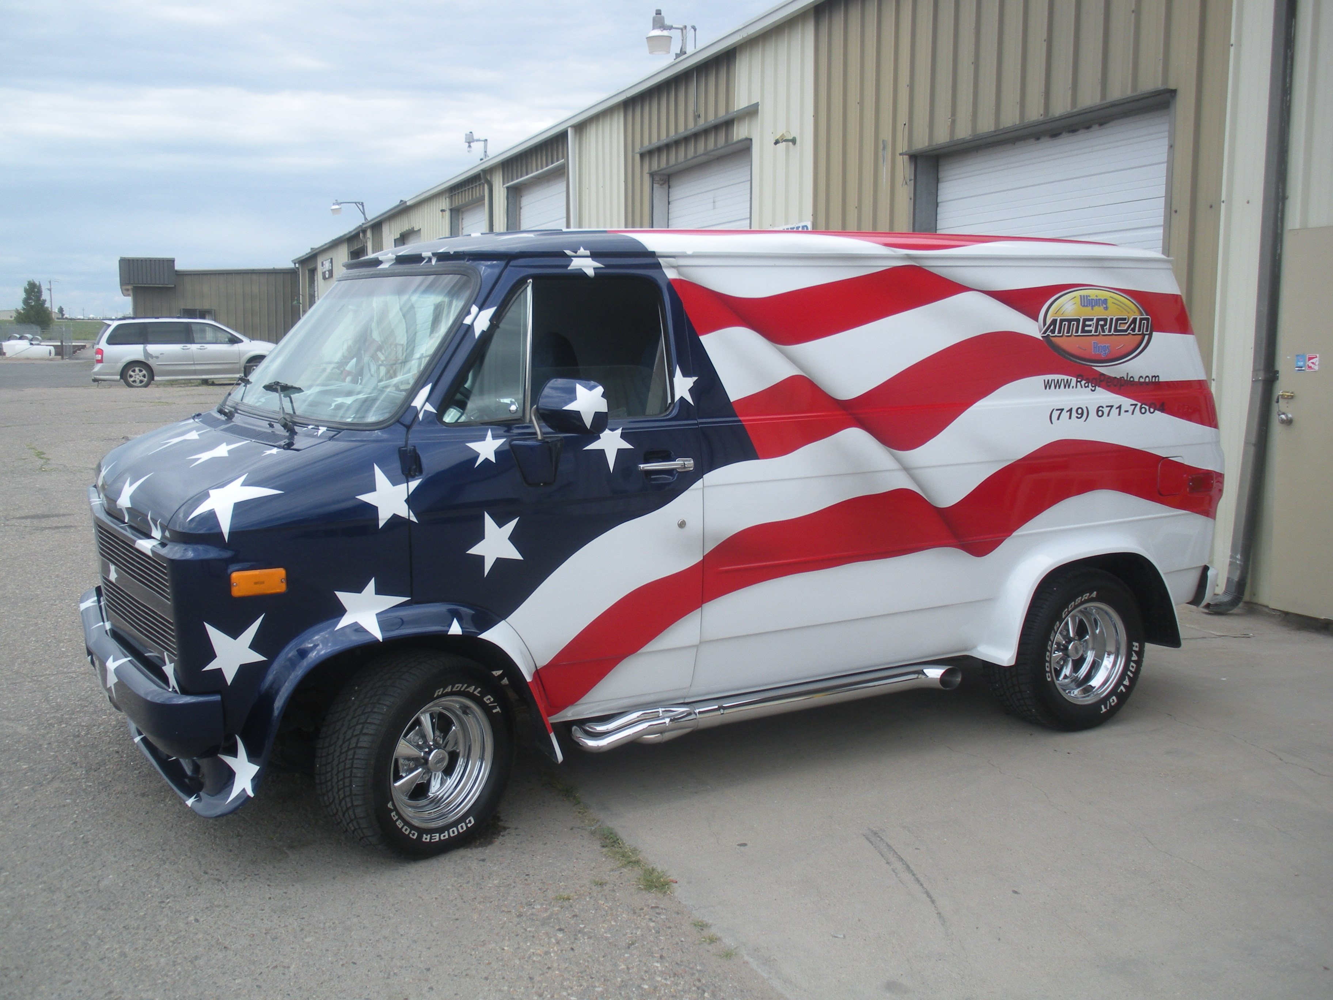

24 N. Research Drive Unit A. Pueblo West, Colorado 81007
Email: americanwipingrags@msn.com www.ragpeople.com
9-12-2013

Certifications:

DBE certified since 2005.
Minority owned business.
Woman owned business.

Awards:

Southern Colorado Small Business of the Year 2008 given by Small Business Development Center of Pueblo
Colorado Small Business of the Year Award Nominee 2013.
Ambassador of the Year Pueblo Latino Chamber 2008
.

P
Performance:

Over the past 13 years, we have met many people some of whom have become new clients. Our focus is on the client not the size of their business. So we have accounts for large and small business as well as residential clients. We ship our lint free cotton rags and our line of microfiber products anywhere in the States.

Contact:

Shelley McPherson - Owner
Office: (719) 647-2744
Cell : (719) 671-7604
Fax : (719) 647-2713
www.americanwipingrags.com

Facility:
Daily operations in an 2500sq. ft
Building.


2124 S. Prairie Unit C Pueblo, CO 81005
Email: americanwipingrags@msn.com www.ragpeople.com
www.americanwipingrags.com

