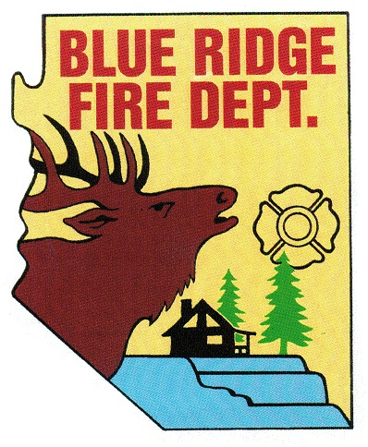
BLUE RIDGE FIRE DISTRICT

Public Safety Personnel Retirement System
Local Board
5023 Enchanted Lane
Happy Jack, Arizona. 86024
928-477-2751
www.brfdaz.org

NOTICE OF WORK STUDY SESSION

Pursuant of A.R.S. 38-43.02, notice is given to members of the general public that members of the Public Safety Personnel Retirement System (PSPRS) will hold a Work Study Session FRIDAY, NOVEMBER 15, 2019 at 1:00 PM at the BLUE RIDGE FIRE DISTRICT STATION in HAPPY JACK, ARIZONA.

Members of the PSPRS Local Board May attend in person or by telephone conference call.

Pursuant to the AMERICANS WITH DISABILITIES ACT, special accommodations will be made available upon a 24-hour prior request to the Secretary of the PSPRS Local Board.

DATE: Friday, November 15, 2019
TIME: 1:00 PM
Place: Blue Ridge Fire District Station

WORK STUDY SESSION CALLED TO ORDER:
TIME:

PLEDGE OF ALLEGIANCE:

ROLL CALL OF PSPRS LOCAL BOARD MEMBERS AND ACCEPTED QUORUM MET:
Cindy Perelli
Linda Blosser
Tammy Rosenhagen
Brandon Sewell
Ryan McNeal

Items for discussion at this Work Study Session:

Exposure Reports:
* Plan for retaining exposure reports after we are no longer using Target Solution.
* Education, importance and training plan for completion of Exposure Reports.
Training could be done in conjunction with the monthly Saturday Training.
* Document that each employee had the training, signed form placed in their file.
* Are Turnouts cleaned after each fire (structure and or wild land). Document they are.
Is there a policy?

Job Descriptions:
* Does BRFD have job duties defined for each type of employee?
(Department requirements)
* The National Firefighters Protection Association (NFPA), use as a guideline only.
* Limited/light duty guideline.
Filling a claim:
* SOG (Standard Operating Guidelines) for employees that are injured or injured on duty. What is the process for a claim and where do they start?

The members of the general public may attend the Work Study Session however the regular Call To The Public will not be called. If a member of the general public wishes to speak or ask a question with reference to an agenda item you are invited to attend the Regular Board Meeting directly following this Work Study Session.

