**JSB Capital Management, LLC**

**Pro-active Wealth Management**

March 11, 2021

Today the much publicized $1.9 trillion “COVID-19 Relief” bill was signed into law that is supposed to provide an economic boost to many Americans via direct payments, extended jobless benefits and disbursed funds for vaccine distribution efforts, among many other things. It is a moot point arguing whether it was properly designed, too bloated or whether it was a bipartisan effort. It is now law and the investment implications are what this newsletter will attempt to describe.

This bill comes on the heels of a significant speech given recently by the Federal Reserve Bank chairman, Jerome Powell, and the two events together form the basis for the analysis herein.

**The Role of the Federal Reserve**

Mr. Powell’s speech created quite a stir for many of the things he didn’t say. He didn’t indicate that the significant rise recently in the interest rates on U.S. Treasury debt was remotely a concern. He didn’t offer any market soothing words to suggest that the current (elevated) interest rates in U.S. Treasury debt should be lower. There was no discussion of controlling the shape or incline of the current Treasury yield rate curve, which formerly was manipulated through something that became known as “Operation Twist.” This manipulation was designed to stimulate the economy (which clearly needs some stimulation thanks to the lockdowns) by the Fed simultaneously buying bonds that mature in 10 years and later while selling very short-term notes thereby “twisting” the yield curve toward a flatter configuration. There was no discussion of easing up on the amount of capital the Federal Reserve Banks have to hold (less bank holding is more money to lend). Consequently, the stock markets reacted predictably by giving back a good amount of their recent gains, especially in the high-flying tech area.

Mr. Powell knew exactly what he was doing through his nonchalance. There was the magic bullet of $1.9 trillion on the way and he determined that he didn’t have to lift a finger in his area of monetary policy. In fact, he passively indicated that he apparently didn’t fear the inflationary consequences of the nearly $2 trillion stimulus package.

In brief the relief package offers [$1,400 direct payments](https://www.wsj.com/articles/when-are-the-stimulus-checks-coming-and-who-will-get-one-11615216538) to many Americans, an extension of a $300 weekly jobless-aid supplement and [a one-year expansion of the child tax credit](https://www.wsj.com/articles/democrats-seek-temporary-expansion-of-child-tax-credit-but-making-it-permanent-is-real-goal-11614776401?mod=article_inline) that will provide periodic payments for many households. It also disburses billions of dollars to schools, vaccine distribution efforts, and state and local governments; provides support to struggling multiemployer pensions; and [makes the biggest changes to the Affordable Care Act](https://www.wsj.com/articles/covid-19-relief-bill-would-expand-affordable-care-act-subsidies-11615299486) since its passage in 2010, among other measures.

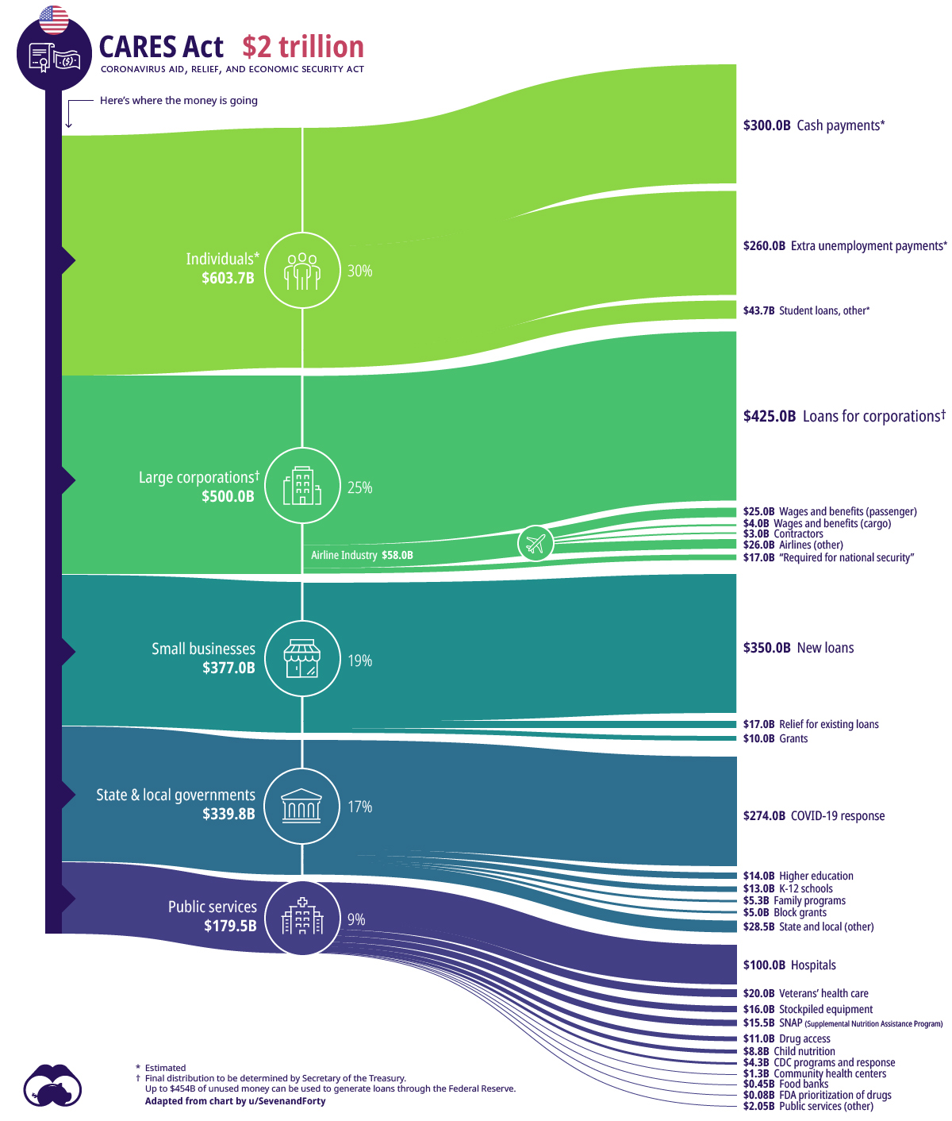

Graph from www.visualcapitalist.com

**The Economic Impacts**

The Gross Domestic Product (GDP – the sum of all goods and services produced domestically) fell by about 2.3% last year. That’s equivalent to around $498 billion of the total GDP (around $20 trillion). Last year’s “relief” measures have more than offset that loss with $3.1 trillion in various government initiatives (some of which has actually yet to be spent). This latest “relief” package brings the total “stimulus” handed out by the feds in response to the coronavirus pandemic to $5 trillion – more than 10 times the actual economic loss last year.

According to the Committee for a Responsible Federal Budget (CRFB), many of these provisions in the latest “stimulus” package have sunset clauses. This means they are scheduled to expire sometime in the future. That trick was used to calculate that the total “cost” of the package can remain just under $2 trillion. However, the CRFB predicts that the total all-in cost will be closer to $4 trillion by the “time the sun sets.”

Indications are that much of the direct payments to individuals and families will be used for needed items, but based on the experience of the last time direct payments were made last year, much of that money made its way into (sometimes speculative) stock purchases. Remember the Robinhood speculators?

**Inflationary Consequences**

Adding $2 trillion in government handouts to the already $3 trillion in stimulus from last year inevitably causes inflation through an artificial and significant injection of money into the existing money supply. This leads to a lot of dollars chasing after a relatively fixed amount of goods and assets (and services) which is one of the primary causes of inflation (called “demand pull inflation” by economists).

How might this effect the performance of the stock market?

Higher interest rates are a hurdle that U.S. stocks have historically overcome, according to LPL Financial LLC (LPL). The firm cited the S&P 500 Index’s track record during periods of rising 10-year Treasury note yields [in a report](https://www.lpl.com/news-media/research-insights/weekly-market-commentary/rising-rates-stock-market-performance.html) Monday. LPL looked at 13 periods since the 1960s in which the 10-year U.S. Treasury note yield increased at least 1 1/2 percentage points. During these periods, lasting about 27 months on average, the S&P 500 recorded an average gain of 15% even though it fell three times (see graph below). “Rising rates are usually bullish for stocks,” strategists Barry Gilbert and Lawrence Gillum wrote in the report. Usually, but not always.

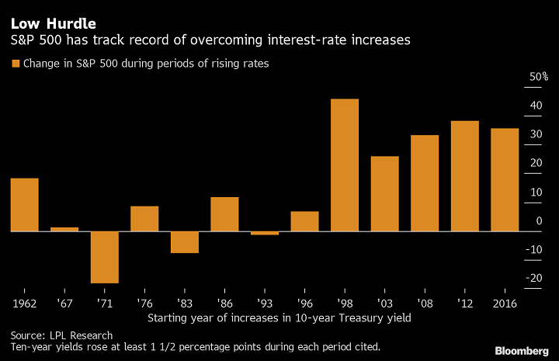

Notice in the graph above that from1986 to today the stock market, as measured by the S&P 500 Index, rose in each instance (except for a very small loss in 1993) that the benchmark 10-year U.S. Treasury debt rose significantly in 8 instances of rate increases. Coincidently, or maybe not so much, the long-term trend of the same 10-year U.S. Treasury debt fell consistently and significantly until recently. See the graph below:

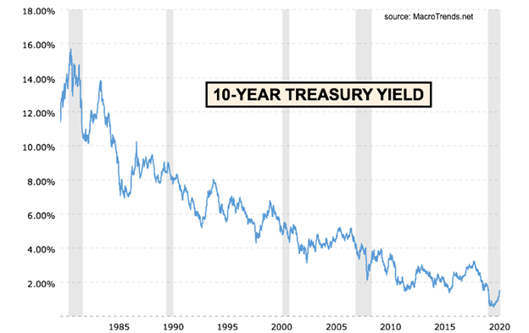

So, one may conclude that the short-term rise in the benchmark 10-year Treasury notes didn’t cause a consequent collapse in stock prices, but that outcome occurred against a powerful backdrop of steadily (year-over-year) declines in the same 10-year Treasury interest rate.

With Treasury yields currently hovering near historically, multi-decade low levels, there just isn’t much capital growth potential (price movements to the upside) left in government bonds. That means there are two likely outcomes for Treasury debt holders right now: First, rates simply stay low, prices remain relatively flat, and the sole source of total return is that 1-2% interest rate that the debt currently pays out; Second, interest rates start rising, bond prices begin falling and the meager interest rate isn’t enough to cover capital losses. Neither scenario is especially appealing.

**Forecast**

It is important to monitor the interest rate paid out by the 10-year Treasury note. As long as investors are faced with the decision to either accept a relatively unattractive payout on the safest investment in the world (U.S. Treasury debt), currently around 1.5% on 10-year Treasuries, or take “some” risk and invest in the growth of the stock market, they will predominantly avoid the 1.5% guarantee for the potential of double-digit returns in stocks. There is a cross-over point where the 10-year interest rate guarantee will begin to attract more and more investments out of the stock market. At that point, the stock market will begin to stall in its current upward trajectory and eventually slide into a likely significant correction. One of the important factors involved in determining the rate on a 10-year piece of paper that eventually attracts the typical stock market investor out of the market is the rate of inflation at any given time. It would be very difficult today to calculate the exact return (yield) on a 10-year treasury obligation that becomes the trigger because no one knows how quickly and how high inflation will go. The proper strategy is to continually monitor the factors of inflation that will no doubt result from the massive stimulus described above and act as soon as is practical. For now, the most likely scenario is that the overall stock market is one of the more attractive investment alternatives. Once the Fed begins to worry about uncontrollable inflation that will be the signal that rates will move significantly higher.

Without a doubt, inflation that is well behaved is stimulative for stock prices as we saw in the graph above. However, there will inevitably come a time when the combination of rising inflation (if the Fed can’t come to the rescue) and increasingly attractive returns (interest rate yields) on the benchmark 10-year notes win out. Our objective is to continually monitor the variables in this equation and hunker down before everyone else wants to run for the hills. That’s the service we endeavor to provide to our clients through decades of experience in these markets.