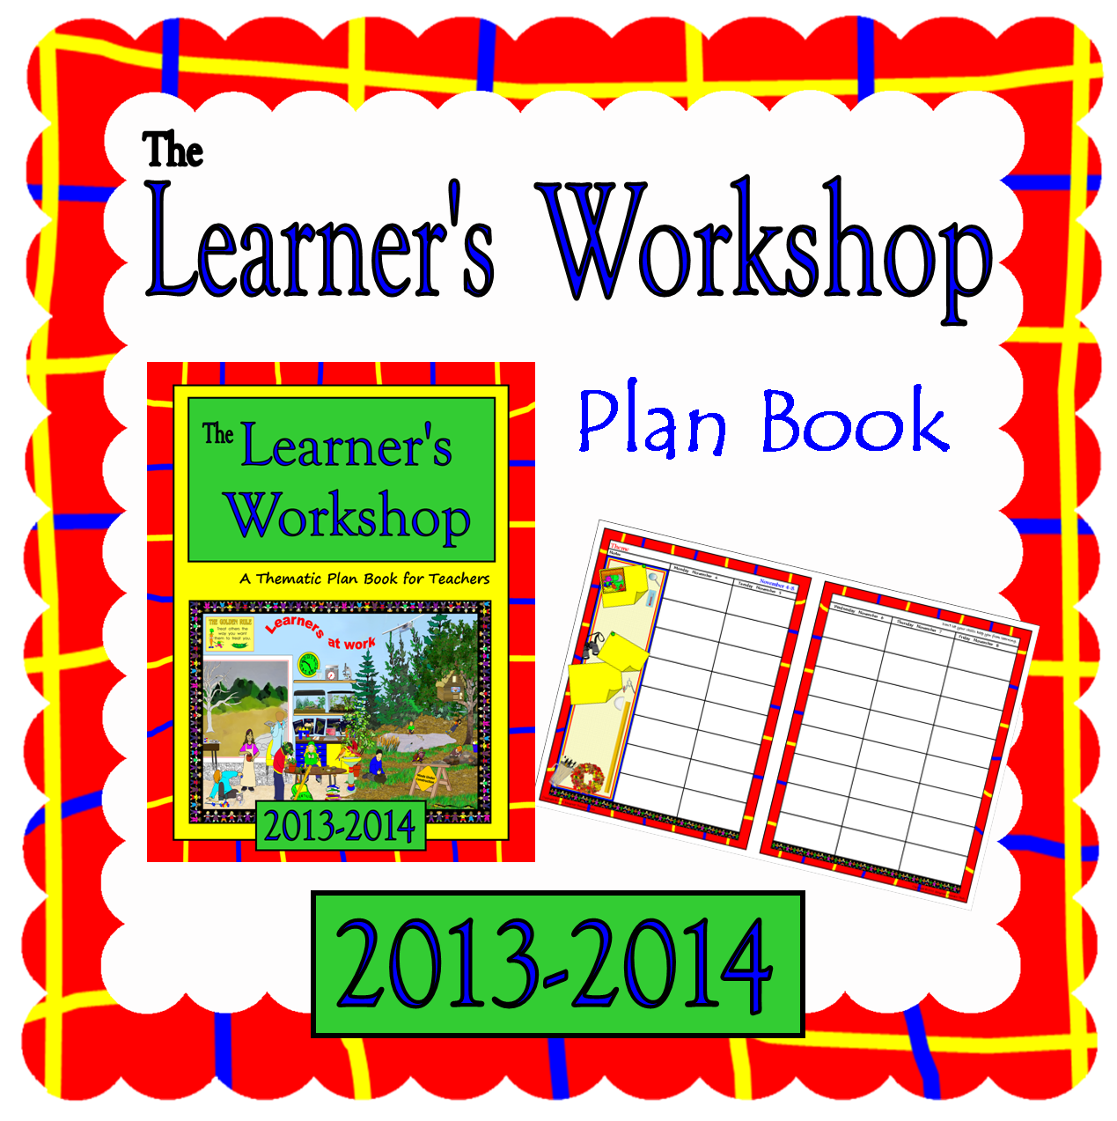
Learner’s Workshop
Plan Book
Workshop style teaching has long been one of my favorite approaches—it empowers children and brings amazing student achievement. As I was reading That Workshop Book: New Systems and Structures for Classrooms That Read, Write, and Think a couple of summers ago, it gave me the idea for this plan book. I'll hope you'll find it exciting, and inspiring!
This plan book may quickly become a treasured scrapbook for teaching year!

Preparation:
1. Look over the pages in this plan book and decide which ones you want to use.
2. Type in the new school year on the cover, and add your personal information to page 3.
3. Print the pages you want (I like to use 24 lb paper for this):
• page 2 and page 37 are the covers: 1 copy single sided, on cover stock.
• pages 3-36 are planning pages for the beginning of the year, and the end of the year: 1 copy, doubled sided, on copy paper.
• pages 38-39 are the weekly lesson plan pages: print as many copies as you need for the year double sided on copy paper.
4. If you wish, write the school year in the blank green space at the bottom of the front cover.
5. Laminate covers and trim.
6. Organize the pages as you wish.
7. Add any other pages you have that you wish to include.
6. Bind the plan book using a plastic comb.

My lesson plan book was my "best friend." During the school year, I lived in it! Everything I needed to remember, think about, or work out, was done in my plan book. I planned murals, centers, yearly plans, unit plans, and daily plans, all in one book. I made lists of materials I had, materials I needed, and things I wanted to get. I made copies of orders and bound them in my plan book, so I wouldn't have to look up the same information the next year. I kept a copy of classroom inventories I was required to turn in, so I wouldn't have to find the serial numbers each year. When I got a new piece of equipment, I added the serial number to my plan book before I set it up—saved me much frustration each year! Phone numbers, contacts, resources—all of them were written in my plan books. Complimentary notes and ideas were taped to the date I received them. My plan books were a storehouse of information and I still have almost all of them! I've used the information contained in them time and time again, right up to today!

I hope you’ll find this plan book a treasured possession for many years to come!

Copyright © 2010-2014 Integreat! Thematic Units www.thematicteacher.com

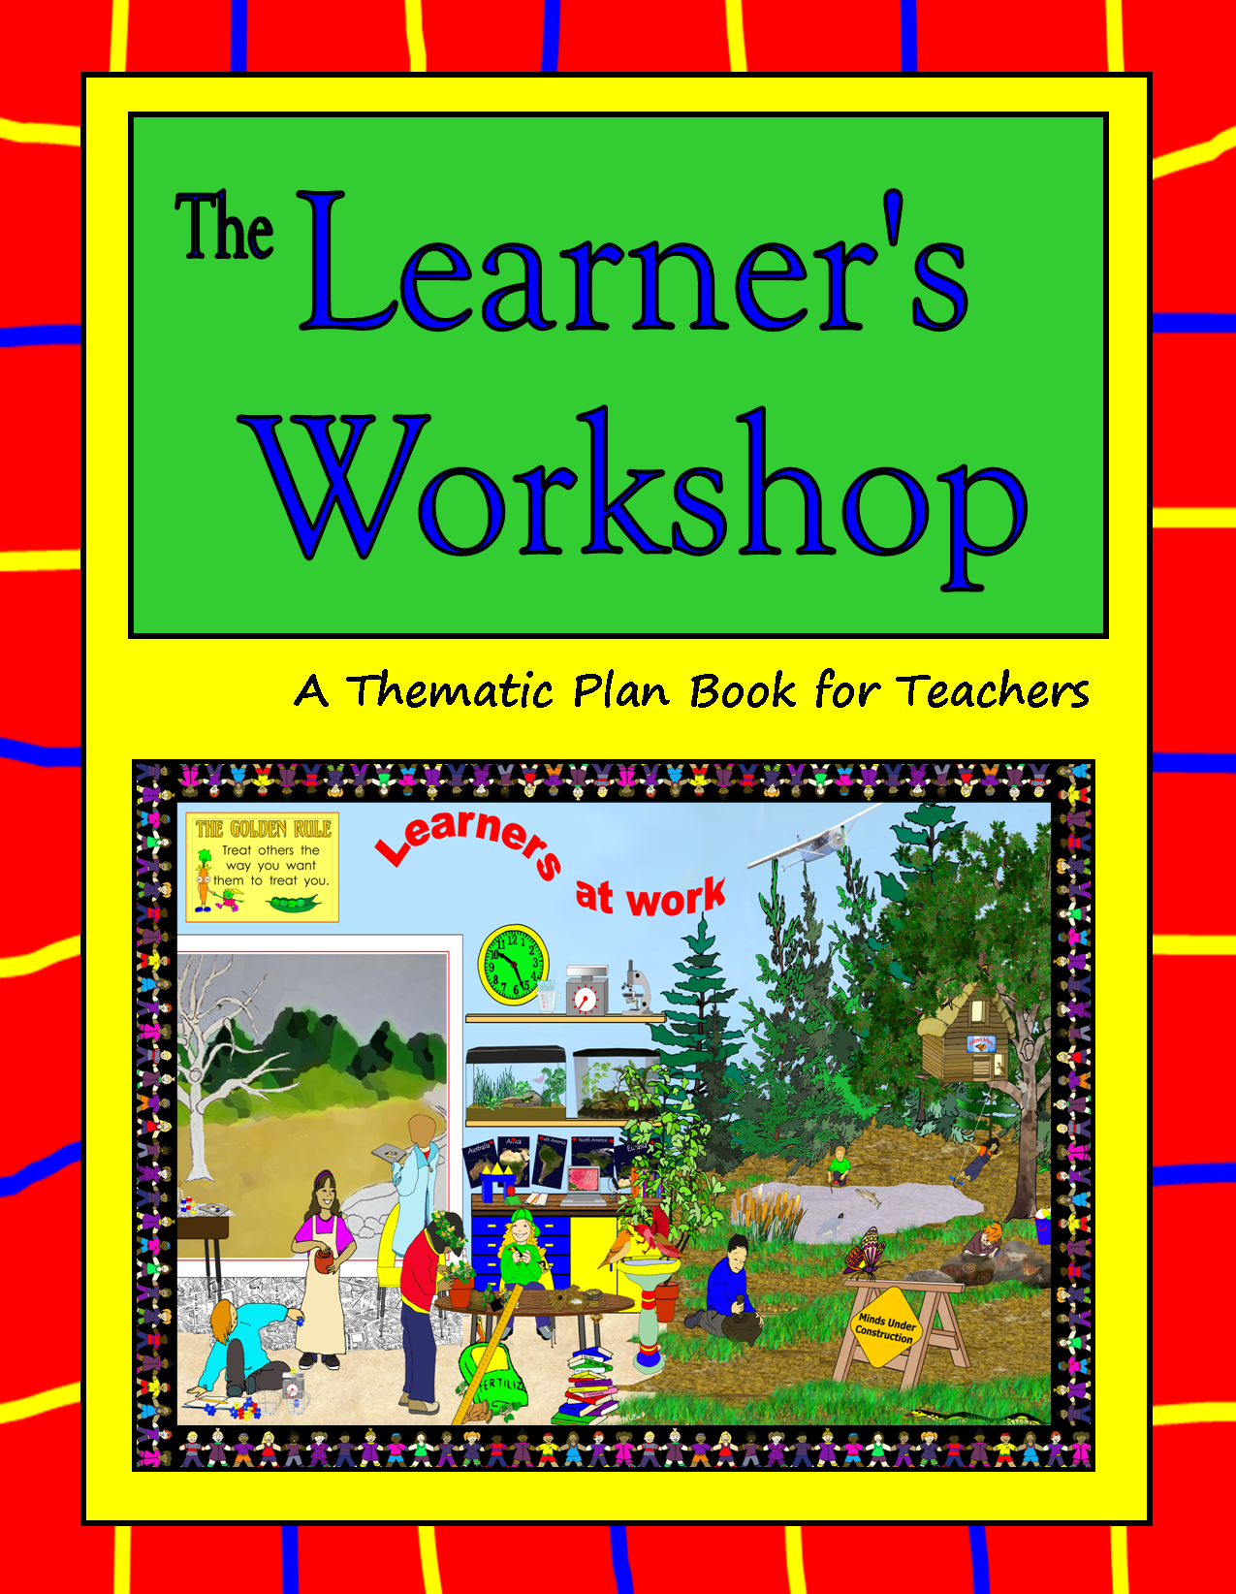
2015-2016

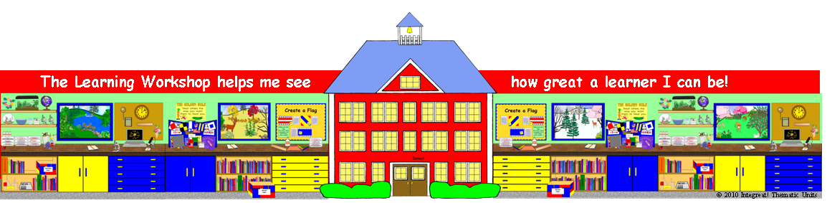
Name
Address
Phone
A Thematic Plan Book for Teachers

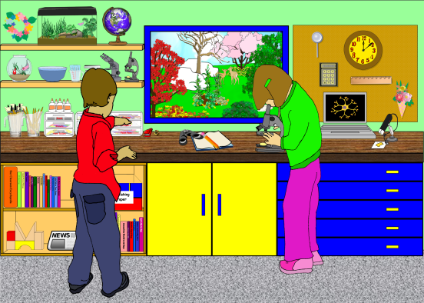
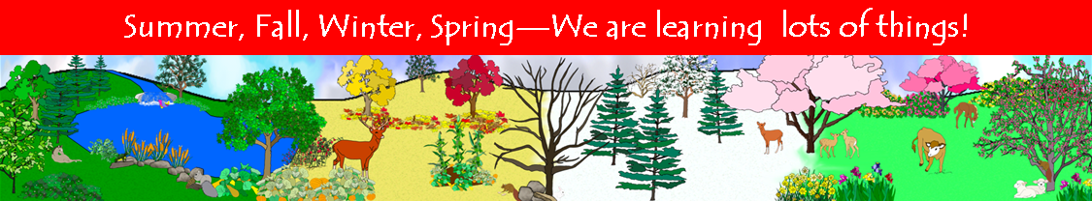
Copyright © 2010-14 by Sandie Flynn
All rights reserved.

No part of this publication may be reproduced, stored in a retrieval system or transmitted in any form or by any means, electronic, mechanical, photocopying, recording, scanning or otherwise, without prior, written permission from the author.

Limited reproduction license: Permission to reproduce this plan book is given to the individual who downloaded it for use in a single classroom. Individuals who downloaded electronic versions of this publication may store their copy on one computer and may make one back up copy. They may change the publication to make it more suitable for their own personal use. They may not copy or distribute the publication, any changes thereof, or any materials included in it to other people by any means including, electronic, mechanical, photocopying, recording, scanning, or otherwise, for personal or commercial reasons.

____ ________________________
____ ________________________
____ ________________________
____ ________________________
____ ________________________
____ ________________________
____ ________________________
____ ________________________
____ ________________________
____ ________________________
____ ________________________
____ ________________________
____ ________________________
____ ________________________
____ ________________________
____ ________________________
____ ________________________
____ ________________________
____ ________________________
____ ________________________
____ ________________________
____ ________________________
____ ________________________
____ ________________________
____ ________________________

Things to Do
____ ________________________
____ ________________________
____ ________________________
____ ________________________
____ ________________________
____ ________________________
____ ________________________
____ ________________________
____ ________________________
____ ________________________
____ ________________________
____ ________________________
____ ________________________
____ ________________________

Copyright © 2010 Integreat! Thematic Units

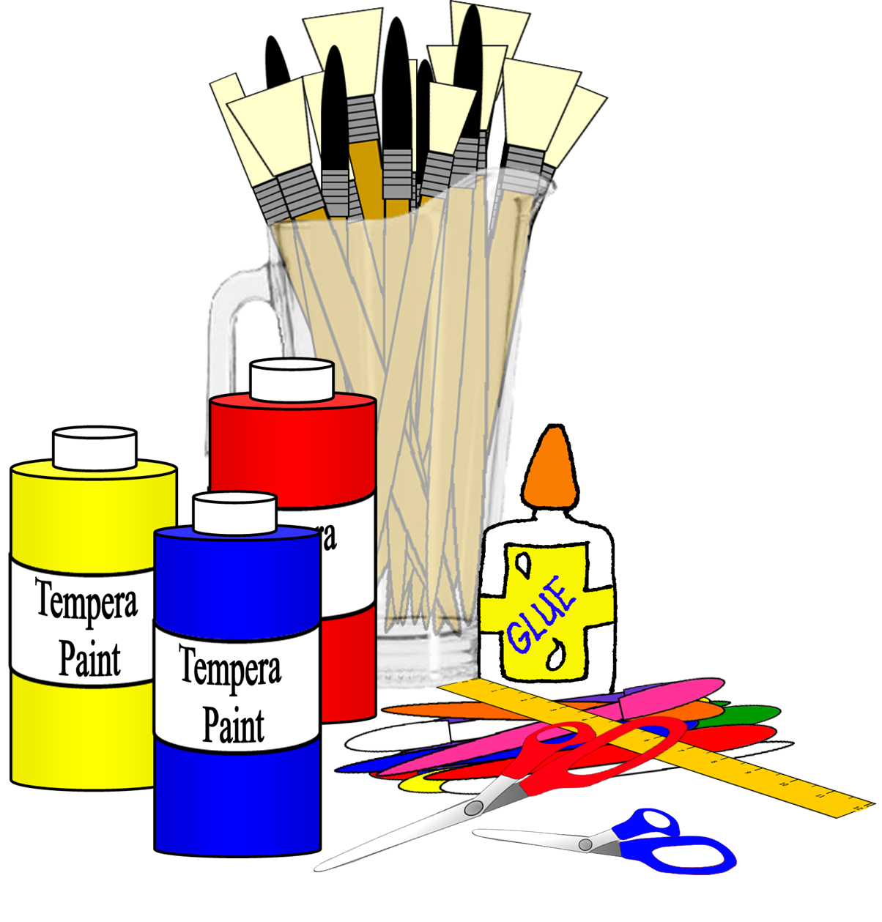
Supplies to Order

Item | Location | Number | Price | Total
Copyright © 2010 Integreat! Thematic Units
Classroom
Inventory



Item | Serial Number | Number
Copyright © 2010 Integreat! Thematic Units
District Calendar
Copyright © 2010 Integreat! Thematic Units

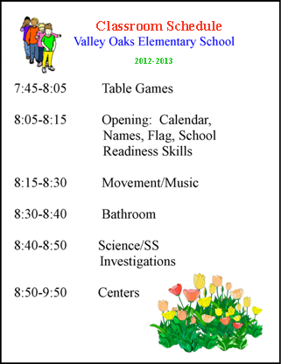
Schedule

Copyright © 2010 Integreat! Thematic Units

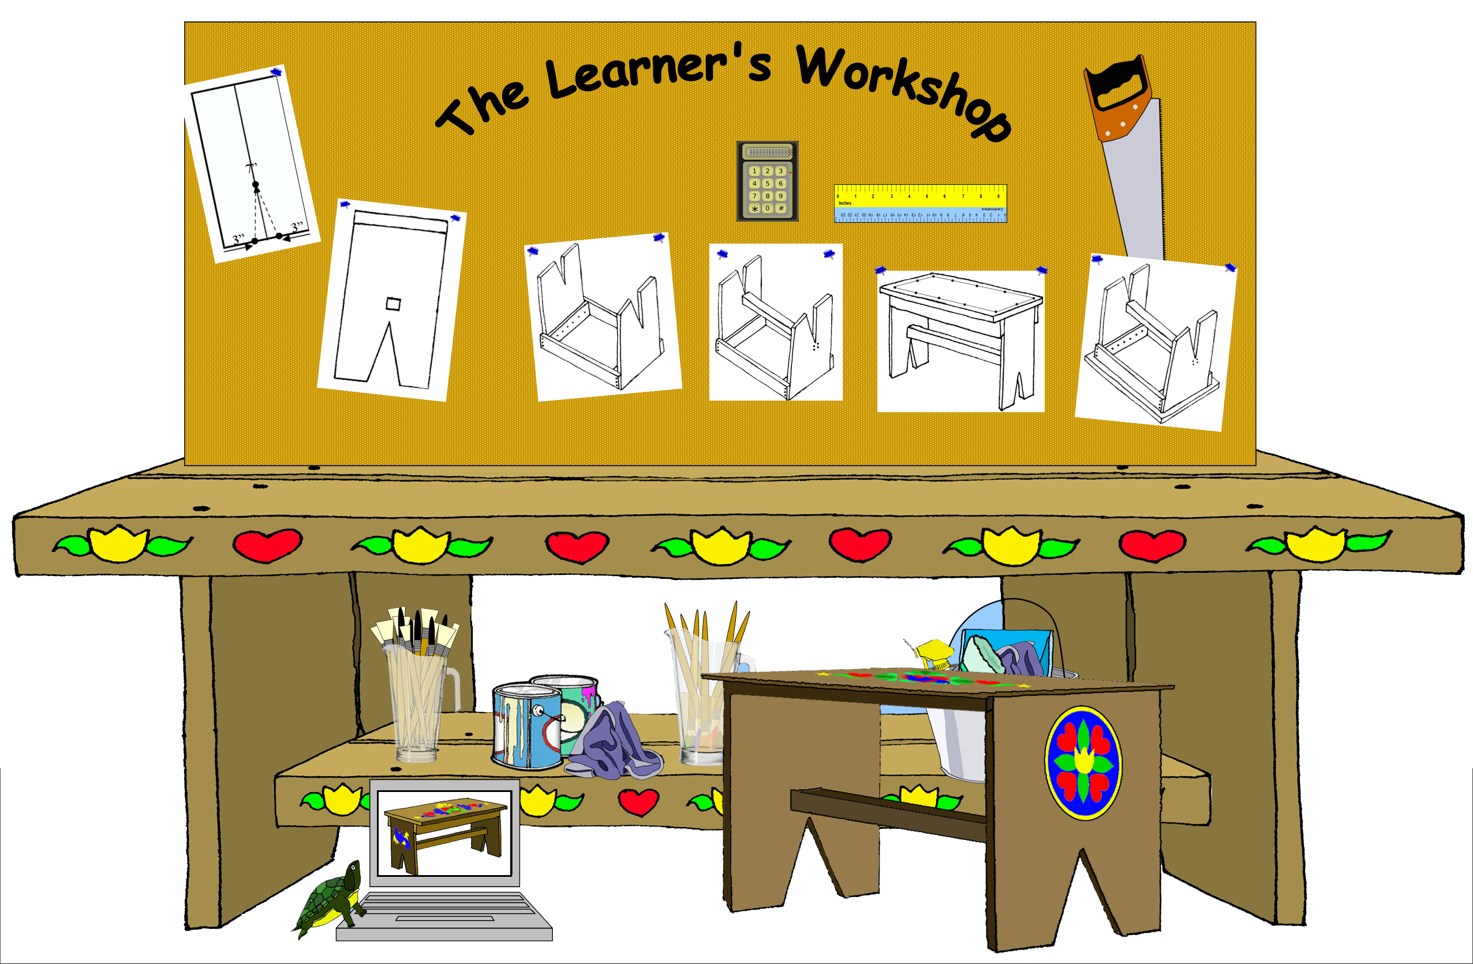
Copyright © 2010 Integreat! Thematic Units

Things to
Remember

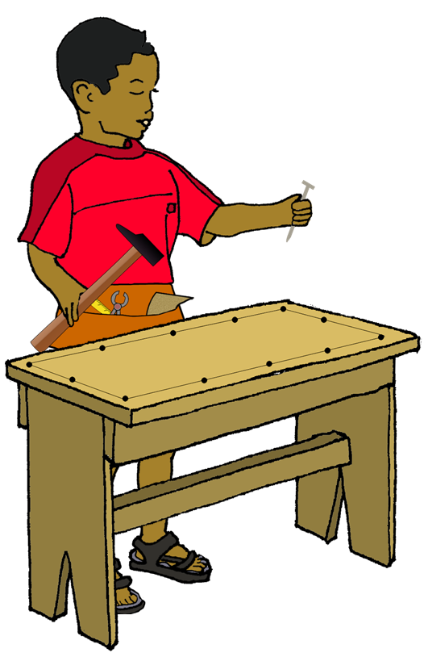
Copyright © 2010 Integreat! Thematic Units

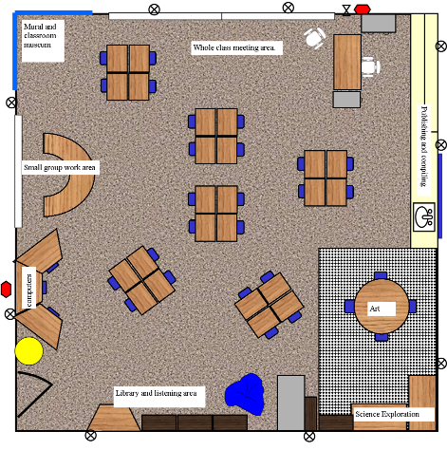
Room Arrangement
Copyright © 2010 Integreat! Thematic Units

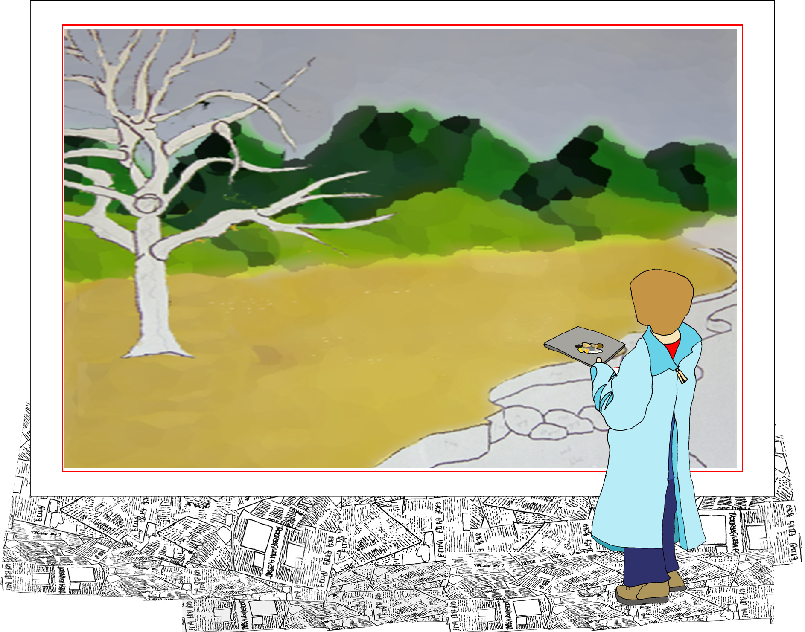
Bulletin Board Ideas
Copyright © 2010 Integreat! Thematic Units

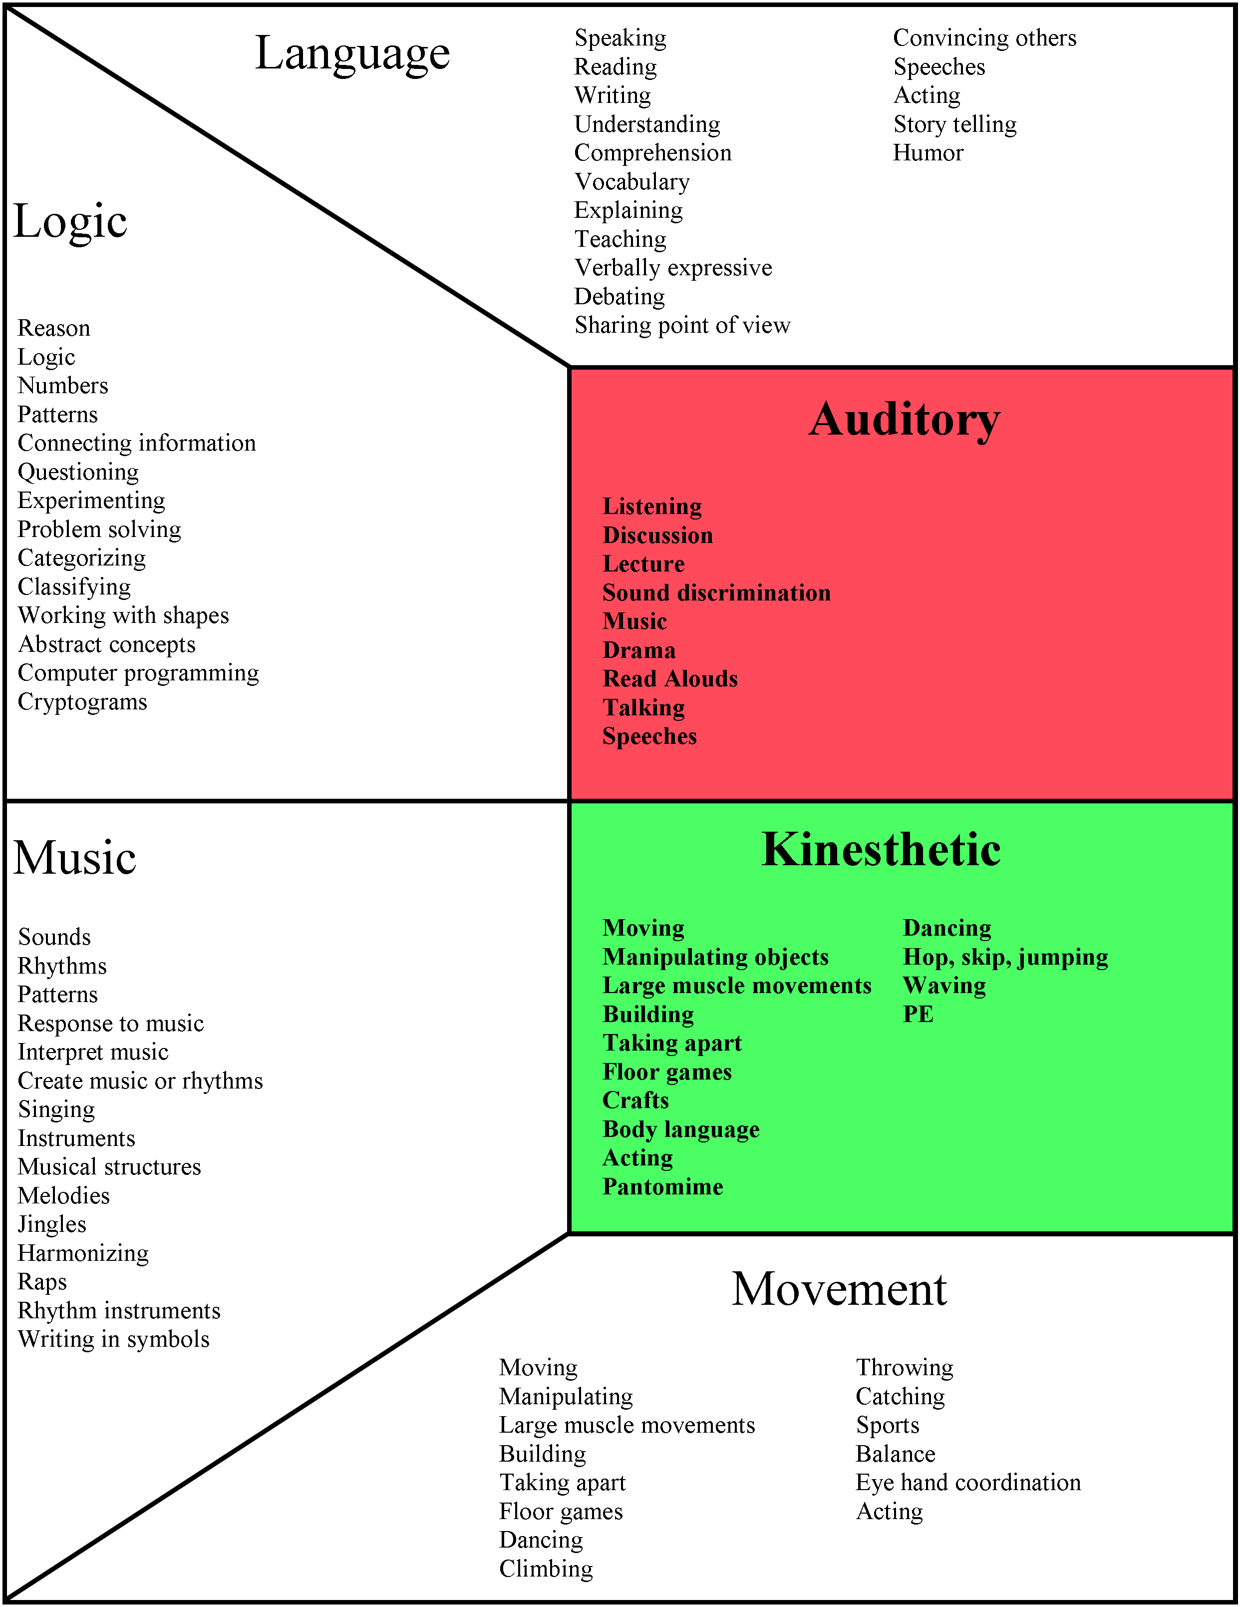

Copyright © 2011 Integreat! Thematic Units
Learning Styles

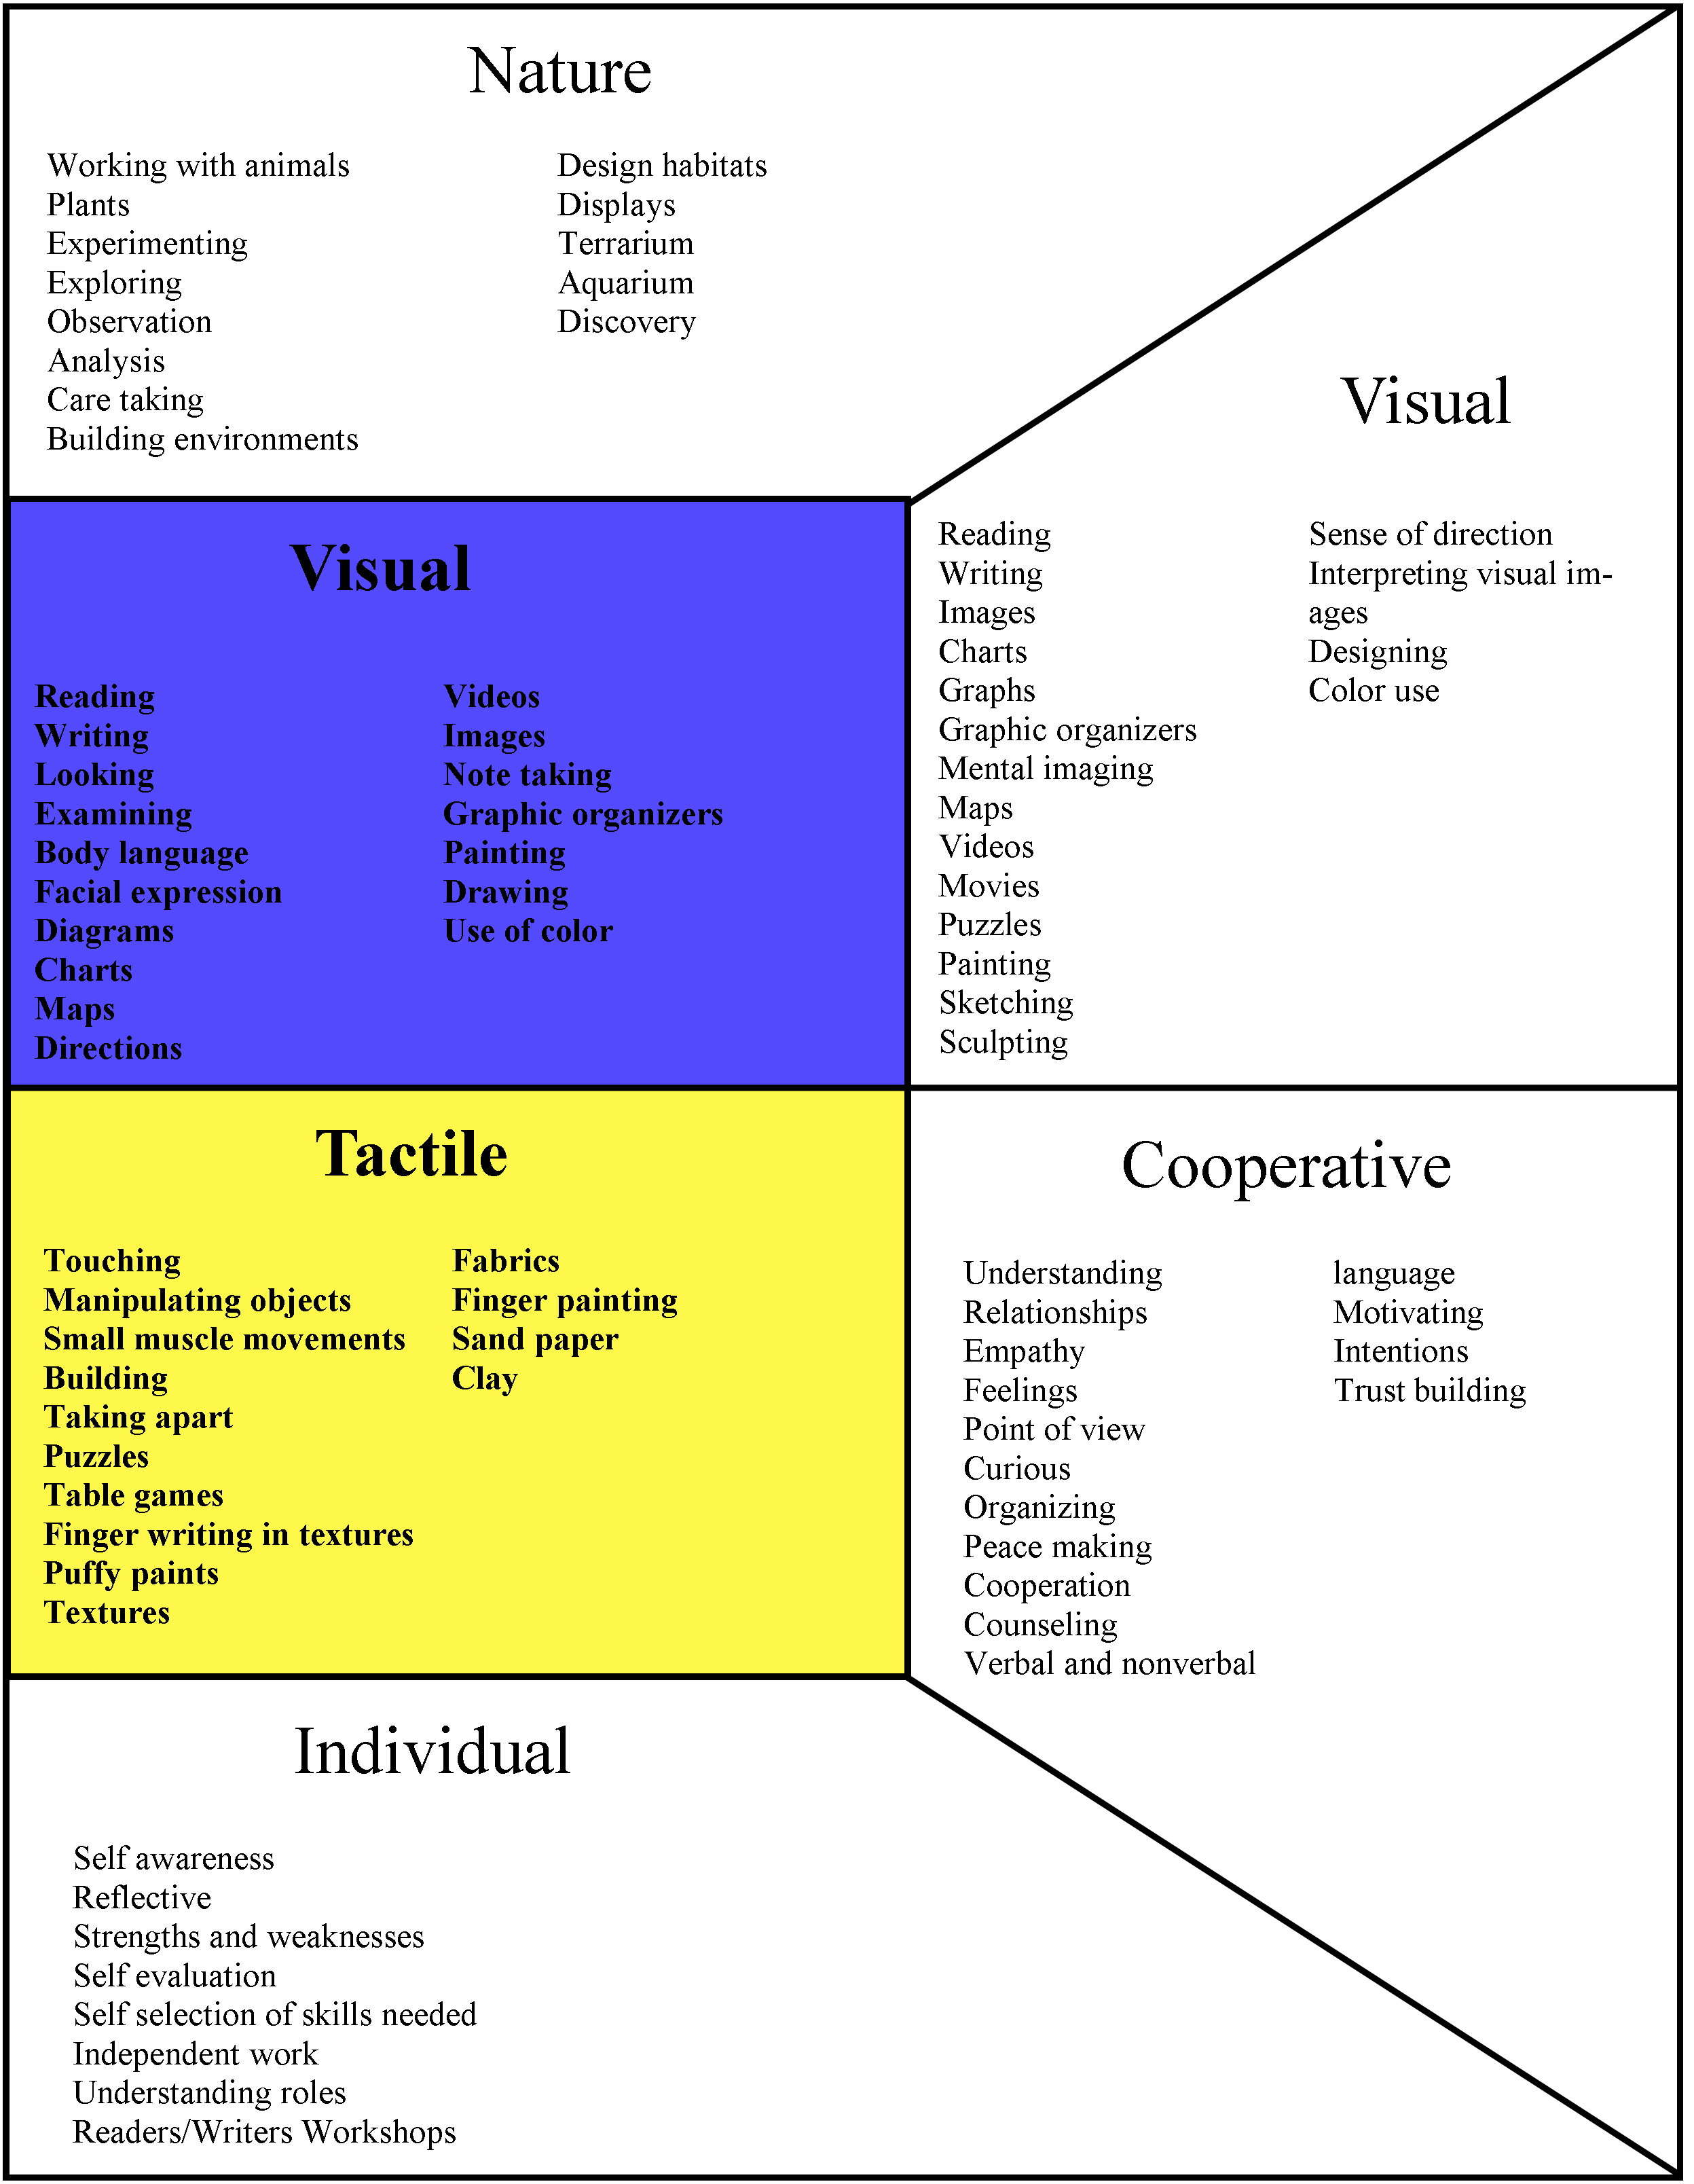
Students learn in a variety of ways, and the manner in which the various learning channels work together in individual children makes for an infinite array of learning conditions. Including many different instructional activities that provide multiple opportunities for different types of student interaction and involvement will help to ensure a rich learning environment that meets the needs of everybody. Add your own ideas to the chart below, and use them to help you plan units and lessons.

Copyright © 2010 Integreat! Thematic Units


Organizing and Integrating
Science & Social Studies Themes

Science & Social Studies Themes
for Grade ____
Science Themes
Social Studies Themes
Theme

Theme

Theme

Theme

Theme

Theme

Theme

Theme

Example:
The Land
Elements & Matter
Rocks
Landforms
Water cycle
Weather
List all the major science and social studies themes you are expected to teach throughout the year. (See “Using the Planning Pages” for more directions.)
Divide the year into a series of units based on themes. Combine science and social studies themes together as much as possible. Divide each theme into smaller units. (See “Using the Planning Pages” for more directions.)
Copyright © 2010 Integreat! Thematic Units
Organizing and Integrating
Science & Social Studies Themes

Science & Social Studies Themes
for Grade ____
Science Themes
Social Studies Themes
Theme

Theme

Theme

Theme

Theme

Theme

Theme

Theme

Example:
The Land
Elements & Matter
Rocks
Landforms
Water cycle
Weather
List all the major science and social studies themes you are expected to teach throughout the year. (See “Using the Planning Pages” for more directions.)
Divide the year into a series of units based on themes. Combine science and social studies themes together as much as possible. Divide each theme into smaller units. (See “Using the Planning Pages” for more directions.)
Copyright © 2010 Integreat! Thematic Units
Organizing and Integrating
Science & Social Studies Themes

Science & Social Studies Themes
for Grade ____
Science Themes
Social Studies Themes
Theme

Theme

Theme

Theme

Theme

Theme

Theme

Theme

Example:
The Land
Elements & Matter
Rocks
Landforms
Water cycle
Weather
List all the major science and social studies themes you are expected to teach throughout the year. (See “Using the Planning Pages” for more directions.)
Divide the year into a series of units based on themes. Combine science and social studies themes together as much as possible. Divide each theme into smaller units. (See “Using the Planning Pages” for more directions.)
Copyright © 2010 Integreat! Thematic Units
Organizing and Integrating
Science & Social Studies Themes

Science & Social Studies Themes
for Grade ____
Science Themes
Social Studies Themes
Theme

Theme

Theme

Theme

Theme

Theme

Theme

Theme

Example:
The Land
Elements & Matter
Rocks
Landforms
Water cycle
Weather
List all the major science and social studies themes you are expected to teach throughout the year. (See “Using the Planning Pages” for more directions.)
Divide the year into a series of units based on themes. Combine science and social studies themes together as much as possible. Divide each theme into smaller units. (See “Using the Planning Pages” for more directions.)
Copyright © 2010 Integreat! Thematic Units

Language Arts Skills

List out the major skill areas for your language arts curriculum. (See “Using the Planning Pages” for more directions.)
Reading Skills:

Writing Skills:

Speaking Skills:

Listening Skills:

Literary Skills:

Genres:

Conventions:

Genres:

Genres:

Conventions:

Conventions:

Genres:

Conventions:

Copyright © 2010 Integreat! Thematic Units
Language Arts Skills

List out the major skill areas for your language arts curriculum. (See “Using the Planning Pages” for more directions.)
Reading Skills:

Writing Skills:

Speaking Skills:

Listening Skills:

Literary Skills:

Genres:

Conventions:

Genres:

Genres:

Conventions:

Conventions:

Genres:

Conventions:

Copyright © 2010 Integreat! Thematic Units
Theme
Theme
Theme
Theme
Genre:

Genre:

Genre:

Genre:

Language Arts Support Materials
Titles and page numbers
Titles and page numbers
Titles and page numbers
Titles and page numbers
Science/SS Book

Science/SS Book
Science/SS Book
Science/SS Book
Book Titles
Book Titles
Book Titles
Book Titles
Match the language arts skills and other resources with the literature genre and your themes. (See “Using the Planning Pages” for more directions.)
Copyright 2010 Integreat! Thematic Units
Theme
Core
Literature
Reading Text
Selections
SS/ Science Text Selections
Other
Trade Books
Theme
Theme
Theme
Theme
Genre:

Genre:

Genre:

Genre:

Language Arts Support Materials
Titles and page numbers
Titles and page numbers
Titles and page numbers
Titles and page numbers
Science/SS Book

Science/SS Book
Science/SS Book
Science/SS Book
Book Titles
Book Titles
Book Titles
Book Titles
Match the language arts skills and other resources with the literature genre and your themes. (See “Using the Planning Pages” for more directions.)
Copyright 2010 Integreat! Thematic Units
Theme
Core
Literature
Reading Text
Selections
SS/ Science Text Selections
Other
Trade Books
Theme
Theme
Theme
Theme
Genre:

Genre:

Genre:

Genre:

Language Arts Support Materials
Titles and page numbers
Titles and page numbers
Titles and page numbers
Titles and page numbers
Science/SS Book

Science/SS Book
Science/SS Book
Science/SS Book
Book Titles
Book Titles
Book Titles
Book Titles
Match the language arts skills and other resources with the literature genre and your themes. (See “Using the Planning Pages” for more directions.)
Copyright 2010 Integreat! Thematic Units
Theme
Core
Literature
Reading Text
Selections
SS/ Science Text Selections
Other
Trade Books

Theme
Core
Literature
Reading Text
Selections
SS/ Science Text Selections
Other
Trade Books
PE/Health
Music
Art
Math
Language Arts
Theme
Theme
Theme
Theme
Genre:
Product:
Subject Area Skills Alignment
Skills List
Area of Study
Area of Study
Area of Study
Area of Study
Area of Study
Theme

Genre:
Product:
Genre:
Product:
Genre:
Product:
Skills List
Skills List
Skills List
Area of Study
Area of Study
Area of Study
Area of Study
Area of Study
Area of Study
Area of Study
Finally, align the other subject areas with your themes. (See “Using the Planning Pages” for more directions.)
Copyright © 2010 Integreat! Thematic Units

Theme
Core
Literature
Reading Text
Selections
SS/ Science Text Selections
Other
Trade Books
PE/Health
Music
Art
Math
Language Arts
Theme
Theme
Theme
Theme
Genre:
Product:
Subject Area Skills Alignment
Skills List
Area of Study
Area of Study
Area of Study
Area of Study
Area of Study
Theme

Genre:
Product:
Genre:
Product:
Genre:
Product:
Skills List
Skills List
Skills List
Area of Study
Area of Study
Area of Study
Area of Study
Area of Study
Area of Study
Area of Study
Finally, align the other subject areas with your themes. (See “Using the Planning Pages” for more directions.)
Copyright © 2010 Integreat! Thematic Units
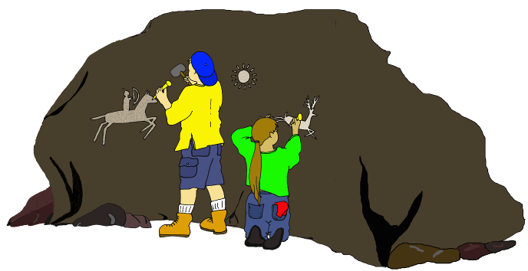
Unit Plans
Theme: _____________________
Brainstorm, organize and coordinate the major skills and projects you want to include in each subject area for each of your themes. This will make it easy for you to write your daily lesson plans. Run off extra copies of these pages as needed to have a planning page for each theme.

Thematic Unit

T
Plans
Math:
Social Studies:
Language Arts—Reading / Listening
Art:
Language Arts—Writing / Speaking
Music:
Language Arts—Literature

PE:
Science:
Projects:
Copyright © 2010 Integreat! Thematic Units
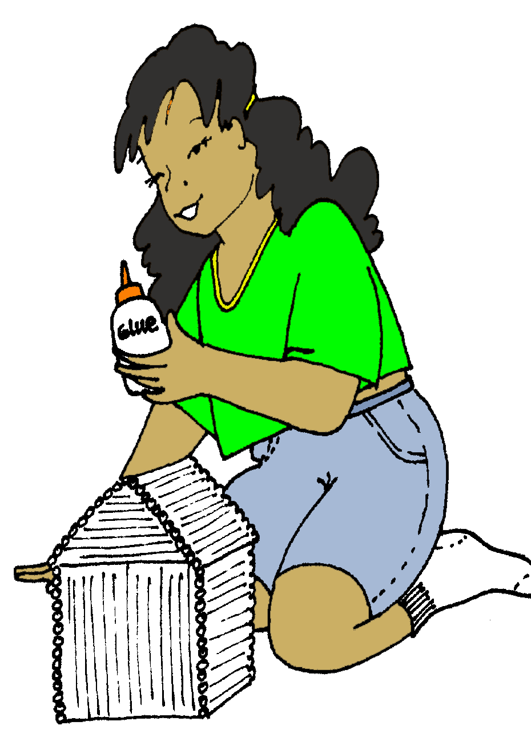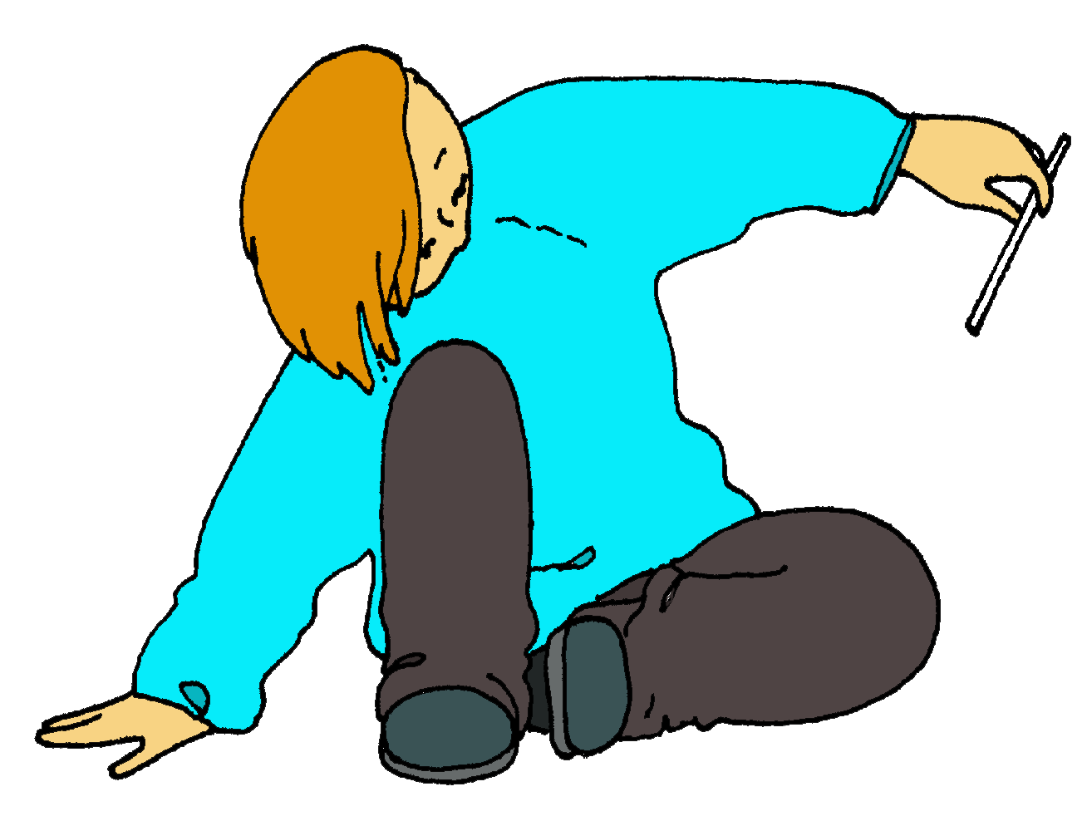
Copyright © 2010 Integreat! Thematic Units
Math:
Social Studies:
Language Arts—Reading / Listening
Art:
Language Arts—Writing / Speaking
Music:
Language Arts—Literature

PE:
Projects:
Unit Plans
Theme: _____________________
Brainstorm, organize and coordinate the major skills and projects you want to include in each subject area for each of your themes. This will make it easy for you to write your daily lesson plans. Run off extra copies of these pages as needed to have a planning page for each theme.

Thematic Unit

T
Plans
Science:

Unit Plan Activities

 | Language | Logic | Visual | Movement
Reading
Writing
Speaking
Listening
Math

Science
Social
Studies
Art
Music
PE
Health
Copyright © 2010 Integreat! Thematic Units
Run off a planning page for each unit you make. This worksheet will focus your attention on creating projects and activities that support multiple learning styles and ways of thinking.
Unit:______________________________

Copyright © 2010 Integreat! Thematic Units
 | Music | Individual | Group | Nature
Reading
Writing
Speaking
Listening
Math

Science
Social
Studies
Art
Music
PE
Health
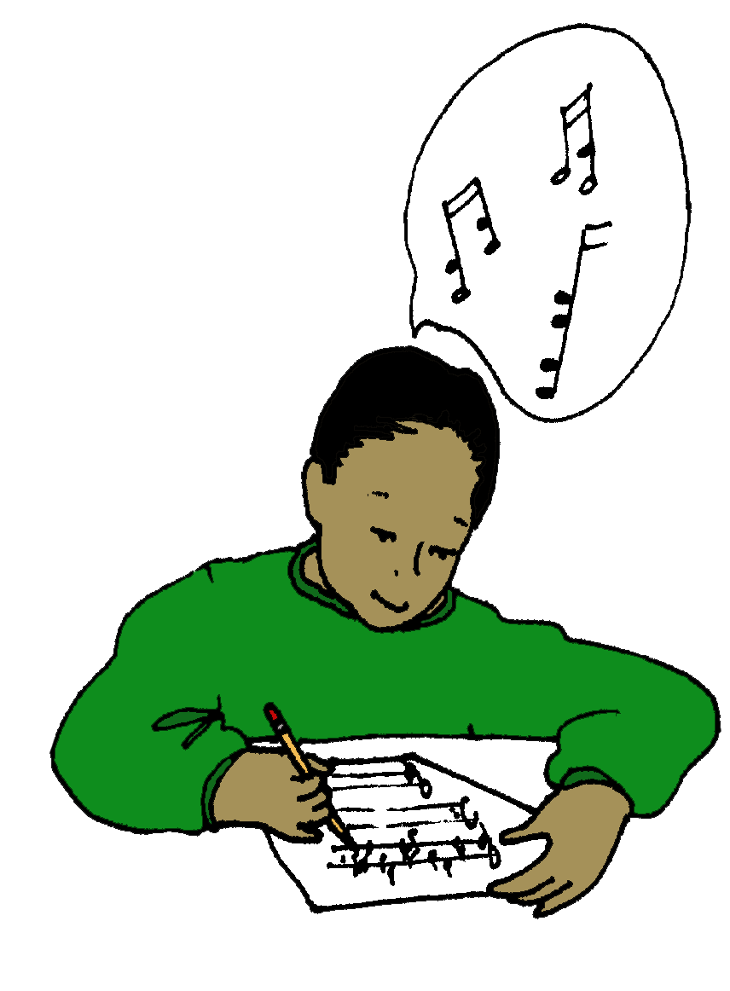
Notes

Copyright © 2010 Integreat! Thematic Units

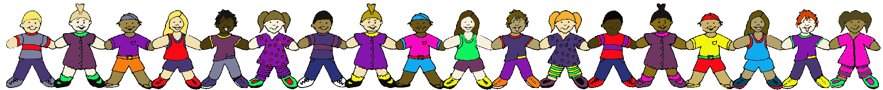
Bloom’s Taxonomy Questions
Knowledge
Who were ….
What was ….
Where did ….
When did ….
Tell what happened when ….
Name the ….
List all the ….
Is it true or false that…
Make a time line of ….
Point to the ….

Comprehension
Retell it in your own words.
What does this mean?
Illustrate
Describe ….
What was the main idea?
Who was the main character?
What might happen next?
Name the characteristics
Give an example of ….
Make a map of ….

Application
What would happen if ….
What would you do in the situation?
Do some research to find out ….
What can you learn from ….
Has this ever happened to you?
How could this be helpful to you?
What would you ask the author?
What would you ask a character?
How is _____ an example of _____?
Analysis
What else could have been done?
Could this happen in real life? Why?
What kind of person is __________?
Why did _____ do that?
What things are similar to ….
What things are different from ….
What is the theme?
What was the turning point?
Outline the steps taken to solve the problem.
Compare / Contrast yourself to the main character

Synthesis
What would it be like to live ….
Change the ending.
Pretend you are ….
Design a ….
Find another way to solve the problem.
How many ways can you….
Create a new ….
Invent another ….
Convince me of your idea.
Combine your characteristics with those of ….

Evaluation
What will happen to the character in the future?
Could this really happen? Why? Why not?
Was this good or bad? Why? Why not?
Would you recommend this? Why? Why not?
Debate ….
Develop a scale to judge ….
What changes need to be made?
What was the most important ….
What character would you want for a friend? Why?

These questions have been collected over a number of years, from a variety of different sources. You can choose some to print on bookmarks and give them to small groups to guide discussions of stories, novels, videos, plays, encounters on the playground, or just about anything else. Focus more of your questions at the higher levels of the taxonomy.


Alphabetic Sentences
These are sentences that contain all the letters of the alphabet, useful for practicing penmanship, keyboarding, or calligraphy. They also present a challenge for children to create their own. I don’t know where I got them, but I like their quaint language. Thanks to whoever collected or wrote them!

Back in my quaint garden, jaunty zinnias vie with flaunting phlox.

Breezily jingling $3,416,857, 209 a wise advertiser ambles to the bank, his exchequer amplified.

Verbatim reports were quickly given by Jim Fox to his amazed audience.

Jay visited back home and gazed upon a brown fox and quail.

Six crazy kings vowed to abolish my quite pitiful jousts.

May Jo equal the fine record by solving six puzzles a week?

Wes quickly gave Bert handsome prizes for six juicy plums.

Just keep examining every low bid quoted for zinc etchings.

Freight to me sixty dozen quart jars and twelve black pans.

We have just quoted on nine dozen boxes of gray lamp wicks.

Fred specialized in the job of making very quaint wax toys.

Astronaut Quincy B. Zack defies gravity with six jet fuel pumps.

My friendly help squeezed back in again and joined the many weavers after six.

William Jex quickly caught five dozen brown pelicans.

Jack amazed a few girls by dropping the antique onyx vase!

A quick movement of the enemy will jeopardize six gunboats.

Jeb quickly drove a few extra miles on the glazed pavement.

Pack my box with five dozen jugs of liquid veneer.

Five big quacking zephyrs jolted my wax bed.

The quick brown fox jumped viciously through my garden zone.


Elements and Compounds
These are common materials often referenced in science activities. They don’t always use common names, so here’s a list that may be a helpful resource.

Common Name Scientific Name Where to get it
alum potassium aluminum sulfate drug store
ammonia water ammonium hydroxide drug store
aspirin acetylsalicylic acid drug store
borax sodium tetra borate laundry section
chalk calcium carbonate drug store
charcoal carbon grocery store
coke carbon drug store
corn syrup glucose grocery store
cream of tartar potassium bitartrate grocery store
diamond carbon your husband
dry ice carbon dioxide WalMart Superstores
Epsom salts magnesium sulfate drug store
graphite carbon pencils
gypsum calcium sulfate nursery
lampblack, soot carbon charcoal rubbings
limestone calcium carbonate lapidary shops
limewater (pickling lime) calcium hydroxide grocery store
lye potassium hydroxide too toxic
marble calcium carbonate lapidary shop
milk of magnesia magnesium hydroxide drug store
mothballs naphthalene drug store
muriatic acid hydrochloric acid pool supply
nail polish remover acetone drug store
pearl calcium carbonate your husband
peroxide hydrogen peroxide drug store
plaster of paris calcium sulfate home improvement
potash potassium carbonate nursery
quartz silicon dioxide lapidary shop
saltpeter potassium nitrate drug store, feed store
salt, rock sodium chloride grocery store
salt, table sodium chloride grocery store
sand silicon dioxide home improvement
soda, baking sodium bicarbonate grocery store
sugar sucrose grocery store
vinegar acetic acid grocery store
washing soda sodium carbonate laundry section

Ideas for Next Year

Copyright © 2010 Integreat! Thematic Units

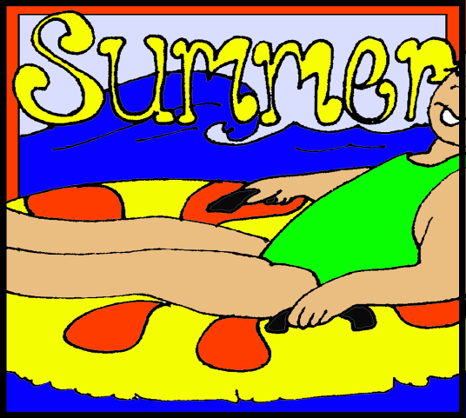
____ _______________________
____ _______________________
____ _______________________
____ _______________________
____ _______________________
____ _______________________
____ _______________________
____ _______________________
____ _______________________
____ _______________________
____ _______________________
____ _______________________
____ _______________________
____ _______________________
____ _______________________
____ _______________________
____ _______________________
____ _______________________
____ _______________________
____ _______________________
____ _______________________
____ _______________________
____ _______________________
____ _______________________
____ _______________________
End of the Year
Things to Do
Copyright © 2010 Integreat! Thematic Units


Copyright © 2010 Integreat! Thematic Units

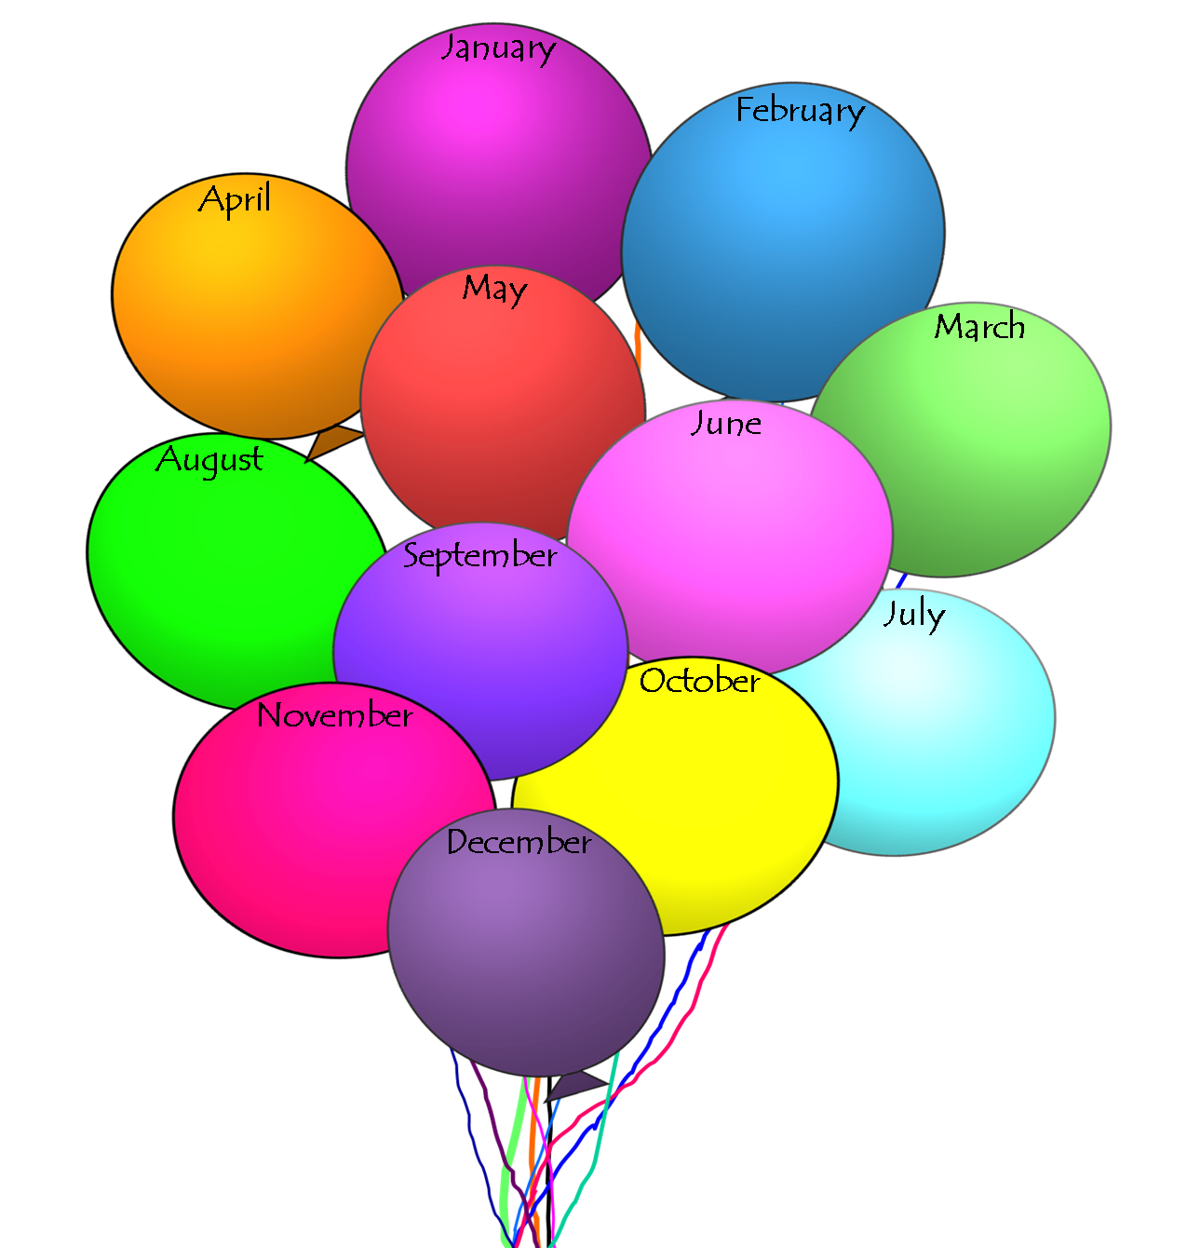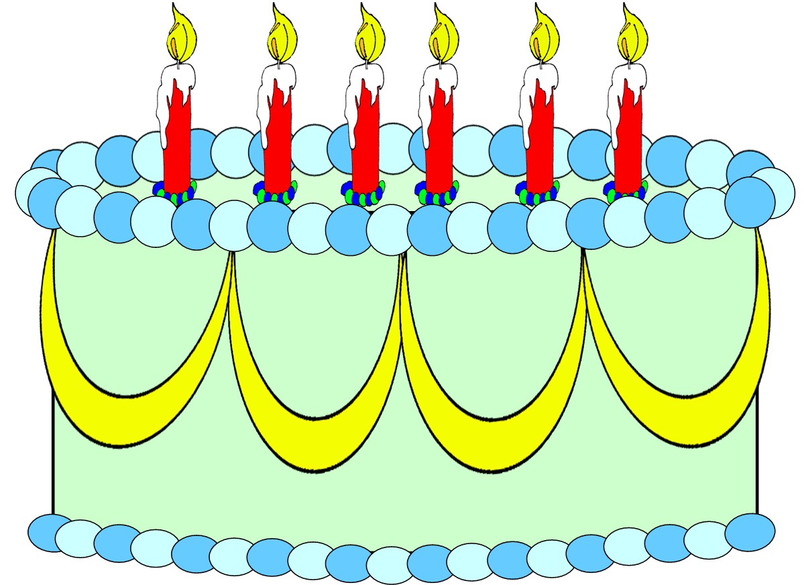
Student Birthdays

Copyright © 2010 Integreat! Thematic Units

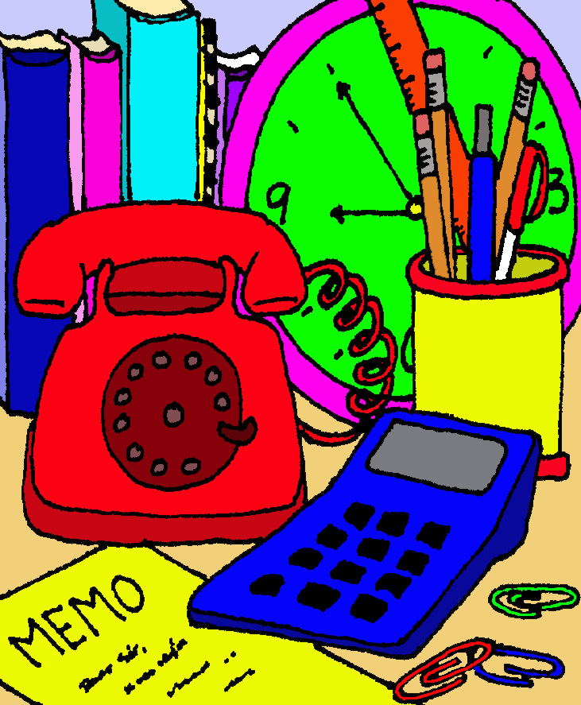
Phone Numbers
Name
Work Phone
Home Phone
Cell
Address
City, State, Zip
Name
Work Phone
Home Phone
Cell
Address
City, State, Zip
Name
Work Phone
Home Phone
Cell
Address
City, State, Zip
Name
Work Phone
Home Phone
Cell
Address
City, State, Zip
Name
Work Phone
Home Phone
Cell
Address
City, State, Zip
Name
Work Phone
Home Phone
Cell
Address
City, State, Zip
Name
Work Phone
Home Phone
Cell
Address
City, State, Zip
Name
Work Phone
Home Phone
Cell
Address
City, State, Zip
Name
Work Phone
Home Phone
Cell
Address
City, State, Zip
Name
Work Phone
Home Phone
Cell
Address
City, State, Zip
Copyright © 2010 Integreat! Thematic Units

Important Info
Substitute Call Number:

Substitute’s Phone Numbers

Copier Number

Book Club Account Number

Public Library

Copyright © 2010 Integreat! Thematic Units

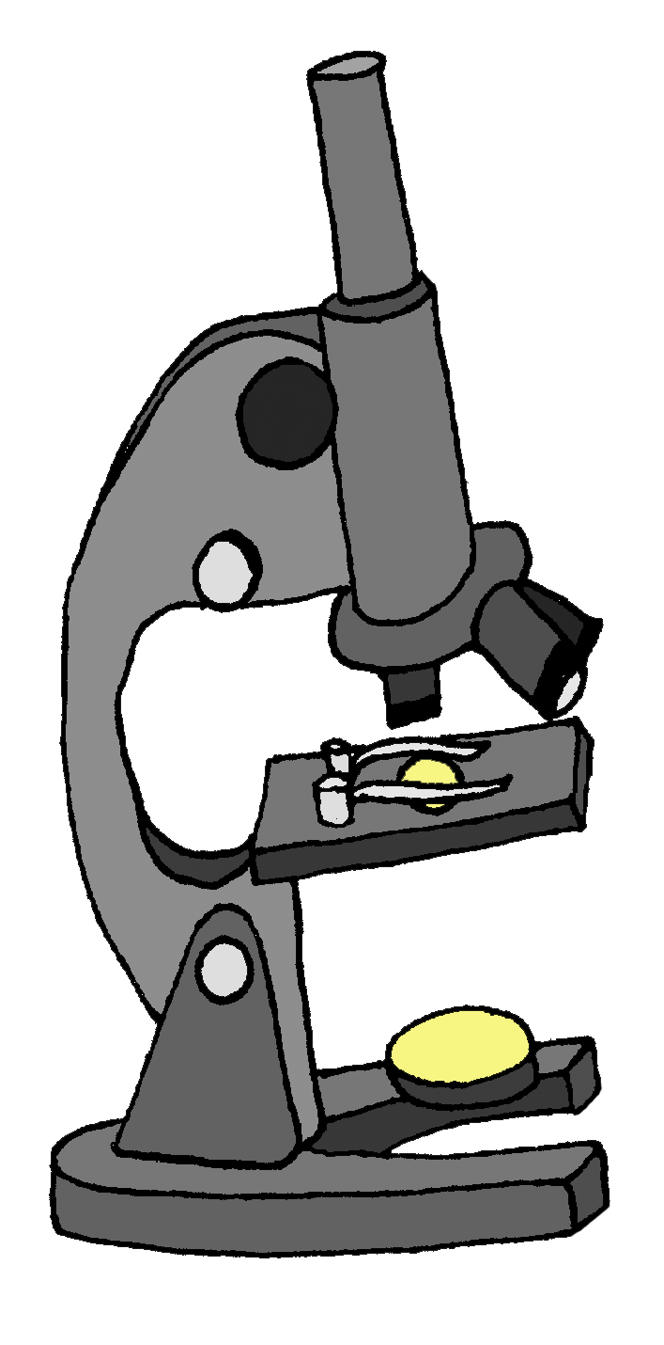
Student Info

Name | Phone | Address | Birthday | Parent’s Names | Allergies

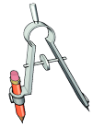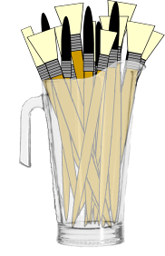

Theme
Tuesday
Monday
Notes

Copyright © 2010 Integreat! Thematic Units

Wednesday
Thursday
Friday
Copyright © 2010 Integreat! Thematic Units

