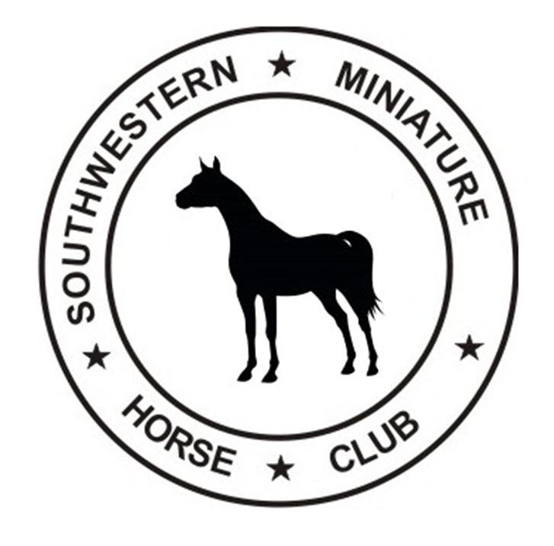

SOUTHWESTERN MINIATURE HORSE CLUB
2018 MEMBERSHIP APPLICATION

Membership is not restricted by ownership of horses or geographic location

Membership Dues:
Family ………………………..$25
Single Adult …………………$10
Single Youth ……………….. $5
Complete the information below and mail with your check, payable to SWMHC to

SWMHC Membership
c/o Jane Wagner
3321 Springfield Rd
Springtown, Texas 76082

NAME ________________________________________________________________

FARM NAME __________________________________________________________

YOUTH NAME _______________________________DOB______________________

YOUTH NAME ________________________________DOB_____________________
LIST OTHER YOUTH ON THE BACK

ADDRESS_____________________________________________________________

CITY______________________________STATE____________ZIP_______________

EMAIL ________________________________________________________________

WEBSITE ___________________________________________________________________

PHONE NO __________________________PHONE 2__________________________

___New Member ___Renewing Member ___Single Member ___Youth ___Family Membership

