RSAI Legislative Update
March 15, 2024

This RSAI Weekly Report from the 2024 Legislative Session includes:
- Second Funnel and the Unfinished Business Calendar
- The Big Three: SSA, AEAS and Teacher Pay in the Senate
- Floor Action in the House
- Ways and Means (Tax) Bills
- School Start Date Status
- Committee Actions in Both Chambers
- Funnel Survivors List
- Unfinished Business List
- Notable Dead Bills
- Advocacy Actions and Links to Advocacy Resources
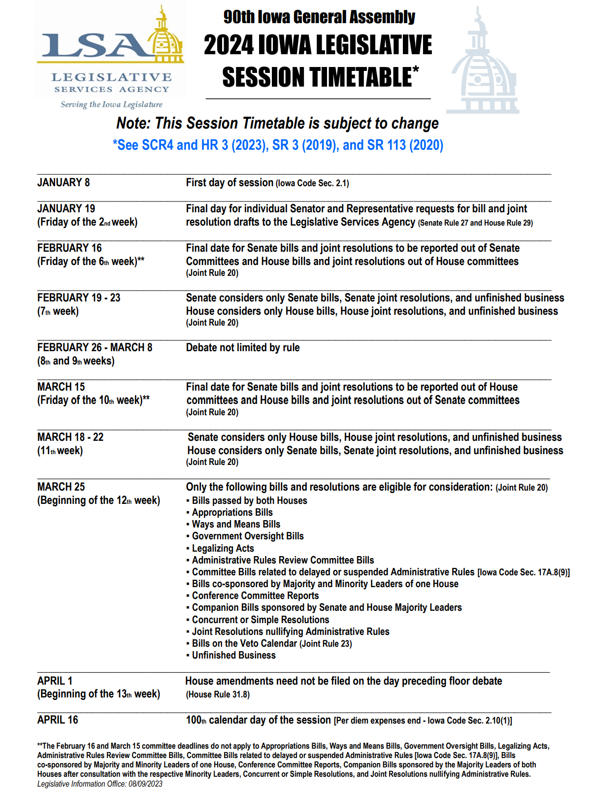
The Second Funnel and the Unfinished Business Calendar
The second funnel deadline finishing up the 10th week of Session, March 15, is the first sign of the Legislative Session getting closer to adjournment. Several bills survived the funnel, moving to the House and Senate Calendars for consideration. Many bills did not. This year, more than 100 bills were moved by the House and Senate to their Unfinished Business Calendars. Among these bills are some of the Governor’s priorities and others, that have yet to be passed by a chamber but remain in the mix for compromise and consideration. Please stay close to your inboxes and attentive to calls to action that might pop up with little time to spare if the legislative logjam breaks.

During week 11, expect much caucus time and floor work, as the chambers may only consider bills from across the rotunda and any bills on their Unfinished Business Calendars. Behind the scenes, work on the state budget is likely underway.

Teacher Pay, AEA Reform and School Funding
All three of these bills are tied together in negotiations and determining the ultimate spending level for public education (and for private education, too, now that Iowa is implementing Education Savings Accounts). All three of these policies are in the Senate awaiting action.
- HF 2630 Teacher and Education Support Pay is assigned to the Senate Education Committee. It sets a teacher pay minimum salary in two steps, hitting $50,000 by FY 2026, a $15 per hour minimum salary for support staff, and appropriates another $22 million for teacher salary supplement to be used at district discretion. See the March 7 Weekly Report for more details. A Subcommittee of Sens. Kraayenbrink (C), Quirmbach, and Rozenboom was assigned on Wednesday, although a meeting date is not yet scheduled. RSAI supports.
- HF 2613 SSA: establishes a 3% increase in the State Cost Per Pupil. See the Feb. 23 RSAI Weekly Report for details of the bill. The Senate’s version, SF 2258, does not specify a percentage increase. It is likely that differences in the total cost of various teacher pay proposals and other state budget priorities are influencing differences in school funding totals, as the House, Senate and Governor strive for consensus on the SSA rate. See advocacy actions below. RSAI supports HF 2613, which is the highest increase proposed and, in concert with HF 2611 Teacher Pay Investments, would exceed the current inflation rate.
- HF 2612 AEA Reform is attached to SF 2386 AEA Reform on the Senate Calendar. The Senate has an amendment filed to the House’s AEA proposal, HF 2612. See the amendment here S-5043. This is a strike-after amendment, which means that the amendment would entirely replace the bill if approved. See the differences between the proposals explained in the March 7 RSAI Weekly Report. RSAI is undecided.

House Floor Action
HF 2487 Reporting Grooming Behavior: Adds grooming behavior to the kinds of discipline taken against teachers that must be reported to the BOEE. Defines such behavior by teachers. Adds Investigation provisions. Requires the BOEE to include the number of investigations of school employees who are not licensed or holders of certificates or authorizations that are referred to law enforcement in its annual reports. Includes protections for personal information. Requires the use of a unique identifier so that an investigation can be searched on the BOEE website but limits who can search. The House approved the bill as amended 99-0; the Senate Education Committee approved it 16-0, sending it to the Senate Calendar (survives the funnel deadline). RSAI is undecided.

HF 2547 Truancy and Chronic Absenteeism/Cell Phone Policies: Attendance Policies: requires school boards and governing boards of nonpublic schools to adopt policies in consultation with the county attorney on attendance and truancy. Specifies what must be included in policies addressing chronic absenteeism including how the policy determines whether a student is chronically absent and what interventions may be used. Specifies exceptions for which the policy would not apply. Enforcement: Requires the county attorney associated with the county where the school’s central office location be responsible for enforcement. Requires that a person who violates the terms of an absenteeism prevention plan or attendance cooperation agreement or refuses to participate in such plans, who is referred for prosecution and is convicted, commits a public offense. Definitions and Corresponding Actions: defines truancy as being absent from school for any reason by 20% of days or hours. Defines chronically absent as absent from school for 10% of days or hours. Requires the school to notify the parent by certified mail and the county attorney when a student is chronically absent. Requires a school engagement meeting if the student is absent for 15-18% of the time, requires a school official to attempt to find the cause for absences and initiate and participate in a school engagement meeting to identify barriers to attendance and needed interventions. Requires the child, the parent, and a school official to participate in the meeting. Requires the participants to create and sign an agreement known as an absenteeism prevention plan. Requires the school official to monitor the participant’s compliance with the plan, including weekly contact during the remainder of the school year. Requires absenteeism arbitration if a student becomes truant and defines the participants (child, parent and county attorney/designee) and the purpose and process for the arbitration. Exempts homeschool students from both processes. Cell Phone Policies: requires school boards to have policies regulating student use of cell phones during classroom instructional time. Student Handbooks: requires the school district, in consultation with the county attorney, to revise student handbooks and school policies on attendance and cell phone usage. Open Enrollment: allows a receiving district to prohibit a pupil from continuing open enrollment if truant and requires the sending district to enroll the truant student.
The bill was approved by the House on a 73-22 bipartisan vote. The Senate Education Committee held a subcommittee which met and considered the bill, sending it forward to the full Committee, but the Committee did not consider it, so the bill is dead due to the March 15 funnel. RSAI is undecided.

HF 2653 Perry Retention Bonuses: allows school districts to use the district management levy to pay for retention bonuses for school employees, if the school is the subject of a disaster proclamation in the 2023-24 school year and in three counties (which is the Perry School district). Limits the payments to $700,000. Authorizes the waiver of various school requirements but does not authorize the waiver of any federal requirements. Effective on enactment. The House approved the bill 94-1, sending it to the Senate. It was assigned to the Senate Ways and Means Committee, so survives the funnel deadline. RSAI supports.

HF 2652 School Safety: Includes provisions regarding radios, Safety review, Firearms detection, and grants for equipment. Radios: Authorizes schools to purchase mobile panic systems that can connect with public safety answering points and law enforcement (911). Requires schools to have a hand-held radio in each school building that can access public safety answering points. Safety Reviews: Requires schools to do comprehensive safety reviews of school buildings. Requires safety reviews to be submitted to the state patrol and local police. Deems such reviews as confidential. Firearms Detection: Requires the Department of Homeland Security and the Department of Education to establish a firearms detection grant pilot program and appropriates $350,000 for the program. Gun Grants: Requires the DHS/DE to establish a grant program to help schools purchase infrastructure and equipment and training for employees carry permits. Provide stipends to employees who participate in the training associated with employee permits to carry weapons. Appropriates $3 million for grants through HF 2586 School Guards and Armed Employees and limits the grants to $25,000 per school. Other: Requires the Department of Public Safety, with the DE and the DHS, and includes the State Building Code Commissioner, to establish a task force on school safety standards and requires a report by December 2024. Prohibits schools from issuing bonds for school building projects for athletic facilities if the schools are not in compliance with these safety provisions. The House passed the bill as amended 59-35, sending it to the Senate, where it is assigned to the Senate Appropriations Committee. Since it is an appropriations bill, it is exempt from the funnel deadlines. RSAI is undecided.

Senate Education Committee Action (Bills Surviving the Funnel)
HF 2278 Open Enrollment Transportation: allows a receiving district with fewer than 2,000 students to send a bus not more than 2 miles into the district of residence to pick up an open-enrolled student if the student lives closer to the school the student attends than the school of residence. Retaliation option: allows a receiving district of more than 2,000 students to send a bus into a contiguous district if that district is less than 2,000 students, and the district of residence has sent vehicles into the receiving district. The bill continues to allow receiving and sending school districts to reach an agreement on sending transportation into the district of residence. Senate Education considered with amendment that will be debated on the floor to clarify that the district of residence is not responsible for transportation costs if the receiving district is busing the students. RSAI is undecided.

HF 2393 Student Dental Exams: exempts dental examinations for students from restrictions on physical exams, similar to exemptions for hearing and vision. Approved by the Senate Education Committee, moving it to the Senate Calendar. RSAI supports.

HF 2545 DE High School Review: Requires DE to review high school graduation requirements, core content, core curriculum and to make policy recommendations. The recommendations must include:
- a plan to regularly review and revise English language arts, math, science, and social studies core content standards (including a focus on US history, western civilization, and civics)
- a plan to make Iowa’s educational standards the best in the nation
- input from relevant stakeholders (including teachers and parents)
- increase the quality of instructional curriculum and maximize local flexibility in graduation requirements and course offerings while maintaining the goal of all HS graduates having necessary skills at graduation, including sufficient knowledge of civics, opportunities to equip high school graduates with sufficient knowledge of civics and US history and the US Constitution, so that high school students are capable of discharging the responsibilities of citizenship.
- a statewide literacy plan to increase student proficiency using systematic and sequential approaches to teacher phonetic awareness, phonics, vocabulary, fluency and text comprehension (components of the Science of Reading)
Requires the report of recommendation to the General Assembly by December 2024. Requires the DE to include an internet link for comments by the public and stakeholders. Approved by the Senate Education Committee, moving it to the Senate Calendar. RSAI is undecided.

HF 2553 Athletic Participation: requires public schools to allow a private school student who lives in the school district to participate in extracurricular athletic activities immediately, pursuant to an agreement between the private school and the public school. If the school charges a fee for enrolled students, specifies that the private student’s parents are responsible for the fee. Prohibits the athletic associations from taking the enrollment of the private school into consideration when determining classes. Approved by the Senate Education Committee and moves to the Senate Calendar. RSAI is undecided.

HF 2586 School Guards and Guns: current law allows school boards to determine whether staff should be allowed to carry guns. In the few cases where it was attempted, there was no insurance coverage for the school district; a good indication that negative results are possible. The bill states that the staff member has immunity from liability. Adds a professional carry certification training for staff members who are authorized by the school district to carry guns. The original bill would have mandated every school district with over 8,000 students enrolled be required to have a school resource officer or private security office in every high school. That original language was removed, allowing school boards to opt out of the SRO requirement. Approved by the Senate Education Committee and moves to the Senate Calendar. RSAI is undecided.

HF 2615 College Information to HS Students: requires community colleges and universities to publish information on income related to different degrees and student loan debt. Requires high schools to give this information to juniors and seniors interested in college. Makes the school college and career transition counselor (if a school district has one) responsible for sharing this information with students. Excludes a shared college and career counselor from counting against the 21-student limited weighting for operational sharing. Approved by the Senate Education Committee and moves to the Senate Calendar. RSAI is undecided.

HF 2617 Pregnancy Education: requires human growth and development courses in grades 7-8 and 9-12 to include human growth and biology related to pregnancy, human development inside the womb, a high-definition ultrasound at least 3 minutes in length showing organ development, and a video showing the development in the womb, which is specified as the “Baby Olivia” video or another comparable to it. The Senate Education Committee approved an amendment to remove the reference to the specific video, but still requires a video. Approved by the Senate Education Committee and moves to the Senate Calendar. RSAI is opposed.

HF 2465 Agricultural Classes as Science: allows high school agricultural classes to include units that meet science curriculum requirements. Requires the State Board of Education to adopt rules. The bill was amended to limit the credit application to two units and to also include a math credit option. Prohibits the State Board of Education from waiving certain requirements. Approved by the Senate Education Committee, sending it to the Senate Calendar. RSAI supports.

HF 2487 Grooming and Mandatory Reporting: addresses BOEE and school district responsibilities related to licensed school employees who engage in grooming behavior toward students or the abuse of students. Makes similar provisions for nonlicensed staff. Requires the BOEE to create a unique identifier and have a searchable site for public access to find information. Moves the BOEE statute into a new Code Section under the DE pursuant to state government reorganization. Approved by the Senate Education Committee anticipating an amendment will be considered on the Senate floor. RSAI is undecided.

Senate State Government Committee (Bills Surviving the Funnel)
HF 2299 Open Records: authorizes a government to provide an open record in a reasonable format rather than the requested format. Does not require the government to supply a record that is available on the internet site of the government and allows the government to send a notice of the availability on the internet. Approved by the Senate State Government Committee, sending it to the Senate Calendar. RSAI supports.

HF 2539 Open Meetings Fines: increases the range of fines for violations of the open meeting law to $500 to $2,500. Requires a court to issue an order removing a member from a governmental body if the member has previously violated the open meetings law. Requires members of such bodies to take a course on open meetings and open records laws. Requires the Iowa Public Information Board to make such training available and for the group overseeing the training to issue certificates. The bill was amended to strike mandatory training by the Iowa Public Information Board. Approved by the Senate State Government Committee, sending it to the Senate Calendar. RSAI is undecided.

House Education Committee (Bills Surviving the Funnel)
SF 2196 Immunization Information Requirements: requires a school nurse include information on exemptions when communicating with parents about vaccination requirements. Requires schools to post exemption information on the internet. Passed by the House Education Committee and moves to the House Calendar. RSAI is undecided.

Ways and Means Committee (Bills Exempt from the Funnel)
HSB 721 Income Tax Constitutional Amendment: proposes a constitutional amendment to require 2/3 approval of both chambers for increasing tax rates. Prohibits a graduated income tax and requires that the income tax be set at one flat rate. Approved by the House Ways and Means Committee 15:8, moving it to the House Calendar. RSAI is opposed.

SF 392 Teacher Recruitment and Retention Incentives: includes grants under the Teach Iowa Scholar Program, licenses issued by the BOEE, and the use of revenues from the district management levy for teacher recruitment and retention programs. This bill was assigned to the Senate Ways and Means Committee in the 2023 Session and has not received additional consideration. RSAI supports.

SF 2398 Income Tax Reduction: phases in faster and lowers the Iowa Individual Income Tax flat rate. See the March 7 RSAI Weekly Report for details. RSAI is opposed.

School Start Date Status
Although several school start date bills received discussion, there is only one remaining school start date proposal alive, which is embedded within charter school legislation.
HSB 585 School Start Date: Passed the House Education Committee on Jan. 30, so survived the first funnel, but has been awaiting a new bill number ever since. RSAI supports.
SF 2010 School Start Date was approved by a Subcommittee but did not advance in the Senate Education Committee. RSAI supports.
SF 2368 Charter Schools: Charter School funding, Open enrollment funding, and right of first refusal on school property. Division III of this bill is the start date, allowing schools to start as early as the Tuesday following the end of the Iowa State Fair. This bill was approved by the Senate Education Committee and is on the Senate Unfinished Business Calendar. HF 2543 is a companion, on the House Unfinished Business Calendar, but they amended the start date out of the House version in the Education Committee. RSAI opposes the charter school provisions of this bill.

March 15 Funnel Survivors
Several bills survived the funnel with Committee Action this week, and others on debate calendars that could still see action, including:
SF 2121 Public Officer Bond (HF 2398 attached) on the Senate Calendar (supports)
SF 2185 Transitional Coaching (HF 2150 attached) on the Senate Calendar (supports)
SF 2196 Immunization Information Requirements approved by House Education Committee (undecided)
SF 2260 Student Teacher Requirements Apprentices in House Appropriations Committee (supports)
SF 2383 PK Expansion is on the Senate Calendar (Appropriations bill, so no funnel) (supports)
HF 2278 Open Enrollment Transportation approved by Senate Education Committee (undecided)
HF 2299 Open Records approved by Senate State Government Committee (supports)
HF 2393 Student Dental Exams approved by Senate Education Committee (supports)
HF 2465 Agricultural Classes as Science or Math approved by Senate Education Committee (supports)
HF 2487 Grooming and Mandatory Reporting approved by Senate Education Committee (undecided)
HF 2539 Open Meetings approved by Senate State Government Committee (undecided)
HF 2545 DE High School Requirements/Core Content Review approved by Senate Education (undecided)
HF 2553 Athletic Participation approved by Senate Education Committee (undecided)
HF 2586 School Guards and Armed Staff approved by Senate Education Committee (undecided)
HF 2615 College Information to HS Students approved by Senate Education Committee (supports)
HF 2617 Pregnancy Education approved by Senate Education Committee (opposes)
HF 2631 Therapeutic Classroom Claims in Senate Appropriations Committee (supports)
HF 2643 Dyslexia Endorsement on the House Appropriations Calendar (supports)

Other Bills on Senate Unfinished Business Calendar
Legislative leaders put bills on the “unfinished business” calendar, allowing them to stay alive past the deadline if both chambers have designated the legislation for further consideration, or if it is attached to another bill that remains eligible.
SF 2195 Reading Instruction on Senate Unfinished Business Calendar with Fiscal Note (HF 2618 on House Unfinished Business Calendar) (undecided)
SF 2258 SSA (HF 2613 attached) (opposes SF 2258 and supports HF 2613)
SF 2336 Public Employee Theft (HF 2453 attached) (undecided)
SF 2364 Commission on Education Leadership Reporting (HF 2152 attached) (undecided)
SF 2365, SF 2378, HF 2151 and HF 2261 BOEE Mandatory Reporter etc. (all on respective Unfinished Business Calendars) HF 2487 approved by Senate Education rolls these all together (undecided)
SF 2367 Data Collection/ Second Enrollment Count (HF 2542 on House Unfinished Business) (opposes)
SF 2368 Charter Schools and Open Enrollment (HF 2543 on House Unfinished Business) (opposes)
SF 2386 AEAs (HF 2612 attached) (undecided)

Notable Bills that died due to the funnel
Remember – nothing is really dead, as ideas come back as amendments to other bills and appropriations and ways and means tax bills are exempt.
SF 108 Employer Verification of Legal Residency (did not advance in the House) (undecided)
SF 2001 Minimum State Foundation Aid (did not advance in the Senate) (undecided)
SF 2009 Teacher Spending Accounts (did not advance in the Senate) (undecided)
SF 2010 School Start Date (did not advance in the Senate) (supports)
SF 2011 Open Enrollment Deadline (did not advance in the Senate) (supports)
SF 2105 Operational Sharing Cap (although it has been through Senate Appropriations, so could be exempt from the funnel) on the Senate Calendar (supports)
SF 2191 Fire Alarm Responses/School Shooter (not approved by House Education) (supports)
SF 2206 Charter School Students in Activities (not approved by House Education) (undecided)
SF 2374 Union Recertification (did not receive full Senate approval) (undecided)
SF 2383 Expanded Preschool (approved by Senate Education and placed on Senate Calendar. Could be referred to Appropriations Committee to be funnel exempt) (supports)
SF 2388 School Administrator Contracts Severance (not approved by House Education) (undecided)
SF 251 Administrative Expenditure Limit of 5% (not approved by House Education) (opposes)
SF 398 Robotics Extracurricular Activities (not approved by House Education) (supports)
HF 2548 Gender-Neutral Terms in World Language Classes (undecided)
HF 2073 (and SSB 3092) Chaplains in Schools (did not advance in either chamber) (opposes)
HF 2076 MSA for Extreme Open Enrollment (not approved by House Education) (supports)
HF 2280 Home School Changes (was not approved by Senate Education) (opposes)
HF 2357 PK Expansion (was not approved by House Education) (supports)
HF 2368 Free School Lunch (was not approved by House Education) (supports)
HF 2544 Social Studies Instruction including Holocaust (not approved by Senate Education) (opposes)
HF 2547 Chronic Absenteeism and Truancy (was not approved by Senate Education) (undecided)
SSB 3092 Coaches in Locker Rooms (did not advance in the Senate) (supports)

Advocacy Actions This Week on School Funding, Teacher Pay, AEA Reform
Adequate School Funding: the House’s 3%, HF 2613, would fall short, but for the commitment to fund teacher salary increases, including the sustainable appropriation of $22 million. See the RSAI Position Paper for additional information. Contact Senators and ask them to support the House recommendation of 3% soon, and confirm a commitment for additional teacher pay in HF 2630. Additional supports:
School districts are up against new property tax publication timelines, which are extremely difficult to meet with the lack of certainty about how much funding will be available. Different SSA rates result in different property tax rates, which have to be communicated to the public. The deadline to report to the county for the mailing of property tax statements is March 15.
See the RSAI website for an RSAI Position Paper providing education funding history, comparing total Iowa education expenditures per pupil, which most recently ranked our state as 35th in the nation, now spending more than $3,000 per student LESS than the national average, and including some talking points to help you advocate with your legislators. RSAI’s Legislative Priority supports an SSA rate that at least matches the inflation rate schools are experiencing.
FY 2025 ISFIS New Authority Calculator allows users to set the SSA rate and calculate the impact for all districts for FY 2025 on your regular program (not including special education or other supplemental weightings or categoricals). Enter the SSA percentage increase and your Budget Enrollment and you can compare to the new money you’d receive if the SSA rate matched inflation (either 3.1% for CPI and 4% for Core Inflation) compared to the 3% set by HF 2613.
AEA and Teacher Pay Bill: Both now in the Senate. Contact senators to support HF 2630 Teacher and Education Professional pay. Also, ask them to continue to work on the AEA bill to include locally elected AEA boards with Authority (this is in the Senate version), be thoughtful about the timeline so school districts and AEAs can plan, consider the implications of special education funding and equity depending on which concept of special education flow-through is considered, and ask them to support a diminished state DE presence, although some is acceptable for special education compliance. Keep reaching out and connecting, so that when something does move, they will remember your concerns.

Quality Preschool and Other RSAI Priorities: Continue to talk about the value of Quality Preschool, and Teacher and other Staff Shortages. SF 2383 Expanded Preschool is on the Senate Calendar may be in trouble due to the estimated impact of the bill on the state budget. The bill is phased in over two years, up to 1.0 weighting for students below 185% of the federal poverty level. Contact Senators to support it. Find Position Papers and other resources on the RSAI Advocacy website to find talking points or other resources to share when you meet with policymakers.

Connecting with Legislators: To call and leave a message at the Statehouse during the legislative session, the House switchboard operator number is 515.281.3221 and the Senate switchboard operator number is 515.281.3371. You can ask if they are available or leave a message for them to call you back. You can also ask them what’s the best way to contact them during session. They may prefer email or text message or phone call based on their personal preferences.
Find biographical information about legislators gleaned from their election websites on the ISFIS site here: http://www.iowaschoolfinance.com/legislative_bios. Learn about your new representatives and senators or find out something you don’t know about incumbents.
Find out who your legislators are through the interactive map or address search posted on the Legislative Website here: https://www.legis.iowa.gov/legislators/find

RSAI Advocacy Resources: Check out the RSAI Website at https://www.rsaia.org/2024-legislative-session.html to find Advocacy Resources such as Position Papers, RSAI Weekly Legislative Recap Reports and Videos, RSAI Calls to Action when immediate advocacy action is required, testimony presented to the State Board of Education, the DE or any legislative committee or public hearing, and links to fiscal information that may inform your work. Be sure to review the 2024 RSAI Advocacy Handbook.

Contact us with any questions, feedback or suggestions to better prepare your advocacy work:
*Margaret Buckton, RSAI Professional Advocate, margaret@iowaschoolfinance.com , 515.201.3755 Cell
*Dave Daughton, RSAI Grassroots Advocate, dave.daughton@rsaia.org, 641-344-5205 Cell

Thanks to our RSAI Corporate Sponsors:
Special thank you to your RSAI Corporate Sponsors for their support of RSAI programs and services. Find information about how these organizations may help your district on the Corporate Sponsor page of the RSAI website at www.rsaia.org/corporate-sponsors.html.
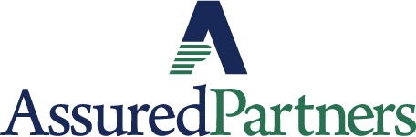 | www.linkedin.com/in/thomas-p-o-brien-03320616/
 | www.classroomclinic.com
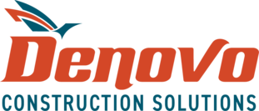 | www.teamdenovo.com
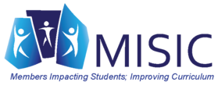 | www.misiciowa.org
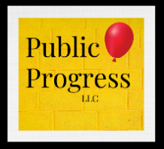 | thepublicprogress.com
 | www.solutiontree.com/st-states/iowa
 | www.wgu.edu

