You are invited to the wedding banquet!
Can you find your way to the wedding cake?
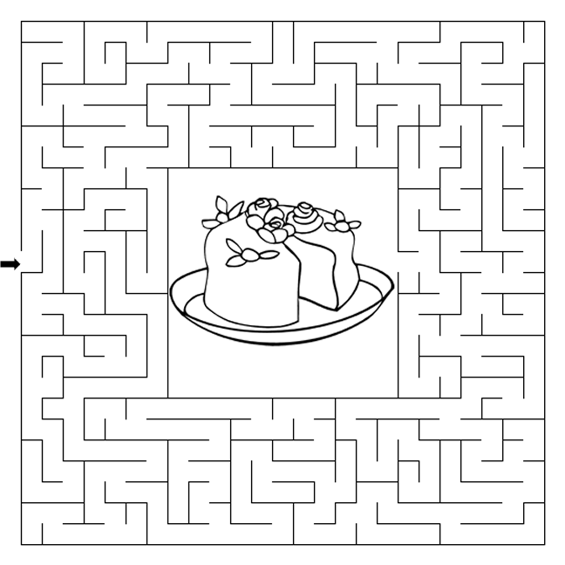
THIS WEEK’S BIBLE TRIVIA QUESTION

According to Amos, why is Israel, out of all the earth's families, being called to account by God for its sins?
God hates them because they are so wicked.
God has a covenant with them
They rub Him the wrong way.
God engages in discrimination.
Amos 3:2
Copyright © Sermons4Kids, Inc. May be reproduced for Ministry Use
Children’s Worship Bulletin

Parable of the Wedding Banquet

Matthew 22:1-14

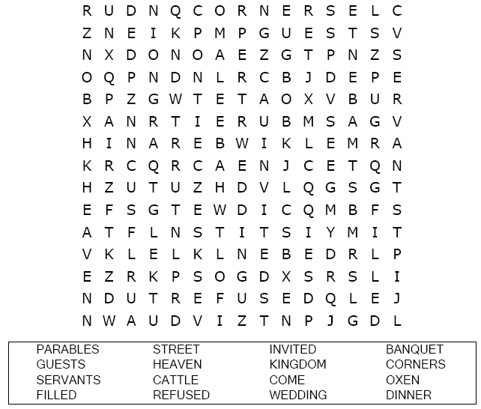

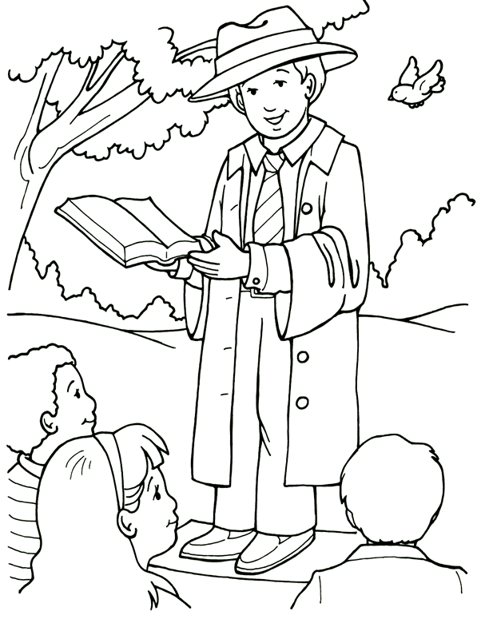
Inviting others to Jesus.
From Thru-the-Bible Coloring Pages for Ages 4-8. © 1986,1988 Standard Publishing.
Used by permission. Reproducible Coloring Books may be purchased from
Standard Publishing, www.standardpub.com, 1-800-543-1301.

Each number represents a letter of the alphabet. Substitute
the correct letter for the numbers to reveal the coded words.

