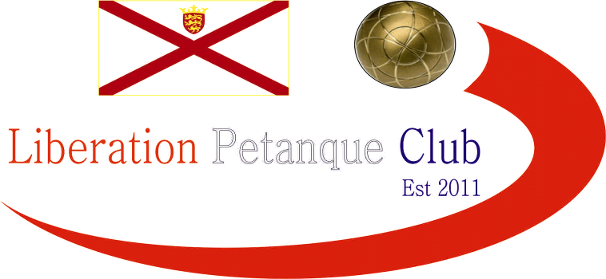

**SUMMER 2024 SEASON**

**WEEK 11 – 12th June 2024**

**CLUB DOUBLES CUP**

# The annual Doubles Cup this year had just 11 entries taking part.

# Last years winners Keith & Mo played the team they knocked out in the Quarter Finals last year Geoffroy & Matt and almost beat them again just losing 8-7. Last years runners up though did win as Gary & Wendy beat Graeme & Keith 11 – 8.

# Big wins for 2022 champions Laurent & Toby over Brian & Lorna 12 – 4 and two 13 – 4 wins for Andrew & Callum over John & Nick and Neil & Ross over Alan & Joey.

# Two big matches in round 2 saw Geoffroy & Matt just beat Laurent & Toby 10 – 9 and Andrew & Callum beat Neil & Ross 12 – 5.

# No other matches were close though as Gary & Wendy won 13 – 3 over Daniel & James. John & Nick beat Premier League team Graeme & Keith 12 – 3 and Keith & Mo lost heavily to Brian & Lorna 13 – 2.

# In Round 3 Geoffroy & Matt handed out a certificate 13 – 0 to Andrew & Callum! Gary & Wendy also made it three wins in a row 13 – 2 over Brian & Lorna.

# An amazing shot by Laurent to hit a very hard boule taking the jack out for four points to beat John & Nick 11 – 9 and looked odds on to win. Ala & Joey got their first official win over Daniel & James after a bye in Round 2.

# In the final Round 2 wins were needed to get through to the quarter finals. Keith & Mo missed out on the knockout stages with only 1 win (a bye). Geoffroy & Matt finished top of the rankings two years in a row with a 5 – 2!!! Win over Gary & Wendy.

# Laurent & Toby win over Neil & Ross put them in second place and Andrew & Callum took third place with a win over Alan & Joey whilst Brian & Lorna 13 – 1 win over Graeme & Keith put them though. John & Nick also went through beating Daniel & James.

# FINAL SWISS RANKINGS

# Inline image

# Quarter-Finals

# Ranked 1st Geoffroy & Matt v Alan & Joey Ranked 8th

# Ranked 2nd Laurent & Toby v Brian & Lorna Ranked 7th

# Ranked 3rd Andrew & Callum v John & Nick Ranked 6th

# Ranked 4th Gary & Wendy v Neil & Ross Ranked 5th

# Well two shocks this year as John & Nick were leading 9 – 0 before a fight back by Andrew & Callum but just too little to late with John & Nick making the semi-finals 11 – 9. Brian & Lorna were losing 8 – 3 with two ends to play but pick up a four and then a two to snatch victory from Laurent & Toby.

# Geoffroy & Matt did make it though but very close as Alan & Joey pushed them all the way to 12 – 10. In the final quarter final s Neil & Ross ran out comfortable winners 13 – 3 over Gary & Wendy.

# Semi-Finals

# Ranked 1st Geoffroy & Matt v Neil & Ross Ranked 5th

# Ranked 6th John & Nick v Brian & Lorna Ranked 7th

# Well great placing by Neil on the very last end with the jack very close to the string, keeping his boules in with little room took the match 9 – 8 for Neil & Ross over Geoffroy & Matt.

# Brian & Lorna hit top form as they both were unplayable to run out 9 – 1 winners over John & Nick.

# John & Nick though did take first place with a 13 – 6 win over Geoffroy & Matt for a great tournament.

# In the final Brian & Lorna continued their great form to gain a big lead over Neil & Ross and looked odds on to win but a combination of a change in tactic with Brian deciding not to shoot on a few occasions and Neil placing proving hard to beat saw Neil & Ross play well together in the second half of the match to win a great final 13 – 11. This made of for finishing third in the last two seasons.

# Winners

# 2024 – Ross Payne & Neil Selby

# Thank you to all those who helped on the evening and played to make it another successful competition.

# NEXT WEEK - SINGLES LEAGUE

# Club email address - [liberationpc@gmail.com](mailto:liberationpc@gmail.com)

# Club Website - [www.liberationpetanque.co.uk](http://www.liberationpetanque.co.uk)

# Kind Regards

# Toby Northern

# Chairman

# Liberation Petanque Club