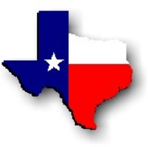Texas History with Mr. Brown Name _______________________________ Period _____
Ch 9 Test Road to Revolution p. 203-208, 3 points for each question

Match the vocabulary term in the box on the left with the correct definition from the box on the right by writing the letter of the definition on the blank provided.

1) ______ State’s Rights  2) ______ Nationalists  3) ______ Provisions  4) ______ Customs Duty  5) ______ Allegiance  6) ______ Centralist  7) ______ Resolution  8) ______ Delegate  9) ______ Faction  10) _____ Siege  11) _____ Provisional Government | A: A lengthy military attack on a fortified place  B: A person who represents others  C: Theory that a state could choose whether to obey or enforce federal laws  D: Loyalty  E: A group of people whop share a viewpoint on an issue  F: A formal Statement of a decision, opinion, or course of action by an official group  G: A supporter of a strong national government and weak state power  H: A specific requirement set by a law  I: A person who supports policies that promote national interest  J: A tax that is collected on goods that are taken into or out of a country  K: A group of people who make laws and provide services on a temporary basis

Multiple Choice Questions
Choose the best answer for each question
12) What action did Haden Edwards take that caused Mexican Governor Blanco to take away Edwards’s land grant?
A) Requested people who owned land grants to provide proof of ownership
B) Overturned local election results appointing his son-in-law the winner
C) Massacred a Cherokee native tribe
D) Wouldn’t let anyone go to McDonalds

13) The Fredonian Rebellion confirmed Mexican authorities fears that:
A) Texas settlers were going to try to take over Texas
B) People named Fred were really cool
C) The Mexican army would not be able to defeat the Texans
D) The law of April 6, 1830 must be overturned

14) What did Mexican General Mier y Teran discover and report about Texas?
A) The land was more fertile than southern Mexico
B) Texas should be granted independence
C) The Anglo Texans were fitting in well and obeying Mexican law
D) Mexico must gain control of Texas from the Anglo Texans

15) The law of April 6, 1830:
A) Gave free land to anyone that wanted it in Texas
B) Outlawed immigration from the United States to Mexico and canceled all empresarial grants that had not been fulfilled.
C) Legalized or permitted slavery in Texas
D) Gave 18 year olds the right to vote

16) Which of the following were actions of Santa Anna:
A) Led Texans to believe that he supported state’s rights
B) Became a cadet in the Spanish regiment in 1810
C) Overthrew Mexican president Bustamante in 1832
D) All of the above
17) ______________________ was the Mexican Customs Officer who was responsible for collecting duties and stopping smuggling in Galveston.
A) Haden Edwards
B) Vincente Fox
C) George Fisher
D) John Davis Bradburn

18) Regarding the disturbance at Anahuac who was arrested by Mexican Colonel Bradburn after tricking Bradburn and his troops?
A) William B Travis
B) William T Logan
C) David Crockett
D) Jose Padilla

19) As a result of Travis and his law partner Patrick Jack being arrested at Anahuac:
A) Many Texans supported their arrest
B) Hundreds of protestors were arrested
C) The stock market crashed
D) Many Texans protested and demanded their release

20) What did the colonists pledge in the Turtle Bayou Resolution?
A) Total independence from Mexico
B) To kill Santa Anna
C) Their continued loyalty to Mexico
D) To turn over a cannon they had been given for defense against the Native Americans

21) Why did fighting break out between Texans and Mexican soldiers at Velasco?
A) Austin and his men were not allowed to sail down the Brazos river passed Velasco
B) The Mexican soldiers tried to confiscate the Texan’s supplies
C) The Mexicans thought the Texans smelled bad
D) Because Austin and his men were in violation of the law of April 6, 1830
22) The convention of 1832 asked for the repeal of _____________________ and most importantly petitioned for the state of Coahuila y Tejas to be divided so that each territory could have its own government.
A) The Mexican Constitution of 1824
B) The law of April 6, 1830
C) The 5th Amendment
D) The ban on owning slaves inTexas

23) Stephen F Austin traveled to Mexico City to present the requests of the Convention of 1833. Upon leaving he was:
A) Granted governorship of Texas
B) Made fun of because of his brightly colored shoes
C) Arrested because of a letter he had written to the Texans
D) Asked to permanently leave Mexico

24) Which of the following was the Texan’s flag at the battle of Gonzalez?
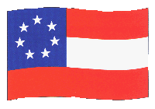

A) B)

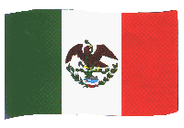
C) D) 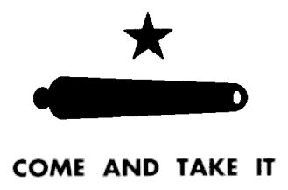

25) What did the battle of Gonzalez show?
A) Texans were becoming more defiant toward the Mexican government
B) Texans could not fight well
C) Texans make nice flags
D) Haden Edwards was a strong leader
26) At the Consultation Texans decided to:
A) Continue to pledge their allegiance to Mexico under the Constitution of 1824
B) Move their settlements out of Texas
C) Declare Independence from Mexico
D) To make Barbeque the official food of Texas

27) At the Grass Fight Texan’s captured a mule train carrying:
A) Silver to pay Mexican troops
B) Grass and hay to feed Mexican horses
C) Santa Anna
D) The deed to the Alamo

28) Hendrick Arnold:
A) Was a skilled and brave, expert scout
B) Led a division during the attack on San Antonio
C) Operated a mill in San Antonio
D) All of the above

29) As a result of the Mexican loss at San Antonio ___________________________________ began gathering an army to deal with the Texas revolutionaries.
A) Stephen F Austin
B) Andrew Jackson
C) Jimmy Carter
D) Santa Anna

