Paul Bunyan 41st Annual Rendezvous by Mike Moran
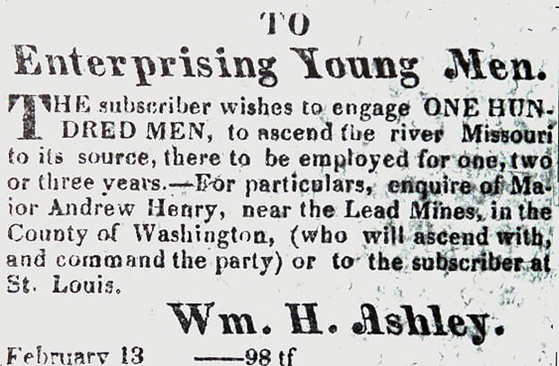
The 41st annual Rendezvous of the Paul Bunyan Plainsmen was held on May 27-30, 2016 at the Paul Bunyan Rifle & Sportsmen’s Club in Puyallup. As people began to gather, they noticed an advertisement for “enterprising young men” tacked on an elk hide bulletin board. Five pairs of people were brave enough to sign up with Captain Henry, and we’ll follow their journal entries as they made their way through this fur trade adventure.
“It seems like forever since we left the trading post in St. Louis, but each day brings a new adventure. Signing on with Captain Henry’s brigade was a great idea. I never thought I’d see a buffalo, but that day on the plains we shot three of ‘em to smoke for our long journey ahead. In the distance we can see the Rockies and it won’t be long now before we find some good streams full of beaver. Our traps will be full in no time.”
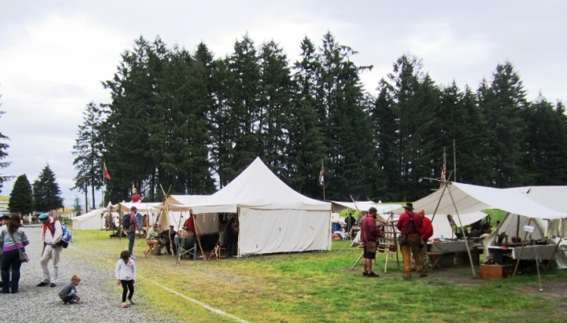
It was a great gathering of people this year for the rendezvous, and the weather was perfect. Cloudy and cool, with a little rain in the afternoons, but warm and dry on the last day. Thursday and Friday the Plainsmen were busy setting up the ranges, and with help from many volunteers all the trail guides shot the course of fire. Traders were setting up along trader’s row, bringing their goods and services to the participants. While the number of traders was down this year, one absence was especially significant. Ram and Margaret Abel of Ram’s Lodge could not make it this year. They’ve been at all 40 previous Paul Bunyan Rendezvous.
Visiting Trader’s Row at the Rendezvous

“These mountains can sure be dangerous. Just last week we were hunting game for the brigade when we spotted three grizzly bears about 100 yards off. Some of the old trappers told stories of what a grizzly might do to a man, so we took careful aim and killed ‘em. We figured there were more around, so we high tailed it out of there, but I fell off my horse and twisted my leg real bad. The others had to build a travois to carry me until my leg felt better.”

The main aggregate score consisted of three events, Rifle, Pistol, and Knife & Hawk. The rifle course started on the pistol range, where shooters posted their scorecards for their tie breaker shot. They then proceeded to the rifle range, where steel targets were set at ranges from 25 to 200 yards. There were 15 targets, with 5 bonus targets you could opt to shoot for an extra point, giving a maximum score of 20. The pistol trail was similar but conducted as a trail walk in the woods. Again there were 15 targets with 5 bonus, and the last target was to shoot from inside the outhouse at very small potatoes. The knife & hawk trail seemed easier this year, with the option on many of the targets for your choice of knife or hawk, but it was still challenging. There were 14 targets which were one point a piece, but on 5 of them you threw both hawk and knife for two points. The last target was trying to hit the heart of a deer with a rock from a slingshot. Mike Holeman and Fallen Woman were are top scoring man and women this year.
James Kennedy shoots the rifle targets
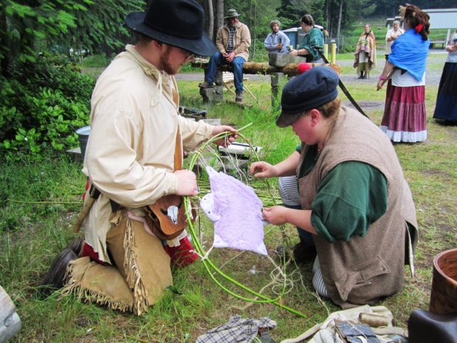
“Lucky for us the Indians who control the good beaver streams took kindly to our requests, and gave us safe passage, and even a canoe. For a might there I wasn’t sure that old chief was going to let us pass, but after a lot of talk and trading, we finally reached an agreement. It sure was nice traveling by canoe, even though we had to get out and carry it a few times. The banks were rich with game, and we shot several animals right from the boat.”

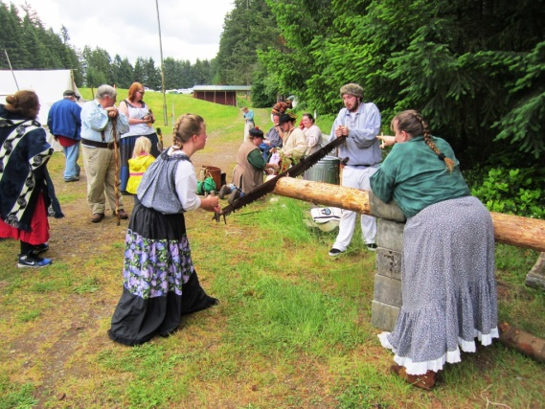
This year the archery range was expanded to include another aggregate score with knife and hawk. Five new targets were made near the archery targets, and each required both knife and hawk for a total of 10 points. The archery range was similar to years past, with two arrows being shot at each of 12 animal targets. The animals had a circle marked on them for two points, and a hit anywhere else on the animal gave one point. Glenn Borg took first in the competition this year, with Wally McKendry, Vern Gibson, and Squatting Hawk following close behind.
Victor Bridges and Dana Atchison stretch their pelt

“We spent some time with the Indians in their village, adding to our supplies and getting to know them. They like playing games, and we spent hours trying to throw a spear through a rolling hoop. We also showed them how to make slingshots and challenged them to hit the heart of a deer with them.”

In addition to the aggregate competitions, there were several novelty shoots. On Saturday afternoon three teams of 5 shooters competed in the Stake Shoot where the objective was to cut through a 4”x4” board. Team Smith won it again. That was followed by a dozen folks competing in the candle shoot which after several heats was won by Bob Tresch. On Sunday, a new event called the Survival Trail had 5 pairs of people travelling all over camp to complete tasks on their journey to the trap beaver. There were two categories that were run simultaneously, Mountain Men for those teams with firearms and Indian Scouts for those without. We’ll read more about their adventures in their journal entries. Bob and Allen Tresch were the top Mountain Men and Russ and Kylie Baker were the top Indian Scouts. Derek Sotelo and Tony Plante won the Chicken Shoot that followed, and Don Kerr won the Trade Gun Challenge on Monday morning.
Kylie and Russ Baker fly on the two man saw

“Well apparently that old Indian chief didn’t let all his braves know what was going on, because just as we found good waters to set our traps in, a bunch of them attacked. Their screams filled the air as their arrows flew overhead. We hunkered down behind some logs and were able to fend them off, but not without using up the last of our ball. Lucky for us we have more back in the canoe, and when finally found a safe place to make camp, we cast more ball to restock.”
Transportation was no problem for these kids

One of the highlights of the rendezvous is the Council Fire on Sunday night. This year Bruce Coe of the Chance Brother’s Band was back to perform his music, giving atmosphere to the event. Three very prestigious individuals were choses as judges for the Apple Pie Contest, deciding between a half dozen entries. Once the apple pie winner was picked, the crowd made quick work of the remaining pie, and before long people were singing and dancing into the night.
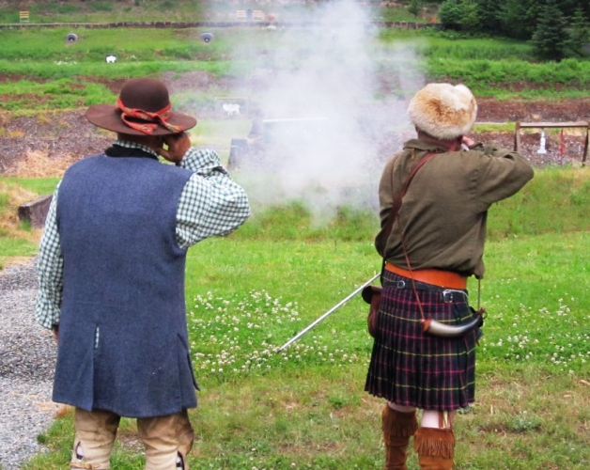
“After all this time we are finally trapping! We’ve set our traps and are pulling beaver in by the bunch. It’s quite a process to skin them and get them stretched out on hoops, but it’s what we’ve travelled all this way to do. Now we just need to get them to the rendezvous to sell them to the traders and pick up some much needed supplies.”

The Juniors had a great showing too, with Mason McGraw taking the top prize of the eight juniors who participated. By Monday morning most of the camps had been packed up and everyone gathered for the final awards and prizes. It was a great event this year, with everyone going away tired and happy.
Bill Sick watches Don Freelove shoot the candles

“I’ve really come to love this country, and think I’ll stay a while. We’ve been cutting logs for a cabin and are making a more permanent camp, with a tent and chairs. The life of a trapper is the life for me.”

Aggregate Scores for Juniors
1. Mason McGraw 19 4. Michael Valdez 18 7. Anthony Guerrero 9
2. Garret Hanson 18.2 5. Kyle McNulty 14 8. Hatchet Jack 5
3. Jarod Barth 18.1 6. Aidan Sachman 10

Aggregate Scores for Adults
1. Mike Holeman 49 26. David Riggs 30 51. 2 Caps 23
2. Squatting Hawk 48 27. Knee Walker 30 52. Eric Smith 23
3. Two Tails 47 28. Chase Smith 29 53. Windy Leftover 23
4. Glenn Borg 41 29. Bill Andrews 29 54. Barefoot Annie 23
5. Mike Nesbitt 40 30. Nelson Freelove 29 55. Chuck Lumadue 22
6. Boyd Phillips 39 31. Dana Atchison 29 56. Gene Duvall 22
7. Chris Bienke 38 32. Ben Smith 27 57. Michael Stephanson 21
8. Mike Moran 37 33. Skunk 27 58. Renita Foust 21
9. Brandon Sachman 35.1 34. Gene Trobaugh 27 59. Queen 21
10. Paul Nelson 35 35. DJ Thacker 27 60. Kerry Sotelo 20
11. Nemo 34.2 36. Three Feathers 26 61. Martha Wendover 20
12. Wilson 34.1 37. Karla Hillberg 26 62. Balls Too Big 19
13. Broken Heart 34 38. Lori Caswell 26 63. Two Fires 19
14. Archie Silcox 33.1 39. Freek 25 64. Neal Gallion 19
15. Tony Woore 33 40. Clarence Atchison 25 65. Ben Woore 18
16. Fallen Woman 32.1 41. Ed Day 25 66. Mark Hansen 16
17. Don Kerr 32 42. Chris Statz 25 67. Jay Kennedy 14
18. Derek Sotelo 32 43. Capper 25 68. Dakota 13
19. Wally McKendry 32 44. Vern Gibson 25 69. Russ Baker 11
20. Cork Jug 32 45. Linda Hansen 25 70. Donna Lees-Kennedy10
21. Victor Bridges 32 46. Tony Plante 24 71. Rich Fox 8
22. Gina Hansen 32 47. Dammit Jim 24 72. Andrew Haugen 5
23. Iron Ball 31 48. Katherine Sachman 24 73. Nicki Florio 4
24. Kerry Parsons 30.1 49. Don Freelove 23 74. Ryan Chapman 3
25. Joe Nevius 30 50. Bud King 23 75. Lory Himes 3

