Gerald Theriot
Commander

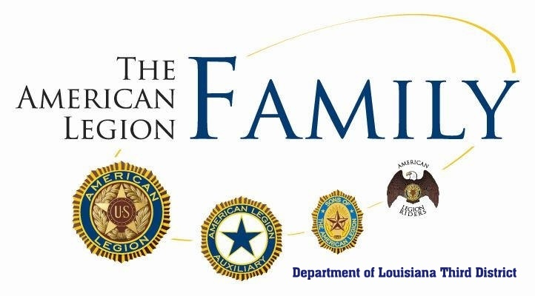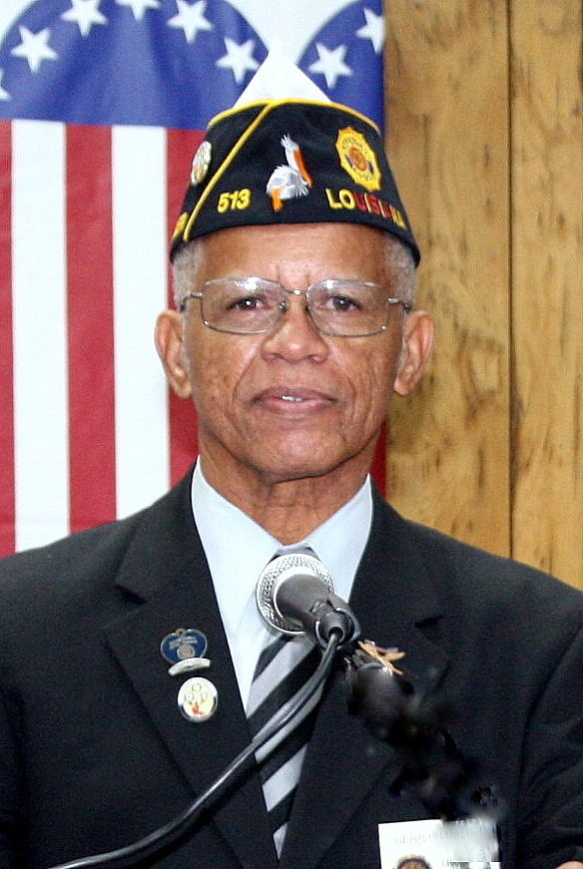

ISSUE 19 - 1
THIRD DISTRICT NEWSLETTER – January 2019

NEW YEARS ARE NEW BEGINNINGS
For most people, the start of a new year is a time to reflect on what we did during the last year. Most people resolve to make the changes that they hope will make the new year smoother. As Legionnaires we should also resolve to more effectively support our organization’s goals and contribute to that end as much as we can. In order to do this, we must understand the history and purposes of our American Legion. We can do this by taking advantage of the training offered by our organization. When I joined the Legion many years ago, I purchased the American Legion Extension Course offered at that time. It was a multi-volume course of books that covered all aspects of the American Legion. Today, the Legion continues to offer training that is available to its members and others.
American Legion Basic Training Course
The American Legion's official training program for officers, members, Legion College applicants and those who simply want to expand their knowledge of the nation's largest veterans service organization is now available online. The American Legion Extension Institute has been rewritten, updated, streamlined and enhanced with videos, digital photos, clickable links, a historical timeline and additional features. It covers the History and Organization of the Legion and its four pillars: Veterans Affairs and Rehabilitation, National Security, Americanism and Children and Youth. The program should take less than two hours to complete. It is divided into six sections, with a quiz at the end of each one, followed by a final exam. A certificate is awarded on completion. The course is free to legionnaires and can be accessed online at www.legion.org/alei If you don’t already have one, a Legion logon ID must be created in order to enroll in the course.
THIRD DISTRICT SPRING CONFERENCE 2019
Our Spring Conference is scheduled for April 5-7, 2019, The conference will be hosted by Houma Post 31. Housing and meetings will be at the Holiday Inn. Our district officers for the upcoming year will be elected at this conference. Please contact Post 31, Commander Lee Shaffers (lshaffers@aol.com) to offer any donations and assistance to help have a successful conference.
MEMBERSHIP
Our District has won another prestigious Department award for membership. Each Department Vice Commander awards a plaque to the district reaching the highest percentage of membership within his area by 12/31/18. Our membership was 83.072%. We are still in second place behind the Second District in overall membership percentage. We have five posts with 100% or better (Posts 63, 294, 328, 419 and 589).
Membership reports can be found on the department website www.lalegion.org.

MEMBERSHIP TARGET DATES

January 17, 2019 80%
February 13, 2019 85%

ORATORICAL PROGRAM
The Third District High School Oratorical contest will be held at Lenox-Hotard Post 31 in Houma, La on February 9, 2019 at 9:00 AM. High school students must inform a local post if they are interested in competing. Post 31 Commander Lee Shaffers (lshaffers@aol.om) is the Chairman for the event. A meal will be served after the contest. The District winner will participate in the Department contest in March 2019 and, if successful, may be able to participate in the national contest in April 2019. Scholarship awards at the national level range from $1500 - $18,000. Please support this program and make students in your areas aware. (www.legion.org/oratrical)
CANDIDATES FOR DEPARTMENT OFFICE:
The Almighty Third District voted to endorse two candidates who seek to serve our Legion Department. Please visit and support their hospitality room during the Mid-Winter Conference.
Jinel Sawyer
FOR: Department Color Bearer
Thibodaux Post 513
Currently serving as Third District Color Bearer and Post 513 Vice Commander
Rudolph “Rudy” Bourg Sr.
Alternate National Executive Committeeman
Lafayette Post 241
Currently serving as ANEC and Post 241 Adjutant / Area G Cdr.
Your support is appreciated
Legion Insurance Trust (LIT)
Help to enroll your post members for the $1000 - $5000 free insurance coverage offered by the organization. Legionnaires, Auxiliares and Sons of the American Legion are all eligible for the coverage. (Link below)
https://www.thelit.com/no-cost-legioncare
Always Pray For Our Legion Family
District Adjutant Skip Pellegrin
District Judge Advocate Forrest Travirca III
John Kravanick, Chauvin Post 380
Kayla Duthu, Houma Post 31

UPCOMING EVENTS
Mid-Winter Conference – Jan 18 - 20
The conference will be held at the Best Western Conference Center in Alexandria. See the Legion website for the proposed agenda. Informative sessions for Adjutants and aspiring department officers will be held during this conference.
Martin Luther King Jr. Holiday – Jan 21
Recognized as a national Day of Service, the American Legion encourages participation in service projects on this day. Thibodaux Post 513 will have a spiritual MLK remembrance program beginning at 3:00 PM. The public is invited.
ACCESS FOR NATIONAL MEMBERSHIP INPUT
Posts with Mylegion.org access can now process their membership directly with the national organization. A new Process Membership link has been added in the left menu column. A pay method must be entered for online payments. There are safeguards to prevent errors. This is a way to ensure that your membership is timely handled.
See “The Dudley” at Cajun Critters Restaurant in Houma. I just saw it by chance.

Gerald Theriot
Third District Commander (2018-19)
gtheriot3dc@comcast.net

