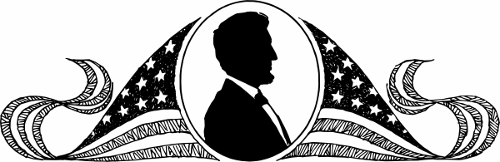
Abraham Lincoln was the 16th 11st16th
Abraham Lincoln
Name _______________________________________________ Date ______________
Copyright © 2011 Integreat! Thematic Units
www.thematicteacher.com
president of the United States.
Abraham Lincoln

Name _______________________________________________ Date ______________
president. He worked to stop
Abraham Lincoln was the 16th
slavery in this country.
Copyright © 2011 Integreat! Thematic Units
www.thematicteacher.com
Name _______________________________________________ Date ______________
Abraham Lincoln

Copyright © 2011 Integreat! Thematic Units
www.thematicteacher.com
Name _______________________________________________ Date ______________
Abraham Lincoln

Copyright © 2011 Integreat! Thematic Units
www.thematicteacher.com
Name _______________________________________________ Date ________
Abraham Lincoln

Copyright © 2011 Integreat! Thematic Units
www.thematicteacher.com

