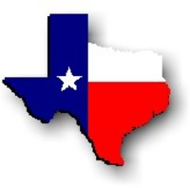Texas History with Mr. Brown Name _______________________________ Period _____
Chapter 24 Texas enters the Modern Era: Section 1 review
Directions: Use your study guide or the text book to answer the following questions.

1) Define: Capital –
2) Define: Agribusiness –
3) Define: Baby Boom –
4) After WWII military bases continued to train ____________________.
5) ___________________________ and the town of Olney began to produce crop duster planes.
6) Many Texans took out loans to start what type of businesses?
7) The borrowing of Oil and Gas companies led to an increase in which other industry?
8) What made Texas farming so expensive?
9) The high cost of farming led to the development of large farming businesses known as:
10) Agribusiness companies increased _________________________, especially in West and South Texas, where the land had always been too dry for farming.
11) What area of South Texas began to produce citrus fruits and vegetables?
12) The decrease of small and family farms led to an increase in the demand for:
13) Major food processing companies moved their _______________________ to Texas.
14) With these companies came _____, and even more Texans left farming to work in industry.
15) What other Texas agriculture industry grew a lot in this time period?
16) The increase in automobiles in Texas led to more problems with:
17) In 1945 the ________________________ approved construction of 7,500 miles of paved roads.
18) In 1949 the legislature dedicated $_____ million per year to building and maintaining rural farm-to-market (FM) roads.
19) In 1956 Congress passed the ________________________________________, which created our Inter State Highway System.
20) Soon _____________ replaced railroads as the primary means of carrying goods to market.
21) In what year was Bell Helicopter established?
22) Name two other military weapon and aircraft companies in Texas:
23) In the 1960s the popularity of high-speed _________ air travel soared.
24) The increase in Airline passengers led to the need for new urban _____________________.
25) Texas companies such as ____________________ and __________________________ made great strides in electronics technology over the years.
26) What did Texan Gordon Teal invent?
27) What did Texan Jack Kilby invent?
28) What did these two inventions lead to?
29) In which Texas city did NASA establish it’s manned spacecraft center?
30) What Houston University hosted JFK’s Moon Race speech?
31) Which Texas born President supported the growth of the Space industry in Texas?
32) In 1969 scientists and engineers at _________________________________ in Houston successfully guided the Apollo 11 astronauts to a safe landing on the moon.
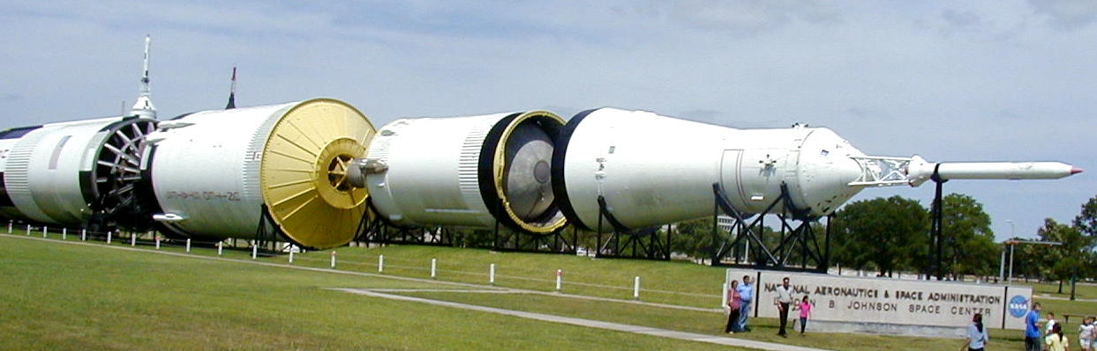
33) In August 1973, the Manned Spacecraft Center in Houston was officially renamed the ___________________________ Space Center.

