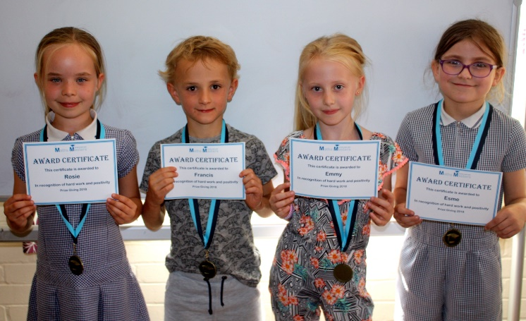
NEWSLETTER
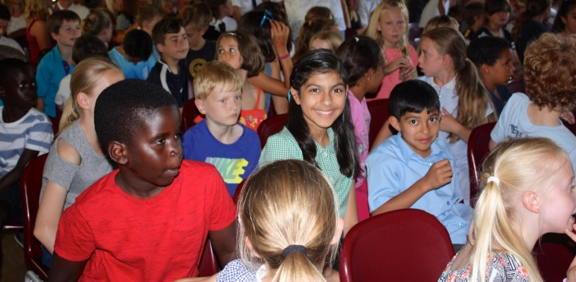
Hello and welcome to the 7th edition of our Maths Masters Newsletter. We hope you’ve all had a wonderful summer and what a scorcher it’s been. Over the last month we have been contacting parents about those much awaited SATS results! Across the country 64% of children achieved the expected level in their maths SATS. Maths Masters pass-rate was close to 100% this year. We were absolutely delighted to learn how well all the SATS students have done, with quite a few children dropping less than 10 marks across all three papers. Some of our Year 2s have already mastered all their times tables through sheer determination and practice, keep up the good work!
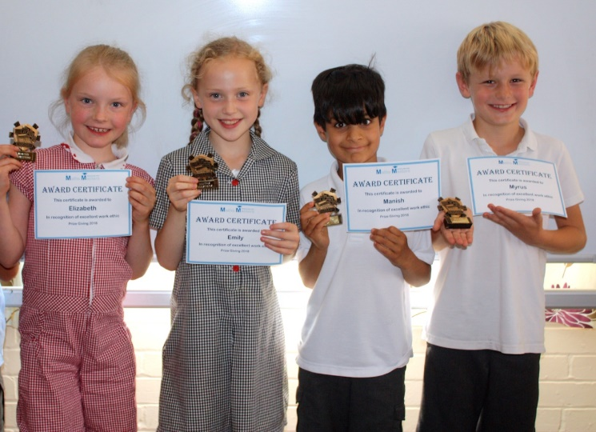
It has been lovely to see some of our mini maths masters attending over the summer holidays. This may be a tough choice when the sun is shining but will make a difference come September!
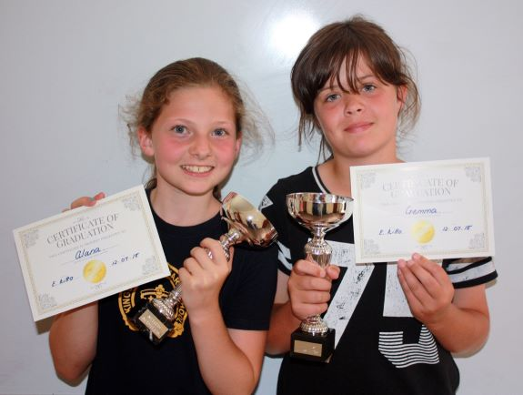
A massive thank you to all those parents and children who were able to attend our 2018 Prize Giving ceremony. We were incredibly proud of all the children’s achievements; what a wonderful afternoon it turned out to be. It was incredibly busy this year, so we may need to look at our Redhill venue for 2019 as it has a greater capacity with plenty of parking.

We would also like to thank Sofea for taking some wonderful photos of the children, which we hope to put up on the website shortly.
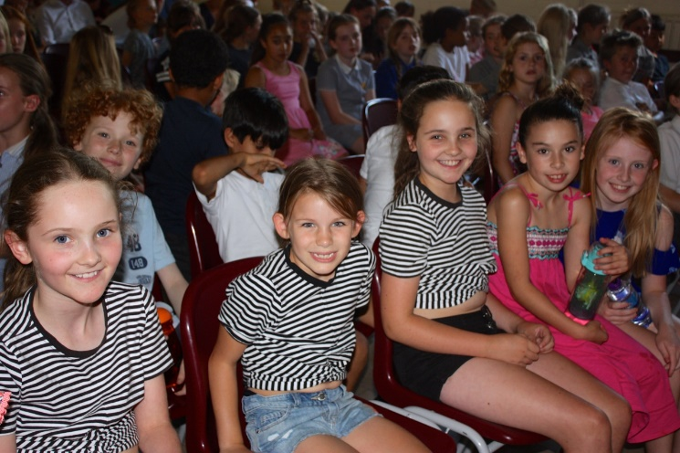

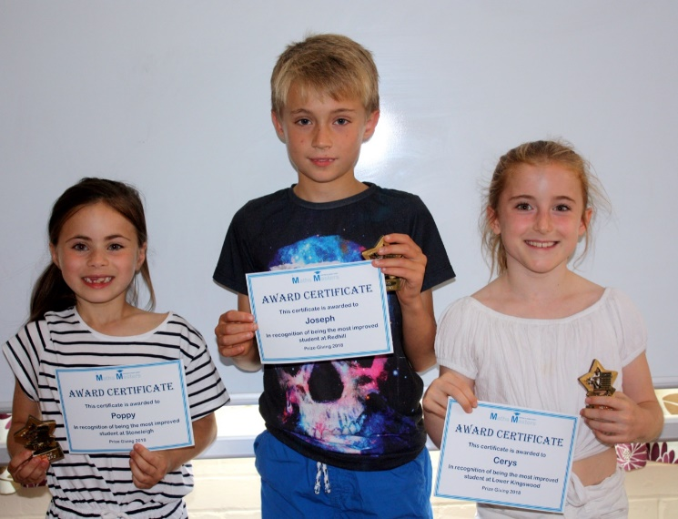

OTHER INFO
A warm welcome to some of our new students, Issy, Lily, Amy, Maisie, Isabelle, Willem, we hope you all have fun and enjoy your sessions at MM.
You’ll probably have noticed a few new Tutors at Maths Masters. We have been busy recruiting to ensure we can still deliver quality over numbers and maintain our 3:1 student : tutor ratio. Ben, Tom and Annabelle have joined our Stoneleigh centre, Jack and Alex our Redhill centre, and Alistair and Elise our Lower Kingswood centre. They’re all doing a magnificent job. Unfortunately, with good news we have some sad, we will be losing Issy, who will be leaving at the end of August and recently said our goodbyes to James and Manisha. James will be going on to a career in IT. Issy is off to Uni to study Geography and Manisha is heading off to further her studies in Medicine.
They have all been a real asset to the team and excellent role models to our children. We are always on the look-out for talented individuals, so if you know of anyone that may be interested in joining the MM team, please get in touch.

HOLIDAYS
Unless you are away for 4 consecutive weeks or more, subscriptions to the club are still payable, our fees are not based on individual lessons. Please feel free to discuss your plans or discuss our holiday policy directly to see how we can assist. We are happy to discuss possible catch-up sessions providing we have prior notice and availability. Please also note we require 1 month’s notice should you wish to leave the club. Whilst we do accept cash or cheque we would ask where possible a standing order is set up as our preferred method of payment.

DATES FOR YOUR DIARY
Maths Masters will open as normal on bank holidays and during half term
We will, however, be closed on the following dates:
Monday 24th December
Tuesday 25th December
Thursday 27th December
CONGRATULATIONS AND GOOD NEWS
If any parents have any good news that they wish to share with us concerning their child’s maths achievements or school reports, please do let us know.
REFER A FRIEND
Thank you to all those that have referred other students, our “Refer A Friend” offer is still running but please note any recommendations need to sign up before a £20 voucher for M&S or Amazon is awarded.

