October 24, 2017
Via Electronic Filing
Ms. Kimberly D. Bose, Secretary
Federal Energy Regulatory Commission
888 First Street, N.E.
Washington, D.C. 20426
Re: FERC Project No. P14425-000
Scott's Mill Hydropower Project,
Liberty University, Inc.
Transmittal of Teleconference Notes on Fish Passage

Dear Ms. Bose:

On behalf of Liberty University, Applicant for the Scott’s Mill Hydropower Project (FERC No. 14425), enclosed herewith are notes from two conference calls with resource agencies regarding fish passage at Scott’s Mill dam (August 25, 2017 and September 29, 2017). These notes also will be included in the consultation record for the license application that Applicant intends to file for the project.

Applicant continues to work with the agencies to provide for fish passage at the Scott’s Mill site. Passage at Scott’s Mill is critical for restoration of diadromous fish in the upper basin of the James River. Applicant is committed to passage of American eel and Sea Lamprey at Scott’s Mill and is working with the agencies and others on a plan for safe, timely and effective passage of other species that can be accomplished cost effectively.

Please contact the undersigned at (916) 719-7022 if you have any questions or comments.
.

Respectfully submitted,

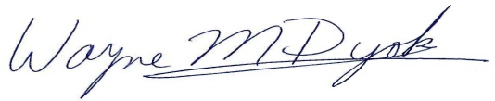
Wayne M. Dyok for
LIBERTY UNIVERSITY, INC.

