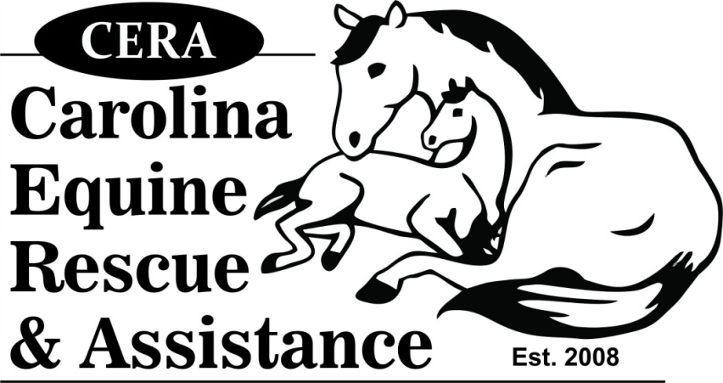
"CERA HORSE SHOW SERIES"
2018 DIVISION SPONSORSHIP
$150.00

Business name, brief description and website link and logo will be advertised on the CERA website / Facebook event page and announced at every show.

Business Name ______________________________________________

Contact _________________________________

Address ____________________________________________________

Daytime Phone ___________________________

Website Address __________________________

Division (Hunter/Jumper or Ranch/Games) – One division is three classes

________________________________________

Please make all checks payable to “Carolina Equine Rescue & Assistance” and return with this completed form to:
Carolina Equine Rescue & Assistance
1107 Summerlin Dairy Rd.
Wingate, NC 28174

For questions and to inquire about additional options, please contact Darlene Kindle, darlenekindle@winstream.net

