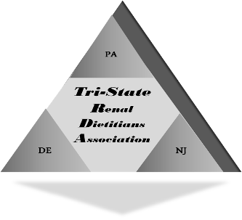
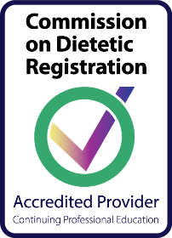

TSRDA SPRING SYMPOSIUM

Green Valley Country Club

201 Ridge Pike,
Lafayette Hill, PA 19444
Date: Thursday, March 30, 2023
Agenda
Approved for 5 CEUs
8:00 - 9:00 am Registration/Breakfast/Visit the Exhibits
Info for Vendors on Screen in Meeting Room

9:00 - 9:15 am Opening Comments
Ann Pittaoulis, Chair-elect, Tri-State Renal Dietitians Association

9:15 – 10:15 am Plant-based Diets for CKD: Friend or Foe?
Kellsey Reed, RD, LDN
Owner/Renal Dietitian | CKD Nutrition LLC| Media, PA

10:15– 11:00 am Break/Visit the Exhibits/Scavenger Hunt

11:00 – 12:00 pm I Believe Neither Blood Pressures Nor Weights!
Christine Chmielewski, MS, CRNP, ANP-BC, CNN-NP
Jefferson Renal Associates, Philadelphia, PA,

12:00 – 12:30 pm Benefits of Joining the AND Renal Practice Group
Karen Wiesen, MS, RD LDN, FNKF
Geisinger Medical Center, Danville, PA

12:30 - 1:15pm Lunch

1:15– 2:15 pm Robotic Kidney Transplantation in Obese Individuals
Amit Sharma, MBBS, MS, MPhil, FACS
Transplant Surgeon, Virginia Commonwealth University
Richmond, VA

2:15 – 3:15 pm The Dietitian’s Role in Value Based Kidney Care
Austin Thomas Kahari, MS, RDN, CSR, LDN
Regional Manager of Panoramic Health/Renal RD

3:15 - 3:30 pm Business Meeting, Tri-State Renal Dietitians Association
TSRDA Board Announcements, etc.

************************************************************************************************ Cost Includes Breakfast, AM Snack, & Lunch
$85.00/Members $100.00/Non-Members
Registration Deadline: March 23, 2023

Name: ___________________________________ Facility: ___________________________________
Phone Number: (______)_____________________ Email: _____________________________________
Make Checks Payable to: Tri-State Renal Dietitians Association. Mail registration form & checks to: Karen Wiesen, MS, RDN, LDN, Geisinger Medical Center, Clinical Nutrition Services, M.C. 15-09, 100 N. Academy Ave, Danville, PA 17822 Paypal payment is available on our website: www.tsrda.org

