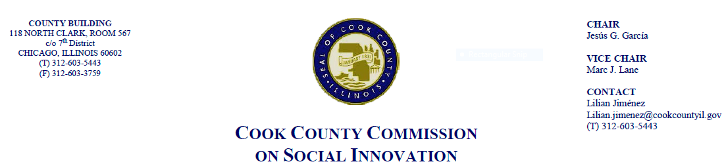
March 15, 2018, 4 P.M.
118 N. Clark, Rm. 569
MINUTES

- Call to Order

The Cook County Commission on Social Innovation convened via an in-person meeting to discuss committee updates and hear from a guest speaker. The meeting was chaired by Vice Chair Marc J. Lane. The meeting was open to the public and took place from 4:08 p.m. to 4:57 p.m.

Commission Members Present:
- Marc Lane
- Morgan Malone
- Ana Guajardo
- John Yonan
- Xochitl Espinoza
- Victor Dickson
- Reggie Greenwood
- Christyn Henson

Commission Staff Present:
1. Lilian Jimenez
2. Victoria Moreno

Meeting Notes and Decisions Made:

- Approval of Minutes
- Commissioners discussed that minutes from January and February 2018 have yet to be approved due to lack of quorum. No quorum for today’s meeting.

- Guest Speaker – Mollie Dowling, Executive Director of OAI, Inc.
- Mollie Dowling, Executive Director of Opportunity, Advancement, Innovation in Workforce Development presented on workforce retention
- OAI, Inc. serves jobseekers and places people into jobs. OAI, Inc. sees workforce development as a way to reduce violence and poverty. They provide a customized, one-on-one Employee Assistance Program
- Many employers are out of touch with what it takes for workers to maintain a family while on a low salary. The living wage in Cook County is $27/hour for one person with one dependent
- OAI, Inc. uses an interactive, data-driven model and surveys to understand employee needs
- Companies that work with OAI, Inc. tend to have between 200-2,000 workers. A smaller company may not be able to afford the services
- OAI, Inc. focuses on career and budget counseling to address areas where people are most vulnerable
- OAI, Inc. receives local funding from Chicago Workforce Funders Alliance and is also leveraging other local sources
- OAI, Inc. works hand in hand with Employee Assistance Programs to maximize the use of benefits
- OAI, Inc. conducts self-assessments of employees and has found that other areas of concern for workers include education, childcare, and housing, for example

Post-Presentation Commission Discussion
- Commissioners discussed companies who might be interested in partnering with OAI, Inc. Ms. Dowling mentioned the importance of worker retention, as there is a high cost of employee turnover, and stated that it is best to work with local companies and have face-to-face interaction
- Comm. Yonan brought of the challenge of confidentiality within Employee Assistance Programs
- Comm. Malone found OAI, Inc. to be a good fit with the inclusive employee framework her committee has been working on
- Ms. Dowling stated that the Commission can be most helpful by spreading awareness of OAI, Inc. and explained that there are other, similar programs that are more expensive
- Ms. Dowling explained that, on the low-end, OAI, Inc. can charge $10,000 for a company of 200 employees and this would include site visits once a month for a year. Fees can be shared in a co-op model
- Comm. Dickson mentioned that this resource would be helpful for companies that hire formerly incarcerated workers
- Comm. Espinoza asked how language barriers are handled as 30% of employees are Latino. Ms. Dowling responded that all OAI, Inc. navigators are bilingual in English and Spanish
- Per Vice Chair Lane’s request, Ms. Dowling described the L3C status of OAI, Inc. and its focus on the environment and human health and safety

- Committee Updates
- Comm. Dickson described three areas being undertaken by the Social Capital Committee: 1) Building support for a conference on how to build social capital featuring various stakeholders; 2) Recommendations around re-entry; 3) Social-economic impact analysis
- Comm. Dickson recommended having a liaison Commissioner because there needs to be better communication across Committees. He highlighted Comm. Malone’s work in working to bridge the Committees
- Comm. Dickson suggested having a directory of all Commissioners
- Vice-Chair Lane requested a meeting of all Committee Chairs before the next Commission meeting
- Comm. Malone talked about the March 6th Human Capital Committee meeting and how they are working on a loose rubric on inclusive employment
- Vice-Chair Lane spoke on behalf of Comm. Raymer and the Financial Committee and stated that February’s guest speakers on worker cooperatives have initiated new conversations within the Committee which include Comm. Espinoza

- Other Business
- There were no registered public speakers.

- Adjourn
- Vice-Chair Lane moved to adjourn. Meeting adjourned at 4:57 p.m.

