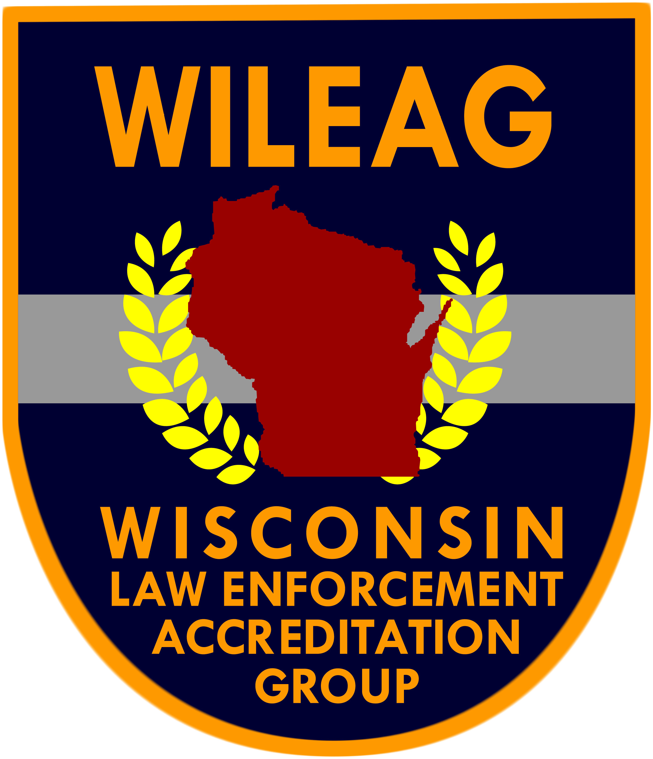 | Accreditation Compliance Report  (5th Edition)
 | Accreditation Compliance Report  (5th Edition) | Chapter 6
 | Accreditation Compliance Report  (5th Edition) | Operations
 |  | Section 1
Standard #: 6.1.7 |  | Patrol
Assigned to: |  | Standard 7
Prepared by: |  | Availability of Body Armor

WILEAG Assessor Use Only
Compliance Verified Non Compliance Not Applicable by Function
Assessor Comments:
Assessor Signature: Date:

Scope and Dimension(s)
The agency makes protective vests available for all sworn personnel and has a written directive establishing guidelines for wearing protective vests, to include requiring the wearing of protective vests in high risk situations. The directive should also address the purchase and replacement of protective vests.

Agency Compliance Information
Written Directive:
Written Documentation:
Observation of:
Interview with:
Agency Comments:
Not Applicable by Function: Explain:

