Our Weekly Activities These are the days/hours for the…
Week of February 18, 2018
Sunday, February 18, 9:30am Sunday school, Fellowship hall; 11am Morning Worship, preaching Rev. James Stansbury. Monday, February 19, 9am TOPS #217, Fellowship hall. Tuesday, February 20, 9:30am Fitness – Strength, Fellowship hall. Wednesday, February 21, 8:30am Walk about the neighborhood begins @ Fellowship hall; 9:30am Fitness – ‘Easy Yoga’, Fellowship hall; 3pm Choir Practice in the Choir room. Friday, February 23, 9:30am Fitness – Chore Development – bands, Fellowship hall.
Week of February 25, 2018
Sunday, February 25, 9:30am Sunday school, Fellowship hall; 11am Morning Worship, preaching Pastor Ric Connor, Presbytery Pulpit Exchange. Monday, February 26, 9am TOPS #217, Fellowship hall. Tuesday, February 27, 9:30am Fitness – ‘Easy Does It’, Fellowship hall. Wednesday, February 28, 8:30am Walk about the neighborhood begins @ Fellowship hall; 9:30am Fitness – Stretch, Fellowship hall; 3pm Choir Practice in the Choir room. Thursday, March 1, 7pm Bay Co. Stamp Club, Fellowship hall. Friday, March 2, 9:30am Fitness – ‘Senior Fitness’ part #1, Fellowship hall.

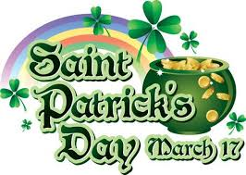
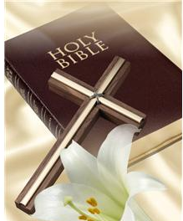
Announcements & Items of Interest . . . February 18, 2018 Rev. James Stansbury, Supply Pastor Old Testament - Genesis 9: 8-17, New Testament - 1 Peter 3:18-22, Gospel – Mark 1: 9-15 Rev. James Stansbury is with us this Sunday –Welcome Jim! His sermon topic – ‘Eternally Assured’ gives us something to ponder while we wait on his message. Here’s another message – we are rapidly moving ahead this year. We’ve already done two of our three winter programs. Coming in March is our final one before Easter. St Patrick’s will be similar to last year plus the Grand Junction Band has agreed to be with us again. That’s Saturday, March 17 at 6pm. You don’t have bring your dancing shoe but be ready for some good ol’ Cabbage & Corn Beef – Southern Style.
For our Visitors . . . there are tan cards in pockets in the back of the pews. Please provide us the information requested & place the card in offering plate. Blue cards are for those wishing to pass on general information to the church. Thank you!
St. Andrews Presbyterian Church ‘serving the Christian community of St. Andrew since1886’ 3007 West 14th St. @ Beck Av, Panama City, FL 32401, 850/785-8358 www.saintandrewspc.com standrewspresch@Knology.net

