Gerald Theriot
Commander

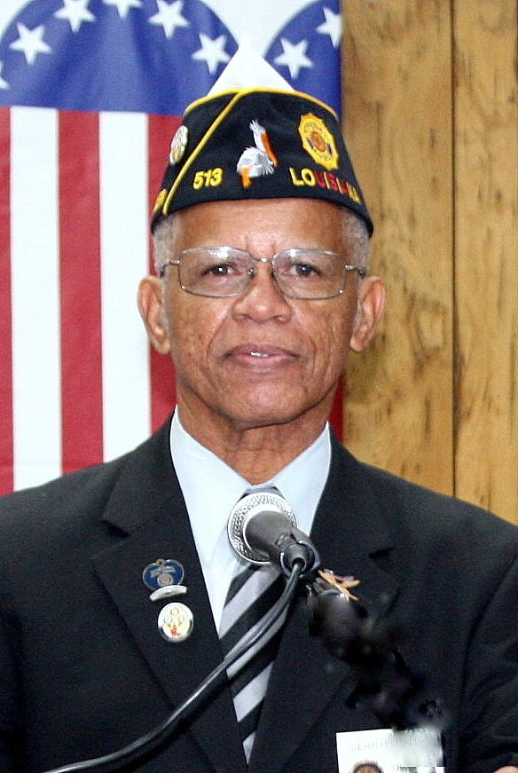

ISSUE 18 - 5
THIRD DISTRICT NEWSLETTER – December 2018

Greetings Members of the Third District
SELVH (Reserve)– CHRISTMAS PARTY
Members of the Third District joined together to host its annual Christmas Party at the Southeast Louisiana Veterans Home (SELVH) in Reserve, La. on December 8, 2018. Residents were treated to cash bingo games and treats that are not part of their normal diet. The veterans are always your appreciative of visits to the home. Drop in anytime. Click on the link below for pictures
https://photos.app.goo.gl/5hvvhy57xf4WHBg87
THIRD DISTRICT SPRING CONFERENCE 2019
Our Spring Conference is now scheduled for April 5-7, 2019, This is a change from the May date due to a conflict with the National Spring Meetings in May 2019. This is the conference in which we elect our new district officers.

MEMBERSHIP

MEMBERSHIP TARGET DATES

December 12, 2018 75%
January 17, 2019 80%
February 13, 2019 85%

The December 5, 2018 membership report shows the Third District dropped to second place (79.5%) behind the Second District (80.2%) in overall membership percentage. Having won the Alcee Legendre membership award, we should strive to maintain the highest percentage rate in the Department. We now have five posts with 100% or better (Posts 63, 241, 294, 328 and 589).
Membership reports can be found on the department website www.lalegion.org. Please contact your Area Commanders for ideas and assistance in reaching your membership quota.
Legion Insurance Trust (LIT)
Help to enroll your post members for the $1000 - $5000 free insurance coverage offered by the organization. Legionnaires, Auxiliares and Sons of the American Legion are all eligible for the coverage. (Link below)
https://www.thelit.com/no-cost-legioncare
ORATORICAL PROGRAM
The Third District High School Oratorical contest will be held at Lenox-Hotard Post 31 in Houma, La on February 9, 2019 at 9:00 AM. High school students must inform a local post if they are interested in competing. Post 31 Commander Lee Shaffers (lshaffers@aol.om) is the Chairman for the event. A meal will be served after the contest. The District winner will participate in the Department contest in March 2019 and, if successful, may be able to participate in the national contest in March 2019. Scholarship awards at the national level range from $1500 - $18,000. Please support this program and make students in your areas aware. (www.legion.org/oratrical)
CANDIDATES FOR DEPARTMENT OFFICE:
The Almighty Third District voted to endorse two candidates who seek to serve our Legion Department. Please visit and support their hospitality room during the Mid-Winter Conference.
Jinel Sawyer
FOR: Department Color Bearer
Thibodaux Post 513
Currently serving as Third District Color Bearer and Post 513 Vice Commander
Rudolph “Rudy” Bourg Sr.
Alternate National Executive Committeeman
Lafayette Post 241
Currently serving as ANEC and Post 241 Adjutant / Area G Cdr.
Your support is appreciated
Help to support the district hospitality room at the Mid-Winter Conference (Jan 18-20, 2019). Donations are welcomed. Contact Rudy or Jinel.

Always Pray For Our Legion Family
District Adjutant Skip Pellegrin is home and under treatment. He is positive in his outlook and thanks all for their prayers.
District Judge Advocate Forrest Travirca III, having difficulty with mobility and health issues.
John Kravanick of Chauvin Post 380 is experiencing medical difficulties.
PDVC and Past District Commander John Cobb (Post 549) passed away on 12/13/18
Services are pending and are tentatively scheduled to occur after the holidays.

MID-WINTER CONFERENCE
January 18-20. 2019 at the Best Western Conference Center in Alexandria. See the Legion website for housing form.

Gerald Theriot
Third District Commander (2018-19)
Gtheriot3dc@comcast.net

