September
2017
TRUE LIES
The Stuart Rod & Reel Club Newsletter
The Stuart Rod and Reel Club is dedicated to improving local fishing through by increasing angler knowledge, encouraging conservation and maximizing the fun involved in light tackle fishing in the Stuart Florida area. We hold monthly meetings on the second Thursday of each month, year-round. Please join us or contact any board member for more information on how you can become a member of the Stuart Rod and Reel Club.
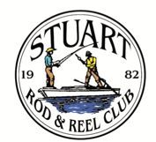

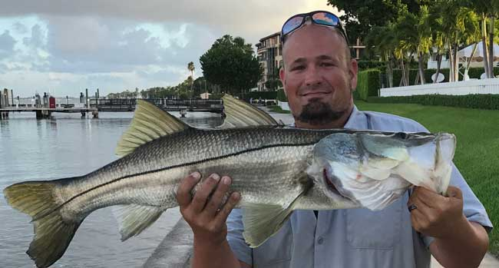
Get to work a little early? Why not do some fishing? New member Justin Steckley caught and released this fine 30 inch snook along a West Palm Beach seawall before reporting to his job.

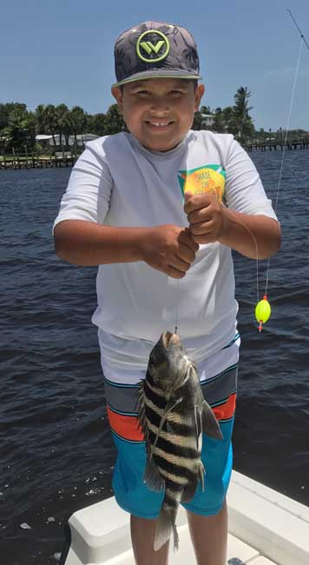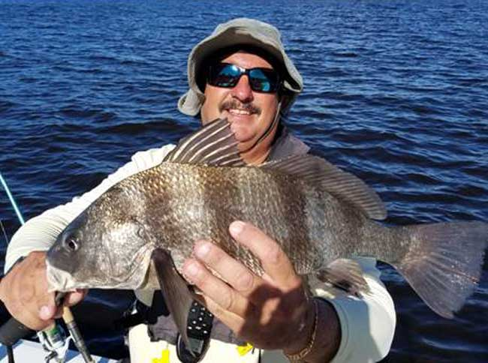
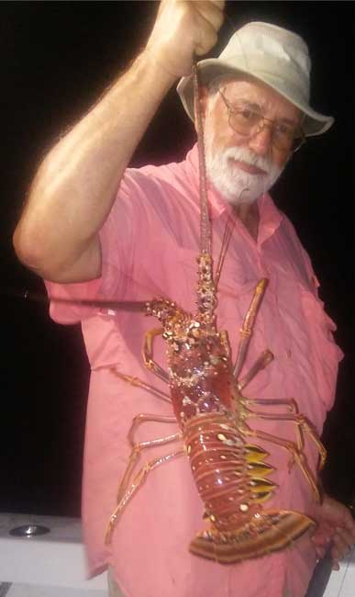
Is there anything more fun than fishing with an enthusiastic kid? Above Left: Keith Palant’s nephew Johnny with a sheepshead.
Above Right: Keith Palant with a black drum.
Left: Gary Mirsky, fishing at night out of Ft. Pierce with Richard Hunt of Little Adam Charters. Gary caught this with a rod and reel. Not a conventional catch!

Welcome New Member:
Jesse Galan
His name has been added to our roster so you can fish with him. Please welcome him when you see him.

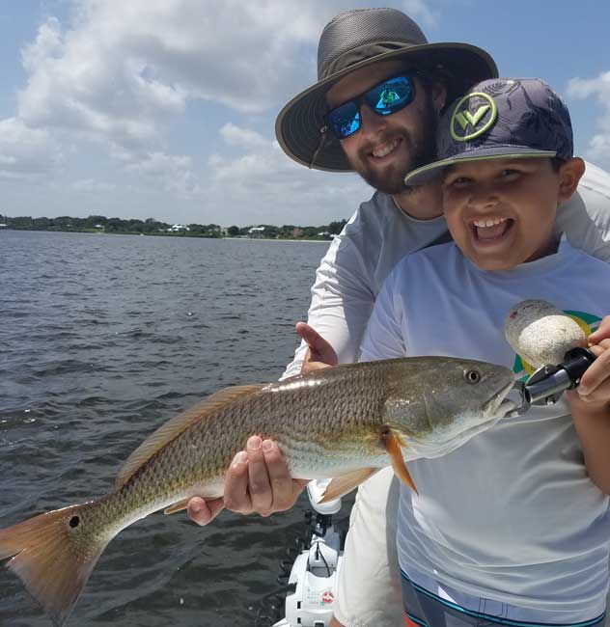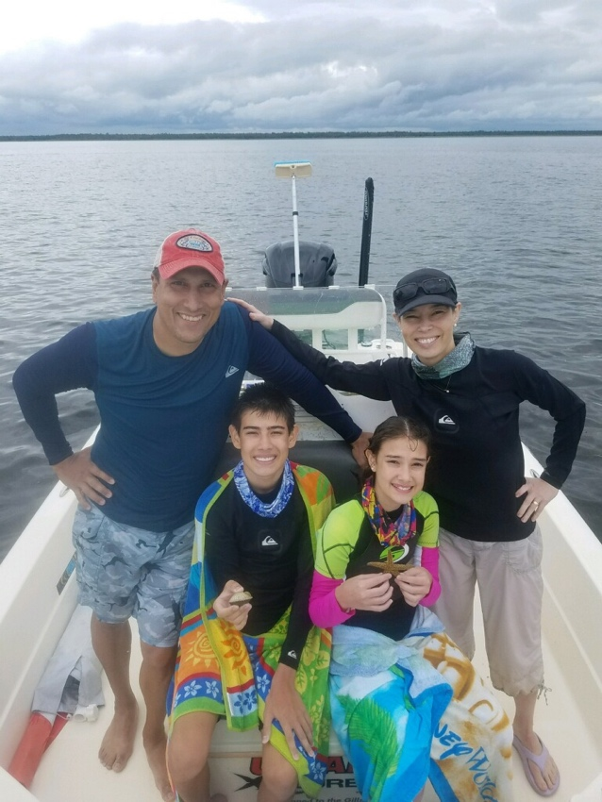
Taking Kids Fishing, that is one of life’s great pleasures and one of the ways to insure Florida’s sporting future: Top Left: Keith Palant’s son Jason and nephew Johnny, aged 10. Top Right: The smiling Juan Giachino family, enjoying scalloping in Steinhatchee.
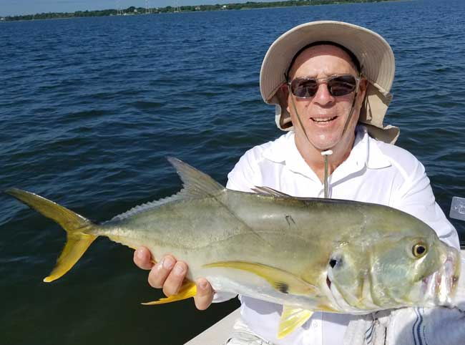
Club Treasurer Pete Noll caught this mighty Jack Crevalle while fishing with Dusty Smith. A Jack this size gives a strong fight on light tackle.

 |  |  | Club Officers
President | Jim Bohrer |  | halieutics@gmail.com | 301-648-2052
Vice President | Jim Bowdish |  | jlsb@crarybuchanan.com | 772-475-5068
Treasurer | Pete Noll |  | mpnoll@aol.com | 772-223-2136
Secretary and Newsletter Editor | Fred Bartlett |  | fredbart@aol.com | 913-909-9326
 |  |  | Board of Governors
Director |  | Roy Buckley | rlbuckley007@aol.com | 772-871-7008
House Committee |  | Jerry Hoge | jhoge@hogeengineering.com | 772-485-7267
Angling Committee |  | Frank Miller | frmiami2@gmail.com | 305-469-4654
Membership Comm. |  | Eric Rosenberg | erosen1031@aol.com | 772-210-5563
Meeting Speakers |  | Jim Bohrer | halieutics@gmail.com | 301-648-2052
Raffle Chairman and Conservation Coordinator |  | Jim Harter | pjharter@comcast.net | 772-223-0648
Director |  | Frank Pryzbylski | 1pratt@comcast.net | 772-486-3531
Events Coordinator |  | Bob Ruggeri | bob.ruggeri@yahoo.com | 772-285-4264
E-mail all newsletter copy and photos to Jim Bohrer at halieutics@gmail.com or to Fred Bartlett at fredbart@aol.com. Closing date for photos and copy is the 25th of the month preceding publication.

Angling Director’s Report by Frank Miller

Here is a recap of our club outing held Aug 11th 12th and 13th: The targeted fish species were trout and redfish and each angler was to total the lengths of their longest redfish and longest trout for their entry. I know fishing has been discouraging but this is very bad. We received no entries, not even one trout! I fished Sunday at dead low tide and you can't do much worse than that. My partner managed one undersized trout. Entries must be legal lengths except for snook, which for club purposes must be 24" and then must be released.

The very high point of the outing was lunch at Sandsprit Park put on by Bob Ruggeri. It was an excellent seafood boil. Many thanks again, Bob. The lunch was outstanding.

Our Fish of the Month target was for the most trout caught between July 14th and August 10^{th.}
Our V.P. Jim Bowdish took the honors so he will be receiving a new maroon F.O.M. winners cap.

On another subject, our Pine Island Outing scheduled for October 13th,14th and15th is still on our schedule and I am asking anyone who is interested in attending to please contact me by email or at the next general club meeting so that I may determine if there is still enough interest to schedule the trip to Pine Island.

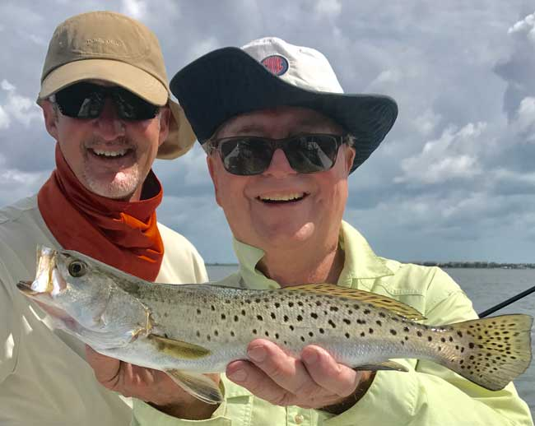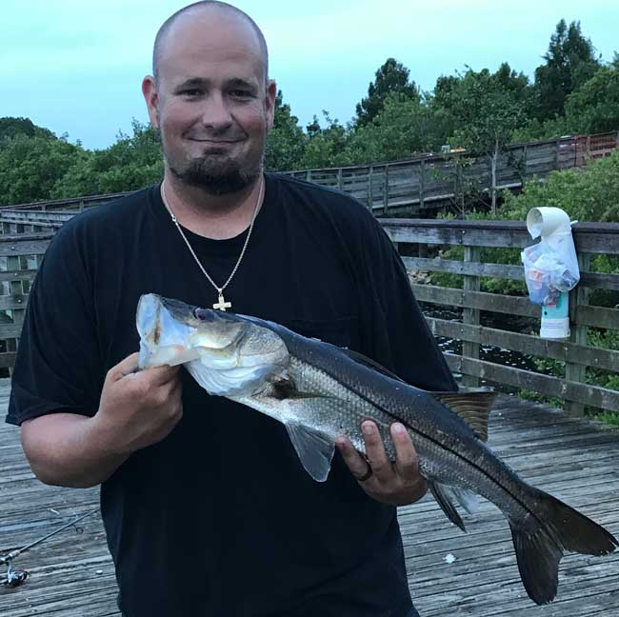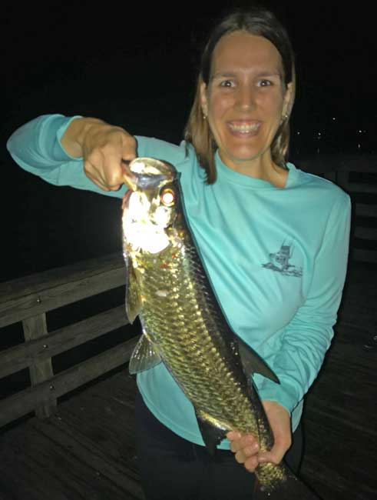
Scott Turnbull (left) and his friend and former law partner Rocky Pozza with the spoils of the day. They are holding an Indian River trout that they released to swim another day. The FWC reports that trout numbers are good statewide, but our members know that our area has been affected by dirty water that has a detrimental impact on the habitat that trout need to survive.
New members with a passion for fishing: Left: Jason Steckley with one of the 25 snook that he and his wife Amanda caught and released one evening. Right: Amanda Steckley with her very first tarpon, a night time cruiser.

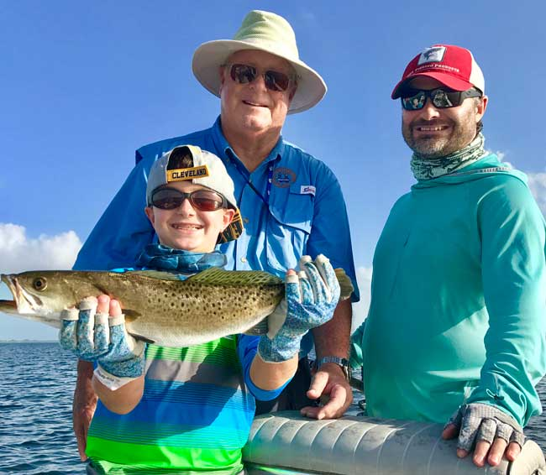
Jim Bowdish (left), friend John Moran (right) and John’s son Charlie all with big smiles with a Little Mud Creek seatrout.
Twelve SRRC Members attended the FWC Spotted Seatrout Meeting in Fort Pierce
Twelve members of SRRC attended the FWC group discussion in Fort Pierce on August 9th. The FWC is soliciting comments and concerns of local fishermen, both recreational and commercial. The basic summary is that spotted seatrout populations are healthy in Florida areas where the water quality is good to excellent. Unfortunately, our area is one of those regions where poor water quality has resulted in the death of the sea grasses in which trout need to feed, shelter and reproduce.

If you would like to comment about sea trout to FWC, submit comments online by visiting MyFWC.com/SaltwaterComments. Please understand (as it was made clear to those in attendance) that FWC has no responsibility for water quality, discharges from Lake Okeechobee or any other habitat issues. To our knowledge, they don’t have any input on these matters. There will apparently be no effort to give sea trout a gamefish-only status and sales of commercially caught trout will continue to be offered statewide.
Please look at the FWC website for more information and for a schedule of other meetings. www.myFWC.com This is very good website to have on your computer, tablet and/or smart phone.

The next scheduled local meetings will concern Goliath Grouper. The next general meeting of the entire Commission will be in the city of Okeechobee on September 27-28th. Please see the FWC website for complete details. The public is welcome to attend these meetings at the appropriate times.

All Stuart Rod and Reel Club Outings are based purely on the Honor System. All scheduled Club Outings will be “Daylight Outings”. You can fish any of the dates listed above. Event will begin at the first safe light in the morning with lines out of the water by 1PM. Scores must be turned into the Angling Director or other board member by email, phone or verbally by 2 PM local time on the day after the event.  Natural Bait (alive or dead) is allowed except for March, May and July. Bait restriction is in effect for September.  Guests and spouses are invited to attend the food services on Saturday at Sandsprit Park. For food at restaurants, guest and spouses will be charged for their meal and beverage costs. | Family members under the age of 18 must be accompanied by a parent or legal guardian to participate in an outing. While guests are always welcome to join members during our outings, you must be a paid member of the Stuart Rod and Reel Club to be eligible to win an outing. Outing scores shall be published in the Club’s Newsletter following the Outing. Outings cancelled due to weather shall be rescheduled for the following weekend. Outing result disputes shall be settled by the Angling Director.  OUTING SCHEDULES AND RULES MAY CHANGE DURING THE YEAR.  FISHING BOUNDARIES  Boundaries will extend from the south shore of the Jupiter Inlet to the North Vero Beach Bridge.

Date | Outing/Event | Details | Host/Food Service | Rules
September  15, 16, 17 | Longest Snook | Longest Snook –Bait Restriction: Any snook caught on bait is worth ½ a fish caught on an artificial lure. 24” snook minimum length | Sandsprit Park 1:00  PM Stuart, Sept 16th. | Longest snook, minimum 24”
October  13, 14, 15 | Pine Island | Total Length in Inches: 1 Trout, 1 Redfish, 1 Snook (24” minimum on snook) | Pine Island Away  No Local Luncheon | Longest total length
November  10,11,12 | Local Redfish | Longest Overall Redfish | Sandsprit Park 1:00 PM, Nov 11th. | Longest total length
December 9 | Christmas Party | No Outing | Dolphin Bar & Fish House Jensen Beach | No Outing.

2017 TOURNAMENT OUTING SCHEDULE
Support our Advertising Sponsors
We are very fortunate to have many local businesses that advertise on our web site and provide additional sponsorship support to the Club. These businesses provide a wide range of products and services for the entire community. Whether you are looking for lodging, restaurants, fishing supplies, boat repair and restoration, guide services, legal services, or roof repair our sponsors deserve your consideration. You can learn more about these businesses by visiting our website at www.stuartrodandreel.com. Click on the advertiser’s tab and you will find a brief description of our sponsors with contact information and links to their websites. Make our advertising sponsors your priority when shopping. Please let them know that you learned about them through the Stuart Rod and Reel Club and that you appreciate their support.

Bait & Tackle  - Crowder Rods  - D.O.A. Lures  - Fish Heads of Stuart  - Snook Nook  - Treasure Coast Rod and Reel  - White's Tackle  - T & A Jigs, Inc. | Area Lodging  - Marriott - Hutchison Island Resort
Area Dining  - Big Apple Pizza  - Crawdaddy’s  - Dixie Grill  - Manatee Island Bar & Grill  - Manero’s Restaurant  - Polka European Deli  - Rancho Chico  - Shrimper’s | Guide & Charter Services  - Cajun Fishing Adventures Louisiana  - Catch 22 Charters Florida  - The Fish Intimidator Louisiana
Marine Products & Services  - C&H Trailer  - Manatee Marina  - Marine Customs Unlimited  - Marine Parts Outlet  - Master Repair  - Metco Marine Electronics  - Outboards Only  - Sailfish Marina  - Stuart Propeller  - Treasure Coast Battery & Alternator | General Business  - Capps Roofing  - Inn of the Dog  - Plaza 95 Marathon, Dairy Queen and Highway Café  Professional  - Crary Buchanan Attorneys

MEMBER’S INFORMATION
MONTHLY MEMBERSHIP MEETINGS WITH SPEAKERS: The monthly membership meeting is the second Thursday of the month. Our home port is The Quality Inn/Flanigan’s Bar & Grill located at 950 SE Federal Hwy. (US 1) Stuart, FL. We have the privilege of listening to many fishing industry and conservation leaders in the Southeastern Florida region. These experts include tackle manufacturers, tournament winning Captains and guides, television and print journalists, and academic researchers. We have a guest speaker from this pool at each monthly meeting. Speakers will address topics of interests such as how to fish for the upcoming outing’s targeted species and our diverse estuary system. This is a great way to gain additional local knowledge of this fishery. Dinner begins at 6PM with Meeting at 7 PM.

MONTHLY OUTINGS: The Club sponsors a fishing outing each month. All outings are based on an Honor System. You don’t have to keep your catch or take a picture of it either. Outings are scheduled for the weekend following the general membership meeting. Outings are usually three day events where anglers select to fish Friday, Saturday or Sunday. Most outings are scheduled from first safe light till 1PM. The targeted fish and scoring change from month to month with interesting twists such as more points for one species than another. The intent is to have fun! The winner of each monthly outing receives a Club logo embroidered fishing shirt. As part of the outing we have several lunches at restaurants along with club and family cook-outs. Additionally, the Board is encouraging members to partake of the lunch regardless of the day fished. These are no-cost events. With two away outings and the remainder based at Sandsprit Park, there is opportunity to participate without travelling around the state. Frank Miller as the Angling Committee Chairman will also consider your ideas about other outings in other parts of the state. This year’s outing schedule was developed to increase participation, emphasizing the fun of fishing. You are able to view the schedule in every edition of True Lies.

NEWSLETTER: We publish a newsletter, True Lies, each month. It is circulated by e-mail. We are constantly looking for your fishing reports, pictures, recipes, and any other Club related information for inclusion. Submitting information is easy. You can send an e-mail to Jim Bohrer (halieutics@gmail.com).

WEB SITE: The Club’s web site (www.stuartrodandreel.com) is a wealth of information. You can find the latest weather and tides, fishing tips and information on our advertisers/sponsors.

RAFFLE: An activity at our membership meetings that generates a great amount of interest is the “Raffle”. Tickets are $1 each or 6 for $5. Raffle prizes vary monthly but usually include a fishing rod, reel or combination. Other prizes have been tackle bags, boxes, pliers, lures and boating accessories. Your purchase of raffle tickets gives you a good chance of winning and helps support the activities of your club.

MEMBER DISCOUNTS: Your Club membership can help you to save some money. White’s Tackle offers a 10% store discount on all purchases. Be sure to mention that you are a current member of the Stuart Rod and Reel Club and that you appreciate the support that they give the club.

The Stuart Rod and Reel Club will join with the St. Lucie Angler’s Club for a fun filled charity tournament on October 22. Check in begins at 8:30 AM with the fishing to begin at 9:00 AM. For an entry fee of $25.00, you will receive a logo Tee shirt and a pink Barbie® fishing rod. This rod must be used in the tournament. The Port St. Lucie Botanical Garden has a nice pond stocked with crappie, bass and tilapia. You can bring your own lures or they will have a supply of worms and small hooks.
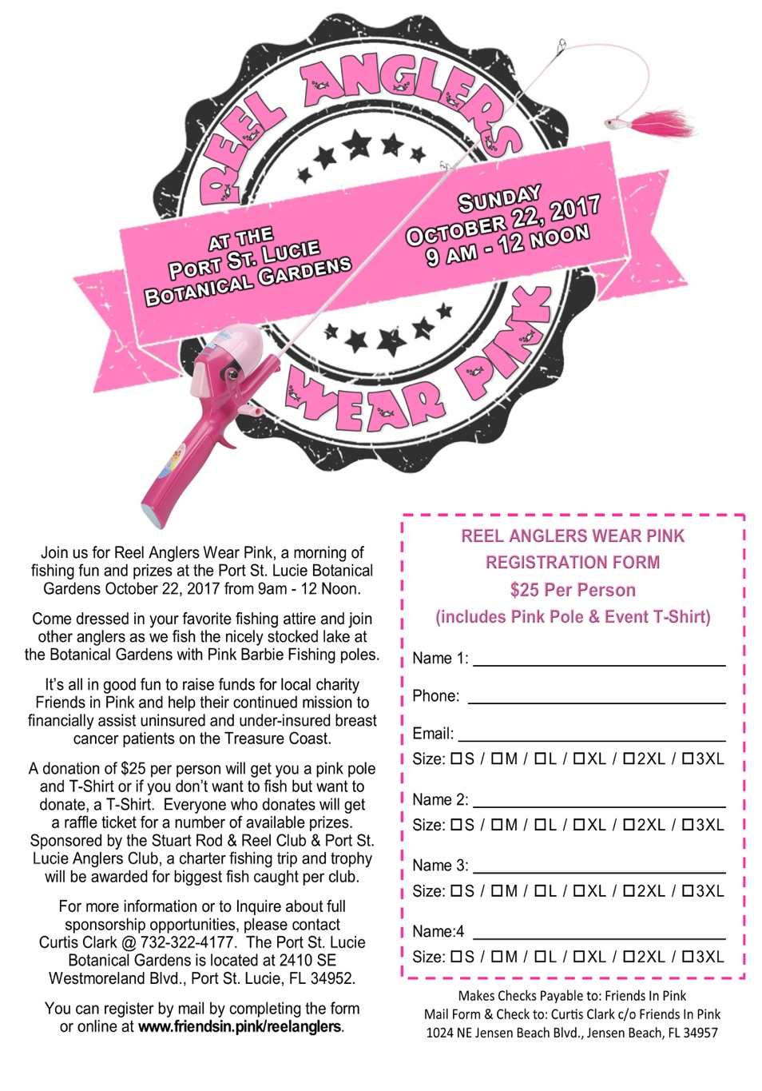

The awards ceremony will take place at about 11:00 with numerous prizes. Each club will have a winner who will receive an off-shore fishing charter with a licensed captain. Please join us for this fun event. There are also numerous sponsorship opportunities available for individuals and businesses. Please contact Mr. Curtis Clark at the voice phone number listed above for more information.

Shelly Bowdish found a very interesting website that provides a wealth of information on Stuart area fishing: http://www.tides4fishing.com/us/florida-east-coast/stuart#_tides
This valuable site provides local area tides, solunar activity and other data that will help you plan a successful and safe trip on the water. In addition, you can enter other geographic areas that may be in your travels. This is a great site to add to your smart phone and/or tablet. Thanks, Shelly, for this link!

WILDERNESS FISHING-2018 SEASON-by Hank Friedman, Club Member.

How would you like to exchange some of our oppressive summer time heat and humidity for cool and refreshing pine scented air? Crystal clear waters, beautiful scenery and some of the world’s best light tackle fishing?

I am planning a trip into northern Quebec, Canada and need some fishing buddies to join me. Right now Canada is a real bargain, $1 US Dollar buys about $1.25 Canadian (just multiply Canadian price by roughly .80 to get US Dollar prices.)

For ideas, Google:
Big Northern Pike and Walleye on the Rupert River Quebec
Jurassic Pike in James Bay Quebec.
Mistassini Outfitter camps
James Bay map2

Believe it or not, these places are usually fully booked beginning the month of May. The fishing seasons are short so contact me now if you would like to go.

If interested and for more details call me at 561 746 6019, Email me at pilothank1@hotmail.com or look me up at the next meeting.

Hank Friedman

Nominations for 2018 Stuart Rod and Reel Club Board of Governors

Nominations are being accepted for the 2018 Board of Governors. This is a volunteer position that allows you to help in club management and direction. You can nominate yourself for a general director position or a specific position on the Board. You cannot nominate another person, only yourself.
A slate of Governors who are running will be presented at the October general membership meeting. The election will be held at the November 2017 general membership meeting.

If you are interested in running, please contact Frank Pryzbylski or Eric Rosenberg soon. Their contact information can be found on Page 4 above. Thank you. Your 2017 Board of Governors.
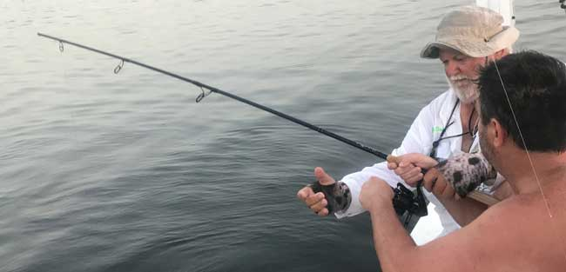

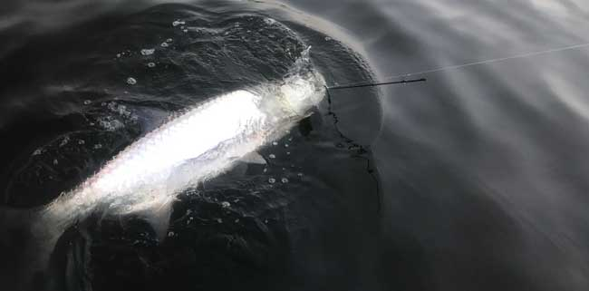
An angling adventure: Tim Goodwin, while fishing with Jim Bohrer, had a strong strike from a 60 pound tarpon. Unfortunately, his rod broke during the fight. You can see the broken rod and the bent guide at the end of the rod in the top photo. After a half hour fight, Tim and Jim got the tarpon to the boat. In the bottom photo, you can see the fish with the broken rod end still attached to the line. Rich Dickerson helped with the photo shoot of this memorable event.
to
GUEST SPEAKER FOR SEPTEMBER
Our speaker for the September General Membership Meeting will be Terry Gibson. Mr. Gibson has been very active in the local “clean waters” movement. Terry lives in Jensen Beach and has been fishing in the southeast since the 1970’s. He has served as an editor for Saltwater Fly Fishing Magazine and Florida Sportsman among others. He is a recreational fishing consultant for the Pew Charitable Trust’s Environmental Group. Please join us for his presentation.
2017 Annual Dues
Fully paid memberships begin the first day of January, and end on the thirty first day of December of each calendar year. An individual membership is one adult 18 years of age or older. Family memberships consist of the member, their spouse or significant other and their children under the age of 18.

Individual membership for a HALF YEAR (June 1 through December) is $45

Family membership for a HALF YEAR is $55
(June 1 thru December)

Send your checks payable to:
Stuart Rod and Reel Club, Inc.
c/o Pete Noll, Treasurer
1888 S. W. Mooring Dr.
Palm City, FL 34990
Membership entitles a single person (or family as applicable) to participate in all outings and to enjoy a meal at every local outing. Members also receive an included meal (with soft drinks) at Shrimper’s and Manatee Island Grill on the appropriate dates. We hold monthly meetings with interesting speakers and share information on where and when to fish in our area.

2017 SRRC Fish
of the Month Contests
The Fish of the Month Contest will run from the day after the monthly membership meeting and end at 12 Noon the day of the following meeting. All fish need to be legal size except for Snook that must be 24-inch minimum. Natural bait (live or dead), artificial lures and flies are allowed. The member catching the most fish will be the monthly winner. The monthly winner will receive a monogrammed club hat.
Date | Species
Jan 13 thru  Feb 09 | Snapper, Bluefish
Feb. 10 thru Mar. 09 | Most Pompano
Mar. 10 thru April 13 | Most Snook
April 14 thru May 21 | Largest Trout
May 12 thru June 18 | Most Snook
June 19 thru July 13 | Most Redfish
July 14 thru Aug 10 | Most Trout
Aug. 11 thru Sept 14 | Most Tarpon Caught and Released
Sept. 15 thru Oct 12 | Largest Snapper
Oct. 13 thru Nov 9 | Largest Redfish
Nov 10 thru Dec 13 | Most Black Drum

The Winner of the Year Overall will be the person catching the most total species during the calendar year. The overall prize is a $50 gift certificate to White’s Tackle in Stuart.

