Adopt one of these wonderfully fluffy dogs today!

See us at www.fluffydog.net in Hartland, WI. Most of our dogs are rescued from kill shelters in southern states. They are all in Wisconsin in loving foster homes awaiting their “furever” homes. All dogs will be spayed/neutered, vaccinated and microchipped.

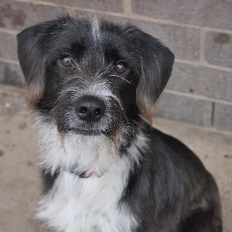 | 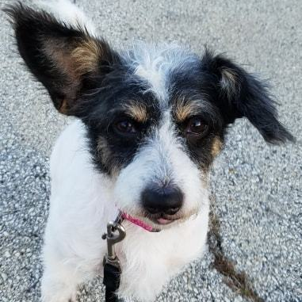 | 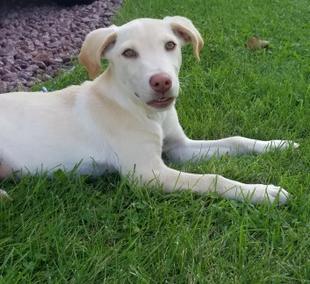 | 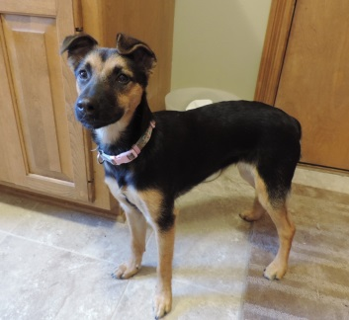
Denim  Male  Wired Terrier  Young | Dottie  Female  Corgi Mix  Young | Janice  Female  Lab Mix  6 months | Kon-Tiki  Female  Shepard Mix  7 months | Mimi  Female  Terrier Mix  Senior
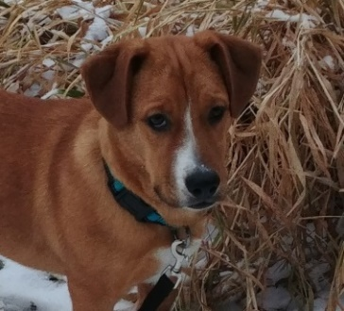 | 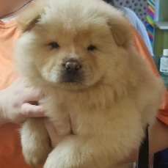 | 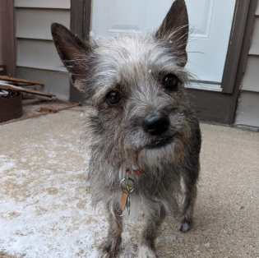 | 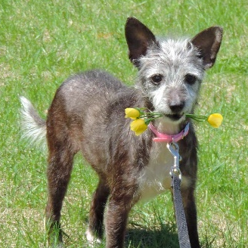 | 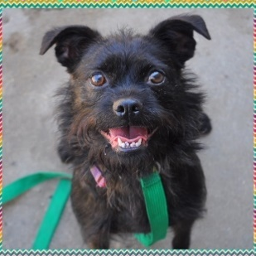
Portobello  Male  Basset Mix  7 months | Garland  Female  Chow Chow  3 months | Dolly  Female  Yorkie Mix  Young | Zinnia  Female  Chihuahua & Chinese Crested Mix  7 years | Bella  Female  Brussels & Boston Terrier Mix  3 years
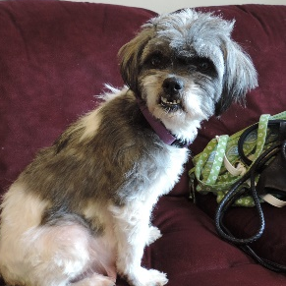 | 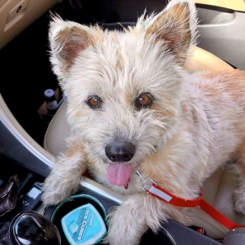 | 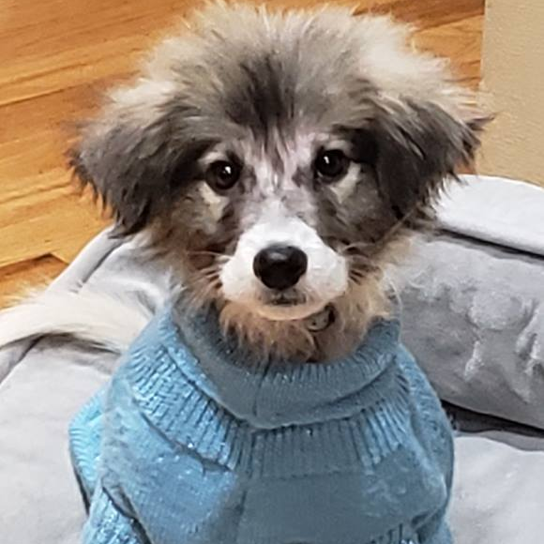 | 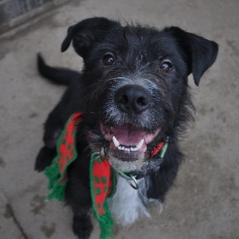 | 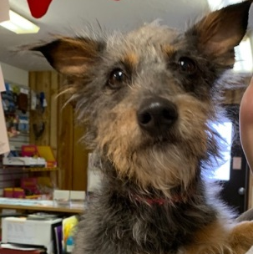
Crouton  Female  Shih Tzu Mix  3 years | Happy  Female  Westie Mix  7 years | Tandy  Male  Large Terrier Mix  3 months | Lennox  Male  Terrier Mix  1 year | Sadie  Female  Yorkie Mix  Young
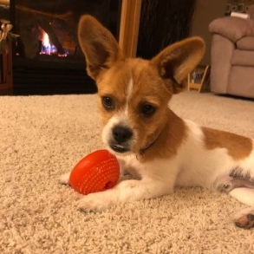 | 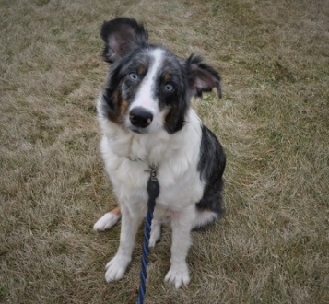 | 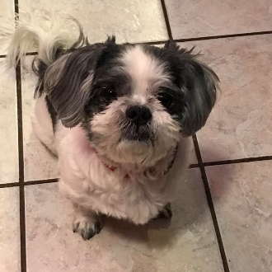 | 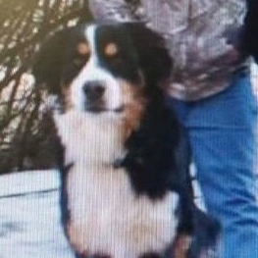
Hubbard  Male  Terrier Mix  6 months | Kepler  Female  Collie/Aussie Sheph Mix  6 years | Darwin  Male  Shih Tzu Mix  4 years | Gunner  Male  Bernese Mountain Mix  2 years | D-O-G  Male  Bernese Mountain Mix  2 years
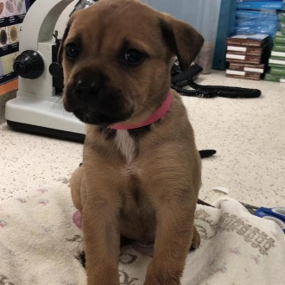 | 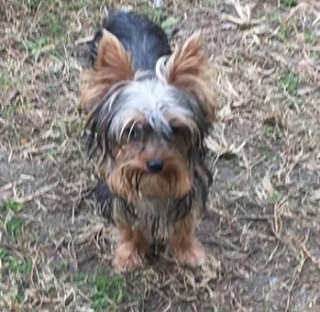 | 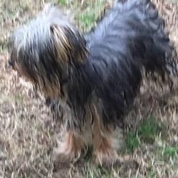 | 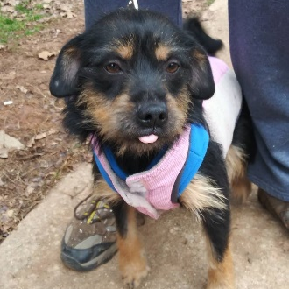 | 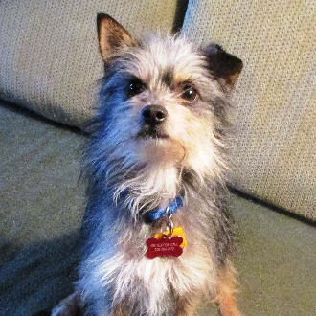
Wallie  Male  Terrier Mix  3 months | Kix  Male  Yorkshire Terrier Mix  6 months | Rice Chex  Male  Maltese & Yorkie Mix  1 year | Mandy  Female  Yorkshire Terrier Mix  Young | Little  Male  Yorkshire Terrier Mix  4 years
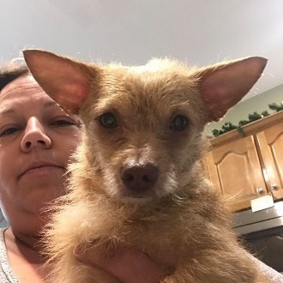 | 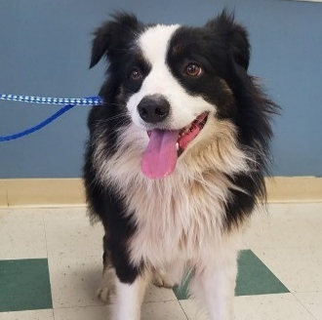 | 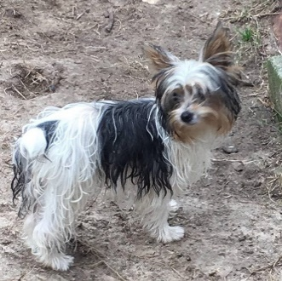 | 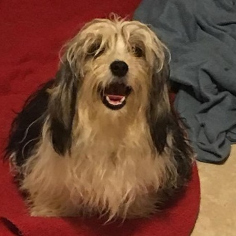 | 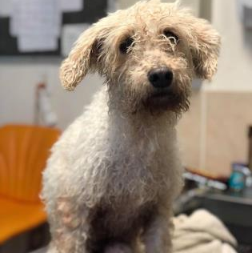
Fifi  Female  Chihuahua Mix  2 years | Roscoe  Male  Collie & Aussie Mix  3 years | Alpha-Bits  Male  Yorkshire Terrier Mix  6 months | Crispix  Male  Maltese & Yorkie Mix  8 months | Susie  Female  Poodle Mix  9 years
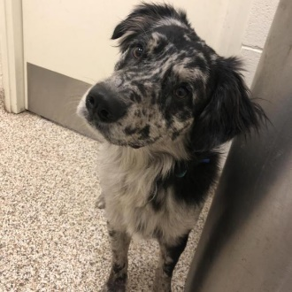 | 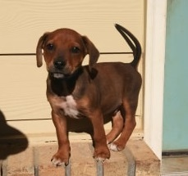 | 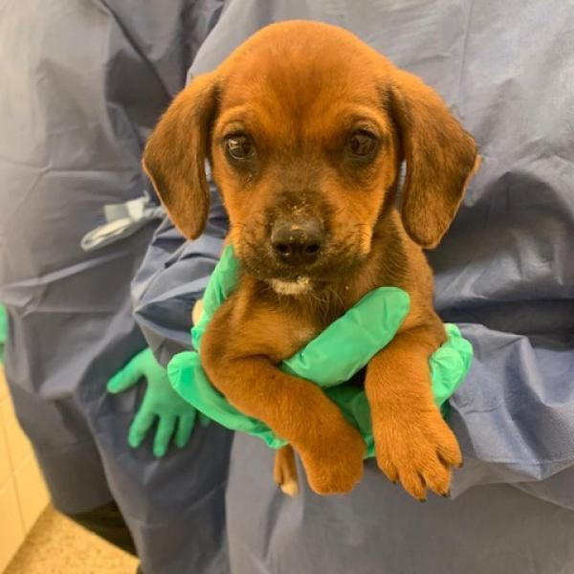 | 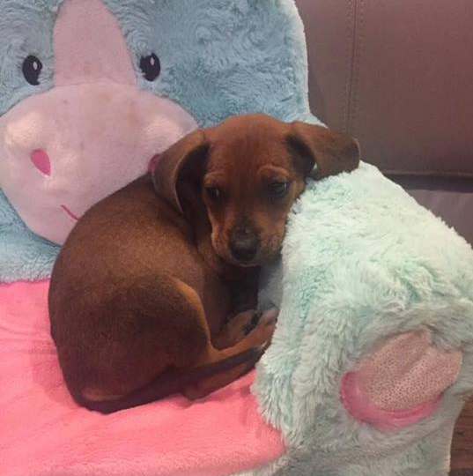
Hunter  Male  Aussie/Catahoula Mix  11 months | Tchalla  Male  Dachshund & Beagle Mix  7 weeks | W’kabi  Male  Dachshund & Beagle Mix  7 weeks | Nakia  Female  Dachshund & Beagle Mix  7 weeks

