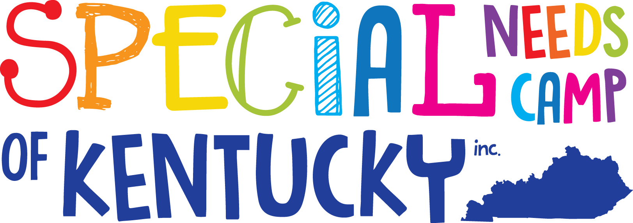
Little SNCKI

Who is it for?
Individuals, who are 6 to 12 years of age with intellectual disabilities.

What is it?
First ever, summer day camp in Eastern Kentucky. Accepted campers will participate in a wide array of exciting activities and events during camp.

When is it?
June 27th, 2020

Where is it?
Bath County High School 645 Chenault Dr., Owingsville KY., 40360

Campers are encouraged to apply now!

Donations are needed and graciously accepted! SNCKI is a 501(c)3 non-profit organization entirely funded by donations.

To donate or apply, please contact us via any of the following ways:
PO BOX 875
Owingsville, KY 40360
(606) 336-0326
Website: www.specialneedscamp.org

