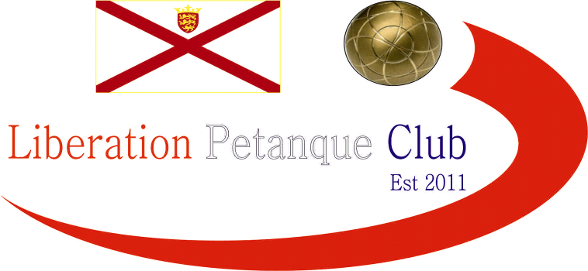

**2022**

**Ladies Singles Open**

# Disappointing only four people entered the competition this year, but we did have the 2021 winner defending her title, Cassie Stewart and the 2018, 2019 winner Joy Hart whom Cassie beat in last year’s final.

# Round one saw Cassie play Janet Gallichan and Cassie started off her defence with a good win 13 – 4. It was a closer affair between Joy and Nicky, but Joy won 13 – 9.

# Round two saw Cassie play Joy and hand Joy a heavy defeat as Cassie hit top form winning 13 – 2.

# Nicky won her match against Janet also 13 – 2 giving her a chance to go through to the final but would need to beat Cassie in the final match to do so.

# Joy also needed to beat Janet to go through and another 13 – 2 result gave Joy a chance on the final.

# Cassie did beat Nicky meaning Joy made the final.

# The final standings after the three qualifying rounds were as follows:

|  |  |  |  |  |
| --- | --- | --- | --- | --- |
|  | **WINS** | **Pts For** | **Pts Against** | **Pts Diff** |
| Cassie Stewart | 3 | 39 | 14 | 25+ |
| Joy Hart | 2 | 28 | 24 | 4+ |
| Nicky Maindonald | 1 | 30 | 28 | 2+ |
| Janet Gallichan | 0 | 8 | 39 | 31- |

# The Final therefore was a repeat of the 2021 final between Cassie Stewart & Joy Hart. With Cassie having already won against Joy 13 – 2 in the qualifying rounds would have been confident of winning back-to-back titles, but it was not to be as Joy won the competition for the third time 13 – 7 and has played in every final!! Well done Joy.

# The third place was taken by Nicky Maindonald with a 13 - 1 win over Janet Gallichan.

# 2022 Winner Joy Hart

# Thank you to those players who took part, your support for our competitions is appreciated.

# Thank you also to Matthew Buesnel, Matt Pinel & Geoffroy Buffetrille for running the competition on the day.

# Sponsored by

# 

# [CoinShares | Digital Asset Investment Strategies for Professionals 🚀](https://coinshares.com/)

# Club email address - [liberationpc@gmail.com](mailto:liberationpc@gmail.com)

# Club Website - [www.liberationpetanque.co.uk](http://www.liberationpetanque.co.uk)

# Kind Regards

# Toby Northern

# Chairman

# Liberation Petanque Club