RSAI 2021 Legislative Priority:
Transportation Equity
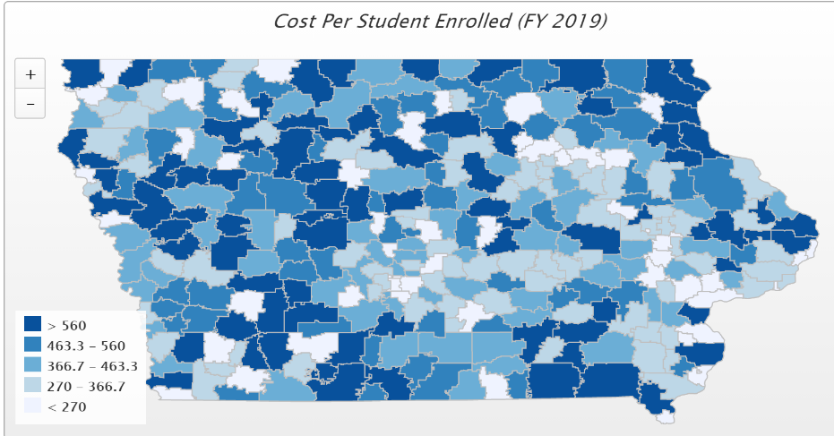
Background: In the 1950s, Iowa had over 4,000 school districts. Students walked to their neighborhood school and transportation costs were nonexistent for Iowa school districts. As budgets have tightened and enrollments declined, Iowa now has 327 districts (FY 2021) with varying square mile, disparate costs per pupil enrolled and hugely varying transportation costs.
Iowa’s foundation formula does not recognize the sparseness of population, square mileage or route miles for school districts, the number of students transported, or variance in road or geographic conditions. Transportation costs are paid out of the general fund.
Recent Progress: in the last three years, the Legislature has made strong gains in closing the transportation expenditure gap:
- SF 455 enacted in 2018 provided $11.2 million to 143 districts with the highest transportation costs in the state, a good start, but did not provide certainty.
- HF 307 enacted in 2019 provided $19 M in transportation as a supplement in the formula beginning in FY 2020, estimated to benefit 190 districts and buy all districts with excessive transportation expenditures per pupil down to $381. ($51 above the 2017-18 state average.) This supplement is intended to grow by the SSA rate annually.
- SF 2164 enacted in 2020, provides an increase of $7.3 million compared to FY 2020, bringing the transportation total to $26.3 million for FY 2021. All districts that experienced transportation costs above the state average in FY 2019 were reimbursed for the difference and a small amount was then distributed to all districts based on enrollment.
Current Reality: the following describes transportation inequities from DE’s FY 2019 Transportation Report:
- The range in transportation expenditures varied from a low of $15.40 to a high of $ 1,038.70 per student enrolled. With transportation funding in the formula, that range from high to low has been closed to $348 per pupil (although lagged by two years – FY 2021 equity payments are based on FY 2019 expenditures). Square miles per district range from a low of 2 to a high of 555 square miles, and route miles range from a low of 924 to a high of 1,036,755 miles.
- General fund dollars spent on busing would otherwise pay for staff and teachers (salary, benefits, training, support), curriculum, programs, technology, and energy. Lack of resources in these areas creates an unequal educational opportunity for students in rural districts.
Formula and Transportation Equity: RSAI supports formula and transportation equity. The Legislature should continue the commitment to close the $155 gap between the state and district cost per pupil within ten years and continue transportation equity support, bringing down all districts to no more than the state average per pupil transportation cost, without requiring burdensome reporting requirements from school districts.

