Calling All Kids (and Big Kids too)!!!

Come to the Tri-Valley Bus Garage during the Pennington County Fair
Join us in making Crafts (Viking Style!)
Saturday July 20, 2019
9 am to 1 pm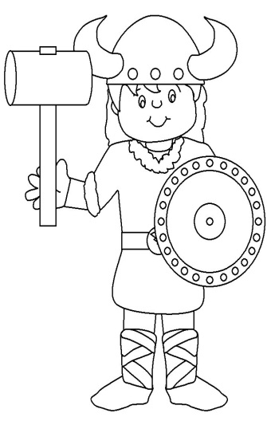
FACE PAINTING TOO!
*Make & Take Crafts *Take a break from the Fair *Experience Scandinavian Culture
Parents/Adults Welcome Too!!!

