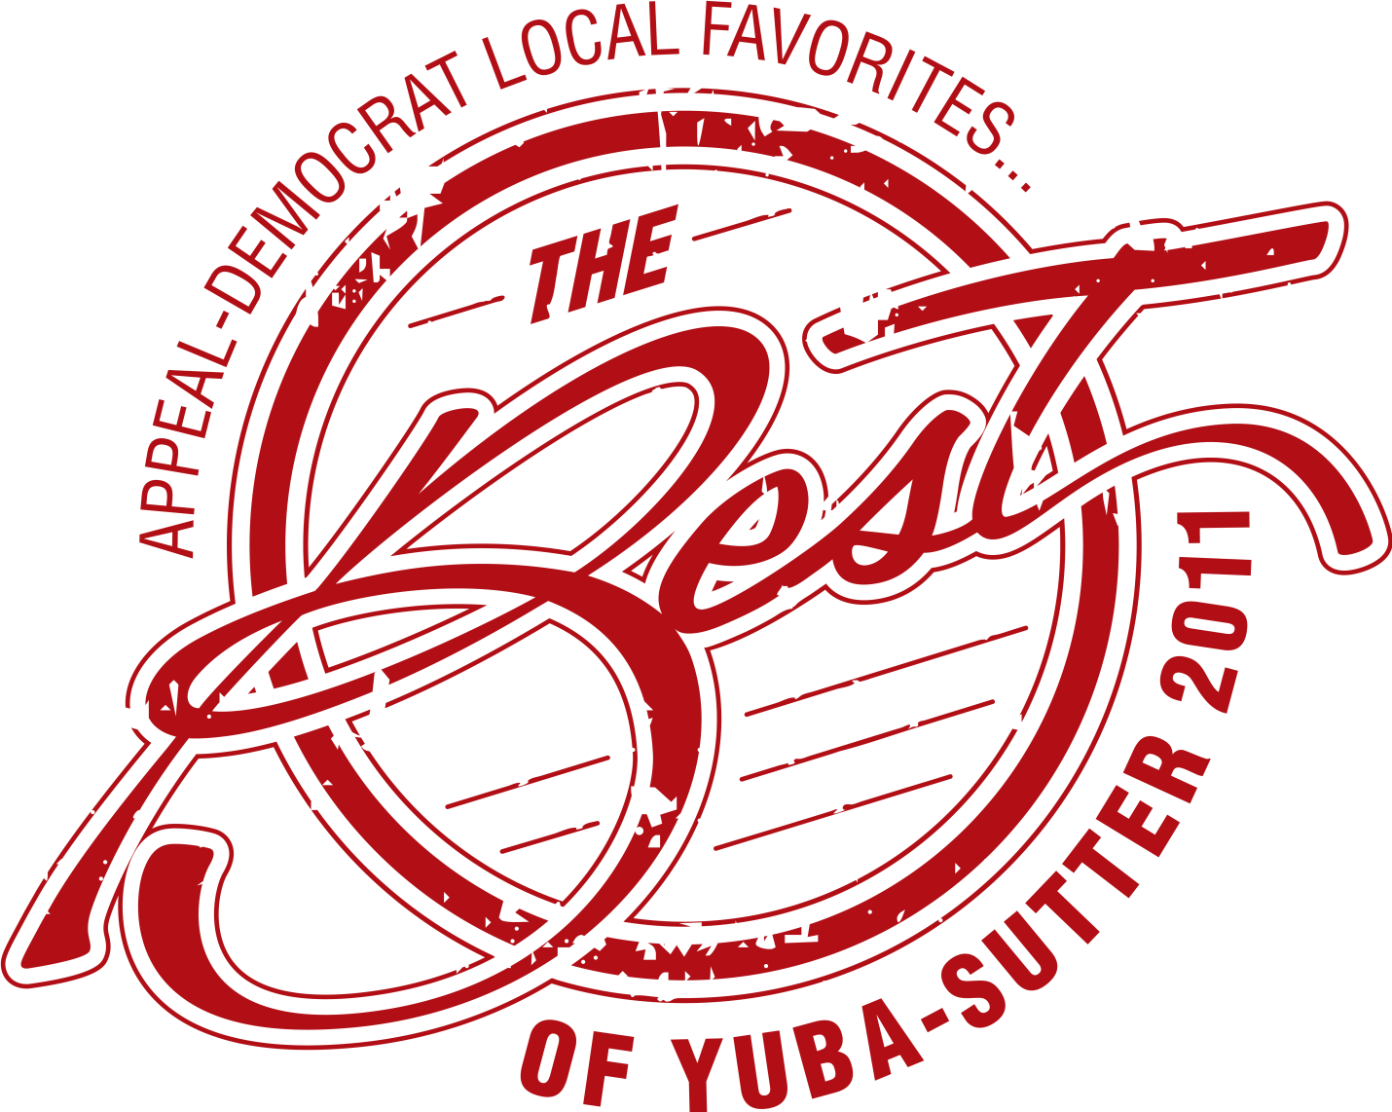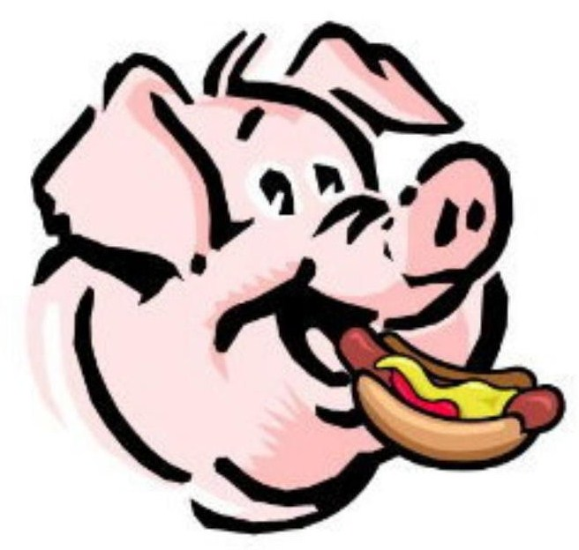

PORKYS TO GO

Specializing in Wood Smoked Meats,

Memphis-Style Ribs, Signature BBQ Sauce

Outdoor BBQ Pits

******************************************************

LOCATION

1190 Bridge Street

Yuba City, CA 95991

Monday – Saturday

11:30am – 6:30pm

Closed on Holidays
CALL : 530-923-7828
********************************

LUNCH PLATES

Available until 3:00 pm

(Served with One Small Side Dish)

Hot Link Sandwich....................$8.95
Pull Pork Sandwich....................$8.95
Tri Tip Sandwich…....................$9.95
Rib Lunch...................................$9.95
Smoked Chicken Lunch.............$8.95

************************************
SIDE DISHES
($2.50 small $5.00 large)
Potato Salad – Cole Slaw
Macaroni & Cheese
Green Beans
BBQ Baked Beans
Mustard & Collard Greens Mix
CORNBREAD & BUTTER – $2.00
WE CATER …ANY SIZE PARTIES, WEDDINGS,
AND SPECIAL EVENTS….
Meet with our Catering Manager
CALL 923-7828
Ask us about catering your party, today.

PORKYS BBQ SAUCES
House Special Blend or
Smokin' Porkys Hot BBQ Sauce

Prices subject to change without notice.
December 2017

DINNERS AND COMBOS
Available All Day
(Served with Two Small Side Items)

Hot Link Dinner...............................$13.95
Smoked Chicken Dinner...................$13.95
Pull Pork Dinner……………………$13.95
Rib Dinner.........................................$14.95
Tri Tip Dinner....................................$15.95
2-Meat Combo Dinner......................$19.95
3-Meat Combo Dinner......................$24.95

****************************************

SLABS OF RIBS
HALF SLAB....(meat only).........$17.95
WHOLE SLAB....(meat only)......$33.95

***************************************
PORKY’S PARTY PLATTERS
(Includes Ribs, Chicken, Pull Pork, Hot Links, Tri Tip)
And 3 - 4 Side Dishes

KING TUT PLATTER…(Feeds 10-11). $139.95
(Must order 1 day in advance)
KING'S PLATTER..(Feeds 6-7)..............$79.00
QUEEN’S PLATTER...(Feeds 4-5)………$59.00
MINI PLATTER ………(Feeds 3)………..…..$44.95

********************************************
PORKY’S “MEAT-ONLY” PLATTERS

Chicken Platter…………………..…..$29.95
Pulled Pork Platter…………………..$29.95
Rib Platter…………………………....$33.95
Tri Tip Platter..……………………...$39.95

DESSERTS - $5.00
Peach Cobbler Bowl
Sweet Potato Pie
Pecan Pie
Cake Slices

