WCC Risk Assessments
Introduction and Purpose:
This risk assessment examines the dangers inherent in the activities carried out by Welshpool Canoe Club. Through consideration of the means by which these dangers (risks) could be eliminated or reduced in severity or likelihood, a number of control measures have been suggested. Those using this risk assessment should note that the dynamic and varied nature of the sport of canoeing, does not allow a completely comprehensive risk assessment to be made. Paddlers, particularly those leading groups, should carry out their own informal and dynamic risk assessments before and during any canoeing activity. This is particularly important on open and moving water, indeed it could be argued that the ability to carry out dynamic risk assessment is the basis of effective leadership.
Using This Document:
The probability of risks occurring (Prob.) is assessed as high (H), medium (M) or low (L). A high probability indicates that the risk occurs regularly on Club activities. Medium probabilities relate to events that have occurred on Club activities or which are likely to do so at some time, whilst low probability risks have never occurred (and are unlikely to do so). It is important that all paddlers are familiar with the risk assessments and it should, therefore, be published on the Club website. It must be recognised that the document will need to be updated regularly. This will be the responsibility of the committee. As a minimum the risk assessment should be reviewed:
- After the Annual General Meeting by the Committee
- After any accident or ‘near miss’
- When any member identifies a significant hazard not already mentioned in the document, or after a change in legislation.
- All significant finding must be recorded.
Carrying Out a Risk Assessment
It is important that those updating this document know how to carry out a risk assessment. These guidelines may also be useful to those carrying out their own dynamic risk assessments when on the water. There are 5 steps to carrying out a risk assessment:
- Identify the hazards – those things with potential to cause harm
- Identify the risks – who might be harmed and how?
- Develop control measures to either eliminate the risk or reduce it to an acceptable level
- Evaluate the probability that the risk will occur
- Record your findings and review them
A Dynamic risk assessment is a continual process that starts before the activity, and continues after the activity has finished. This kind of assessment is the Leaders response to the actual conditions prevailing, and how they will affect risk for the planned activity.
It is important to keep the ‘big picture’ in mind and not get bogged down in detail. Risk assessments are best carried out by a group, to use a wide pool of knowledge and ideas.
Date: 2nd Jan 2021
Reviewed by: Richard Rendall, Mike Perks, Liz Hinkley, Gillian Roberts
Action points:
Risk Assessment:
Swimming Pools (The Flash) (BCU/UKCC L1 Coach and above)
Hazard | Risks | Control Measures | Prob.
Preparing for start of Session | Swimmers in pool & Blocking Fire Exit /  The Group | Boats to be positioned at top end of pool, avoiding Fire Exits and not overhang pool edge. Use good manual handling  techniques. Paddlers and coaches, must wear helmets, while in the water. Brief group (max12) of session aims (the use of  the safe storage area for boats and equipment, at the beginning  and at the close of the session is supervised by the lead coach  or designated person)  - Use appropriate warm-up - | M
Knock unconscious | Head injuries | Check correct fitting of helmets and report any damage (the use of helmets is mandatory for any person in the water) | M
Slips & Trips | Falling injuries | Obey pool rules. Do not run. (Flash Risk assessment)  Report sharp edges or loose tiles, to pool Lifeguard and reception | L
Water | Drowning (near drowning) | Ensure participants can swim (If not, 1 to1 coaching, should be used) Teach capsize drill. Lifeguard on duty at all sessions.  Coaches running sessions are experienced  (BCU/UKCC L1 and above) | L
Equipment/  People | Entrapment in boat on  Capsize/Cuts & Bruises  – Lifting boats  -Muscular & Joint damage | Teach capsize drill. Boats are easy to exit. Maintain equipment,  Duty coaches and paddlers , to check and report all faulty equipment. Equipment is stored safely at end of pool session.  Teach good manual handling, and encourage during all pool sessions. Experienced paddlers often observing sessions. | M
Very Sheltered Waters & Sheltered Waters (Glossary of terms should be used)
(BCU/UKCC L1 Coach and above)
As for swimming pools, with the following extra hazards:
Hazard | Risks | Control Measures | Prob.
Injury or medical conditions | Condition worsening or Lack of treatment | Check Child Permission forms. Question Adults current health. Current First Aider available.  Use Appropriate warm up. | L
Other water users | Collision | Watch out for other craft. Move out of the way of all water users. | L
Locks / Weirs | Getting caught in deep recirculating hydraulics | Avoid locks - Avoid weirs. (Define safe paddling area) | L
Rubbish | Cuts, other injuries | Avoid (Define safe paddling area) First aid kit. | L
Knocked unconscious | Drowning (Near drowning)  Head injuries | Use approved Buoyancy Aids (check correct fitting)  Suitable helmets to be worn or required by Lead Coach – Check for correct fitting. | L
Weather/Cold water | Hypothermia, Immersion Hypothermia | Dress appropriately for conditions. Group members to monitor themselves and others in cold conditions. | L
Boats & Equipment | Manual Handling Injuries | Teach and use correct lifting and rescue techniques. Buoyancy bags should be correctly fitted. | L
Water | Contracting Illness – E.g. Wieles disease | Do not ingest water. Wash hand before eating. Shower after paddling. | L
Environment | Trees over hanging bushes | Avoid – Define safe paddling area | L
Polo
As for swimming pools or placid water, with the following extra hazards:
Hazard | Risks | Control Measures | Prob.
Other Players | Impact Injuries | Wear polo helmets with face guards, Obey rules. | M
Risk Assessment: Rivers and Open (inland) Waters
(River and Canoe Leaders)
(Glossary of terms should be used)
The following risk assessment covers typical paddling trips on rivers and open inland water in the UK and abroad. The hazards present and their severity will vary depending on the waters.
This risk assessment is relevant to paddling on artificial courses.
Hazard | Risks | Control Measures | Prob.
Travel | Car/ Minibus accidents | Follow the Highway Code. Do not drive when tired. Plan and allow time for shuttles, do not rush. Use seat belts | L
Roof rack problems | Train members to secure boats. | (1&2* training). Check roof racks before travel. | M  M
Trailer accidents | Tow at correct speed | Check Trailer and Boats are secure, take extra care.
Long Days | Exhaustion | Adjust trip length to suit participants. Carry food and drink. Flask - Hot drinks or means of making a hot drink. | L
Poor Leadership | Loosing control of Group | C.L.A.P. | M
Environment | Hypothermia | Dress correctly for expected conditions. Carry hot drinks, spare clothing, Group Shelter/Tarp or exposure bags. Appropriate level of First Aid provisions. | M
Environment | Hyperthermia | Carry cold drinks on hot days. | L
Water | Accelerated/ Immersion Hypothermia | Rescue swimmers fast. Teach rolling. Competent River  Leadership | M
Water | Drowning (Near drowning) | Require that all members are competent swimmers. Instruct on capsize drill, rolling and swimming in moving water. Teach rescue techniques. Competent River Leadership | L
Water | Waterborne diseases | Try not to ingest water. Take further precautions when there is a known problem. | L
Water | Large Stoppers etc. | Avoid by good Leadership. Teach methods for paddling through, in and out of friendly stoppers. Identify unfriendly  water features. Paddlers should be made aware about correct swimming position and rescues from stoppers. | M
Rocks | Head Injury | Helmets must be worn, during all river trips or as required by | M
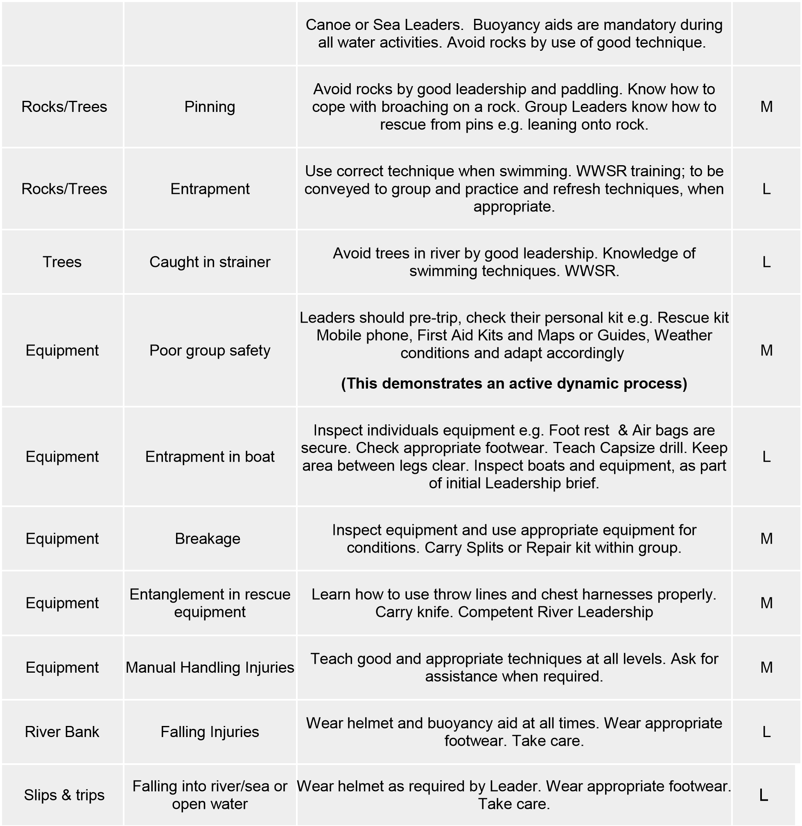
Risk Assessment: Sea (Glossary of terms should be used)
As for rivers and open waters, with the following extra hazards:
Hazard | Risks | Control Measures | Rob.
Tides & Weather | Losing control of group | Good Leadership and planning. Consider the expected speed of the group.  Consult tide times closely. Calculate timing of loss of light at dusk. Carry working VHF Radios/Phones/ EPIRB and Flares, Strobes if required. Plan  route carefully, including emergency routes, with maps, guides and charts, contact coast guard if required. Ensure that you have a comprehensive  weather forecast. Assess the likely effect of the weather. Consider the sea state and possible influences, such as tide and current. | M
Other sea vessels | Collision & Capsize | Avoid large vessels, with good Leadership and planning. | L

