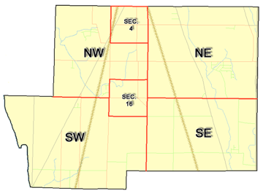 | Pleasant Township  Zoning Commission Minutes  1035 Owens Rd W.  Marion, Ohio 43302
Meeting called by: | Scheduled | Type of meeting: | Regular Monthly
Chairperson: | Mr. Holler | Secretary: Alternate | Scott Ballenger
Timekeeper: |  | Date: July 16, 2020 | Time 7:30 pm
Call to Order by: | Mr. Holler Moment of silence followed by the pledge to the flag.
Roll Call: | Scott Ballenger, Jack Dean, Harry Holler, Tom Leib, Dwight Williams  Absent Dwight Williams & Tim Michael
Minutes: | Read and approve minutes from previous meeting (June passed out earlier).  Motion to approve minutes by: Mr. Leib Seconded by Mr. Dean: All approved
Attendees Address Board: Have sign in sheet on desk by door.
Type in attendees and addresses:
.
----- Agenda Topics -----
Business
Zoning Reports: | Zoning Inspector goes over reports and provides copy to board.
Unfinished:
New:
Announcements: | Next meeting will be August 20, 2020
Adjournment: | Motion to adjourn by: Mr. Ballenger Seconded by Mr. Dean, all in favor all approved
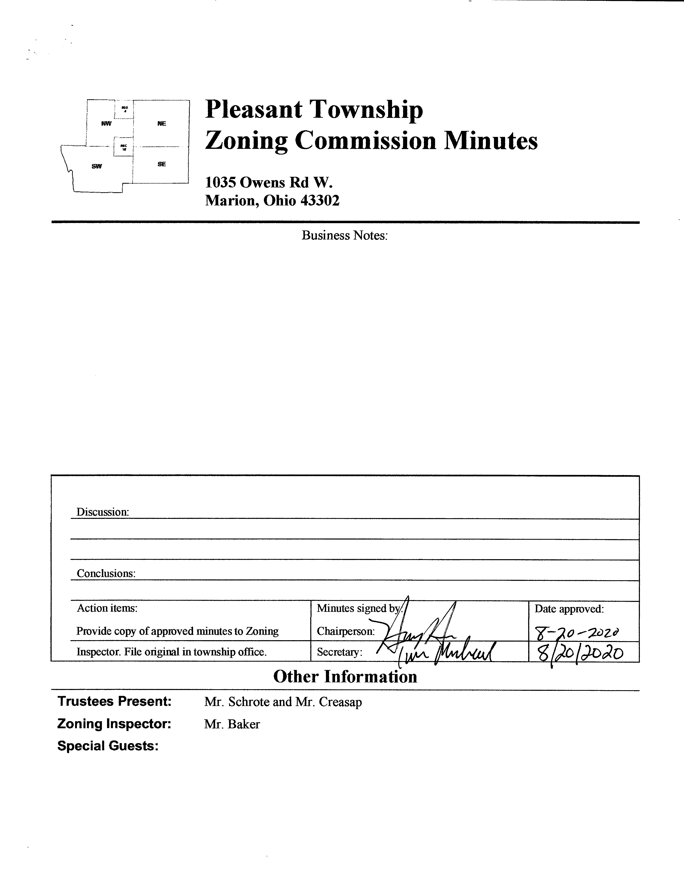

Minutes
- The Pleasant Township Zoning Commission met for their regularly scheduled monthly meeting on July 16, 2020 at the Pleasant Township Senior Centre. Zoning Commission Board members present were: Mr. Ballenger, Mr. Dean, Mr. Leib, Chairperson Mr. Holler, and Township Zoning Inspector Mr. Baker. Absent from the meeting Mr. Williams and Mr. Michael.
- Minutes were read from the June 18, 2020 regularly scheduled Zoning Commission meeting. There being no stated corrections a motion to approve the minutes was made by Mr. Leib and seconded by Mr. Dean. All members present agreed to passage of the minutes.
- Mr. Tom Baker Pleasant Township Zoning Inspector submitted the following inspection report for the month of June 2020: there were 2 permits for additions, 4 permits for accessory buildings, 4 permits for fences, 1 permit for porch, 2 permits for pools, and 1 driveway permits. Dollar amount for new construction totalled $233,130.00, with income from permits totalling $1,050.00, and income from appeals totalling $600.00.
**Special notes, 1775 Marion Waldo Rd. 1 parcel lot and its zone both commercial & residential, also anticipate receiving 2 project variance requests soon**
- Ms. Evelyn Warr-Cummings of the Marion County Regional Planning Commission provided an updated version of the draft model language document covering solar energy for inclusion in the Pleasant Township Zoning Resolution based on discussions held during the June Zoning Board meeting. The updated version was provided by emailed to the Zoning Board members for discussion prior to the July 2020 meeting.
The Zoning Board Requests:
- page 4 #8 “Setback requirement for all equipment including fencing shall be as follows” change from 120 feet to 130 feet to keep consistent with state setbacks and remove the word public.
- Page 5 #12 “$20K bond”, is this the correct amount? Guidance requested from county engineering department.
- Permit fee? What is the correct amount we should be charging?
Mr. Holler will follow up with Ms. Evelyn Warr-Cummings.

- There being no additional business for discussion Mr. Ballenger made motion to adjourn, seconded by Mr. Dean all Zoning Board Members in attendance agreed and the meeting was adjourned. The next scheduled Zoning Board Meeting will be held on August 20, 2020 at 7:30 PM.

