The Fenwick Foundation

Oral Care Initiative for Low-Income Older Adults
with a Focus on Portable Dentistry

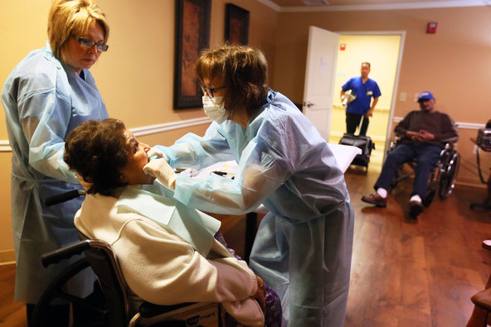

The Need

For too many low-income older adults living in long-term care residences, the lack of any basic dental care is staggering. Some dental treatment resources exist; yet, large numbers of this older adult population do not receive any dental care and suffer from general poor dental health, as well as a full range of dental maladies including periodontal disease, dental caries (tooth decay) and abscess. Additionally, even where resources are available, the logistics of providing treatment to this target population quite often renders care unattainable. We set out to tackle this problem.

HealthySmiles Pilot. Our 2015-2016 pilot project, HealthySmiles, provides basic dental treatment to Northern Virginia’s low-income older adults living in long-term care residences. The pilot is testing different approaches to treatment (to “kick the tires”/assess feasibility) and identifying an array of providers and treatment options – focusing on attracting local dentists, clinics, dental schools and government partners, to provide sustainable services for the target population. We have identified areas for cost efficiencies (e.g., maximizing patients provided treatment with mobile dentistry services, groups for in-office visits). We are working with local agencies, other nonprofits and facility management/staff to ensure coordination of efforts and to make sure that all available existing resources are utilized.

Portable Dentistry Has Emerged from Our Pilot. What has emerged most from our pilot is that, while the cost of oral care is the biggest issue facing this need, the logistical challenges are a close second. These dual challenges can more readily be addressed with a focus on treatment in the facility – a focus on portable dentistry and care.

Initiative Timeframe. Our initiative will continue through the end of Calendar Year 2019. Beyond, we are determined to establish a broader, more expansive and sustainable program.

Anticipated Initiative Goals. Our efforts are focused on providing care as follows:

Group 1  225-275 patients | Exams, Basic Cleaning, X-Rays, Development of Treatment Plans
Group 2  225-275 patients | More Extensive Dental Treatment – Cavity Fillings, Gum Disease Treatment, Scaling, Other
Group 3  TBD | Root Canals, Implants, Dentures – In coordination with local agencies, clinics and existing resources

Community Impact. Impact includes: (1) cost-effective treatment for a significant number of low-income older adults; (2) development of a robust mobile dentistry treatment approach that will reach many more individuals than the traditional office or clinic approaches; (3) increased attention to the need for dental care for this population ‒ people are rather shocked that this need is not being adequately addressed and would like something done about it.

Stakeholders and Community Support. We are coordinating with various stakeholders, including public officials, Area Agency on Aging organizations, citizen groups focused on the needs of older adults, long-term care residences, affordable housing organizations, families and others focused on the needs of older adults. (Our founder, Thomas Fonseca, is a former Chair of the Arlington Commission on Long-Term Care Residences, former Vice Chairman of the Arlington Commission on Aging, former Chairman of the Arlington County Community Services Board, a Northern Virginia Volunteer Ombudsman, the 2014 Recipient of the Virginia Elder Rights Coalition Award and a former nine-year volunteer guardian to a nursing home resident.)
Sustaining the Project. We see the development of a sustainable mobile dentistry treatment approach having a significant cost-effective and logistical impact on the provision of dental care to older adults. It makes sense from many perspectives, particularly the logistics of providing care to the target population. We are also working with community partners ‒ long-term care facilities (which provide in-house space, staff support, needed water hook-ups, etc.), affordable housing organizations, government agencies and others. Our experience to date and coordination with “buy-in” by facilities makes us uniquely qualified to manage this effort and attain actual results.

About The Fenwick Foundation
Our Vision and How HealthySmiles Fits

The Fenwick Foundation was founded in 2011 to provide services for unmet and “below the radar” needs that have a beneficial health and life-quality impact on low-income older adults, Veterans, and others with special needs. Our major initiative, Enriching Lives, focuses on providing a wide range of quality outings and activities designed to get individuals “out of the house” - to foster improved quality of life and health, combat loneliness and isolation, and address the palpable sense of boredom that so often exists at long-term care residences. We also have a very popular in-facility gardening program, which promotes physical activity and encourages the formation of gardening clubs for residents to become actively involved with beautification initiatives at long-term care residences - their homes.
As part of our strategic growth plans, our dental care initiative moves us into the realm of direct health care but for the same reasons – because there is a clear and “NOW” need, it is an “under the radar” problem, and because, to be successful, the impediments to care ‒ cost and logistical challenges ‒ must be successfully addressed. Our experience, as well as the success of our dental pilot, gives us unique capabilities to successfully tackle our new dental initiative.

More about The Fenwick Foundation

Website: www.thefenwickfoundation.org

Facebook: www.facebook.com/fenwickfoundation

Twitter: www.twitter.com/fenwfoundation

