Site Solutions

P.O. Box 1903 • Orinda, CA 94563 • 925.377.0199 • sitesolutions@hotmail.com

Remote Assessment Pictures

Contact Information
Name: |  | E-Mail:
Telephone:

Picture Instructions
Pictures are used to help identify potential risks and possible solutions and will be reviewed during the on-line portion of the assessment. Please take the following pictures, examples below, and e-mail them to sitesoultions@hotmail.com, prior to the assessment. Smart phone pictures work well, they are
easy to take and send.

Picture Analysis
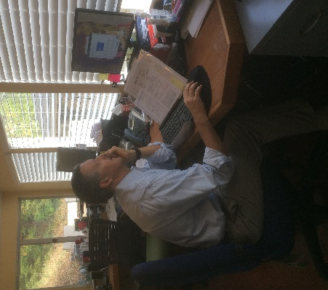 | Example 1  Take a profile picture of you in the workstation. Make sure it shows how you are positioned in the workstation. Take it from far enough back so the chair and monitor are included in the picture.
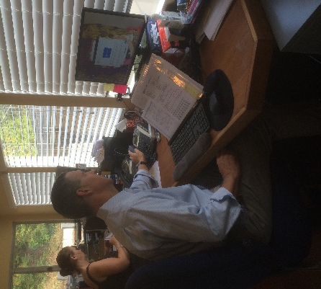 | Example 2  Take a profile picture showing an activity that causes discomfort. Make sure it shows how you are interacting with the workstation.
Additional Picture: Optional | Please add an additional picture of the workstation that illustrates an area of concern to you.

Please e-mail pictures to Site Solutions: Sitesolutions@hotmail.com

