RSAI Position Paper
Transportation Equity: A 2019 Legislative Priority

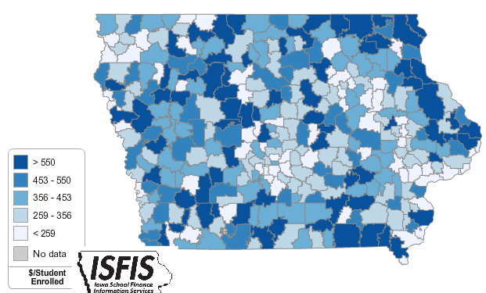
Background: In the 1950s, Iowa had over 4,000 school districts. Students could walk to their neighborhood school and transportation costs were nonexistent for Iowa school districts. As budgets have tightened and enrollments continue to decline, Iowa now has 330 districts (FY 2019) with varying square miles per pupil and hugely varying transportation costs.
Iowa’s foundation formula does not recognize the sparseness of population, square mileage or route miles for school districts, the number of students transported, or variance in road or geographic conditions. Transportation costs are paid out of the school general fund.
Current Reality: the following statistics describe current transportation inequities today from the DE FY 2018 Transportation Report:
- FY 2018 State cost per pupil was $6,667. There were 45 Iowa school districts that required at least 10% of that general fund cost per pupil for transportation.
- The range in transportation expenditures varies from a low of $18.84 to a high of $ 1,196.64 per student enrolled. Square miles per district range from a low of 2 to a high of 555 square miles, and route miles range from a low of 745 to a high of 978,903 miles.
- Property tax characteristics, including low valuation per pupil and corresponding higher tax rates, create challenges for districts with low tax capacity to pay for buses out of PPEL or Sales Tax funds, further stressing the general fund budget. When districts have larger transportation costs, both taxpayer and student inequities worsen.
- General fund dollars spent on busing would otherwise pay for staff and teachers (salary, benefits, training, support), curriculum, programs, technology, and energy. Lack of resources in these areas creates an unequal educational opportunity for students in rural districts.
- SF 455, enacted in 2018, provided $11.2 million for those districts with the highest transportation costs in the state. That funding was provided as miscellaneous income to an estimated 143 school districts, which means that over 80 school districts with transportation costs above the statewide average of $314 per pupil enrolled did not benefit. Funding must be more certain, as part of the formula, in order to provide enough certainty for school budgeting purposes if students in rural Iowa are to be treated equitably.
RSAI calls on the Iowa Legislature to address the issue of Transportation Equity: Supports a mechanism that covers school transportation costs that does not unreasonably disadvantage property tax payers in property poor districts or compete with general funds otherwise spent on providing education to students.

