**Monday-Thursday**

7 Courses for 2 People - $130

The Feast of the 7 Fishes

**SAMPLE MENU.RESTRICTIONS MAY APPLY.**

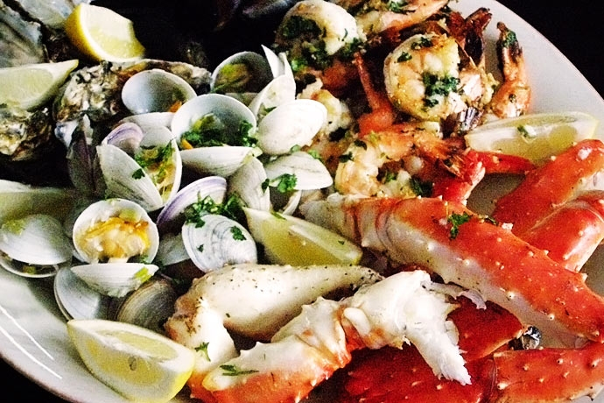

Primo.

**Cozze Gratinatte**- Green Shelf Mussels baked Tuscany style

Secondo.

**Crochette di Pesce** –White fish cakes, remoulade sauce

Terzo.

**Crema di Aragosta**- Chef Nicola’s Lobster bisque

Quarto.

**Insalata alla Pescatora-**  Baby shrimp, beans, lentil, celery, lemon basil vinaigrette.

Quinto.

**Spaghetti alle Vongole**- Homemade spaghetti, clams, garlic, white wine

Sesto.

**Lasagna di Mare**- House made seafood lasagna, Vodka sauce.

Settimo.

**Branzino in Aqua Pazza**- Chillian Sea bass, white wine, tomato broth, peas

**Nicolacolumbus.com 614.459.7000 4740 Reed Rd. Upper Arlington, Oh**