CENTER DIRECTOR: NANCY LEE

ASSISTANT DIRECTOR: DEANA DILLON

TELEPHONE: (614) 837-3020 / FAX (614) 833-6471

HOURS: MON-FRI: 8:30 a.m. - 4:30 p.m.

As of September 2022, our Center will be open
Monday-Friday 8:30 a.m. – 4:30 p.m.

WEB PAGE: http://pickeringtonseniorcenter.org
EMAIL: NLee@pickeringtonseniorcenter.com
EMAIL: DDillon@pickeringtonseniorcenter.com

Follow us on Facebook at:
Pickerington Senior Citizens Center

MEMBERSHIP INCENTIVE PROGRAM
Any member who signs up four new members will receive a $25.00 Visa Gift Card. Tell Deana to put your name on the form when you refer a new member.

THE BOOSTER CLUB
We appreciate any contributions made to our Booster Club. The money donated helps with funding activities for our members and with purchasing items needed for our kitchen, office, and other supplies.

Lori Cope, Kate Custer, Terrie Daroe, Debra Daugherty, Brenda Durran, Margie Exenkamper, Diane Federer, Linda Johnson, Pam Keeler, Anna Logan, Carol Lowy, Darla O’Connor, Janette Scott, Joyce Sloan, Helen Talbert, Sarah Tonetti, Wayne Upton, Sally Varvel.

PANCAKE BREAKFAST
We will not have a Pancake Breakfast this October.

VOLUNTEER OF THE MONTH
Our Center would like to honor John Samborsky as Volunteer for the month of October. John is in charge of noodles, from purchasing supplies to production of the noodles. He also sells them at community activities such as the Lions Club Fish Fry. John will receive a $15.00 gift card. Enjoy your reserved parking space for the month of October.

FRIENDLY TIES SQUARE DANCING
Fall dance lessons have resumed on Tuesday evenings from 7-9 p.m. as of September 13, 2022 to May 23, 2023, except November 8th (Election Day) and December 27th (holiday break). All our dances are on Sundays from 7-9:30 p.m.

HEAL2TOE FOOT CARE SERVICES
Thursday / October 6th & 27th / 9 a.m.
Tonia is a State of Ohio Registered Nurse. She charges $35.00 for the following:
- 30-minute treatment – Trim, thin & file nails
- Corns & callouses filed & buffed smooth
- All tools are sterilized for each patient
- Payment due at time of service – Self-pay only
- No Medicare or Insurance will be billed
To schedule an appointment at our Center call: HEAL2TOE FOOT CARE SERVICES (614) 686-3646.

ANNUAL SOUP DINNER & BINGO
Thursday / October 13th
Your choice of either bean or vegetable soup. Let us know which you would like when you purchase your ticket. You’ll turn in your ticket when you get your soup. The cost is $7.00 for soup, dessert, coffee or iced tea, and bingo. If you’re only playing bingo, the cost is $3.00. Soup will be served from 5-6 p.m. Bingo starts at 6:30 p.m. We’ll have two groups working, one for dinner and the other for bingo. If you’re willing to help, please call Annabelle Marion at (614) 855-7339.

UP COMING BOARD OF TRUSTEES ELECTION
We will be electing 3 members to our Board of Trustees for 2023. If you are a member of our Center, a resident of Violet Township, and are interested in running for our Board of Trustees, OCTOBER 15, 2022 is the DEADLINE TO NOTIFY our Board president Doug Hoek by telephone at (201) 739-7241 or by email dhoek1088@aol.com to have your name on the ballot.

NOODLE MAKING
We will be making noodles on Tuesday, October 4th and Tuesday, October 11th at 8 a.m.

EUCHRE TOURNAMENT
Saturday / October 15th / Lunch noon / Euchre 1 pm

Patty Bond and Sunny Schewe will be hosting our 14th Euchre Tournament at our Center. The cost is $5.00, to be paid in advance. Tickets are now on sale in our office. You do not need to be a member to participate.

SELF PRESERVATION/PERSONAL SAFETY CLASS
Tuesday / October 18th / 2 - 4 p.m.

The Fairfield County Sheriff’s Office will be holding this class at our Center. It will begin with a Power Point presentation discussing situational awareness and personal safety tips and then turn to hands on self-defense instruction led by a certified Gracie instructor. It will be tailored for seniors.

GARAGE SALE
Saturday / October 22, 2022 / 8 a.m. - 2 p.m.

Cost for tables: 12-foot table - $15.00
6-foot table - $10.00
Card Table - $5.00
You can set up your table and merchandise on Friday from Noon – 3:30p.m. If you’re unable to do your set up on Friday, you can set up Saturday morning at 7:00 a.m. For anyone interested, Inferno Pizza (John) will be selling pizza by the slice. Our Garage Sale last year was a great success! Come join us this year for all the great deals and fun!

HUMANA
Friday /October 28th / 11:30 a.m.
Talk with a Doctor! Bring your questions and you’ll get answers. Come to our Center and meet Cyndi Grotsky with Humana Insurance and Laurie with Dedicated Senior Medical Center.

PICKERINGTON FOOD PANTRY
Some of the most needed items are personal hygiene products, soap, paper towels, toilet paper, toothpaste, toothbrushes, spaghetti & sauce, juices, condiments, tomato (paste, sauce or diced), baking & pantry staples (flour, sugar, salt, baking soda & spices), peanut butter & jelly, bread, and butter. We have a collection container in our library.

We thank everyone who has donated to the Food Pantry. These items are very much needed and greatly appreciated! We hope you will continue to support us to aid those in need at this time.

UPCOMING ANNUAL BREAKFAST WITH SANTA
We are accepting donations for gifts for the children to “shop” for during the party, as presents they can give to their family members for Christmas. Some suggestions are: puzzle books, jewelry, knick-knacks, figurines, empty Pringle cans. Please bring your donations to our Craft room. If you have any questions, contact Jeanne Carroll at (740) 862-6055.

STRENGTH CLASS
Mondays and/or Wednesdays / 10 - 11 a.m.

Join us at our strength classes led by Kelley Deibert. The focus is on building upper and lower body strength, stretching, and improving your balance. Bring your own weights. If you need a stretch band Kelley has bands, you can purchase for $2.00.

LINE DANCING
Mondays / 11:15 a.m. - noon

You can sign up for 12 weeks for $12 or register to “pay-per-class” at $1 per class. Sign-up forms are available in our office or from our instructor Marilyn. Make checks payable to Marilyn Morgan.
For additional information contact Marilyn at: mnm@columbus.rr.com

BID EUCHRE
Mondays / 12:30 p.m.

We play bid euchre every Monday at our Center.

WATERCOLOR CLASS
Every Monday / 1-3 PM
Join Jenene Warmbier for adventures in watercolor painting. Jenene is a great teacher. No previous training, or talent necessary, just the desire to express yourself with “Paints and Brushes.” You can stop in our office and get a list of supplies you will need for the class.

CORNHOLE
Every Tuesday / 11 a.m.
We play Cornhole every Tuesday. We have a tournament on the last Tuesday of each month, with prizes for the winning team. The winning team for the August Cornhole Tournament was Bill Dunnette and Ray Knight. Cornhole is open to both men and women. Come and join in on all the fun!

MAH-JONGG
Tuesdays / 12:30 p.m.

We play Mah-Jongg in our Card Room. Both experienced and new players are welcome! Please call our office at (614) 837-3020 if you’re interested in joining us.

HAND AND FOOT
Tuesdays / 1:00 p.m.

We play the card game Hand and Foot in our Card Room every week. Each player is dealt two sets of cards, the hand, and the foot. Come join us and learn how to play this fun game!

BINGO
Tuesday /October 25th / 1:00 p.m.
This month we will play Bingo on the 4th Tuesday. No Potluck this month. Bingo starts at 1:00 p.m. The cost is $1.50. We will resume playing on the 2nd and 4th Tuesdays of each month as of November.

TUESDAY AFTERNOON MATINEE
October 11th / 1:15 p.m.
Join us at our Center for a classic movie on our large screen t.v. The movie for the month of October will be “Field of Dreams” featuring Kevin Costner, Ray Liotta, James Earl Jones, Amy Madigan and Burt Lancaster. We’ll supply the movie, popcorn, snacks, coffee, and water. You may use our chairs or bring your own folding chair.

CRAFT GROUP
Every Wednesday / 10 a.m. – noon
Our craft group offers fun activities for our members, but also raises money for our Center. They provide tray favors for two carry out meals which our Center provides for our shut-in members. Another important fundraising activity the Craft Group participates in is our Breakfast with Santa, usually held on the first Saturday of December.

SEWING CIRCLE
Every Wednesday / 1:00 – 2:30 or 3:00 p.m.
We now have a sewing circle and would love to have anyone interested in sewing, knitting, crocheting, cross stitch or needlepoint come and participate. We get together to sew and to socialize in our craft room. Bring along your own project and materials and join us!

DUPLICATE BRIDGE BRIDGE
Wednesdays Thursdays
9:30 a.m. 12:30 p.m.
We’re looking for more members to play Bridge. Anyone interested in joining us, please call our Center and give your name and phone number. The cost to play either Bridge or Duplicate Bridge is $1.00 per week.

EUCHRE
Every Wednesday / 12:30 p.m.
Come in, join your friends, and play some Euchre. We start playing at 12:30 p.m. The cost is only $2.25 which includes the games and the loner pot. Please be here at least 10 minutes ahead of time to get signed up so we can begin on time at 12:30.

TITLE BOXING
Thursdays / October 6th, 13th, & 20th

Maria Manzo from Title Boxing will lead the class at our Center from 9:15 to 10 a.m. Sessions are around the Rock Steady Boxing curriculum which increases the neuroplasticity of the brain to help produce healthy brain cells. The exercises are designed to improve quality of life, have fun, and get results - all at the same time! You can purchase a bag and gloves for $25.00 at the class.

CHAIR VOLLEYBALL
Thursdays / 11:30 a.m. / October 6th, 13th, & 27th
We play Chair Volleyball at our Center on Thursdays. It’s led by Darie Wilson. No need to sign up, just show up on Thursdays and join in the fun. We now have 2 nets. If you have any questions, please call Darie at (740) 358-6394.
FRIDAY FITNESS CLASS
Every Friday / 9:15 – 10:00 a.m.

This is a 45-minute Cardio Class. It’s a total workout. Come see the power you have and make great things happen for your health and well-being. We have plenty of room for you to move and groove to great music with instructor Maria Manzo.

SOCIAL EUCHRE
Every Friday / 11 a.m.

This is a relaxed pace Euchre game where we can meet and play cards non-competitively. If you like to play cards for fun and you don’t mind teaching others when needed, then please join us. We welcome anyone who wants to play cards.

GAME ROOM
Our Game Room is open all day, Monday through Friday. We have a shuffleboard table and a dart board. No need to call ahead, just come and enjoy.

LIBRARY

We have videos, puzzles, and a large selection of books to choose from. Come check out our cozy library. We are currently in need of large print books for our library. If anyone has any large print books to donate, we would appreciate it.

EQUIPMENT

Our Center has several walkers and a wheelchair that are available for our members to borrow. Just give us a call at (614) 837-3020 to check availability and we will have it ready for you to pick up.

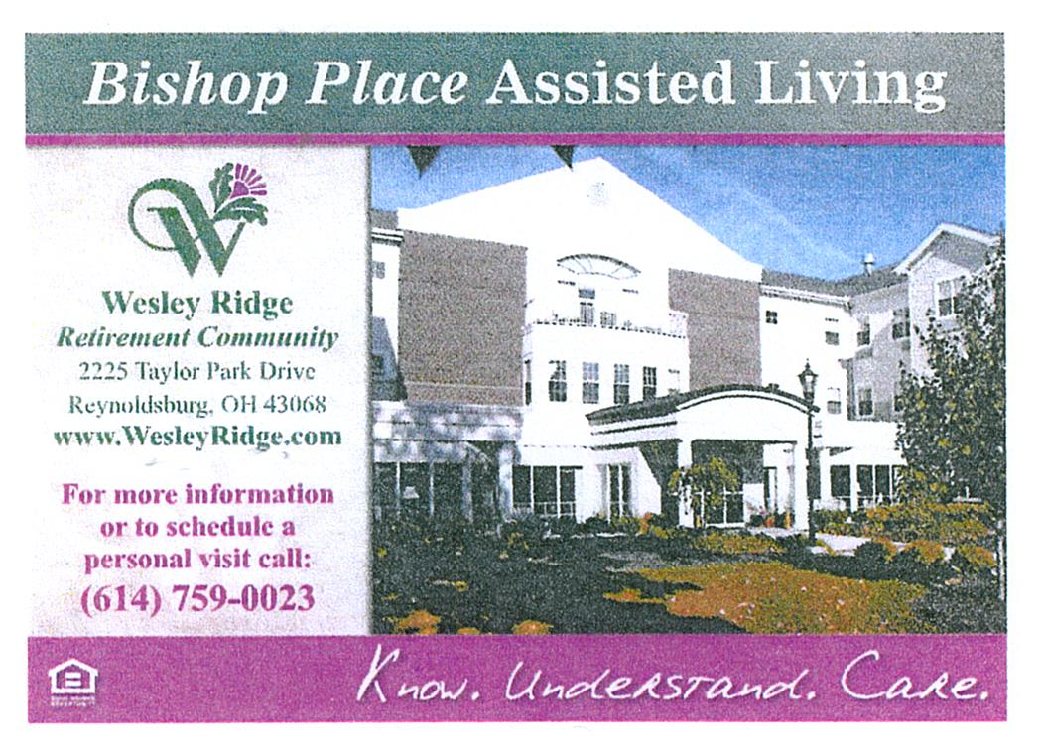
TRIPS FOR 2022

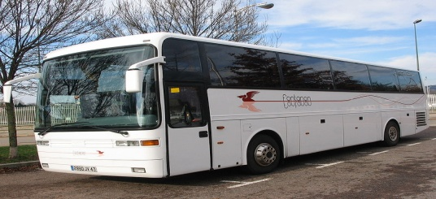

LACOMEDIA DINNER THEATRE
Black Patent Leather Shoes – Thurs. / Oct. 6th
The motorcoach will leave our Center at 8 a.m. Please be here before 7:45 a.m. to check in.

SNOOTY FOX
Wednesday / October 19th
Join us as we venture to the Cincinnati area for a shopping adventure full of fun, food, and great deals! We’ll visit 4 upscale clothing and furniture thrift stores and enjoy beverages, danish, snacks, a boxed lunch, dessert, and wine tasting along the way. Different items at each stop but beverages at all of them. They accept cash and major credit cards, no checks. This trip will be a blast so grab your friends. SPACE AVAILABLE
Cost per person: $41.00 - due on sign up

TIMELESS HOLIDAY TREASURES
Thursday / November 10th
We start the day at Hartville Kitchen where we’ll shop at the bakery & roam around their shops to check out jewelry, clothing, handbags and the Candy Shop. Get your goodies before we depart for lunch & the Dazzling Diamond Variety Show, a 1-man performance featuring the music of Neil Diamond & the stories that inspired the songs. After the show we head to Hartville Flea Market featuring over 100 unique shops of fashion, crafts, antiques, home décor and more. If we have time, we’ll stop at the World’s Largest Hardware Store. It's so much more than a hardware store, it has
everything for men and women, and great Christmas items. SPACE AVAILABLE
Cost per person: $121.00 - due on sign up
New TRIP - LACOMEDIA DINNER THEATRE
White Christmas / Wednesday / November 16th

The classic film White Christmas is the inspiration for this heartwarming musical comedy about two veterans who have a successful song and dance act after World War II. With romance in mind, they follow a duo of beautiful singing sisters to their Christmas show at a Vermont Lodge. It features songs “Blue Skies,” “Sisters” and the most famous holiday song of all “White Christmas.”
Cost per person: $63.00 – due on sign up
Sign up starts on Monday, October 3rd

NASHVILLE, TENNESSEE
December 4th – 7th
Enjoy 3 Nights lodging at the Gaylord Opryland Hotel. During your free time at the hotel you can walk around and visit the many shops and step aboard a Delta Riverboat and enjoy the lush indoor gardens while a guide offers unique facts about all the plants and fish. WAITING LIST
Final payment due before October 10th

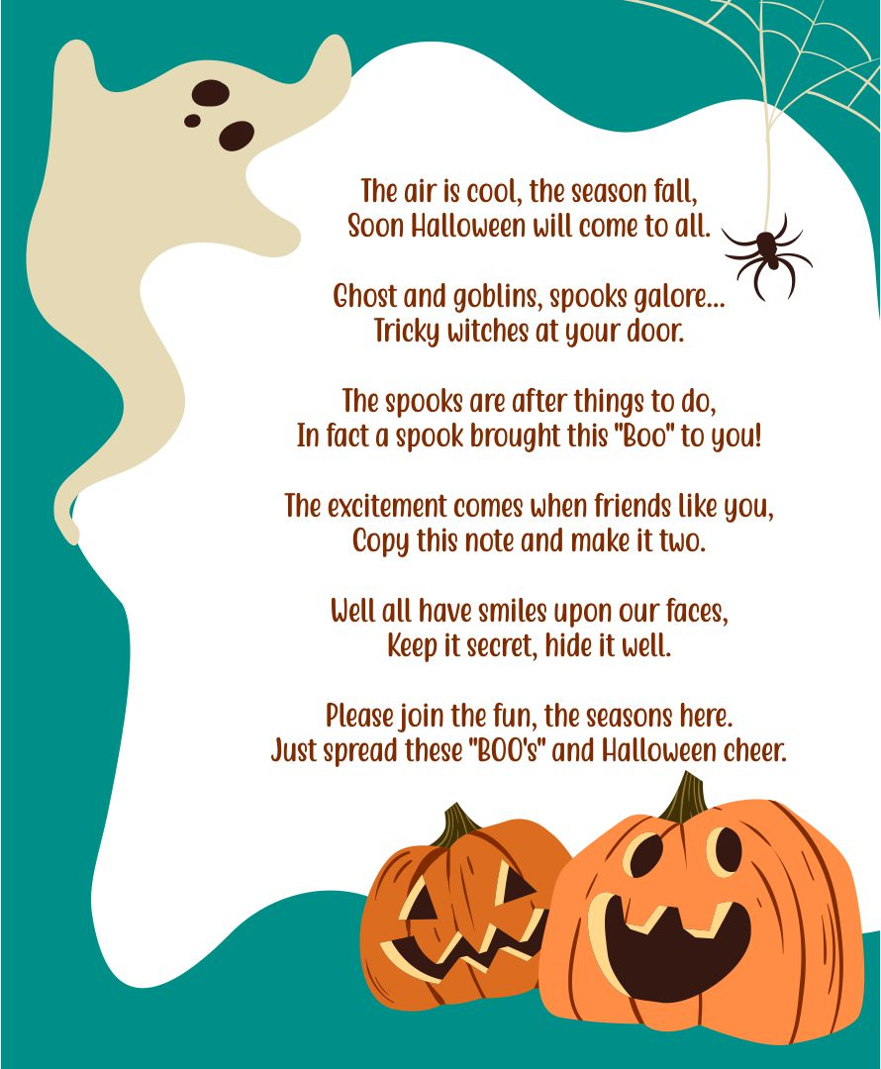
NOTES FROM DEANA 😊

(1) Robert Cubra, Nellie Nihiser, Maggie Shinn; (2) Jacqueline Bennett, Martie Dillon, Susan Mason, Candi Moore; (3) Debbie Joseph, Angelo Manzo, Peggie Rice; (4) Jeannie Paul, Marilyn Spence; (5) Susie Mueller; (6) Wallie Carpenter, Lily Chou, Faith Hoek, Gertrude Stacoffe; (7) Lilia Checca, Ellen Mastracci; (8) Julie Larson, Annie Vigil; (9) Joann Westlake; (10) Maryann Bowen; (11) Bill Morgan; (12) Linda Frazee; (13) Wayne Schultz, Larry York; (14) Margaret Centofanti; (15) Betty Burk, Donna Short; (16) Jim Barber, J. Elaine Greiner, Charles Guinstead; (17) Lauretta Bain, Ken Ellinger; (18) Carol Focke, Bill Haislet; (19) Marilyn Burkart, Jeanne Carroll, Jim Joseph, Kenneth Schneider; (21) Bud Delong, Sharon McDougal, Jerry Pocta, Carolyn Smith; (22) Hilda Coldsmith, Richard Smith; (23) Carolyn Fenlon, Thomas Laughery, Pauline Limback, Patty Moone, Grace O’Connell; (24) Rod Frazer, Margretta Heath, Howard Illian, Debra Sherman; (25) Joseph Douglas, Dee Machinski, Mike Welling; (26) Martha Gravatt, Ann Harper, Connie McClellan; (27) Barb Smithberger; (28) Julia Archer, Susan Pocta; (29) Charlene Hertzer, Pat Roper; (30) Lynn Wilcox; (31) Gordon Burke, Richard Erwin, Chris Foley, John Samborsky.
MEMBERS IN SORROW
Ann Hackworth’s sister passed

MEMBERS KNOWN ILL
Ellie Berry - broken leg
Ann Harper - back surgery
Craig Luzader - surgery

Thursday / October 27th / 1-3 p.m.

Our Center, Brookdale Senior Living, and Embassy of Pickerington will be hosting our 4th Annual Halloween Party. There will be snacks, games, music, and prizes for the best costumes.
Tickets are FREE
RSVP IN THE OFFICE BY THURSDAY, OCT. 20th

iPHONE TRAINING CLASS
I will be hosting another Apple iPhone training class on Friday, October 21st @ 9:30 a.m.
PLEASE SIGN UP IN THE OFFICE

-

Thank you, Ed Drobina for volunteering to help around the center with building maintenance when needed.

Also, thank you, Mary Boyer for purchasing and planting the beautiful mums in our flowerpots out back. We appreciate you both!!

