[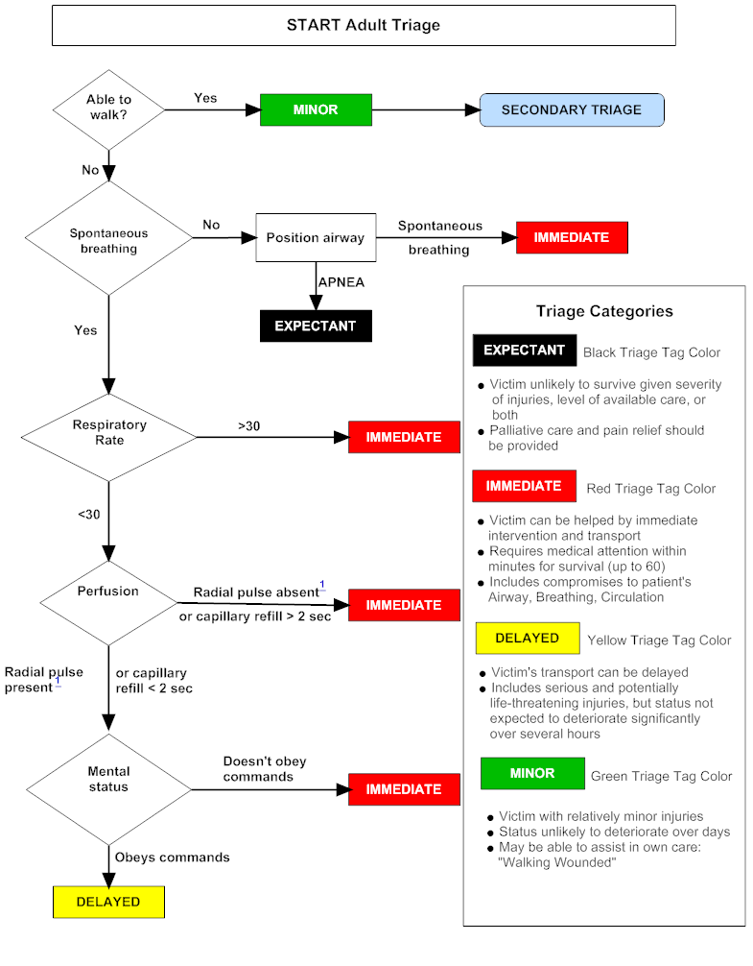](http://www.google.com/url?sa=i&source=images&cd=&cad=rja&docid=MmJ9rUYkCWQBjM&tbnid=cSTiBGQeB3vxRM:&ved=0CAgQjRwwAA&url=http://chemm.nlm.nih.gov/startadult.htm&ei=Kgi6Uf7VGejV0QGpioHYDA&psig=AFQjCNHsE9Dd4uHQ9k1pCT_kIWVcyi5XVw&ust=1371232682451308)