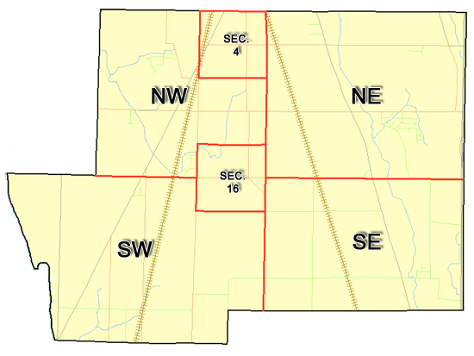 | Pleasant Township  Zoning Commission Minutes  1035 Owens Rd W.  Marion, Ohio 43302
Meeting called by: | Scheduled | Type of meeting: | Regular Monthly
Chairperson: | Mr. Holler | Secretary: | Stephanie Barkley
Timekeeper: |  | Date: Feb 16th, 2023 | Time 7:30 pm
Call to Order by: | Mr. Holler Moment of silence followed by the pledge to the flag.
Roll Call: | Jack Dean, Harry Holler, Tom Leib, Dwight Williams, Joe Thompson, Tyron Canterbury  Stephanie Barkley
Minutes: | Read and approve minutes from previous meeting.  Motion to approve minutes by: Mr. Leib Seconded by Mr. Canterbury: All approved
Attendees Address Board: Have sign in sheet on desk by door.
Type in attendees and addresses: see attached
.
----- Agenda Topics -----
Business
Zoning Reports: | Zoning Inspector goes over reports and provides copy to board.
Unfinished:
New:
Announcements: | Next meeting will be March 16th ,2023
Adjournment: | Motion to adjourn by: Mr. Willimas and seconded by Mr. Canterbury , all in favor all approved

Pleasant Township
Zoning Commission Minutes

1035 Owens Rd W.
Marion, Ohio 43302
Business Notes:

 | Discussion:
 | Conclusions:
 | Action items: |  | Minutes signed by: | Date approved:
 | Provide copy of approved minutes to Zoning |  | Chairperson:
 | Inspector. File original in township office. |  | Secretary:
Other Information
Trustees Present: |  | Mr. Lust
Zoning Inspector:
Special Guests:

Minutes
The Pleasant Township Zoning Commission met for their regularly scheduled monthly meeting Feb 16th, 2023 at the Pleasant Township Senior Centre Zoning Commission Board Members were present: Mr. Dean, Mr. Leib, Mr. Thompson, Mr. Williams, Mr. Canterbury and Mr. Holler, and Secretary Miss Barkley and trustee Mr. Lust was present.
- Minutes were read from the Jan 19th,2023 regularly scheduled Zoning Commission meeting. There were no corrections to be made. A motion to approve the minutes was made by Mr. Leib and seconded by Mr. Canterbury. All members present agreed to passage of the minutes.
- Mr. Tom Baker Pleasant Township Zoning Inspector was unable to attend the meeting but gave us the reports that was read by Miss Barkley January was 4 permits, 1 violation. $720.30 was from permits. The zoning board went over a map that was provided by Mr. Baker on a proposed nursing home that possibly could be building in the township on the corner of Marion Cardington and 423. Mr. Lust reported that Clint Canterbury received a grant for the fire station to have full-time employees on staff by the end of March.
- Board members started going back through the zoning book started with 11.15 and ended at finish. Miss Barkley will reach out to Mr. Creasap to see if there is any additional changes in chapters 12-15 to see if there is any corrections that needs to be made. There being no additional business for discussion Mr. Williams made motion to adjourn, seconded by Mr. Canterbury Board Members in attendance agreed and the meeting was adjourned. The next Board Meeting will be held on March 16th ,2023 at 7:30 PM.

