GFWC BWC NEWS
  - club Monthly updates
PUBLIC ISSUES  We had a great speaker, Katrina Rodriguez, from Victim Services. She shared about her how she supports victims of crime.  She shared ideas about how the club can support her department: Used Cell phones, Laundry Detergent, Self Care Bags.  MLK DAY OF SERVICE  MONDAY, JANUARY 20  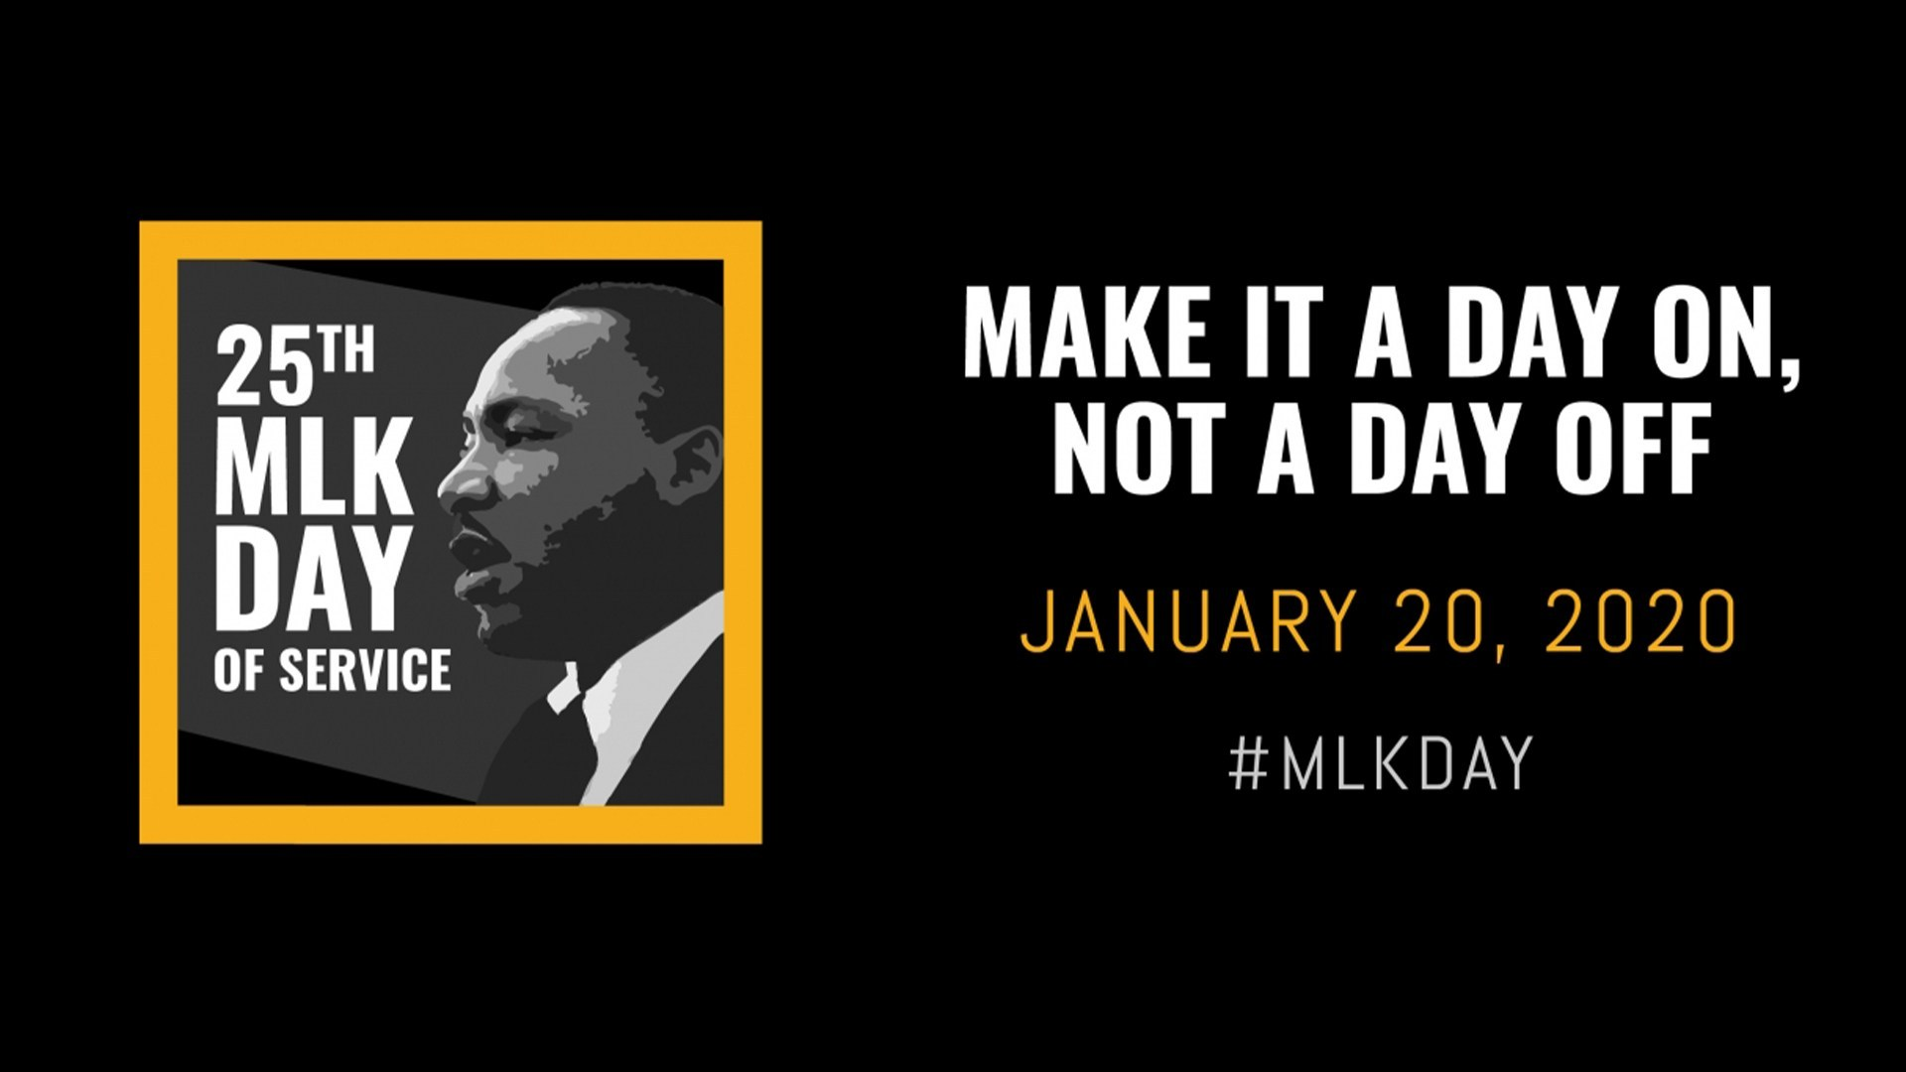  BLANKETS FOR PROJECT LINUS  Join us 10 – 1:00 at Pilgrim Lutheran Church to make fleece blankets for Project Linus.  Report planning meeting during blanket making. | SNACKS NEEDED  Granola Bars and Fish Crackers  Bring to February Meeting  For our LOCAL Elementary Schools  UPCOMING EVENTS:  February Club Meeting: February 4 th Elsie Stuhr  6:00 Tea Meeting 7:00 Club Meeting  Dr. Suess Day  Reading at Greenway Elementary: March 2nd  OFWC Leadership Seminar for Club members  March 14  Check out our WEBSITE  http://www.beavertonwomansclub.com/

