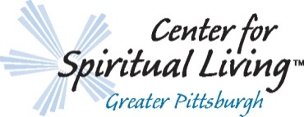
Membership Program 2018
Our Vision:
We are an open, vibrant, diverse spiritual community that inspires spiritual growth and encourages the realization of everyone’s full potential.

Our Mission:
To love and support a thriving community that teaches, nurtures, and empowers all in the use of universal spiritual principles in an atmosphere of love, positivity, and acceptance.

Membership:
All persons are welcome to join our community activities, classes, and Sunday Celebrations. Becoming a member is a step beyond that in dedication to your spiritual growth and support of the Center with the energy of your attendance and giving. The benefits are bountiful. Along with connection to a spiritual community and being part of a growing Center, those who choose to join CSL Greater Pittsburgh as members also enjoy additional benefits such as:
- Automatic membership in our parent, global organization, Centers for Spiritual Living
- Voting privileges at annual and special meetings
- Eligibility to serve as a group leader or trustee

As a member of CSL Greater Pittsburgh, you are supported with love, guidance, and inspiration; in turn, as a Center we thrive from your support of time, talent, and treasure as an expression of the giving nature of life.

Membership is a symbol of commitment to your spiritual growth as well as the growth of the CSL Greater Pittsburgh community!
----------------------------------------------------------------------------------------------------
Membership Form
Thank you for your interest in joining the CSL Greater Pittsburgh community as a full Member. Please provide the following information:

Name (please print clearly): _______________________________________________________

Address: ______________________________________________________________________

Home Phone: _____________________________ Cell Phone: __________________________

Email Address: _________________________________________________________________

By signing this Membership Form, I affirm my conscious alignment with the Vision and Mission of CSL Greater Pittsburgh and my loving commitment of the giving of my time, talent, and treasure:

______________________________________________________________________________
Signature Date

Please return this form by August 31, 2018.
You can turn in the form in person on Sunday at the Center or by mailing to:
101 W. Main Street, Suite 103; Carnegie, PA 15106

