INSTRUCTIONAL GUIDE / USERS MANUAL
IPORTAL - http://iportal4languages.eu/

Discover MY WORKSPACE
Attention!
In iPortal, always use buttons and links to navigate around the website. Avoid using the Back and Forward buttons of your web browser.

The tab MY WORKSPACE allows you to edit your Profile, join and manage Sites, add Announcements and much more. This is your personal space and you can customise it.

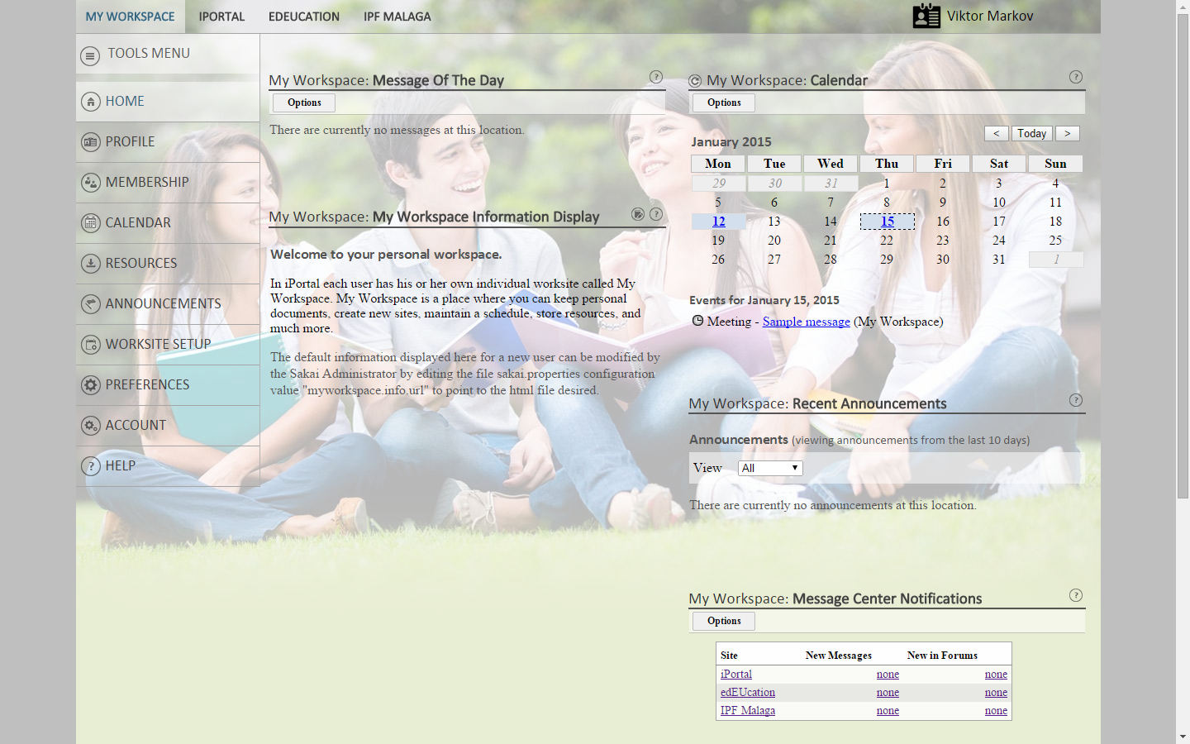

HOME: Here you can check your Messages and Announcements. You also have a Calendar to keep you updated on future Events.

PROFILE: Your Profile is where you can personalise your account by adding your profile picture and detailed information about yourself. You can also add pictures, compose a message, search other users’ profiles and edit your privacy settings.

MEMBERSHIP: This allows you to look up and join other accessible learning sites in the role of a student. Here you can manage your membership of other sites. Click on Joinable Sites to find and join a learning site.

CALENDAR: This is a tool where you can organise your day to day schedule. It’s very helpful to remind you of Exams, Deadlines, Activities, Meetings and much more. Here you will also find Events added by sites which you are a member of. You can also add your own events, visible just to you.

RESOURCES: Resources under My Workspace is the place where you keep your personal resources, not visible to other users. You can save resources from other joined sites, you can upload them manually or create a folder on your desktop where you can drag and drop files and folders between your computer and the site.

ANNOUNCEMENTS: Here you can add any announcements such as future meetings, assignment deadlines, scheduled lessons, etc. You can also specify the recipients of the announcement and it will appear in their Calendar.

WORKSITE SETUP: Here you can fully manage and setup your own sites or just partially the sites you are member of. They are all grouped under one tab. For more information read the “Manage a Site”tutorial.

PREFERENCES: You have the option to edit your settings and adapt your site to your liking. For example you can choose which joined sites you will have in the Top bar, how you receive notifications, change the language and time zone.

ACCOUNT: Here you can view or modify your login details.

HELP: The Help tab gives you a very detailed step by step guide on how to use each section. It is very useful when uploading and creating work.
Manage a SITE

Create a SITE

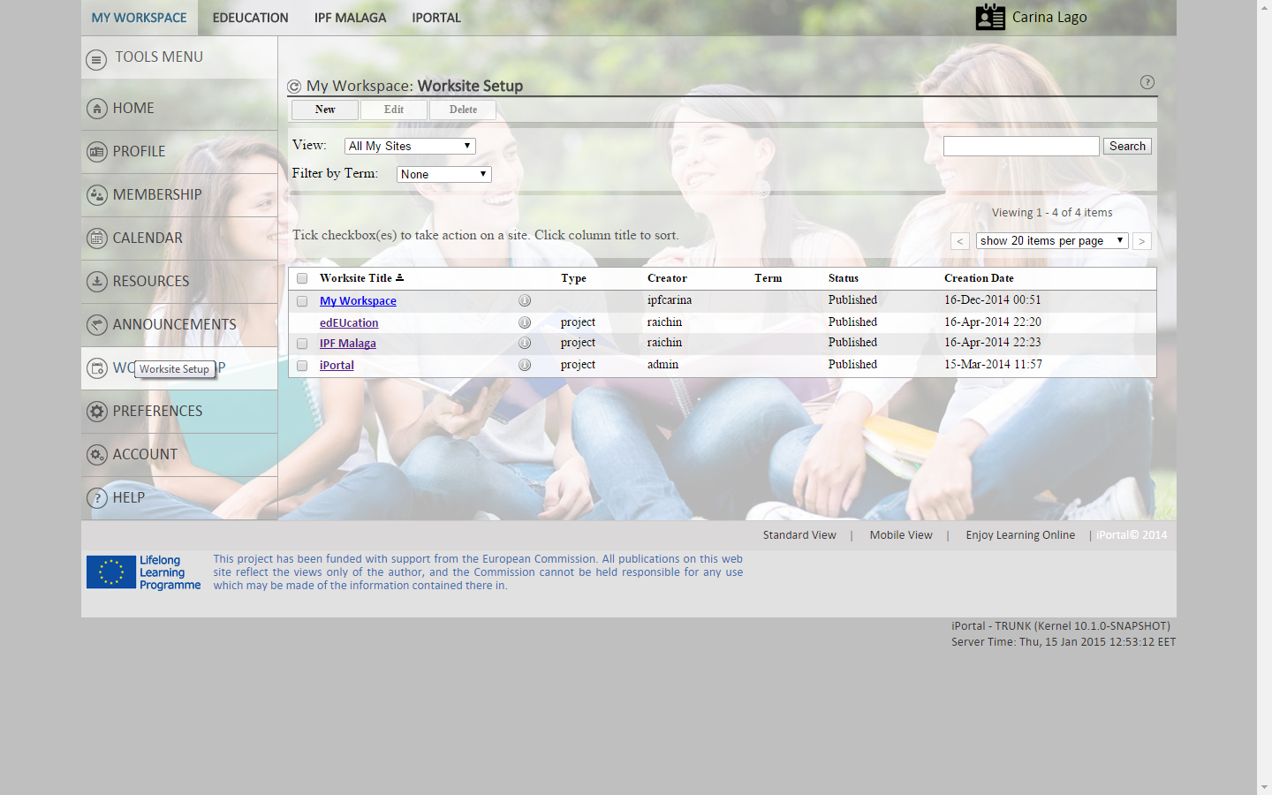

As a teacher you will first need to set up a site.
- Go to WORKSITE SETUP under MY WORKSPACE and click on New.
click on Continue

- Choose Course site or Project site.
click on Continue

- Then name it, choose the site language and fill in the necessary information.
click on Continue

- Then you choose the tools you want to include on your site. You can start with HOME, INFO, SITE MEMBERS, SECTION INFO and SEARCH.
click on Continue
- Choose whether you want to publish your site now, or later, whether you want to keep it public or private and how you want other users to access your site.
click on Continue

- Confirm your site setup selections and click on Create Site.

Congratulations, you have just created a site and your will receive a confirmation in your email.

Edit a SITE

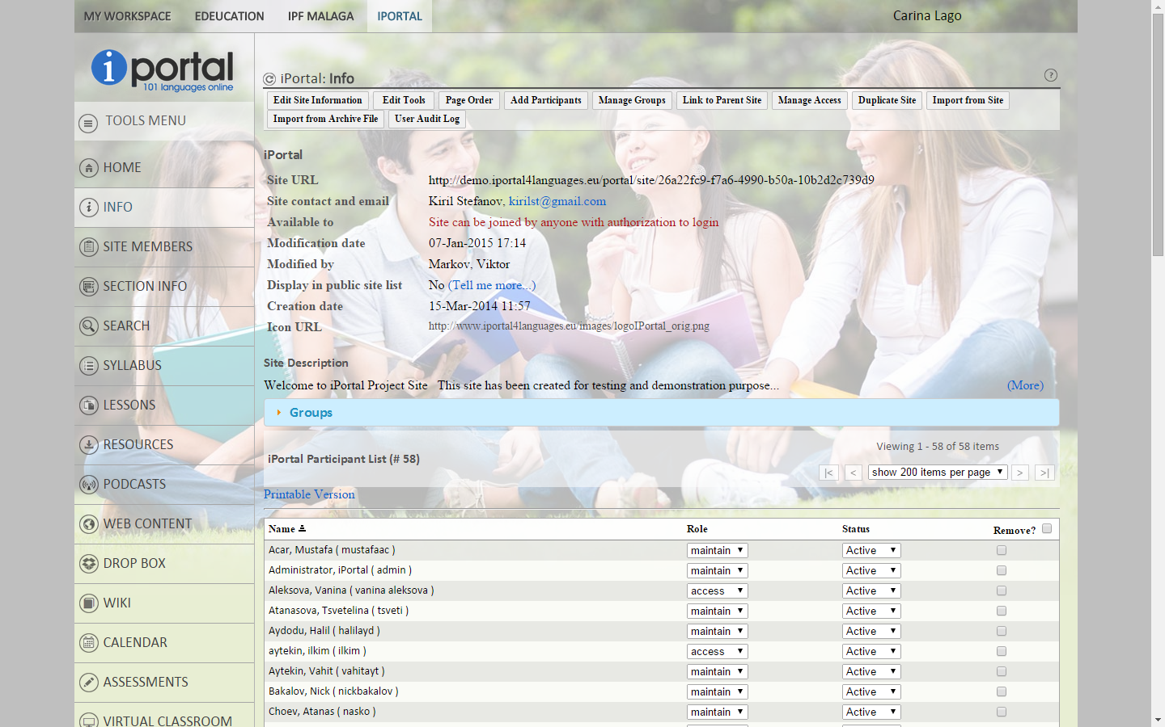

Now let’s explore how to edit the Site you have just created.
- At the top of the iPortal website click on the newly created tab with the title of your site. In the Tools menu on the left click on INFO.

- Go to Edit site Information to change the name, language or any information. Click continue

- Under Edit Tools you can add /remove the tools you would like to include on your site. Click continue

- Page order allows you to choose the order of how the tools will be viewed. You can also rename them, if you need. Click continue

- Add Participants is where you can add your students or who you would like to view your site. By adding the participant’s iPortal username or e-mail address you can choose to Activate or deactivate them. Click continue

- Choose how you would like to Manage Groups and create new groups by filling in all the required information. Click continue

- Link to a Parent Site simply means that for users who are members of two linked sites and have permission to view both sites, they will see navigation hints between the parent and child sites. Choose the Parent Site on the scroll down bar and link it to the site that you are working on. Click continue

- To go back to whom you would like to access your site click on the Manage Access option and change the site visibility. Click continue

- The Duplicate Site function is related to the possibility to start the same course anew. So you can keep all the content that you as a teacher have created and start working on a new session of courses with new participants. In the "Site Title:" field, type a name for the duplicate site; select the Academic term, and then click Duplicate

- You can import and combine information from other sites you may own under the option Import from Site. Click continue

- By clicking on Import from Archive File you can add material from your computer. Click continue

- User Audit Log shows you all the participants that have access to your site and the role they have.

How to Start a Course
This tutorial will show you how to start a Course. how to structure your Syllabus and Lessons, as well as how to use Resources, Drop Box, Calendar, Web Content and Assessments.
How to Structure a Syllabus
The syllabus is the official outline for your course. As a teacher, if you or your department has prepared an online syllabus already, you can direct the Syllabus tool to link to it. Otherwise, you can enter material to post directly to your syllabus. You can make your syllabus visible to the general public or just to members of your course.
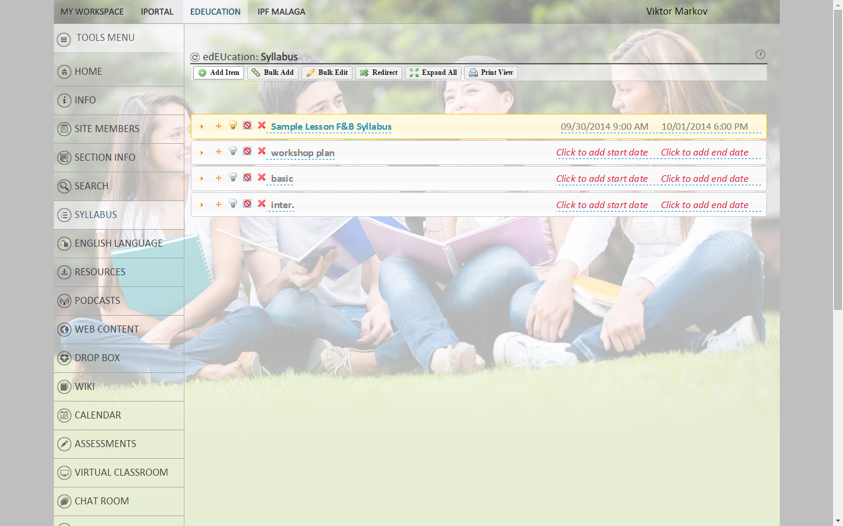
- To add a Syllabus you click on the Tools Menu bar and click Syllabus and then click Add. You must then enter a title for your syllabus item, and then enter your content. You can copy and paste text from another file (e.g., an HTML file or a Word document). Click on the tick when finished.
- Under "Attachments", you can attach a file from your local computer, from existing Resources or specify the URL for a file on the web.
- When you are finished, click Post to post the item, Preview to view it, Save Draft to save it as a draft, or Cancel to cancel. Click Update if you have just modified previously entered content to save the changes.
- To edit a Syllabus item click Create/Edit, and then click the name of the item you wish to edit. Once you have made the changes click Post. You also have the delete option when modifying Syllabus.
Getting Started with Lessons
Click on the tools menu bar and click Lessons, to add your content on this page select an option on the "Add Content" dropdown menu, where you will find the following options:
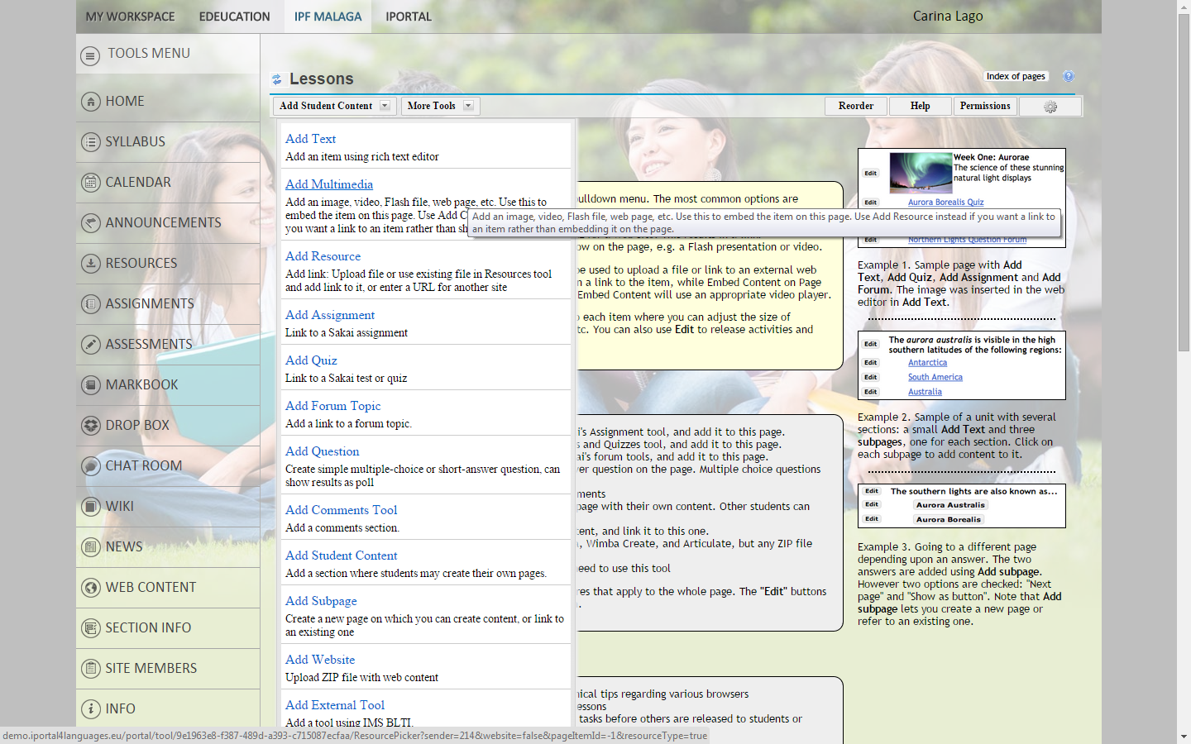
Add Student Content
Dropdown menu

- Add Text - type text using rich text editor. Click save

- Add Multimedia - Add an image, video, Flash file, web page, etc. Use this to embed the item on this page. You can upload an existing file or add a URL. Click save

- Add Resources - Upload a file or use an existing file in Resources tool and add a link to it, or enter a URL for another site. Click save

- Add Assignment – Here you will find a list of all assignments already created in the Assignments tool. Select the one you wish to add and use selected item. If you don’t have any assignments available you must create a new assignment by clicking Create new assignment using Assignments. This will allow you to create a new assignment or modify an existing one. When you are ready to add the new assignment, click the Continue with Add Assignment button at the top. That will return you to the list of assignments, where you can choose the assignment you’ve just created.

- Add Quiz – If you don’t have any quizzes available you must choose the option Create new quiz using Tests and Quizzes at the top of the page. Give your assessment a title, then choose an assessment type (Quiz). Click Create.
This will take you to the next step where you select a question type and follow the steps to add a question and answers. Click Save

- Add Forum Topic – If you don’t have any forums available you can create a new topic. New forums and topics can only be created by you or someone with your level of access. Use Forum Settings and Topic Settings to change the title and other details of this forum. Use Template Settings to set up a template for all new forums.

- Add Question - This function lets you add multiple choice and short answer questions to a Lessons page. These questions can be graded, or used as surveys.
To add a multiple choice question:
- Select Multiple Choice as the question type.
- Type in the text of your question under Question Text.
- Insert the possible answer choices under the Possible Answers heading. Press Add New Answer to add an additional answer choice, and check the checkbox next to the answer text to mark it as a correct answer.
To add a short answer question:
- Select Short Answer as the question type.
- Type in the text of your question under Question Text.
- Insert the possible answer choices under the Possible Answers heading. Press Add New Answer to add an additional answer choice.
For both question types you can grade the questions by supplying a title in markbook and giving a maximum number of points. You can choose to leave text for both correct and incorrect answers for students to view after they have given their answer.
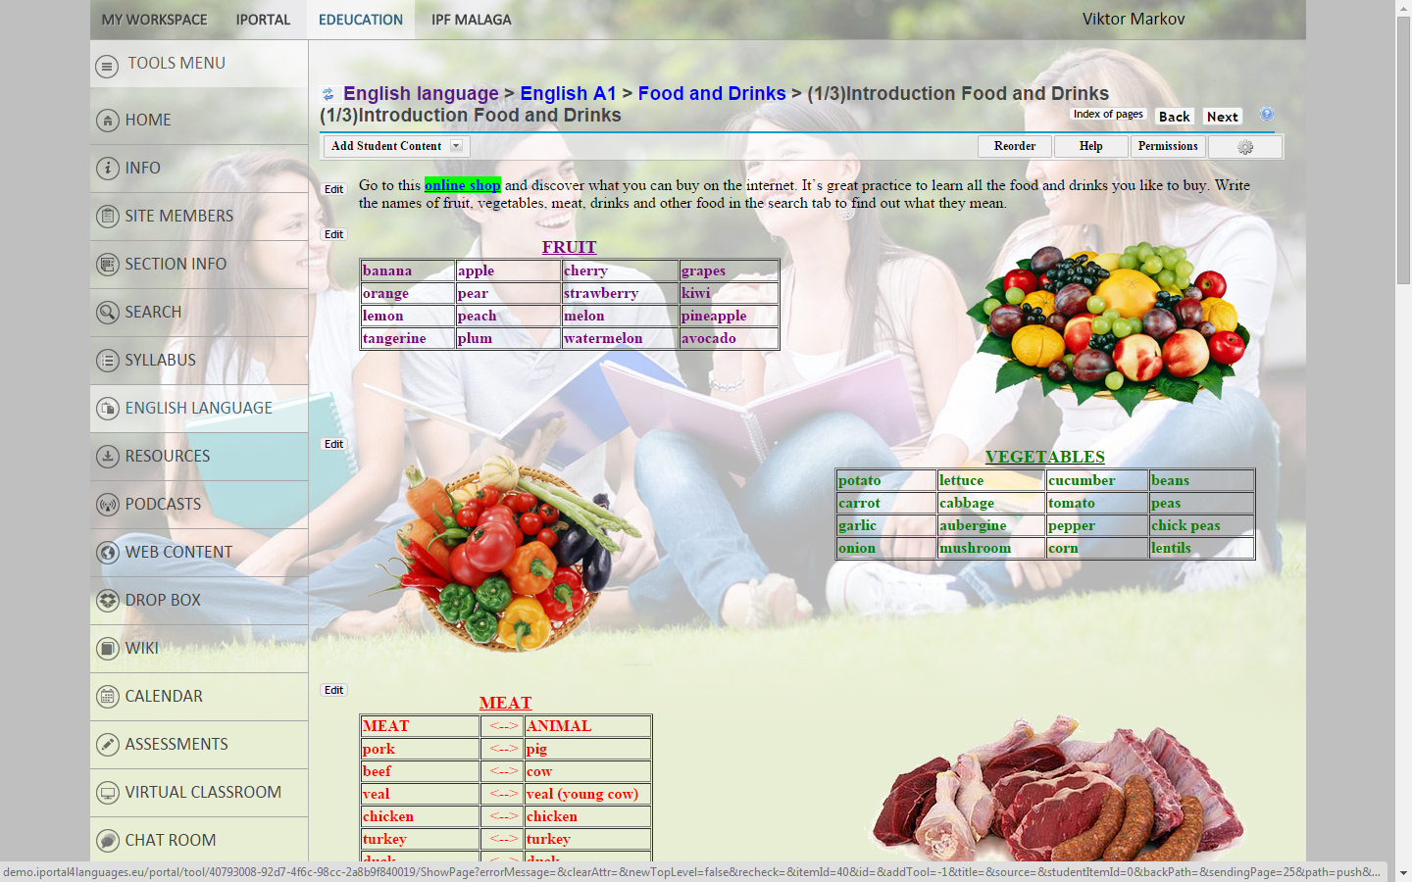
- Add Comment Tool – You can give the option of adding a comment to your students or yourself directly into the lesson content.
- Add Student Content - This tool allows students to add pages of their own. Those pages look much like regular Lessons pages, although there are fewer options. This allows students to share material with the rest of the class. There is an option to allow other students to comment on their work. Student pages can also be graded, or assessed according to a scoring rubric.
- Add Subpage - Create a new page on which you can create content, or link to an existing one. Select Add Subpage. Fill in the text field labelled Page title with the title of your new subpage and click Create. This will take you to a blank Lessons page, where you can add new content pieces as you see fit. This tool allows you to create a structure of parent-child pages for your lessons.
- Add Website – Here you can supply a file to be uploaded, specify a URL where the item is available or choose a file that has already been uploaded.
- Add External Tool - This function can be used to add external tools that use the IMS Basic Learning Tool Interoperability standard. This standard allows applications to be written that will support any course management system. Typically these are commercial web applications run by publishers. Use the "Add Content" dropdown menu and choose Add External Tool.

How to Organise Resources
Using the Resources tool, you can share many kinds of material (e.g., files, links to other web sites, and simple text documents that display within the page) with members of your site, or make them available to the public. You also have your own private Resources area in My Workspace.
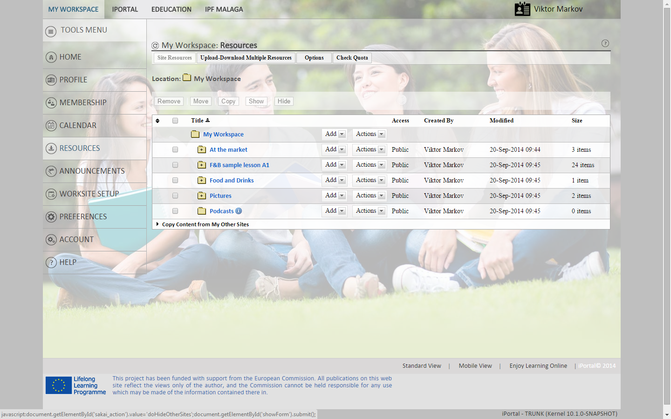
- Under Site Resources you will find a list of all the iPortal resources created. Click on the dropdown link Add to make changes to the file. Under the drop down link Actions you can Copy, Edit, Move or Remove the file.
- On the Upload – Download Multiple Resources page you can follow the instructions to create a folder on your desktop that will allow you to drag and drop files and folders between your computer and this site's Resources tool. This involves using a protocol called WebDAV. The WebDAV setup process is different for each operating system. Follow the simple steps to get started.
- The Permissions link allows you to choose whether you want the resources to have the access (student) or maintain (teacher) permission.
- Select or deselect resources types to indicate whether resources of that type can be created in this site under Options.
How to use Drop Box
The Drop Box feature allows instructors and students to share documents within a private folder for each student. The Drop Box works like Resources, it allows you to upload many types of files and multiple files at a time. Files in your Drop Box can only be seen by you and the site maintainers. Other participants cannot access them.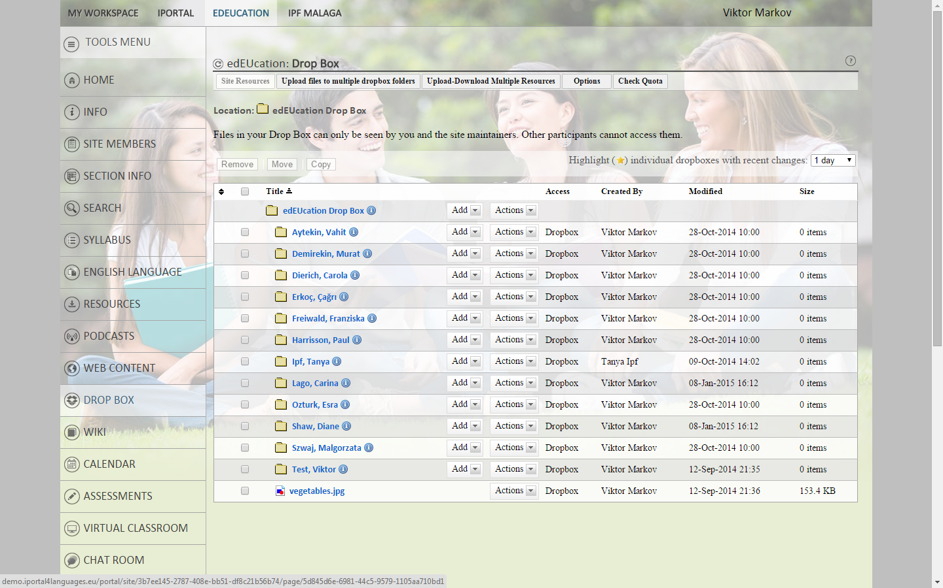
- To Upload a file to multiple drop box folders select the files you wish to upload and select the users. Click on continue.
- The Upload – Download tab is the same process as the Resources. Follow the instructions.
- Under Options you can choose whether email notifications should be sent for submissions within this dropbox.
How to use Calendar
Calendar allows you to post events in a calendar format. The calendar has day, week, month, year, and simple list views.
The Calendar can be used to post important dates in a class, such as start and end dates, assessment dates, etc.
Project sites may use Calendar to post key dates, such as deadlines.
How to Upgrade your lessons
Podcasts
- The Podcasts tool allows you to store and distribute multimedia content to site participants. Participants may download materials manually or via an RSS feed. Content can take many different forms, including audio lectures, video presentations, and slideshow presentations.
Web Content
- The Web Content tool allows you to display external web sites within their worksites.
- To set up a Web Content link, you can specify the URL for any web site and a brief descriptive title. A link will appear in the menu bar with the title you've chosen; when you click the link, the web site will open within your worksite.
Wiki
- There are a wide number of ways to use wikis for teaching - a web search will find any number of suggestions and case studies. For example, students can develop a collection of resources about the topic they are studying, and make them available to the outside world. Other lecturers like to produce a wiki page as a way of publishing lecture notes and course guidance for students to read, but not edit.

How to Assess your Students
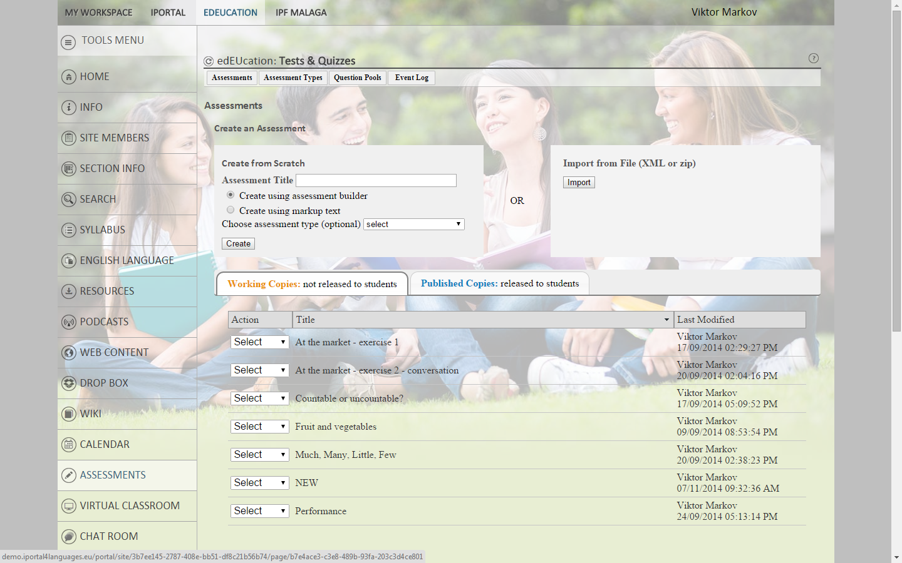
- Select the Assessments on the tool menu and click on the Assessments button. Here you can add a new assessment by following the steps, giving it a name and choosing the type of assessment.
- Once you have created an assessment you can publish the assessments to make it available to participants.
- You will see a number of participants that filled in the assessment, click on the number and choose the participant you wish to assess.
- Once assessed you can send it off to the participants so they can view the scores.
- You can add and edit more questions to the test at any time.
How to Communicate

You have several tools in the iPortal website, such as Chat Rooms, Messages, Forum and E-mails, to communicate between participants and teachers.

- You can use the Chat Room tool for real-time, unstructured conversations among site participants who are logged into the site at the same time. You can set both access and maintain permissions by ticking the boxes.

- The Messages tool is intended for private correspondence with other individuals or groups in your site. Messages are organised into sections, received, sent, deleted and draft. The navigation links allow you to compose your messages, create folders and edit settings and permissions.

- The Forums tool allows you to create and organise an unlimited number of discussion forums. By using Forums, you can view statistics for individual course participants and forum topics.
Use ranks to identify people based on their post count or to denote certain individuals, such as the teaching staff within a class.

- Email allows users to send an email message to site participants. To compose an email, you can select recipient(s) from the pre-configured recipient view. If you want to send a copy to non-site-participant, enter the recipient’s email address in the "Other recipient(s)" text field. If you want to attach file(s), click "Attach a file" to browse for a file on your computer. Enter a subject and a message.
How to use a Virtual Classroom

Let’s explore how to organise and use a Virtual Classroom.

- Under iPortal click on the virtual classroom tab. Here you will find a list of your virtual classes. Click on the Room Name to view the class or to make modifications.
- By clicking Edit you can modify the room name and type, change the number of users and start and end dates on the drop down calendar.
- The Recurrence option allows you to modify how many times and how often you would like to receive updates.
- You can allow all users access or select which groups and users can view the classroom. You can add by entering the user name or email. Calendar and notification options are available. Click Create
- Under Recording you can view the virtual classrooms created.

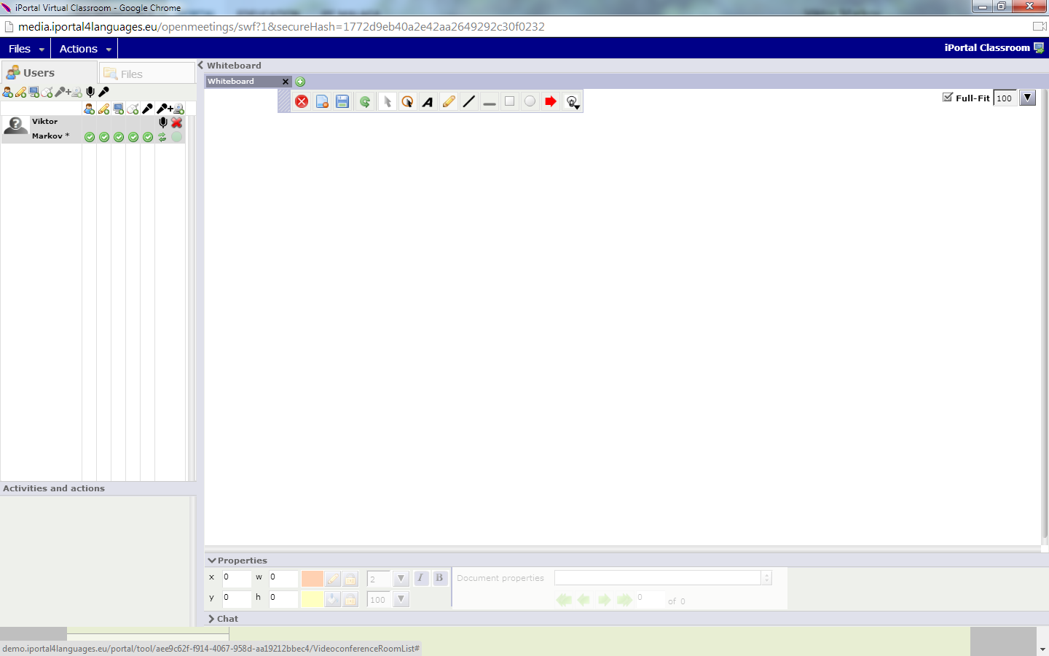

How to create a New Room

- By clicking New Room you can create a new virtual classroom by following the same steps as when you edit a classroom. Click Create
- You can view the status of the server under Check Server.

I will provide more information on this after the London meeting.

How to navigate 3D Learning

I will provide more information on this after the London meeting.

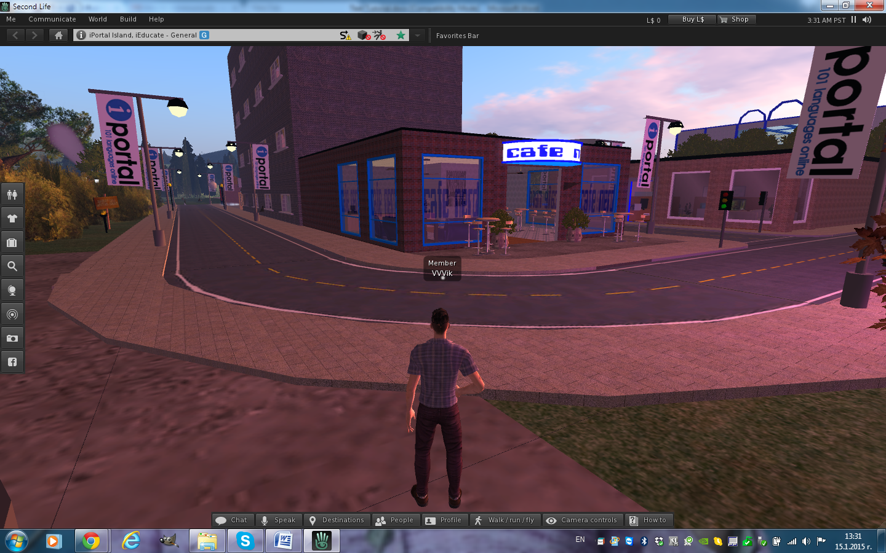
What are Email Archives and External Tools

Each site has an automatically generated site email address, which you can view via the Email Archive tool. By default, the emails you send to the site email address are copied to the email addresses of all site participants.

The External Tools function can be used to add external tools that use the IMS Basic Learning Tool Interoperability standard. This standard allows applications to be written in order to support any course management system.

Manage a Course

How to Organise Admin Communication

Announcements
The Announcements tool is used to inform site participants about current items of interest. Announcements can have multiple attachments, such as documents or web addresses (URLs).
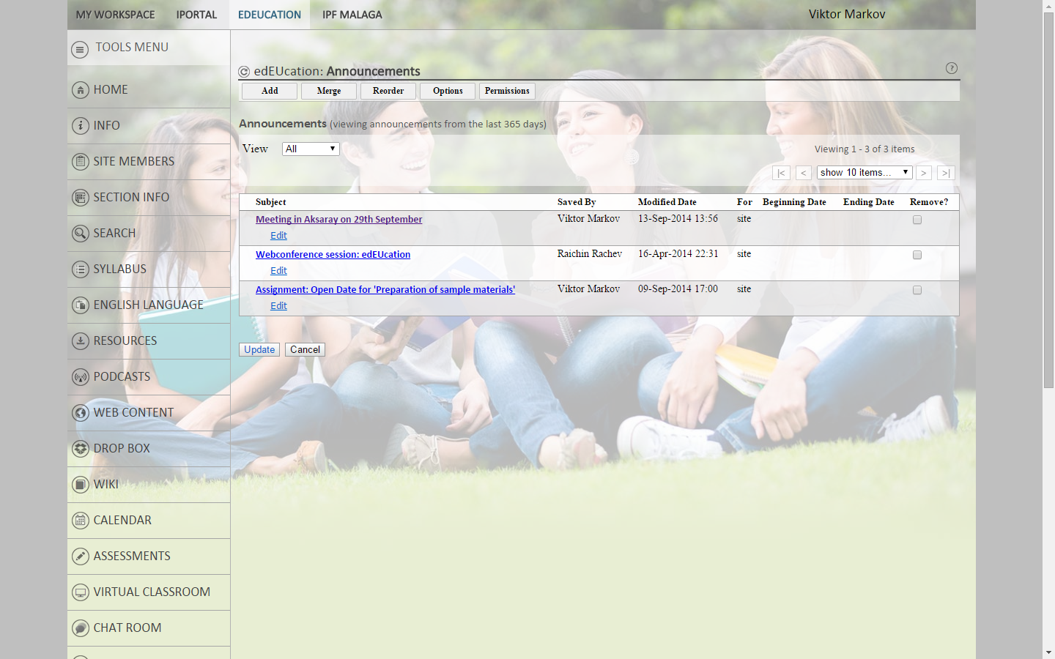
- When creating an announcement, you can select Show to make it visible; Hide to hide it, or Specify Dates to set a beginning date and ending date for the announcement's visibility.
- The most recently added or edited announcement will appear first. To change the order of the announcements, you can either edit each announcement until they display in the desired listing, or use the reorder feature.

RSS News
RSS is a data format used to syndicate news on the web. It allows continuously updated content from a remote news site to appear in another web site.
- To set up your worksite to display news, you must specify a URL pointing to an RSS news feed. An RSS news feed is a specially formatted list of news articles. You can find RSS feeds by using an Internet search engine (e.g., Google or Yahoo).
How to create Assignments

The Assignments tool allows you to create, distribute, collect, and grade online assignments. Assignments are private; student submissions are not visible to other users of the site.
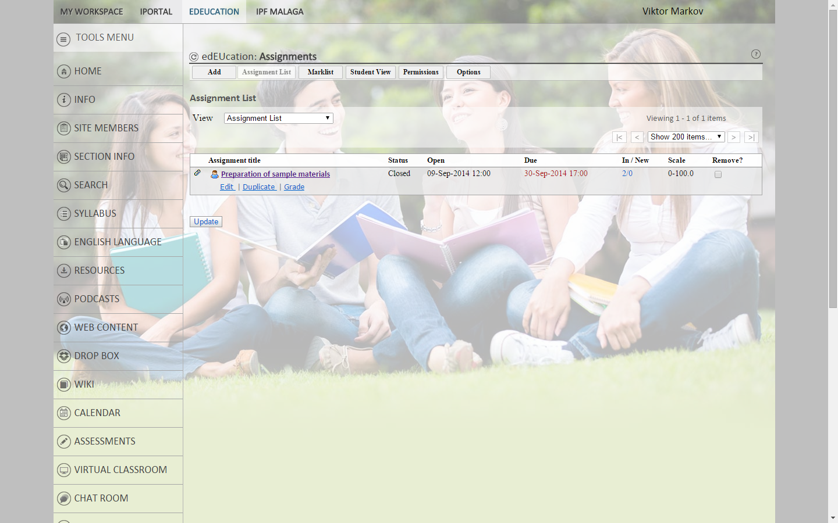
Let’s have a look at how to add a new assignment
- To add a new assignment click Assignments in the tools menu bar, and then, at the top, click Add. Fill in the fields marked with a red star.
- In the "Assignment Instructions" box, type a description of the assignment. This step is optional.
- Under the text box for assignment instructions, you have the options to hide/add due dates to schedule and add announcements & declarations to the assignment.
- You can choose whether you want to add the assignment to Markbook. Students can only be marked in the assignment tool.
- You have the options to choose whom you would like to access the site and how you choose to notify the students when the mark is released.
Once complete click Post to make the assignment accessible to students.
How to Mark students
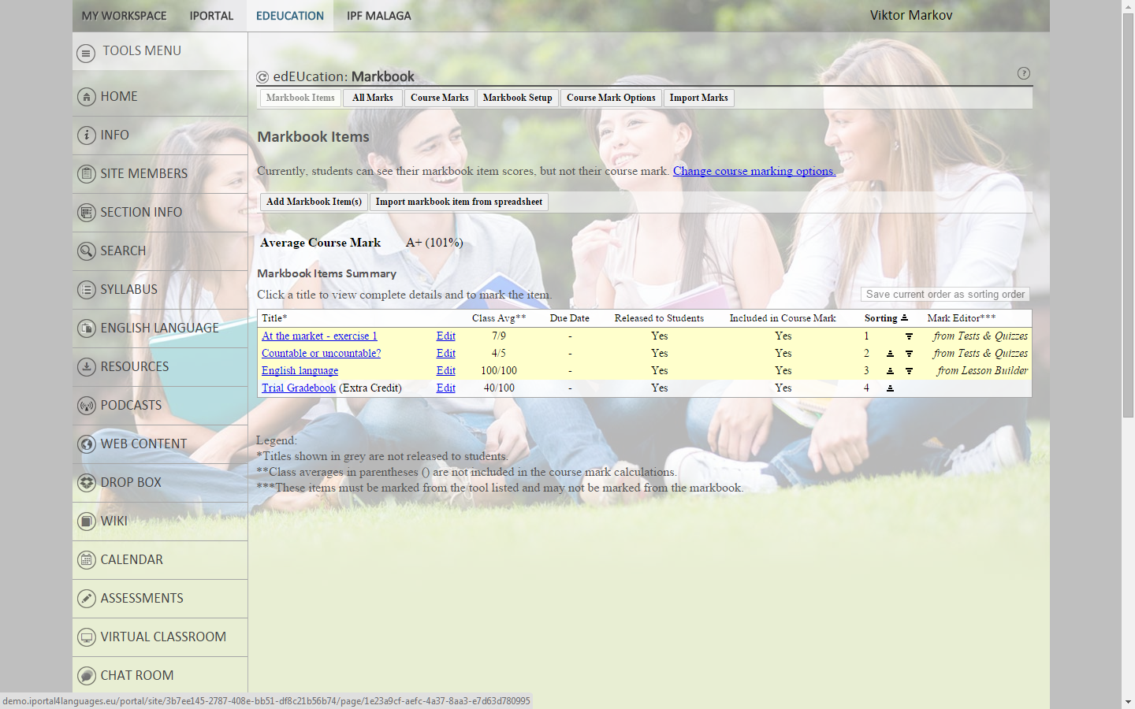
- To mark students you enter Markbook and choose the student you would like to mark and follow the steps.
- You can choose how to set up your marking if by points or percentage. The value of the grade can be modified by changing the percentage.
- Marks can also be imported by using an excel spreadsheet. By entering Import Marks you can choose the file you would like to import.
How to Feed back on your Course

How to create a SURVEY
- Click on add survey and enter a question with an optional description. Enter the opening/ closing days of the survey and choose the min/max number of answer options.
- You can make the survey public to make it visible to participants. Select when the results will be visible, for example, always or only to participants who have voted. Click save and add options
The SITE STATISTICS TOOL allows authorized users to view site usage statistics.
- Statistics can be accessed from the initial tool page, which presents a quick overview of site visits, activity and resources statistics.
- You can chose which activities you would like to view on the overview chart and the time period.
The POST’EM tool allows you to give feedback to the whole group of students just by uploading one common spreadsheet file (in .CSV format), yet allowing the students to see only their personal feedback, without the feedback of the other students. It helps a teacher to send feedback in one file, instead of sending personal messages to every single student.

